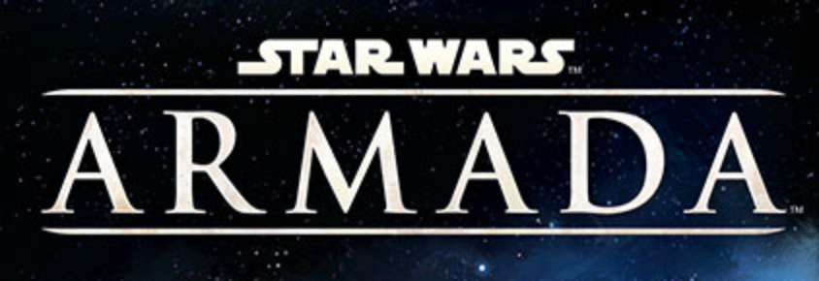
STATION ASSAULT
Version 0.2
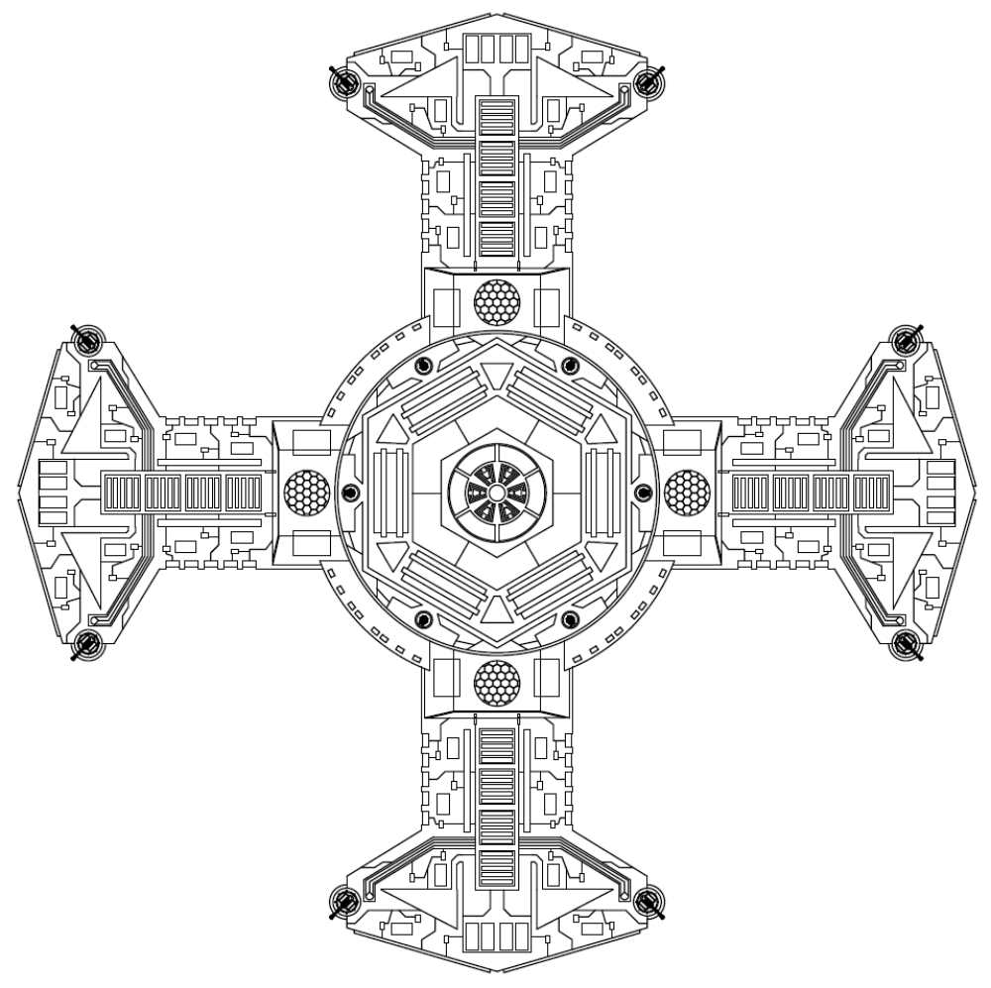

Station, Platform, Round dial and original scenario design by Matt Taylor/AdmiralCrunch. v0.2 rules update, station status cards and card graphic design by Craig Fleming/rythos42 (rythos42 at gmail dot com).

Collaborate on updates by forking at https://github.com/rythos42/ArmadaStationAssault!
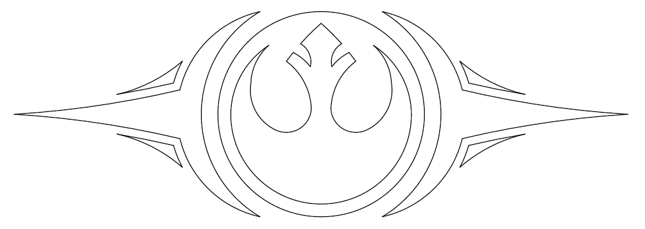
Once more our galaxy is plunged into darkness. For millennia the Republic stood as a beacon against that darkness. It insured a civilization of peace, justice, and liberty for all beings. That beacon is now threatened with extinguishment.
We know who has perpetuated this; the same ones who have done it time and again before. They who have wanted nothing more than to dominate us. To deprive us of our guardians. To tear down the liberties we have treasured. To strip us of all we hold dear.
In these dark times a call has always gone out. A call answered by our fore bearers without hesitation or remorse. A call answered with blood and tears to the last full measure. Who now will heed this call? Who will rise with me and take back what is rightfully ours? Who will rise... For Justice! For Freedom! FOR THE REPUBLIC!
Rebel Call
- Admiral Quar Wrunsh

Hello Commander. It gladdens me to know you are still well. We have lost so many in our campaign to restore the Republic; losing an officer of your caliber would be unacceptable.
I'm afraid that I must ask to put you in harms way once again though. Our intelligence network has informed us of a new imperial station in the Thesme Sector. It is a smaller modular station which was assembled quickly. As you can imagine its location poses an imminent risk to our operations in the area, and we need that base wiped out immediately. An Imperial response will be rapid and brutal, so you will have little time to complete this task. Fleet command will provide you with whatever resources they can. Good luck, and may the force be with you.
- Mon Mothma

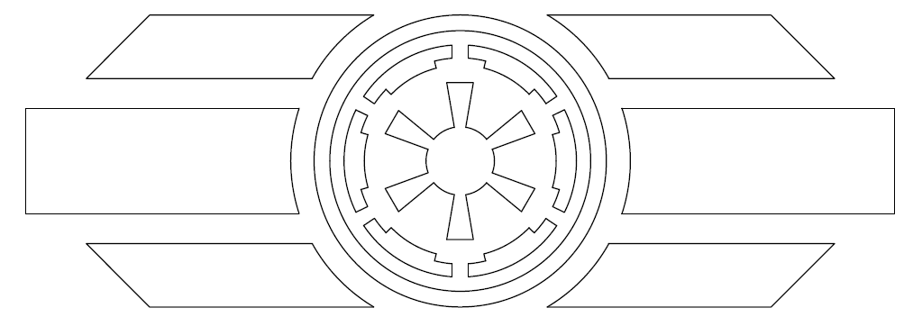
Order. We must never forget that our mandate is to bring order to a chaotic universe. Me must not allow those that would divide us to prevail. It is through unity that we find strength. It is through strength that we will build a better future.
Our beloved Emperor saw us through the chaos of the Clone Wars when the Separatist would have torn our civilization in twain. They did not succeed, nor will any movement that wishes for the division of that which so many of us have fought and died to remain whole.
Remember your Oaths, men. Together we are a mountain on which any wave of change will break. We are legion. We are loyal. We are United. We are eternal. We are the Empire
Loyalty to the Oath
- High Minister Pak Olem

Commander; your reputation precedes you. A reputation however means nothing without results. Successfully completing your next assignment would cement your reputation and go far in advancing you within the fleet ranks. Of course, I don't have to remind you of the cost for failure.
Now for the task at hand; the Rebellion has a small platform station that they have been randomly moving around the Belderone Sector. The Emperor wants it destroyed. Our analysts have pinpointed its next most likely location. You will take a small fleet there and vaporize it immediately. We expect this operation to be handled swiftly and efficiently. Nothing less will be tolerated.
- Grand Moff Tarkin

RULES

Station Assault is a Solo Module for Star Wars: Armada. Your sole objective is to defeat the enemy Station by destroying all four of its Platforms within 8 rounds. Turns will alternate between the player and Station. The player always goes first.

Assembling your Station
- Print and cut out Cards.pdf
- Print and cut RoundDial.pdf
- Print and cut StationStatusCards.pdf or StationStatusCards-NoBackground.pdf
- Print and cut Stations.pdf, or 4 Platforms to play against and only print them. The Platforms are:
  - QR-E(asy)
  - QR-M(edium)
  - QR-H(ard)
  - QR-S(hipyard). This is a practice Platform with no guns.
  - QR-T(anks). As in fuel tanks. It has no guns but explodes when you kill it.
  - Mix and match the Platforms as you desire!

Optional: Print this document, or just pages 4-5.

Setup
Build a 400 point fleet.

Place the Round Tile in the play area such that it is equidistant from 3, with at least distance 5 worth of space around it. Place the Station Core on the Round Tile, with the arrow pointing at Round 1. Choose some combination of Platforms and place them on the Station Core.
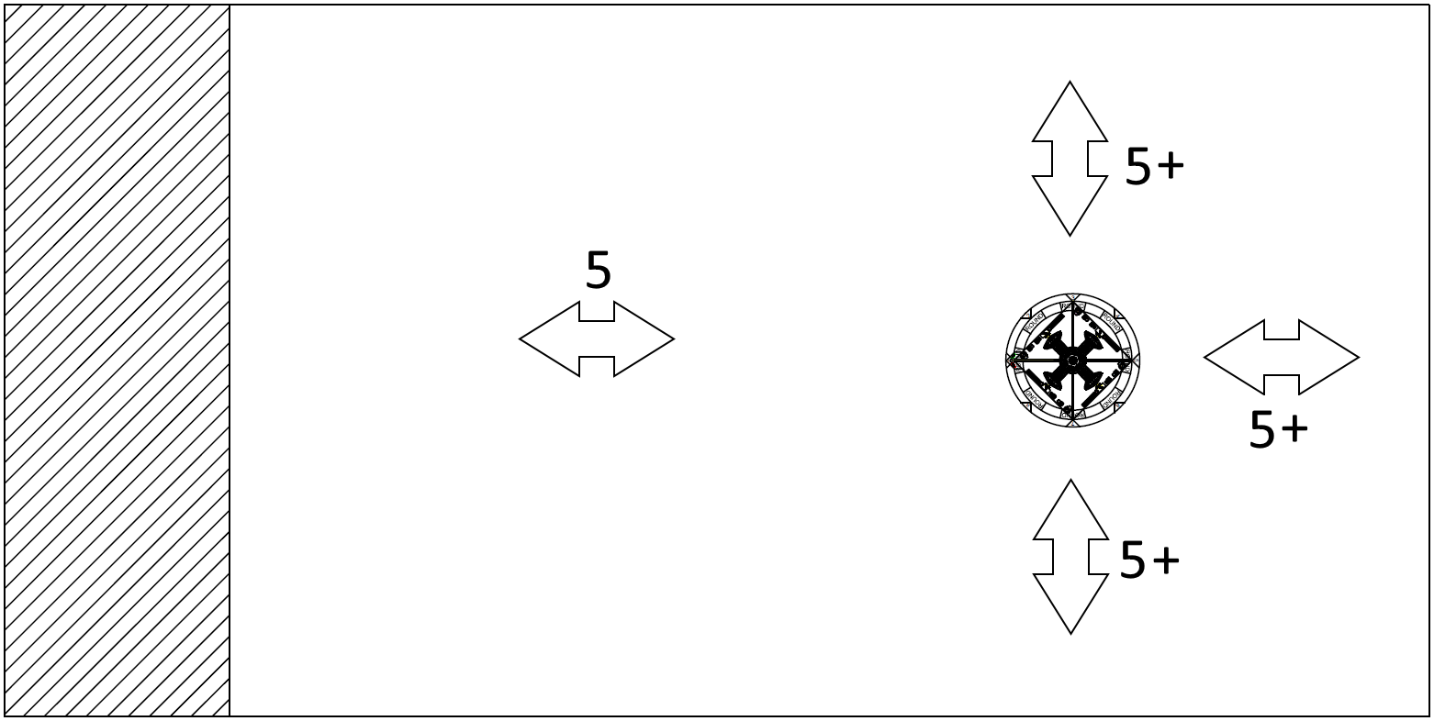

Take the obstacles as a stack, hold them above the space between your deployment zone and the Station, and drop them from a couple feet above your table. Shift them such that they are at least distance 1 from each other and the station.

Shuffle the Targeting deck. Shuffle the Damage deck (from the Core Box).

Deploy your fleet entirely at one side of the table, at least distance 5 from the Station Core.

Gain 1 Command Token of your choice for each 10 points you are below the scenario point value, or each partial amount. (ie, if your bid is 8, gain 1 Token. If your bid is 12, gain 2 Tokens). Give these Tokens to any ship in your fleet.

The Turn
- Player turn - play as in standard rules
- Station Turn
  - Draw a new Targeting card
    - Each Targeting card will tell you the target priority for the Station to shoot, as well as a special effect for the Station this turn.
  - Fire once from each Platform.
  - Rotate the Station to the next Round marker on the Round Tile.

Special Rules
- Player accuracies turn any 1 hit into a crit and also give 1 additional Critical Effect.
  - Platform accuracies affect defense tokens in the following order: Scatter, Brace, Evade (if not cancelled by range), Redirect
- Platforms target hull zones in this order:
  - The one it gets the most dice with.
  - The one that has the least shields.
  - The closest one.
- If a Platform or any Ship overlaps Squadrons, move the Squadron the least distance possible until it no longer overlaps. The Player cannot purposefully overlap a Platform with Squadrons.
- Treat each Platform as though it were its own ship. This means a number of Damage cards have no effect - Coolant Discharge, for example, because each Platform has only 1 attack.
- If a Damage card is drawn for a Platform that cannot be applied (there are a lot of them), roll a Red dice and check the following table. Apply this result as the damage result instead.
  - HIT: Red dice are no longer able to be fired from this Platform.
  - CRIT: Blue dice are no longer able to be fired from this Platform.
  - BLANK: Black dice are no longer able to be fired from this Platform.
  - HIT/HIT: Deal another damage card to this Platform.
  - ACCURACY: Shields can no longer be recovered on this Platform.
- Destroyed Platforms still count for blocking LOS.

Scoring
At the end of the 8th round, total your score.

- Add up the VP total printed on each Platform.
- If all Platforms were destroyed in 8 rounds, add 100 VPs.
- Subtract the cost of each lost ship or squadron, including upgrades.
- If all non-Flotilla Ships were lost, subtract 100 VPs.

