Variability
in Xtext DSLs

This documentation explains how to use the tooling provided as part of the dslvariantmanagement Google Code project. It supports the expression of negative variability in arbitrary Xtext DSL.

Feature Access

Create an Xtext Project
The get started, we create a new Xtext project. Just use all the defaults in the New Xtext Project wizard. Enter the following into the mydsl.xtxt file as the language grammar.
System:
(entities+=Entity)*;

Entity:
"entity" name=ID "{"
(attributes+=Attribute)*
"}";

Attribute:
name=ID ":" type=ID;
Generate the DSL, and verify that it works. Create an openArchitectureWare project my.dsl.test and put a test.dsl file with the following content into the src folder.
entity E1 {
a : String
}

entity E2 {

}

Create a p::v Project
The next step is to create a project that holds the p::v variant model and its EMF export. Create a new Variant Project (using the Wizard) named my.dsl.pv. Then open the project properties and set the Variant Model Ecore Export to Simplified Result.
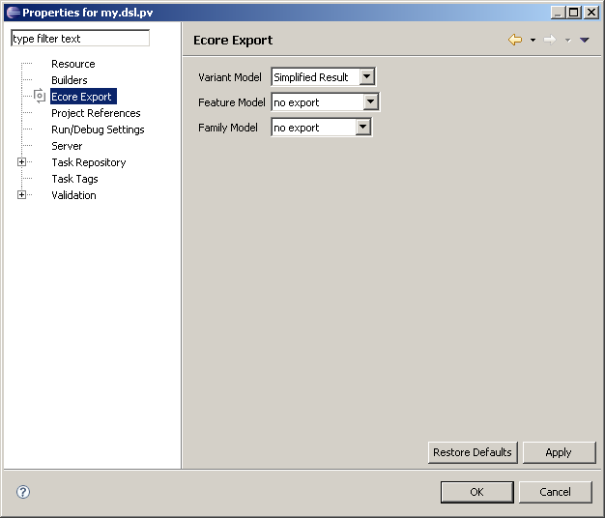
In the variant model that has been created by the wizard in the project’s root folder (my.dsl.pv.xfm) create a couple of features. Make sure these are optional features!
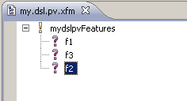
Then save the model. A my.dsl.pv.xfm.xmi next to my.dsl.pv.xfm should appear. This contains the variant model in EMF form. Whenever you change something in the .xfm make sure you save it to trigger the export and update the .xfm.xmi file.

Access Features from DSL
Add the org.openarchitectureware.var.featureaccess plugin to dependencies of DSL project. Then modify the grammar to include the red stuff. Because of the missing language modularization features of Xtext 4.x this cannot be provided as a “library” of some form. Copy and Paste is necessary.
System:
(featureModel=FeatureModelImport)?
(entities+=Entity)*;

Entity:
"entity" name=ID "{"
(attributes+=Attribute)*
"}";

Attribute:
name=ID ":" type=ID (featureClause=FeatureClause)?;

FeatureClause:
"feature" feature=ID;

FeatureModelImport:
"featuremodel" uri=STRING;
The code above allows to reference a feature model file from a DSL and add feature clauses to attributes. If you want feature clauses on other elements, just add the (featureClause=FeatureClause)? snippet to it.
We now have to add various stuff to several of the files in the language and editor. Let’s start with the language utilities in Extensions.ext. To the Extensions.ext add this:
extension org::openarchitectureware::var::featureaccess::ext::utils reexport;

String featureModelUri(emf::EObject this):
((System)eRootContainer).featureModel.uri;
The constraints, Checks.chk must also be extended, to detect missing feature model imports and references to undefined features.
context FeatureClause ERROR "no feature model imported":
featureModelUri() != null;

context FeatureClause ERROR "feature '"+feature+
"' does not exist in feature model":
getAllFeatures(featureModelUri()).contains( feature );
Now let’s focus on the editor. Code completion must be customized to show the features in the feature model when pressing Ctrl-Space for the FeatureClause. To ContentAssist.ext add this:
extension org::openarchitectureware::var::featureaccess::ext::utils;

completeFeatureClause_feature(emf::EObject ctx, String prefix) :
proposeFeatures(ctx, prefix);

proposeFeatures(emf::EObject ctx, String prefix) :
let features = getAllFeatures(ctx.featureModelUri()):
let filteredFeatures = (prefix != null ? features.select(f|f.startsWith(prefix)) : features) :
filteredFeatures.collect(ff|newProposal( ff, ff, "featureclause.gif") );
Finally, let’s customize the icons and the labels. To the EditorExtensions.ext add this:
image( FeatureClause this ): "featureclause.gif";
image( FeatureModelImport this ): "featuremodelimport.gif";
label( FeatureClause this ): feature;
label( FeatureModelImport this ): "feature model "+uri;
Also make sure you copy the icons in org.openarchitectureware.var.featureaccess/icons into the icons folder of your my.dsl.editor

Example
After regenerating your DSL, the following should be a valid instance:
featuremodel "platform:/resource/my.dsl.pv/my.dsl.pv.xfm.xmi"

entity E1 {
a : String feature f1
}

entity E2 {

}
And code completion, as well as constraint checking should also work:
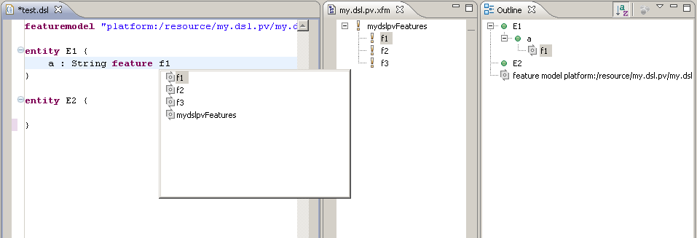

Negative Variability

Create a generator
To see the result of tailoring the model create a generator in the generator project created by the wizard. The example below simply dumps the model in the same way as the original syntax.
«DEFINE main FOR System»
«FILE "output.txt"»
«FOREACH entities AS e»
entity «e.name» {
«FOREACH e.attributes AS a»
«a.name» : «a.type»
«ENDFOREACH»
}
«ENDFOREACH»
«ENDFILE»
«ENDDEFINE»
In the my.dsl.generator project add the following two plugin dependencies: com.ps.consul.eclipse.ecore and org.openarchitectureware.var.tailor
In the generator project’s generator.oaw add this meta model package to the set of registered packages:
<bean class="org.eclipse.mwe.emf.StandaloneSetup">
<platformUri value=".."/>
<registerGeneratedEPackage value="com.ps.consul.eclipse.ecore.pvmodel.PvmodelPackage" />
</bean>

Adapting the Example
In the my.dsl.test project add a dependency to the my.dsl.generator plugin and create a simple workflow stub test.oaw:
<workflow>
<component file="org/example/dsl/generator.oaw" modelFile="test.dsl" />
</workflow>
You can now run this workflow; it should generate the following code. No surprise.
entity E1 {
a : String
}

entity E2 {
}

Create a Variant
In the my.dsl.pv project, create a configuration space called cfg, basically a location for configuration models (.vdm). When creating one via the wizard, one configuration is automatically created, it is called cfg.vdm;
Make sure in the my.dsl.pv project properties the following two export options are set:
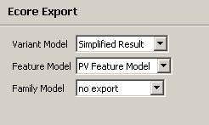

Adding a Tailor step to the Generator
In the generator project’s generator.oaw remove the parser component and add this:
<component file="org/openarchitectureWare/var/tailor/model/tailorPV.oaw"
architectureModelFile="${modelFile}"
configurationModelUri="${configModelUri}"
dslPackage="platform:/resource/my.dsl/src-gen/org/example/dsl/mydsl.ecore"
parserCartridge="org/example/dsl/parser/Parser.oaw"
constraintFile="org::example::dsl::Checks" />
/>
In the my.dsl.test project you have to add a new parameter to the invocation of the generator.oaw workflow: you have to pass in the URI of the selected configuration.
<workflow>

<component file="org/example/dsl/generator.oaw"
modelFile="test.dsl"
configModelUri="platform:/resource/my.dsl.pv/cfg/cfg.vdm.xmi"
/>

</workflow>

Testing Model Tailoring
If you now make sure the feature f1 is not selected in the cfg.vdm configuration model and rerun the test.oaw workflow, the output should look like this:
entity E1 {

}

entity E2 {

}
Note how the attribte a is missing, because it’s feature has been unselected.

Adapting the outline View
You might want to adapt the outline view so it provides a viewpoint that puts the feature on top, and then arranges below it all the model elements that depend on this feature.
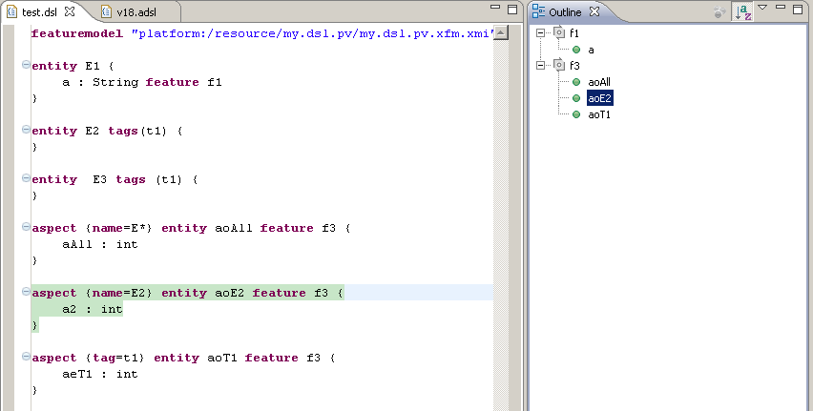
Here is the code:
viewpoints(): {
"Features"
};

viewpointIcon(String vpName) :
switch (vpName) {
case "Features": "vp_feature.gif"
default: "vp_default.gif"
};

// -------------------------------------------------------------------------
// Features

create UIContentNode outlineTree_Features(emf::EObject model) :
let features = model.allLocalElements().typeSelect(FeatureClause).collect(fc|fc.feature).toSet():
setLabel(model.label()) ->
setImage(model.image()) ->
setContext(model)->
children.addAll( features.createFeatureNode(model) );

create UIContentNode createFeatureNode( String feature, emf::EObject model ):
setLabel(feature) ->
setImage("feature.gif") ->
setContext(null)->
children.addAll( feature.createRefNodes(model) );

createRefNodes( String feature, emf::EObject model ):
model.allLocalElements().typeSelect(FeatureClause).select(fc|fc.feature == feature).collect(fc|fc.eContainer).createRefNode();

create UIContentNode createRefNode( emf::EObject obj ):
setLabel(obj.label()) ->
setImage(obj.image()) ->
setContext(obj);

You might have to copy the feature.gif and the vp_feature.gif from the org.openarchitectureware.var.featureaccess plugin’s icons folder over into your language editor’s icons folder.

Aspects – Positive Variability
First we have to extend the grammar to contain pointcuts, pointcut clauses and tags. Please add the red stuff to your grammar and rebuild the language.
System:
(featureModel=FeatureModelImport)?
(entities+=Entity)*;

Entity:
(pointcut=Pointcut)?
"entity" name=ID
(tags=TagsClause)?
(featureClause=FeatureClause)? "{"
(attributes+=Attribute)*
"}";

Attribute:
name=ID ":" type=ID (featureClause=FeatureClause)?;

// --------------------------------
// Feature Stuff

FeatureClause:
"feature" feature=ID;

FeatureModelImport:
"featuremodel" uri=STRING;

// --------------------------------
// AO Stuff

TagsClause:
"tags" "(" (tags+=Tag)* ")";

Tag:
name=ID;

Pointcut:
"aspect" "{" (matches+=Match)* "}";

Match:
AllMatch | ExactNameMatch | StartsWithNameMatch | EndsWithNameMatch | TagMatch;

AllMatch:
"*";

ExactNameMatch:
"name" "=" name=ID;

StartsWithNameMatch:
"name" "=" name=ID "*";

EndsWithNameMatch:
"name" "=" "*" name=ID;

TagMatch:
"tag" "=" name=ID;

Testing Model Aspects
In the my.dsl.test project change the test.dsl file to contain the following:
featuremodel "platform:/resource/my.dsl.pv/my.dsl.pv.xfm.xmi"

entity E1 {
a : String feature f1
}

entity E2 tags(t1) {
}

entity E3 tags (t1) {
}

aspect {name=E*} entity aoAll feature f3 {
aAll : int
}

aspect {name=E2} entity aoE2 feature f3 {
a2 : int
}

aspect {tag=t1} entity aoT1 feature f3 {
aeT1 : int
}
Rerun test.oaw to generate the output. Here is the expected result:
entity E1 {
a : String
aAll : int
}

entity E2 {
aeT1 : int
a2 : int
aAll : int
}

entity E3 {
aeT1 : int
aAll : int
}
The aoEAll aspect has adviced all entities. Therefore, each of them has the aAll attribute in the output. The aoE2 aspect advises only E2. Hence only E2 has the a2 attribute. Finally, aoT1 advises all entities with the tag t1. Since E2 and E3 have this tag, they end up with the aeT1 attribute in the output.
Note how all three aspects depend on the feature f3. If you remove this from the configuration and regenerate the output, no AO weaving will take place since the aspect itself will have been removed before weaving.

