Variability
in Xtext DSLs

Markus Voelter, voelter@acm.org
Version 0.7
This documentation explains how to use the tooling provided as part of the dslvariantmanagement Google Code project. It supports the expression of negative variability in arbitrary Xtext DSL.
This document really only contains the user guide, but no background information about the approach or concepts. Please read the following PDF instead:
http://www.voelter.de/data/articles/ArchitectureAsLanguage-PDF.pdf
http://www.voelter.de/data/articles/ArchitectureAsLanguage-Part2-PDF.pdf

Tooling
The variability tooling is currently implemented based on pure::variants (http://pure-systems.com).
You need to install pure::variants version greater 3.0.4, including the "pure::variants - Connector for Ecore" and "pure::variants - Connector for Source Code Management" feature. An evaluation version is available at http://www.pure-systems.com/pv-update.
Note that the Community Edition is not sufficient.

Feature Access

Create an Xtext Project
To get started, we create a new Xtext project. Just use all the defaults in the New Xtext Project wizard. Enter the following into the Mydsl.Xtext file as the language grammar.
grammar org.xtext.example.MyDsl with org.eclipse.xtext.common.Terminals

generate myDsl "http://www.xtext.org/example/MyDsl"

System:
(entities+=Entity)*;

Entity:
"entity" name=ID "{"
(attributes+=Attribute)*
"}";

Attribute:
name=ID ":" type=ID;
Generate the DSL, and verify that it works. Create a plugin project org.xtext.example.mydsl.test in the runtime workbench and put a test.mydsl file with the following content into the src folder.
entity E1 {
a : String
}

entity E2 {

}

Create a p::v Project
The next step is to create a project that holds the p::v variant model and its EMF export. Create a new Variant Project (using the Wizard) named org.xtext.example.mydsl.pv. Then open the project properties and set the Feature Model Ecore Export to PV Feature Model.
In the variant model that has been created by the wizard in the project’s root folder (org.xtext.example.mydsl.pv.xfm) create a couple of features. Make sure these are optional features!
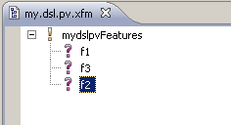
Then save the model. A org.xtext.example.mydsl.pv.xfm.xmi next to org.xtext.example.mydsl.pv.xfm should appear. This contains the variant model in EMF form. Whenever you change something in the .xfm make sure you save it to trigger the export and update the .xfm.xmi file.

Access Features from DSL
Add the org::openarchitectureware.var.featureaccess plugin to dependencies of DSL project. Make sure you check the reexport flag. Then modify the grammar to include the red stuff.
System:
(featureModel=FeatureModelImport)?
(entities+=Entity)*;

Entity:
"entity" name=ID "{"
(attributes+=Attribute)*
"}";

Attribute:
name=ID ":" type=ID (featureClause=FeatureClause)?;

FeatureClause:
FeatureAndList | FeatureOrList | FeatureExpression | Feature ;

FeatureAndList:
"featureAndList" (retained?="retain")? "(" featureList+=ID ("," featureList+=ID)* ")";

FeatureOrList:
"featureOrList" (retained?="retain")? "(" featureList+=ID ("," featureList+=ID)* ")";

FeatureExpression:
"featureExp" (retained?="retain")? "(" expression=OrExpression ")";

Feature:
"feature" (retained?="retain")? feature=ID;

OrExpression:
operands+=AndExpression ("or" operands+=AndExpression)*;

AndExpression:
operands+=Operand ("and" operands+=Operand)*;

Operand:
(isNot?="not")? expression=Atom;

Atom:
feature=ID | "(" expression=OrExpression ")";

FeatureModelImport:
"featuremodel" importURI=STRING;
The code above allows you to reference a feature model file from a DSL and add feature clauses to attributes. If you want feature clauses on other elements, just add the (featureClause=FeatureClause)? snippet to it.
To understand what the retain keyword means, please see the Retained Features section below. For the rest of the other sections, you can ignore it.
We now have to add various things to several of the files in the language and editor. First, create a file Extensions.ext in the language project’s org.xtext.example.extensions package. To this file add the following code:
import myDsl;

extension org::openarchitectureware::var::featureaccess::ext::utils reexport;

String featureModelUri(emf::EObject this):
((System)eRootContainer).featureModel.importURI;
Please make sure your language project has the Xpand nature by selecting, in the context menu of the project, the Configure->Remove/Add Xpand nature (and/or look into the .project file to check it’s there!).
We also want to use constraint checks based on the Check language. To enable this feature in TMF, open the GenerateMyDsl.mwe workflow and add the following XML to the list of fragments of the Xtext generator. Then regenerate the language.
<fragment class="org.eclipse.xtext.generator.validation.CheckFragment"/>
In the validation package of your language you now find three .chk files. To the MyDslCheck.chk file add the following code:
import myDsl;

extension org::xtext::example::extensions::Extensions;
extension org::openarchitectureware::var::featureaccess::chk::featureconstraints;

context FeatureClause ERROR "no feature model imported":
featureModelUri() != null;

context Feature ERROR "feature '"+feature+"' does not exist in feature model":
getAllFeatures(featureModelUri()).contains( feature );

context FeatureAndList ERROR "one ore more features in list not found":
getAllFeatures(featureModelUri()).containsAll( featureList );

context FeatureOrList ERROR "one ore more features in list not found":
getAllFeatures(featureModelUri()).containsAll( featureList );

context Atom ERROR "feature '"+feature+"' does not exist in feature model":
feature != null ? getAllFeatures(featureModelUri()).contains( feature ) : true;

Now let’s focus on the editor. Code completion must be customized to show the features in the feature model when pressing Ctrl-Space for the FeatureClause. In the UI project, in to the class MyDslProposalProvider please add the following code:
public void completeFeature_Feature(EObject model,
Assignment assignment,
ContentAssistContext context,
ICompletionProposalAcceptor acceptor)
{
List<String> features = FeatureSupport.getAllFeatures(getFeatureModelUri(model));

for(String f : features){
ICompletionProposal completionProposal =
createCompletionProposal(f, context);
acceptor.accept(completionProposal);
}
}

private String getFeatureModelUri(EObject o){
return ( (FeatureModelImport)
((org.xtext.example.myDsl.System)EcoreUtil.getRootContainer(o)).getFeatureModel() ).getImportURI();
}
Finally, let’s customize the icons and the labels. To the MyDslLabelProvider class add this:
String image( EObject ele ){
return ele.eClass().getName().toLowerCase()+".gif";
}
Also make sure you copy the icons in org.openarchitectureware.var.featureaccess/icons into the icons folder of your UI project (you may have to create the icons folder in the root of the UI project).

Example
After regenerating your DSL, the following should be a valid instance:
featuremodel "platform:/resource/org.xtext.example.mydsl.pv/org.xtext.example.mydsl.pv.xfm.xmi"

entity E1 {
a : String feature f1
}

entity E2 {
a : String featureAndList (f1, f2, f3)
b : String featureOrList (f1, f2)
c : String featureExp (f3 and not ( f1 or f2) )
}
And code completion, as well as constraint checking should also work:
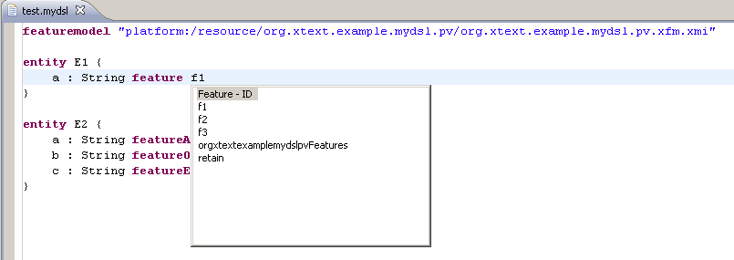

Negative Variability

Create a generator
To see the result of tailoring the model create a template in the generator project created by the wizard. The example below simply dumps the model in the same way as the original syntax.
«DEFINE main FOR System»
«FILE "output.txt"»
«FOREACH entities AS e»
entity «e.name» {
«FOREACH e.attributes AS a»
«a.name» : «a.type»
«ENDFOREACH»
}
«ENDFOREACH»
«ENDFILE»
«ENDDEFINE»
In the org.xtext.example.mydsl.generator project add the following two plugin dependencies:
com.ps.consul.eclipse.ecore, org.openarchitectureware.var.tailor
In the generator project’s MyDslGenerator.mwe add this meta model package to the set of registered packages:
<bean class="org.eclipse.emf.mwe.utils.StandaloneSetup">
<platformUri value=".."/>
<registerGeneratedEPackage value="com.ps.consul.eclipse.ecore.pvmodel.PvmodelPackage" />
</bean>
Also, in the MweReader component replace the example model file with a workflow variable ${modelFile}. The workflow should look like this:
<workflow>

<component class="org.eclipse.emf.mwe.utils.DirectoryCleaner" directory="src-gen"/>

<bean class="org.eclipse.emf.mwe.utils.StandaloneSetup">
<platformUri value=".."/>
<registerGeneratedEPackage value="com.ps.consul.eclipse.ecore.pvmodel.PvmodelPackage" />
</bean>

<component class="org.eclipse.xtext.MweReader" uri="${modelFile}">
<!-- this class will be generated by the xtext generator -->
<register class="org.xtext.example.MyDslStandaloneSetup"/>
</component>

<component class="org.eclipse.xpand2.Generator">
<metaModel class="org.eclipse.xtend.typesystem.emf.EmfRegistryMetaModel"/>
<fileEncoding value="Cp1252"/>
<expand value="templates::Template::main FOR model"/>
<genPath value="src-gen"/>
</component>

</workflow>
(Btw, you can delete the model package in the generator project…)

Adapting the Example
In the org.xtext.example.mydsl.test project add a dependency to the org.xtext.example.mydsl.generator plugin and create a simple workflow stub test.mwe:
<workflow>
<component file="workflow/MyDslGenerator.mwe" modelFile="platform:/resource/org.xtext.example.mydsl.test/src/test.mydsl" />
</workflow>
You can now run this workflow. In case the workflow does not even execute, make sure that all of the dependencies of the generator plugin are reexported to make them visible to the example project.
Manifest-Version: 1.0
Bundle-ManifestVersion: 2
Bundle-Name: org.xtext.example.mydsl.generator
Bundle-Vendor: My Company
Bundle-Version: 1.0.0
Bundle-SymbolicName: org.xtext.example.mydsl.generator; singleton:=true
Eclipse-RegisterBuddy: org.eclipse.xtext.log4j
Bundle-ActivationPolicy: lazy
Require-Bundle: org.xtext.example.mydsl;visibility:=reexport,
org.eclipse.xpand;visibility:=reexport,
org.eclipse.xtend;visibility:=reexport,
org.eclipse.xtext;visibility:=reexport,
org.eclipse.emf.mwe.core;visibility:=reexport,
org.eclipse.emf.mwe.utils;visibility:=reexport,
org.eclipse.xtend.typesystem.emf;visibility:=reexport,
com.ps.consul.eclipse.ecore;bundle-version="3.0.1";visibility:=reexport,
org.openarchitectureware.var.tailor;bundle-version="1.0.0";visibility:=reexport
Bundle-RequiredExecutionEnvironment: J2SE-1.5
The result of the workflow should be a file output.txt in the src-gen folder with the following content (and maybe a couple of additional empty lines).
entity E1 {
a : String
}

entity E2 {
a : String
b : String
c : String
}
So far, no surpise. We didn’t evaluate the feature dependencies, so the output is the same as the input, without the feature dependency clauses.

Create a Variant
In the org.xtext.example.mydsl.pv project, create a configuration space called cfg, basically a location for configuration models (.vdm). When creating one via the wizard, one configuration is automatically created, it is called cfg.vdm;
Make sure in the org.xtext.example.mydsl.pv project properties the following two export options are set:
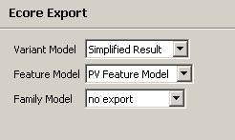

Adding a Tailor step to the Generator
In the generator project’s MyDslGenerator.mwe remove the MweReader component and add this:
<component file="org/openarchitectureware/var/tailor/model/tailorPV.mwe"
standaloneSetup="org.xtext.example.MyDslStandaloneSetup"
architectureModelFile="${modelFile}"
configurationModelUri="${configModelUri}"
constraintFile="org::xtext::example::validation::MyDslChecks" />
/>
In the org.xtext.example.mydsl.test project you have to add a new parameter in the test.mwe workflow: you have to pass in the URI of the selected configuration.
<workflow>
<component file="workflow/MyDslGenerator.mwe"
modelFile="platform:/resource/org.xtext.example.mydsl.test/src/test.mydsl"
configModelUri="platform:/resource/org.xtext.example.mydsl.pv/cfg/cfg.vdm.xmi" />
</workflow>

Testing Model Tailoring
If you now make sure that none of the features in the configuration model (.vdm) is selected rerun the test.mwe workflow, the output should look like this:
entity E1 {

}

entity E2 {

}
If you then, for example, select the feature f1 to be in the configuration, the output should look as follows:

entity E1 {
a: String
}

entity E2 {
b: String
}

Retained Features
All of the discussion above focused on removing model elements if the feature they are associated with is not selected. Consequently, a subsequent code generator cannot explicitly exploit the feature dependency – the elements are simply deleted. In many cases this is what you want. However, in some cases this is not the desired behavior; you want to be able to write a generator or transformation that uses the feature-dependency information.
So you need to be able to retain the feature dependency in the model until it is fed into the generator. The retain keyword can be used for this.
entity E1 {
a : String featureAndList retain (f1, f2, f3)
b : String featureOrList retain (f4, f5)
c : String featureExp retain (f4 and not ( f1 or f2) );
d : String feature retain f4;
}
To find out whether a feature clause (any of the forms shown above) is true you can include the extension file org::openarchitectureware::var::
featureaccess::ext::utils and call the isFeatureClauseTrue extension, passing in the feature clause.
To make this work you have to run the remover component (as shown above) before. It is loading the actual configuration model and makes it available to the isFeatureClauseTrue extension.
Here is example code to verify this functionality. Update the template to call a helper function for each attribute:
«FOREACH e.attributes AS a»
«a.name» : «a.type» «a.featureClauseValue()»
«ENDFOREACH»
In the Extensions.ext right next to the templates implement this helper function as follows. As you can see, it calls the isFeatureClauseTrue utility mentioned above.
import myDsl;

extension org::openarchitectureware::var::featureaccess::ext::utils;

featureClauseValue( Attribute a ):
a.featureClause.isFeatureClauseTrue();

Querying the configuration model directly
Instead of evaluating feature clauses expressed in the model in a transformation or generator, you can also directly query the feature model.
Here is an example:
«IF isFeatureSelected("SubclassHint")»
…
«ENDIF»
Note that there’s no code completion or static checks towards the feature model. The name of the feature is provided as a String.
Also, the query is run against the configuration model loaded earlier in the workflow, see the workflow example in the above section Adding a Tailor step to the Generator.

Aspects – Positive Variability
First we have to extend the grammar to contain pointcuts, pointcut clauses and tags. Please add the red stuff to your grammar and rebuild the language.
System:
(featureModel=FeatureModelImport)?
(entities+=Entity)*;

Entity:
(pointcut=Pointcut)?
"entity"
name=ID
(tags=TagsClause)? (featureClause=FeatureClause)? "{"
(attributes+=Attribute)*
"}";

Attribute:
name=ID ":" type=ID (featureClause=FeatureClause)?;

// --------------------------------
// Feature Stuff

…

// --------------------------------
// AO Stuff

TagsClause:
"tags" "(" (tags+=Tag)* ")";

Tag:
name=ID;

Pointcut:
"aspect" "{" (matches+=Match)* "}";

Match:
AllMatch | ExactNameMatch | StartsWithNameMatch | EndsWithNameMatch | TagMatch;

AllMatch:
"*";

ExactNameMatch:
"name" "=" name=ID;

StartsWithNameMatch:
"name" "startswith" name=ID ;

EndsWithNameMatch:
"name" "endswith" name=ID;

TagMatch:
"tag" "=" name=ID;

Testing Model Aspects
In the org.xtext.example.mydsl.test project change the test.mydsl file to contain the following:
featuremodel "platform:/resource/my.dsl.pv/my.dsl.pv.xfm.xmi"

entity E1 {
a : String feature f1
}

entity E2 tags(t1) {
}

entity E3 tags (t1) {
}

aspect {name startswith E} entity aoAll feature f3 {
aAll : int
}

aspect {name=E2} entity aoE2 feature f3 {
a2 : int
}

aspect {tag=t1} entity aoT1 feature f3 {
aeT1 : int
}
Make sure that feature f3 is selected in your configuration model. Rerun test.mwe to generate the output. Here is the expected result:
entity E1 {
a : String
aAll : int
}

entity E2 {
aeT1 : int
a2 : int
aAll : int
}

entity E3 {
aeT1 : int
aAll : int
}
The aoEAll aspect has adviced all entities. Therefore, each of them has the aAll attribute in the output. The aoE2 aspect advises only E2. Hence only E2 has the a2 attribute. Finally, aoT1 advises all entities with the tag t1. Since E2 and E3 have this tag, they end up with the aeT1 attribute in the output.
Note how all three aspects depend on the feature f3. If you remove this from the configuration and regenerate the output, no AO weaving will take place since the aspect itself will have been removed before weaving.

The Indexer
To make sure, you don't lose the overview of your feature dependencies, it is possible, to integrate the feature dependent Xtext models with pure::variants relations view.
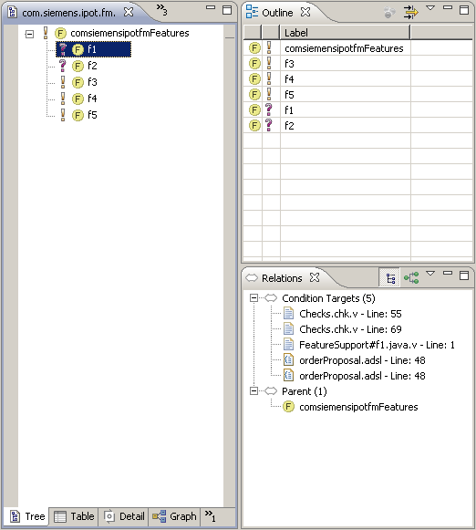
To do this, you have to implement an extension point in pure::variants relations builder plug-in. For the feature syntax explained above, we already provide such an extension. It can be found in the following project:
org.openarchitectureware.var.pv.indexer
To implement indexing support for your own DSL (illustrated with the MyDsl example) do the following:
Create a new plugin project. Add dependencies to
- com.ps.consul.eclipse.relationsbuilder
- org.eclipse.core.resources
- org.openarchitectureware.var.pv.indexer
Extend the extension point com.ps.consul.eclipse.relationsbuilder.Indexer in the following way. Adapt the id, name and extensions parameter to your needs, while reusing the existing class org.openarchitectureware.var.pv.indexer.FeatureDependencyIndexer provided as part of the org.openarchitectureware.var.pv.indexer plugin.
<extension
point="com.ps.consul.eclipse.relationsbuilder.Indexer">
<indexer
class=" org.openarchitectureware.var.pv.indexer.FeatureDependencyIndexer"
extensions="mydsl"
id="org.xtext.example.mydsl.indexer.MyDslIndexer"
name="MyDslIndexer">
</indexer>
</extension>
Make sure that the project that contains the files that should be indexed has the following two natures:
<nature>com.ps.consul.eclipse.core.ConsulNature</nature> <nature>com.ps.consul.eclipse.relationsbuilder.RelationIndexNature</nature>
It also has to have the following builder:
<name>com.ps.consul.eclipse.relationsbuilder.RelationsBuilder</name>
Finally, in the indexer properties the file extension of your new to-be-indexed files is added:
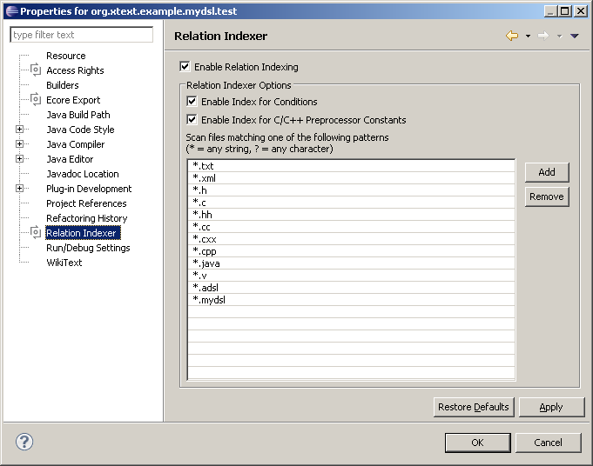
This indexer reindexes .mydsl files whenever they are changed. It is good practice, after restarting Eclipse, to also trigger a rebuild, to clean and reestablish the index.

Adapting Text Files and Code
Whenever parts of your application are not described with models but rather with code or other textual artifacts, you need a way of also adapting them based on features. Consider a Java interface that, depending on a feature, contains a certain method or not. Then an implementation class of that interface has to provide an implementation of that method if the configuration feature is selected. If that class is manually written, you have to somehow adapt the manually written code depending on the selected features.

Notations
The way this works in principle is this: you create a .v file that contains all the code that might go into the manually written code. In that file, you use comments and certain notations to mark up parts of the code that depend on features. Here is an example where the second method in the class depends on the feature f2. The file is called SomeModule.java.v
public class SomeModule extends SomeModuleBase {

@Override
public OrderProposal proposeOrder(Dealer Dealer) {
// TODO Auto-generated method stub
return null;
}

//# f2
@Override
public void op1() {
System.out.println( "haha" );
}
//~# f2

}
This file is typically located in a directory that contains only .v files. A workflow component copies those files to the actual source directory, processing the feature dependent regions on the fly. It also removes the .v extension. In the example above, the op1 method will only be in the resulting Java file, if the feature f2 is selected.
The following piece of code shows the workflow configuration:
<component class="org.openarchitectureware.var.tailor.code.CoderComponent">
<sourcePath value="platform:/resource/org.xtext.example.mydsl.test/src-variants"/>
<genPath value="platform:/resource/org.xtext.example.mydsl.test/src"/>
<configurationModelSlot value="configurationModel"/>
<configurationModelWrapperClass value=" org.openarchitectureware.var.featureaccess.pv.PVConfigurationModelWrapper"/>
</component>
The sourcePath describes where the .v files can be found. The genPath defines where the processed files will rest. The configurationModelSlot is the name of a workflow slot in which the already loaded configuration model can be found (if you used the model tailoring before, this slot is configurationModel). Finally, the configurationModelWrapperClass is a strategy to work with the model. The class shown in the code above is the one you have to use with pure::variants.
Note: if you don’t use the model tailoring before, the configuration model can be loaded with the normal EMF model loading workflow component since pure::variants exports the feature model as an XMI file (obviously you have to load this exported to XMI file, not the VDM file directly).

The Builder
To check your markup in .v files against the feature model, you can use the DotVBuilder. If you have installed the variant management plug-ins, your context menu for projects will contain an Add/Remove DotV Nature entry. If you select this, the builder will be enabled. Before it does anything sensible though, you will have to configure them feature model in the project properties.
Open your project properties and in there select the DotV tab.
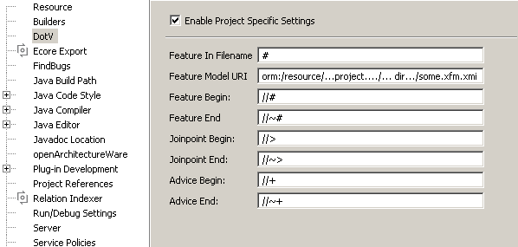
You can change all the special characters that marked up feature dependencies, although this is not recommended. However, you have to enter the feature model URI, using the platform:/resource notation. You will then get an error message, if you refer to a non-existent feature.
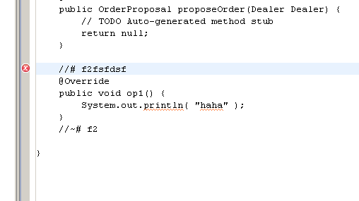
Note that after restarting eclipse, you will have to do a full rebuild to update the cache.

The Indexer
There is also a predefined indexer for out .v files which is active automatically if you install the variant management plug-ins. To activate it for your project open your project properties and select the Relation Indexer tab. There, add the .v extension to the list of extensions. Click okay and do a full rebuild.
You should now get relations into your .v files, just as shown above with the mydsl files.

Currently Not Support – Scrapheap

Adapting the outline View
You might want to adapt the outline view so it provides a viewpoint that puts the feature on top, and then arranges below it all the model elements that depend on this feature.
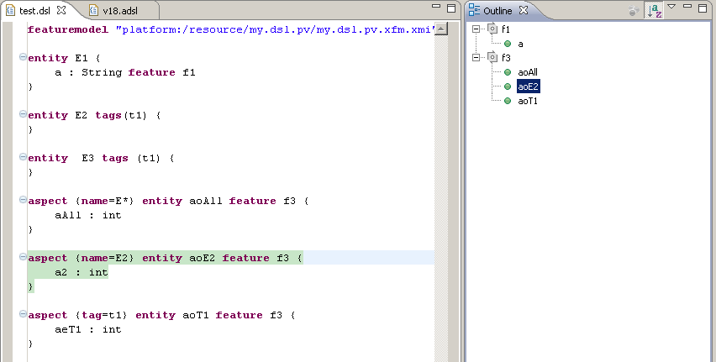
Here is the code:
viewpoints(): {
"Features"
};

viewpointIcon(String vpName) :
switch (vpName) {
case "Features": "vp_feature.gif"
default: "vp_default.gif"
};

// -------------------------------------------------------------------------
// Features

create UIContentNode outlineTree_Features(emf::EObject model) :
let features = model.allLocalElements().typeSelect(FeatureClause).collect(fc|fc.feature).toSet():
setLabel(model.label()) ->
setImage(model.image()) ->
setContext(model)->
children.addAll( features.createFeatureNode(model) );

create UIContentNode createFeatureNode( String feature, emf::EObject model ):
setLabel(feature) ->
setImage("feature.gif") ->
setContext(null)->
children.addAll( feature.createRefNodes(model) );

createRefNodes( String feature, emf::EObject model ):
model.allLocalElements().typeSelect(FeatureClause).select(fc|fc.feature == feature).collect(fc|fc.eContainer).createRefNode();

create UIContentNode createRefNode( emf::EObject obj ):
setLabel(obj.label()) ->
setImage(obj.image()) ->
setContext(obj);

You might have to copy the feature.gif and the vp_feature.gif from the org.openarchitectureware.var.featureaccess plugin’s icons folder over into your language editor’s icons folder.

Because of the missing language modularization features of Xtext 4.x this could not be provided as a “library” in oAW 4.x. TMF Xtext provides better modularization support, but we didn’t change the approach yet. Hence, copy and Paste is necessary.

