Feature-Dependencies in Xtext DSLs

This documentation explains how to use the tooling provided as part of the dslvariantmanagement Google Code project. It supports the expression of negative variability in arbitrary Xtext DSL.

Feature Access

Create an Xtext Project
The get started, we create a new Xtext project. Just use all the defaults in the New Xtext Project wizard. Enter the following into the mydsl.xtxt file as the language grammar.
System:
(entities+=Entity)*;

Entity:
"entity" name=ID "{"
(attributes+=Attribute)*
"}";

Attribute:
name=ID ":" type=ID;
Generate the DSL, and verify that it works. Create a plugin project my.dsl.test and put a test.dsl file with the following content into the src folder.
entity E1 {
a : String
}

entity E2 {

}

Create an p::v Project
The next step is to create a project that holds the p::v variant model and its EMF export. Create a new Variant Project (using the Wizard) named my.dsl.pv. Then open the project properties and set the Variant Model Ecore Export to Simplified Result.
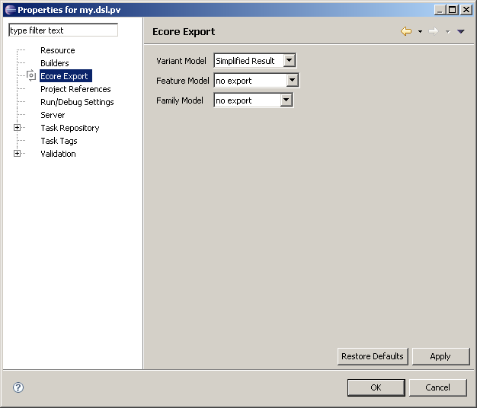
In the variant model that has been created by the wizard in the project’s root folder (my.dsl.pv.xfm) create two features:
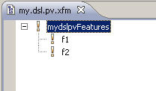
Then save the model. A my.dsl.pv.xfm.xmi next to my.dsl.pv.xfm should appear. This contains the variant model in EMF form. Whenever you change something in the .xfm make sure you save it to trigger the export and update the .xfm.xmi file.

Access Features from DSL
Add the org.openarchitectureware.var.featureaccess plugin to dependencies of DSL project. Then modify the grammar to include the red stuff. Because of the missing language modularization features of Xtext 4.x this cannot be provided as a “library” of some form. Copy and Paste is necessary.
System:
(featureModel=FeatureModelImport)?
(entities+=Entity)*;

Entity:
"entity" name=ID "{"
(attributes+=Attribute)*
"}";

Attribute:
name=ID ":" type=ID (featureClause=FeatureClause)?;

FeatureClause:
"feature" feature=ID;

FeatureModelImport:
"featuremodel" uri=STRING;
The code above allows to reference a feature model file from a DSL and add feature clauses to attributes. If you want feature clauses on other elements, just add the (featureClause=FeatureClause)? snippet to it.
We now have to add various stuff to several of the files in the language and editor. Let’s start with the language utilities in Extensions.ext. To the Extensions.ext add this:
extension org::openarchitectureware::var::featureaccess::ext::utils reexport;

String featureModelUri(emf::EObject this):
((System)eRootContainer).featureModel.uri;
The constraints, Checks.chk must also be extended, to detect missing feature model imports and references to undefined features.
context FeatureClause ERROR "no feature model imported":
featureModelUri() != null;

context FeatureClause ERROR "feature '"+feature+
"' does not exist in feature model":
getAllFeatures(featureModelUri()).contains( feature );
Now let’s focus on the editor. Code completion must be customized to show the features in the feature model when pressing Ctrl-Space for the FeatureClause. To ContentAssist.ext add this:
extension org::openarchitectureware::var::featureaccess::ext::utils;

completeFeatureClause_feature(emf::EObject ctx, String prefix) :
proposeFeatures(ctx, prefix);

proposeFeatures(emf::EObject ctx, String prefix) :
let features = getAllFeatures(ctx.featureModelUri()):
let filteredFeatures = (prefix != null ? features.select(f|f.startsWith(prefix)) : features) :
filteredFeatures.collect(ff|newProposal( ff, ff, "featureclause.gif") );
Finally, let’s customize the icons and the labels. To the EditorExtensions.ext add this:
image( FeatureClause this ): "featureclause.gif";
image( FeatureModelImport this ): "featuremodelimport.gif";
label( FeatureClause this ): feature;
label( FeatureModelImport this ): "feature model "+uri;
Also make sure you copy the icons in org.openarchitectureware.var.featureaccess/icons into the icons folder of your my.dsl.editor

Example
After regenerating your DSL, the following should be a valid instance:
featuremodel "platform:/resource/my.dsl.pv/my.dsl.pv.xfm.xmi"

entity E1 {
a : String feature f1
}

entity E2 {

}
And code completion, as well as constraint checking should also work:
