**College of Forestry, Wildlife and Environment**

**Annual Progress Report**

All graduate students are required to complete the following form by the beginning of spring term. Include only those activities since the last review.

Student Name: ____Rylee Tomey________________ ______________ Date: 09/30/2025

Date of entrance into program: 01/10/2025 Banner ID: 904279893

Plan of Study Submitted: No Research proposal submitted: No

Date of last committee meeting: 05/14/2025 On Assistantship: Yes

Date or expected date of Preliminary Exam (if applicable): ________________ Passed? ______________

Expected date of final defense ___Spring 2029_____________________________

Current GPA: 3.8

_________________________________________________________________________________________

**Professional Performance**

The student should complete the following information:

Awards and recognition received:

Presentations made at professional meetings:

Manuscripts accepted for publication or published:

Tomey RD, Rupprecht CE, Kuzmin IV, Jones DW, Chipman RB, Ditchkoff SS. 2025. A Historical Review of Rabies Epidemiology and Management in Alabama. *Journal of Wildlife Diseases.*

Other scholarly activities:

Comment on your progress in achieving your academic goals during the past year. Note areas in which you are experiencing any difficulty.

* In the past year, we have held several discussions with stakeholders which have helped prepare the project for next steps.

**Annual Progress Report**

**School of Forestry and Wildlife Sciences**

**Page 2**

**Student Name:** Rylee Tomey  **Student ID _**904279893

**Portion completed by Committee:**

**Academic Performance**

This student is making adequate progress toward completing his/her degree. Yes _______ No __X_____

If the answer is “no,” please describe reasons for progress that is less than expected.

*Rylee has encountered some very difficult personal challenges in the past 6-9 months that have limited her productivity. Rylee has been very open with us regarding these challenges, and we have been as accommodating as possible. We are hoping to work closely with her in the coming months to make up some of the work that has lagged in the interim.*

**Committee Signatures:** **If you have not yet formed a committee, please note this on the form.**

Committee formation in progress? Yes No If no, please explain:

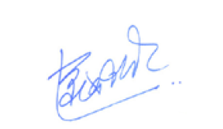

________________________________________ ________________________________________

________________________________________ ________________________________________

________________________________________ ________________________________________

:

**Student** Your signature below indicates that you have discussed the contents of this progress report with your major professor.

Student Rylee Tomey Date 09/30/2025

**Major Professor** Your signature below indicates that you have discussed the contents of this progress report with the student.

______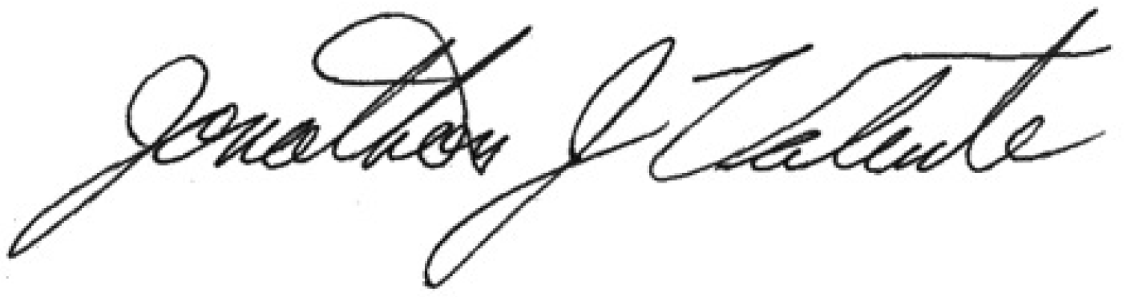____ Date _____30 September 2025_______________

Major Professor 1

_________________ Date 30 Sep 2025

Major Professor 2