Spatial Visualization and Exploration

June 05, 2025

Table of Contents

### 0.0.1 Importing Data

# 1 Zipcode -> County

df <- df %>%  
 mutate(ZIPCODE = as.character(ZIPCODE)) %>%  
 left_join(  
 zipcodeR::zip_code_db %>%  
 dplyr::select(zipcode, county, state),  
 by = c("ZIPCODE" = "zipcode")) %>%  
 rename(COUNTY = county) %>%  
 dplyr::select(-state)  
  
# Map of Respondents / County ----------------  
alcounty <- counties(state = "AL", cb = TRUE, class = "sf") %>%  
 mutate(NAME = toupper(NAME))   
dfcounty <- df %>%  
 filter(!is.na(COUNTY)) %>%  
 count(COUNTY, name = "Respondents")  
mapcounty <- alcounty %>%  
 left_join(dfcounty, by = c("NAMELSAD" = "COUNTY")) %>%  
 mutate(Respondents = replace_na(Respondents, 0))  
centroids <- st_centroid(mapcounty)  
centroids_coords <- centroids %>%  
 mutate(  
 lon = st_coordinates(geometry)[, 1],  
 lat = st_coordinates(geometry)[, 2])  
  
ggcounty <- ggplot(mapcounty) +  
 geom_sf(aes(fill = Respondents), color = "black", size = 1) +  
 geom_text(  
 data = centroids_coords,  
 aes(x = lon, y = lat, label = ifelse(Respondents > 0, Respondents, "")),  
 size = 3, color = "grey40") +  
 scale_fill_distiller(  
 palette = "YlGnBu", # switch to 'greys' for B/W   
 direction = 1,  
 name = "Respondents",  
 breaks = range(mapcounty$Respondents, na.rm = TRUE),  
 labels = round(range(mapcounty$Respondents, na.rm = TRUE))) +  
 theme_minimal(base_size = 14) +  
 labs(title = "Survey Respondents by County") +  
 theme(  
 legend.position = "right",  
 legend.title = element_text(size = 10),  
 legend.title.position = "top",  
 legend.text = element_text(size = 10),  
 panel.grid.major = element_blank(),  
 axis.text = element_blank(),  
 axis.title = element_blank(),  
 plot.title = element_text(face = "bold"))  
ggcounty

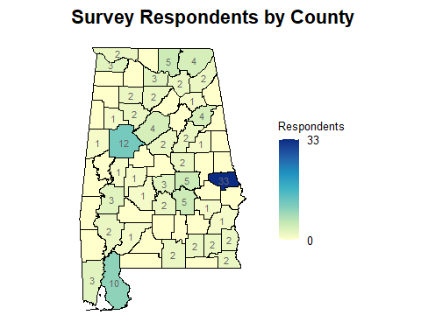

# Export ------  
ggsave(filename = "county_respondents.pdf",plot = ggcounty, path = oup, width = 8,   
 height = 6,units = "in") # Vector PDF  
ggsave(filename = "county_respondents.tif",plot = ggcounty, path = oup, width = 8,   
 height = 6,dpi = 600, units = "in") # TIFF