Human Resources Dashboard – Tableau Project Report

# Project Title

Human Resources Dashboard

# Objective

The objective of this Tableau dashboard is to provide a comprehensive analysis of the company’s workforce demographics, hiring trends, departmental distribution, and compensation insights. It allows HR managers and business leaders to monitor employee lifecycle metrics, understand performance patterns, and make informed decisions related to workforce planning and talent management.

# Problem Statement

Organizations often face difficulty in consolidating employee data to get clear visibility into hiring trends, workforce composition, and salary structures across departments and locations. This HR dashboard addresses the issue by integrating key human resource metrics into a single, interactive Tableau dashboard—making it easier to track active vs. terminated employees, analyze gender diversity, evaluate education vs. performance, and uncover salary patterns by age and role.

# Data Description

- Data Source: Internal HR records (hypothetical/anonymous data)  
- Data Volume: 9,000+ employee records including current and terminated employees  
- Key Fields:  
 - Employee Status (Hired, Terminated)  
 - Gender and Age  
 - Department and Location  
 - Education Level and Performance Rating  
 - Salary and Position  
 - Date of Hire

- Data Cleaning & Transformation:  
 - Standardized department names  
 - Filtered out incomplete salary and education records  
 - Segregated HQ vs. Branch employees for comparative location analysis

# Dashboard Snapshot

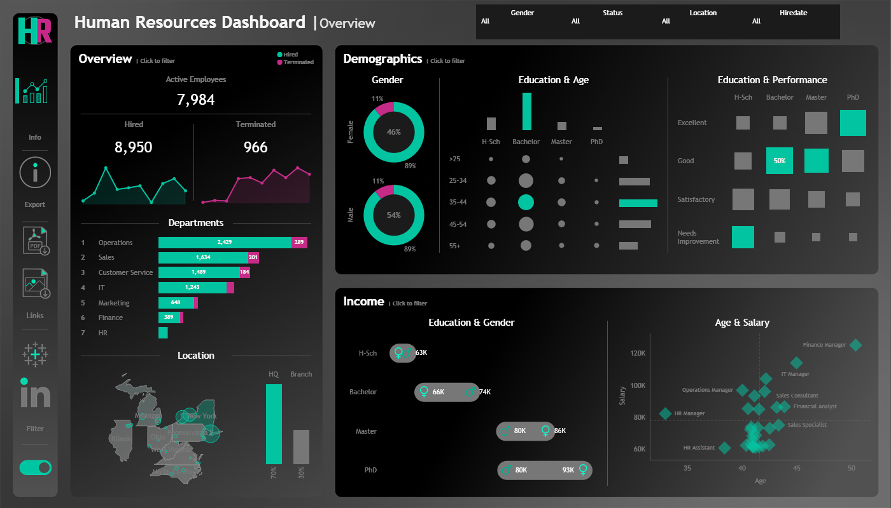

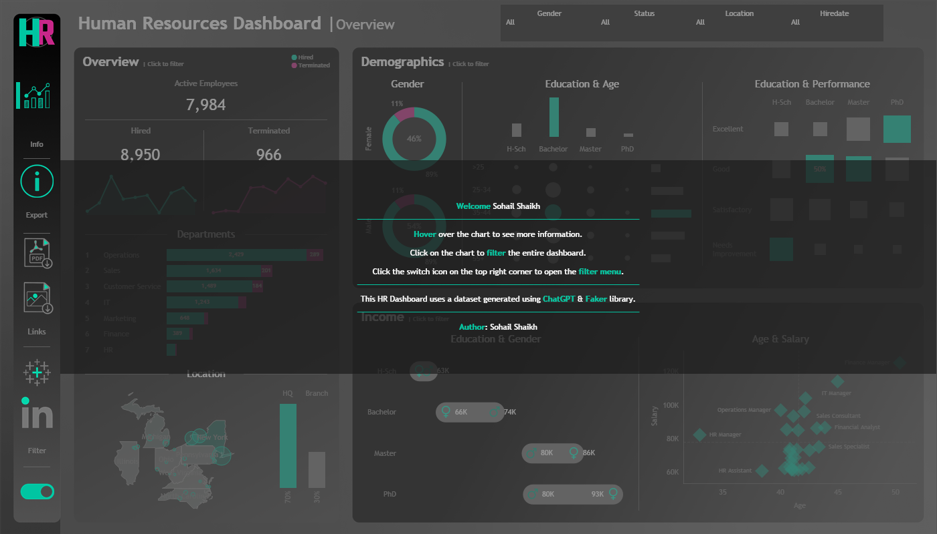

# Target Audience

- HR Managers: To monitor department-wise staffing and terminations  
- Executives: To analyze diversity, performance, and salary trends  
- Workforce Planners: To identify gaps in education, performance, and age distribution  
- Recruiters: To understand hiring patterns and turnover rates

# Key Features

- Overview Panel:  
 - Summary KPIs for Active, Hired, and Terminated Employees  
 - Department-wise bar chart with hiring/termination split  
 - Interactive filters by gender, hire date, status, and location

- Demographics Panel:  
 - Gender distribution via donut charts  
 - Education vs. Age matrix  
 - Education vs. Performance bubble grid

- Income Analysis:  
 - Education vs. Gender salary comparison  
 - Scatter plot of Age vs. Average Salary by job role

- Geographic Distribution:  
 - U.S. map highlighting employee density by state  
 - HQ vs. Branch comparison in vertical bar chart

# Tools and Techniques

- Tableau: For building interactive dashboards with dynamic filtering  
- Excel: Used for initial data wrangling and transformation  
- Calculated Fields: For average salary, headcount by department, education-performance correlation  
- Maps and Scatter Plots: For spatial and salary-based insights

# Dashboard Summary & Insights

📊 Key Insights:

- Headcount Overview:  
 - 7,984 active employees, with 8,950 hired and 966 terminated  
 - Operations and Sales have the highest employee counts

- Demographic Highlights:  
 - Gender distribution is fairly balanced (54% male, 46% female)  
 - Most employees hold a Bachelor's or Master’s degree  
 - 18% of employees are aged 35–44 with a Bachelor's degree

- Performance vs. Education:  
 - Employees with PhDs have the highest percentage of “Excellent” performance ratings  
 - 50% of Bachelor’s degree holders are rated “Good”

- Compensation Insights:  
 - Average salaries increase with education level  
 - Female PhD holders earn up to 93K compared to 80K for males  
 - Age vs. Salary scatterplot reveals Finance and IT Managers as top earners

- Location & Distribution:  
 - 70% of employees are based at HQ; 30% are distributed in branches  
 - Key states include New York, Pennsylvania, and California

# Project Scope and Limitations

- Scope:  
 - Focuses on employee data from recent years across departments  
 - Includes comparison by education, gender, location, and age

- Limitations:  
 - Data does not include detailed tenure or promotion history  
 - No insights into employee engagement or satisfaction levels  
 - External market benchmarking for salaries is not included

# Outcome / Expected Results

This HR dashboard empowers stakeholders to:  
1. Identify workforce trends by gender, age, and education  
2. Monitor hiring and termination patterns by department  
3. Analyze how education level impacts performance and pay  
4. Evaluate compensation gaps across genders and roles  
5. Improve strategic decision-making for recruitment and retention

# Future Enhancements

- Integrate predictive analytics for attrition forecasting  
- Add employee satisfaction or engagement survey scores  
- Include filters for tenure, promotion history, and training programs  
- Expand dashboard to include benchmarking with industry salary data

# 📈 Data Pipeline Explanation

This project follows a structured data generation and preparation pipeline, starting from synthetic data creation using Python and the Faker library, to final transformation and export into a format compatible with Tableau. Below is a step-by-step breakdown of the process:

1. Data Generation Using Python & Faker Library:  
The dataset was synthetically created using the Faker library, which generates realistic names, dates, and locations. A total of 8,950 employee records were generated, simulating real-world HR data with variations in gender, department, salary, education, and more.

2. State and City Assignment:  
U.S. states and their respective cities were manually defined. Employees were randomly assigned a state and city using weighted probabilities to reflect realistic geographic distribution (e.g., 70% in New York).

3. Department and Job Title Mapping:  
Employees were assigned to one of seven departments (HR, IT, Sales, etc.) using pre-defined probabilities. Each department had its own list of job titles with customized probability distributions to reflect realistic hiring patterns (e.g., more developers than IT managers).

4. Education Level Assignment:  
Job titles were mapped to appropriate education levels. This mapping ensures logical consistency between role and qualification.

5. Hire Date Simulation:  
Hire dates were randomly generated for the years 2015 to 2024 using custom probability weights.

6. Performance Rating & Overtime:  
Performance ratings were randomly assigned using realistic distributions. Overtime status was assigned with a 30% chance of “Yes” and 70% for “No.”

7. Salary Calculation:  
Base salary ranges were defined for each job title and department. Salaries were randomly generated within these ranges.

8. Birthdate Generation:  
Age groups were distributed according to HR norms. Birthdates were generated based on realistic age distributions and job requirements.

9. Termination Status:  
11.2% of employees were marked as terminated with logically consistent termination dates.

10. Adjusted Salary Calculation:  
Adjusted salaries were calculated based on gender-based education multipliers and age-based increments, ensuring realistic pay variations.

11. Data Formatting and Export:  
Final dataset was saved as 'HumanResources.csv' and used for Tableau dashboard creation.

## 🛠 Tools Used

|  |  |
| --- | --- |
| Tool | Purpose |
| Python | Core data generation and transformation engine |
| Faker | Generation of realistic fake data |
| Pandas/NumPy | Data manipulation and handling |
| Tableau | Data visualization and dashboard development |

## ✅ Outcome

This pipeline ensures the dataset mimics real-world HR patterns while remaining anonymous and safe for public/academic use. The final CSV file was used in Tableau to derive valuable insights on demographics, performance, and compensation.