

**LAB 5**

CSM 3023 - PEMBANGUNAN APLIKASI BERASASKAN WEB

BACHELOR OF COMPUTER SCIENCE (SOFTWARE ENGINEERING) WITH HONOURS SEMESTER 3

# NAME :MUHAMMAD AMIR FAKHRIE BIN MOHD ZAMRIE

MATRIC NO: S65453

DATE : 22 / 5 / 2024

TASK 1 – Using Scriplet to Access a simple JavaBeans

Code:

Message1.jsp

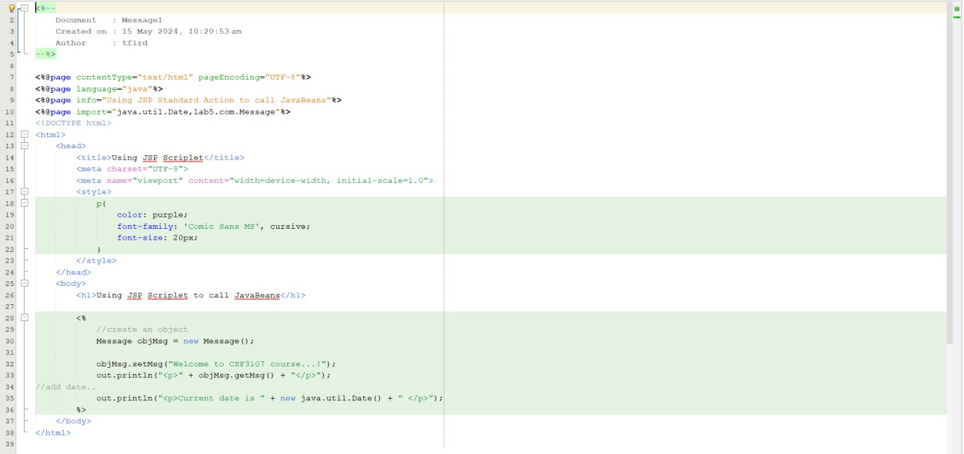

Output:

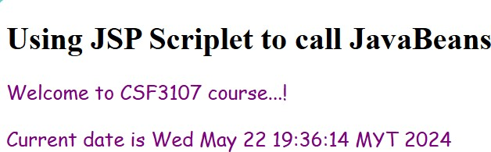

Reflection:

1. What you have learnt from this exercise? Access javabeans using scriplet code
2. Explain the difference when calling JavaBeans using JSP standard action and java scriplet.

JSP offers two ways to interact with JavaBeans: standard actions and scriptlets. Standard actions, like jsp:useBean, provide a dedicated way to manage bean lifecycles.

Scriptlets, on the other hand, let you embed raw Java code directly in your JSP. While this offers flexibility, it mixes concerns and can be less readable for developers unfamiliar with Java

Task 2 – Problem Solving using JavaBeans Code:

registerTraining.jsp

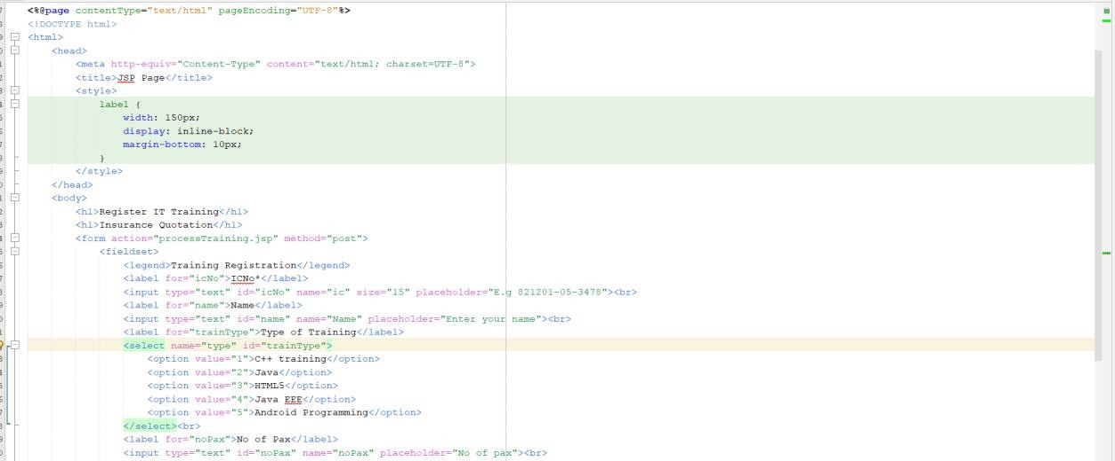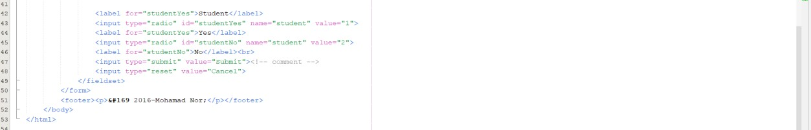

processTraining.jsp

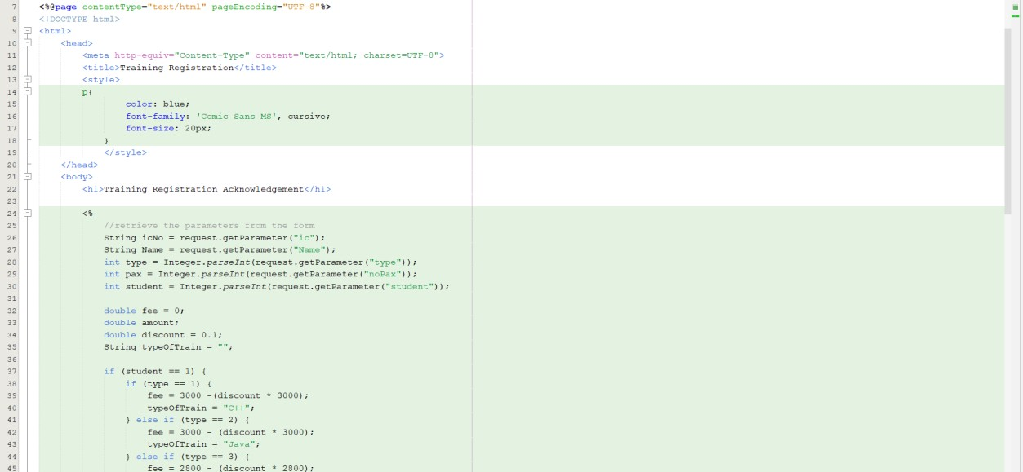

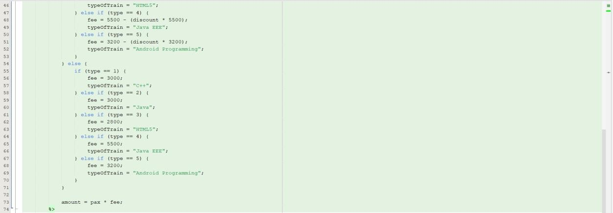

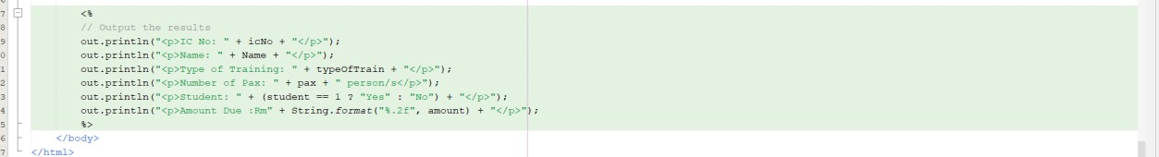

Output:

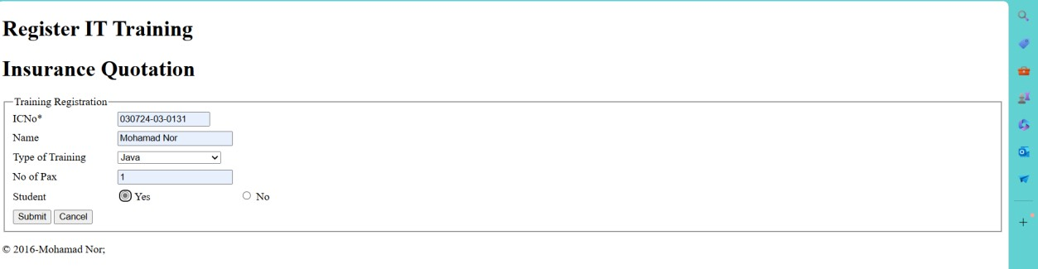

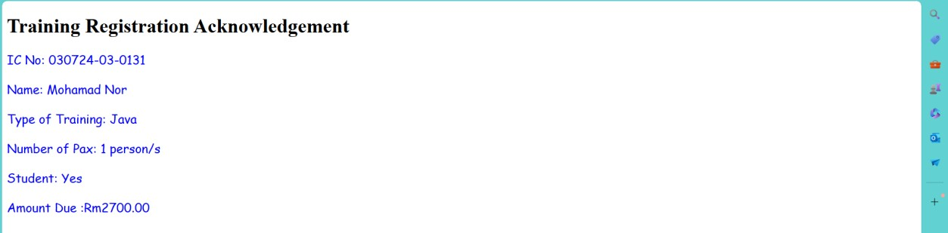

Reflection:

1. What have you learn from this exercise? Solving the calculations using javabeans
2. Describe the steps how you construct Register JavaBeans?

# A JSP form collects user information about training registration.

* Clicking "Submit" sends this data to another JSP page.

# The second JSP retrieves the data and performs calculations based on the chosen training and student status.

* Finally, it displays the information and calculated amount on the screen.

Task 4 – Using Java Standard Tag Library (JSTL)

Task1- Assign value” Welcome to CSF3107-Web Programming 2 Course” and display the value inside JSP page

Code

Jstl1core.jsp

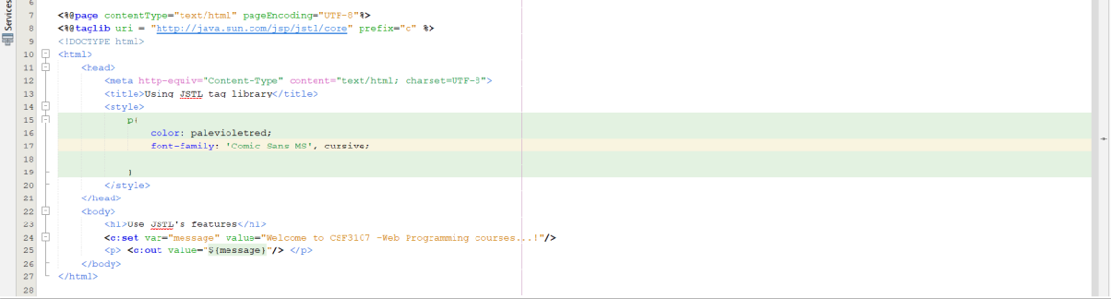

Output



Task 2 – Using JSTL’s core to request information from one page and display the information Code

userRegistration.html

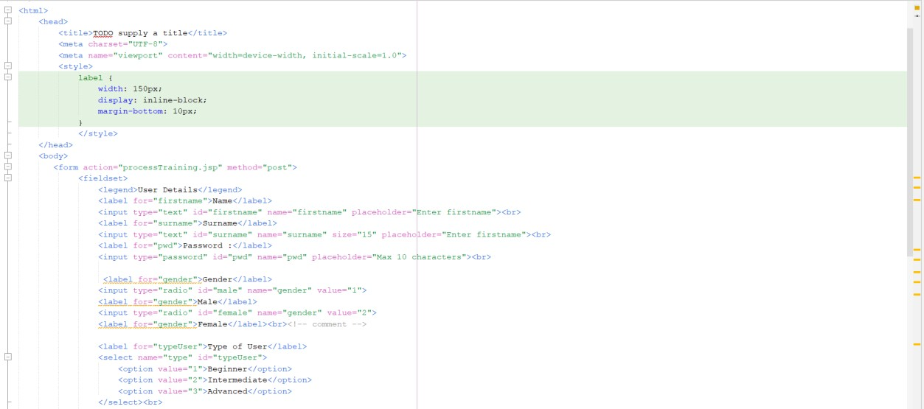

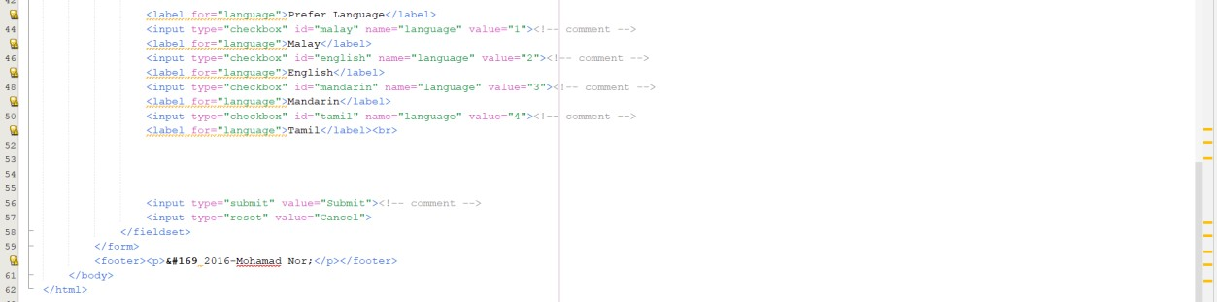

processUser.jsp

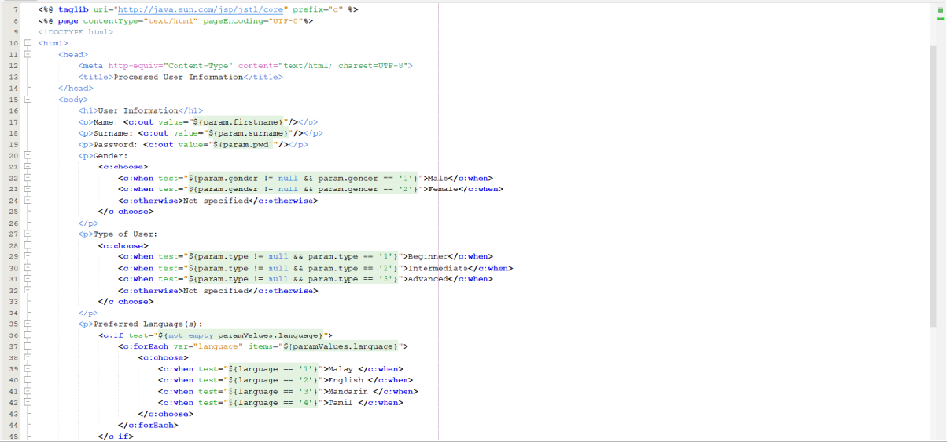

Output

Reflection

* 1. What you have learnt from this exercise?

Use jsp:include and jsp:param to display information on JSP page

* 1. List TWO other JSP Standard Action Tag
     + Jsp:forward
     + Jsp:useBean

Task 3 – Using JSTL’s fmt to format number and currency Code

jstlFormat1.jsp

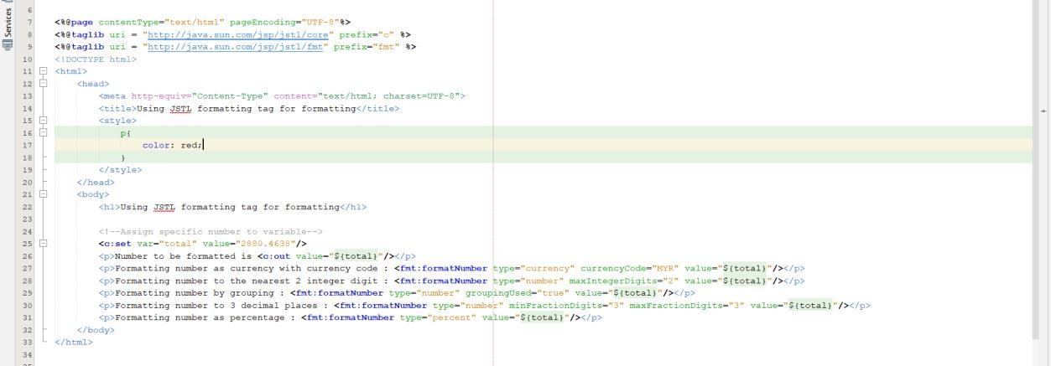

Output

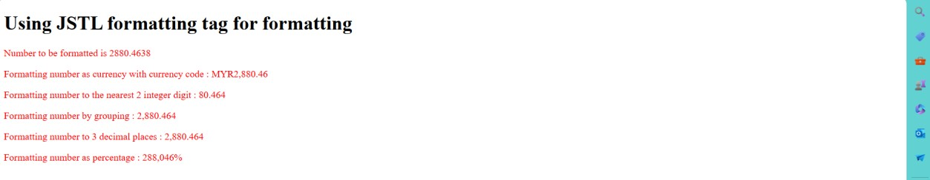

Reflection

1. What the purpose of using JSTL tag library?

Reduced code: JSTL tags replace repetitive scripting tasks with concise and readable tags.

Improved maintainability: Code becomes easier to understand and maintain due to a standardized approach.

1. List 5 categories of JSTL library.
   * Core tags
   * Formatting tags
   * Sql tags
   * Xml tags
   * Functions

Task 5 – Using JSP Standard Tag library

Code

Task1 Using JSTL;s fmt to format Date Fmt_formatDate.jsp

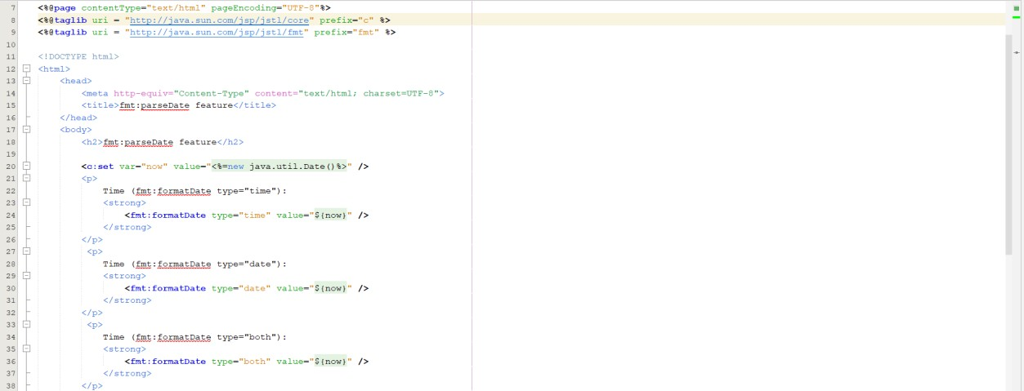

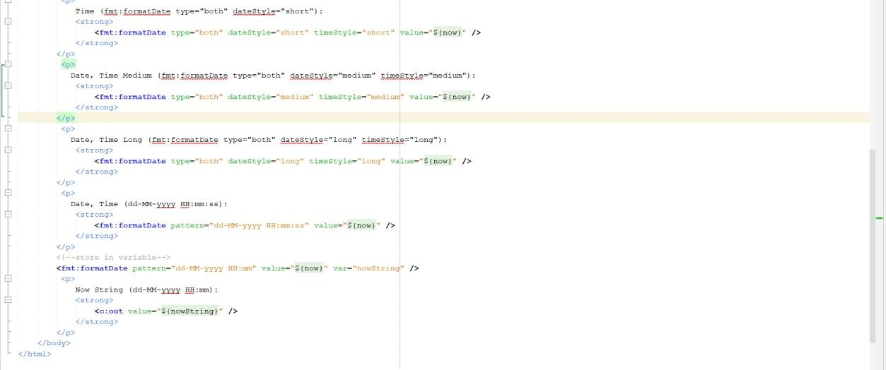

Output

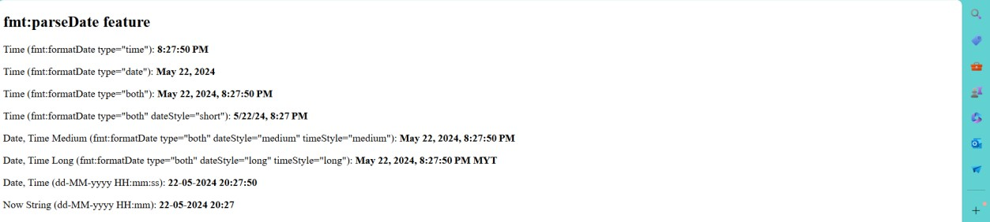

Task 2 Using JSTL fmt to parse DATE Code

Fmt_parseDate.jsp

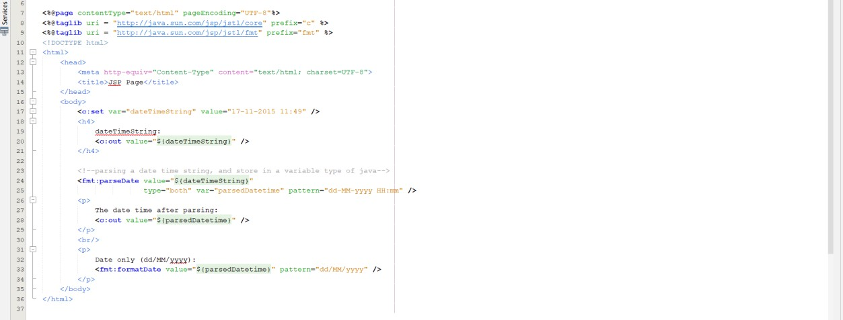

Output

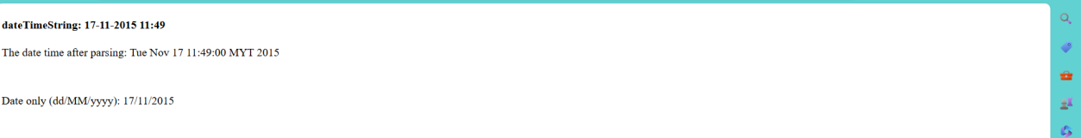

Exercise

1. Write a JSP’s form that asks the user to key-in the radius of circle. The program should

calculate the area of circle and the perimeter of circle. Finally, use JSTL library to format your result into 3 decimal places.

Code

Circle.jsp

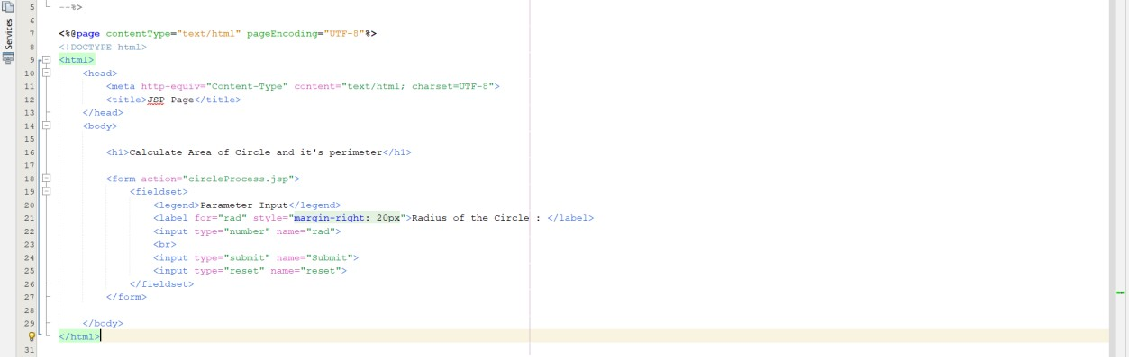

circleProcess.jsp

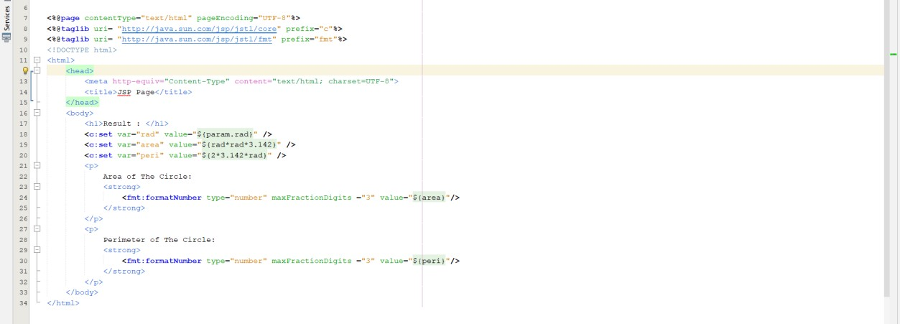

Output

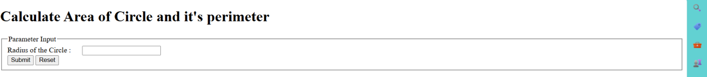

1. Rahim bought 800 shares of stock at a price of RM10.50 per share. He must pay her stock broker a 5 percent commission for the transaction. Write a web based program that calculates and displays the following: • The amount paid for the stock alone without the commission. • The amount of the commission. • The total amount paid (for the stock plus the commission). You should use JavaBeans to implement business logic and JSTL for display purposes.

Code

Business.jsp

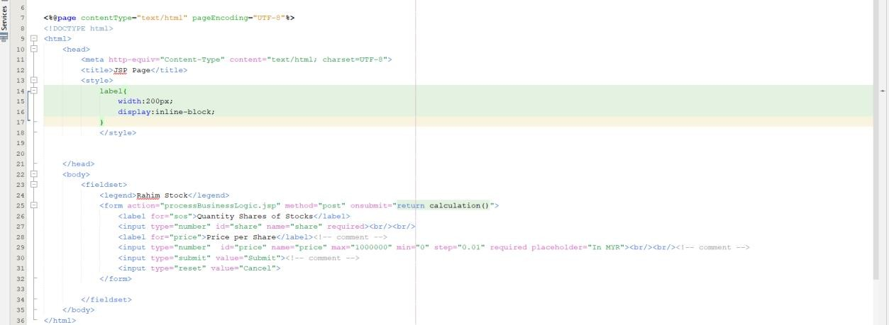

processBusinessLogic.jsp

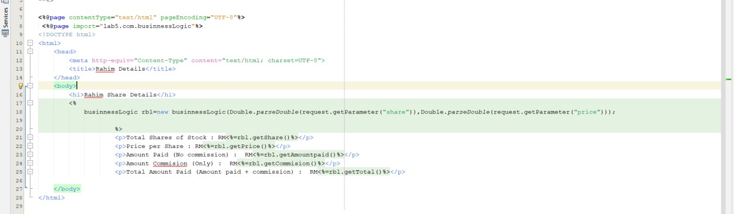

businessLogic.java

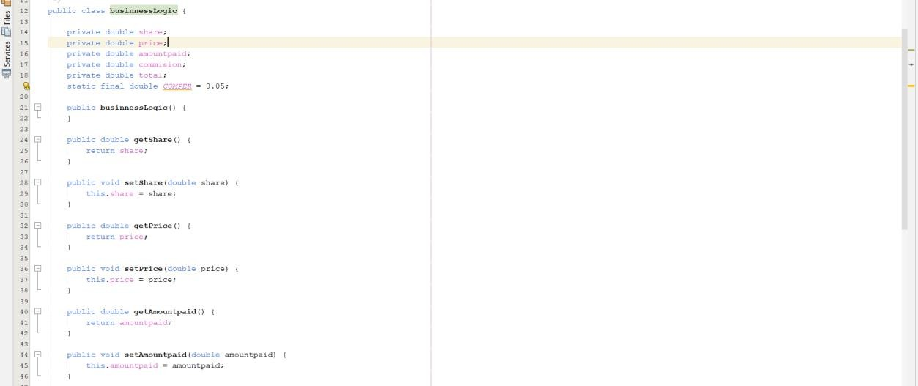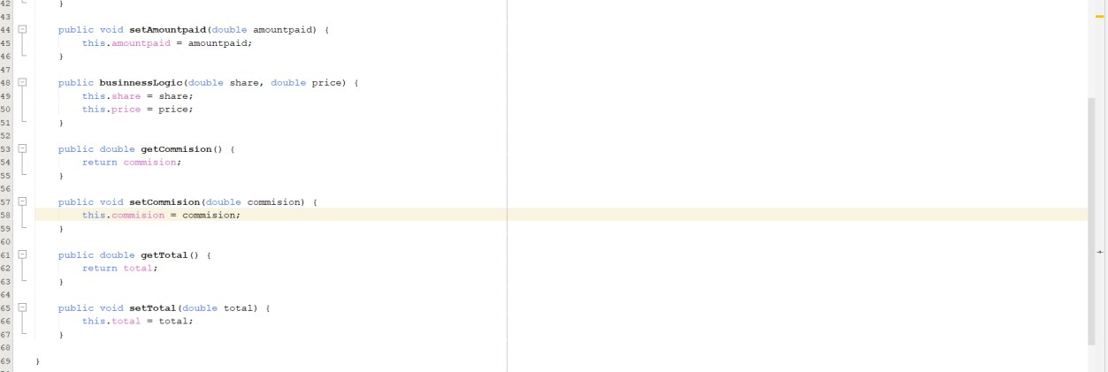

Output

