

SUBJECT CODE: CSF3023

SUBJECT NAME: WEB-BASED APPLICATION DEVELOPMENT LAB REPORT : 7

|  |  |
| --- | --- |
| NAME | MATRIC NO. |
| MUHAMMAD AMIR FAKHRIE BIN MOHD ZAMRIE | S65453 |

Task 1 Output

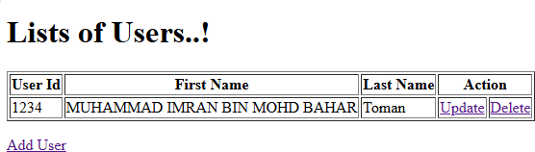

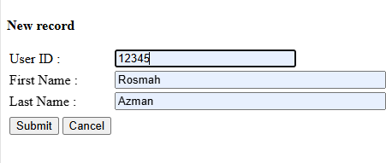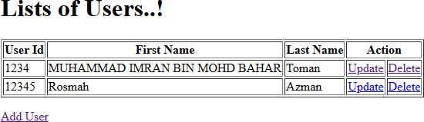

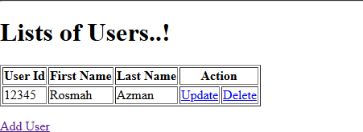

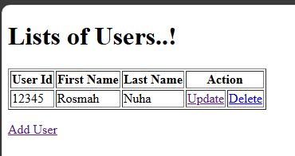

Reflection:

1. Why we use servlet for Java Web Application?

Implementation of MVC as for servlet it act as controller for dynamic web content.

Exercise 1

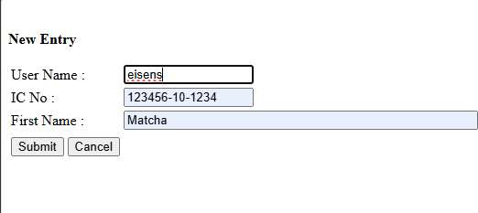

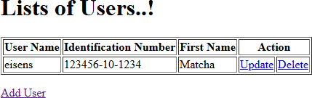

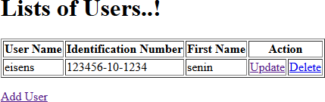

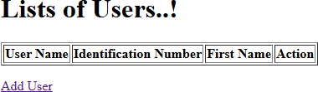

Exercise 2 Output

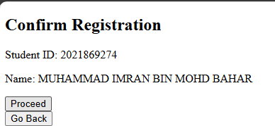

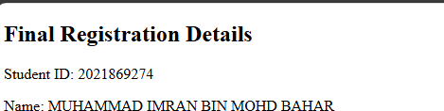

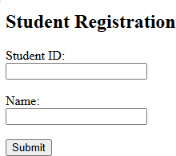

Code

