

SUBJECT CODE: CSF3023

SUBJECT NAME: WEB-BASED APPLICATION DEVELOPMENT LAB REPORT : 8

|  |  |
| --- | --- |
| NAME | MATRIC NO. |
| MUHAMMAD AMIR FAKHRIE BIN MOHD ZAMRIE | S65453 |

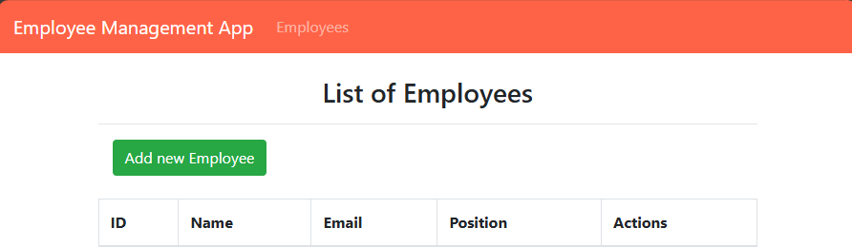

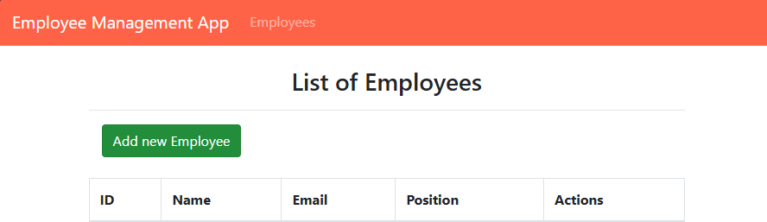

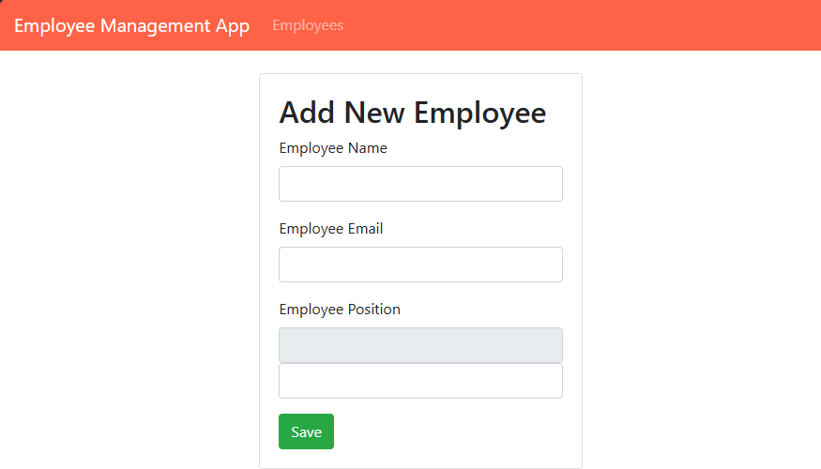

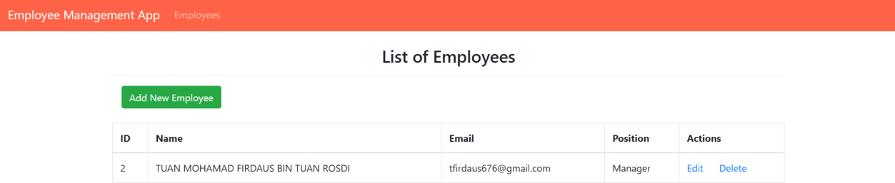

Exercise Exercise

Using this database shema, please create MVC Application [CRUD] for Car Shop, using JSP, Servlet, and MySQL.

CREATE DATABASE if not EXISTS carshop; USE carshop;

CREATE TABLE if not EXISTS CarPricelist( Car_id INT NOT NULL AUTO_INCREMENT, Brand VARCHAR(15), Model VARCHAR(30), Cyclinder INT, Price DOUBLE, PRIMARY KEY (Car_id) );

The application should be able to handle these activities:

1. View all data
2. Add new data
3. Edit/Update current data
4. Delete the specific data

