**Question 1:**

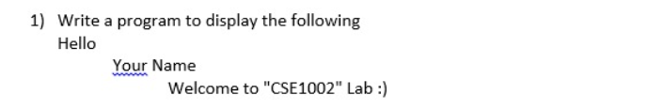

**Code:**

#include <stdio.h>

void main(){

printf("Welcome to\n\tCSE 1002\n\t\tLab");

}

**Output:**

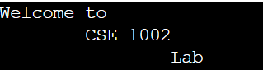

**Question 2:**

**Code:**

**#include<stdio.h>**

**void main(){**

**int a,b,c,d,e;**

**float sum=0;**

**printf("Enter 5 numbers\n");**

**scanf("%d",&a);**

**scanf("%d",&b);**

**scanf("%d",&c);**

**scanf("%d",&d);**

**scanf("%d",&e);**

**sum=(float)(a+b+c+d+e)/5;**

**printf("The average of 5 numbers is %f",sum);**

**}**

**Output:**

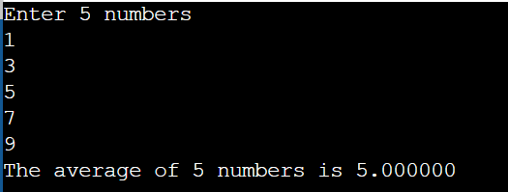

**Question 3:**

**Code:**

**#include<stdio.h>**

**void main(){**

**char name[50];**

**float cg;**

**printf("Enter name and cgpa\n");**

**scanf(" %s",&name);**

**scanf("%f",&cg);**

**printf("First character of name is %c and cgpa is %f",name[0],cg);**

**}**

**Output:**

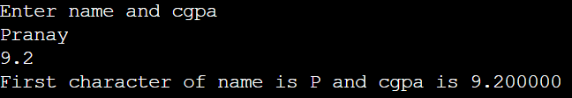

**Question 4:**

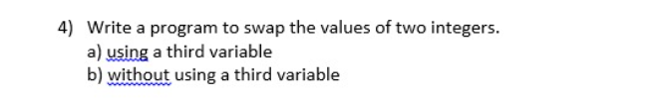

**Code:**

**4a)**

**#include <stdio.h>**

**void main(){**

**int a,b;**

**printf("Enter 2 numbers\n");**

**scanf("%d %d",&a,&b);**

**printf("The value of a is %d and b is %d\n",a,b);**

**a=a+b;**

**b=a-b;**

**a=a-b;**

**printf("After swapping the value of a is %d and the value of b is %d",a,b);**

**}**

**4b)**

**#include <stdio.h>**

**void main(){**

**int a,b,temp;**

**printf("Enter 2 numbers\n");**

**scanf("%d %d",&a,&b);**

**printf("The value of a is %d and b is %d\n",a,b);**

**temp=a;**

**a=b;**

**b=temp;**

**printf("After swapping the value of a is %d and the value of b is %d",a,b);**

**}**

**Output:**

**4a:**

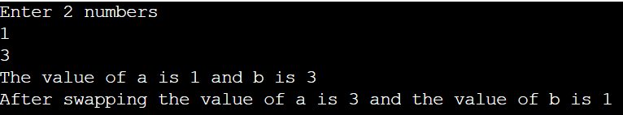

**4b:**

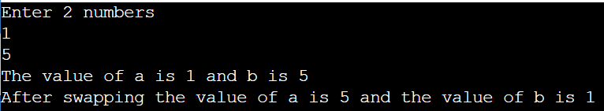

**Question 5:**

**Code:**

**#include <stdio.h>**

**void main(){**

**int a;**

**printf("Enter a number\n");**

**scanf("%d",&a);**

**a%2==0? printf("The number is even") : printf("The number is odd");**

**}**

**Output:**

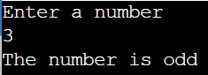

**Question 6:**



**Code:**

**#include <stdio.h>**

**void main(){**

**float a,b,c;**

**printf("Enter the 3 numbers\n");**

**scanf("%f %f %f",&a,&b,&c);**

**if(c<=b && c<=a){**

**printf("%f is lowest",c);**

**}**

**else if(b<=a && b<=c){**

**printf("%f is lowest",b);**

**}**

**else{**

**printf("%f is lowest",a);**

**}**

**}**

**Output:**

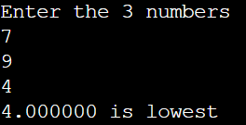

**Question 7:**



**Code**

**#include <stdio.h>**

**void main(){**

**char ch;**

**printf("Enter any character:\n");**

**scanf("%c",&ch);**

**if(ch>='A' && ch<='Z'){**

**printf("%c is uppercase alphabet",ch);**

**}**

**else if(ch>='a' && ch<='z'){**

**printf("%c is lowercase alphabet",ch);**

**}**

**else{**

**printf("%c is not an alphabet",ch);**

**}**

**}**

**Output:**

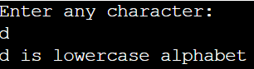

**Question 8:**



**Code:**

**#include <stdio.h>**

**void main(){**

**int mark;**

**printf("Enter your mark\n");**

**scanf("%d",&mark);**

**if(mark>=90){**

**printf("S grade");**

**}**

**else if(mark>=80 && mark<90){**

**printf("A grade");**

**}**

**else if(mark>=70 && mark<80){**

**printf("B grade");**

**}**

**else if(mark>=60 && mark<70){**

**printf("C grade");**

**}**

**else if(mark>=55 && mark<60){**

**printf("D grade");**

**}**

**else if(mark>=50 && mark<55){**

**printf("E grade");**

**}**

**else {**

**printf("F grade");**

**}**

**}**

**Output:**

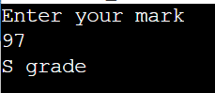

**Question 9:**

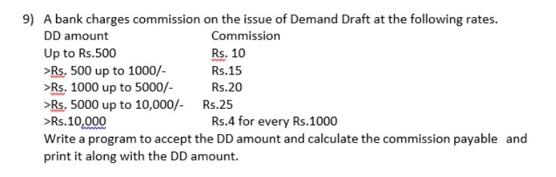

**Code:**

**#include <stdio.h>**

**void main(){**

**int dd,com=0;**

**printf("Enter the amount:\n");**

**scanf("%d",&dd);**

**if(dd<=500){**

**com=10;**

**printf("The dd amount is %d and the commission is %d",dd,com);**

**}**

**else if(dd>500 && dd<=1000){**

**com=15;**

**printf("The dd amount is %d and the commission is %d",dd,com);**

**}**

**else if(dd>1000 && dd<=5000){**

**com=20;**

**printf("The dd amount is %d and the commission is %d",dd,com);**

**}**

**else if(dd>5000 && dd<=10000){**

**com=25;**

**printf("The dd amount is %d and the commission is %d",dd,com);**

**}**

**else{**

**int n = dd/1000;**

**com=4*n;**

**printf("The dd amount is %d and the commission is %d",dd,com);**

**}**

**}**

**Output:**

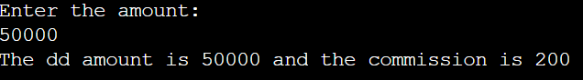

**Question 10:**



**Code:**

**#include <stdio.h>**

**int main(){**

**int a,b;**

**char c;**

**printf("Enter the 2 numbers\n");**

**scanf("%d %d",&a,&b);**

**printf("Enter the operation to be performed: + or - or * or / or %% \n");**

**scanf(" %c",&c);**

**float quo = (float) a/b;**

**switch(c){**

**case '+':**

**printf("The sum of the two numbers is %d",a+b);**

**break;**

**case '-':**

**printf("The difference of the two numbers is %d",a-b);**

**break;**

**case '*':**

**printf("The product of the two numbers is %d",a*b);**

**break;**

**case '/':**

**printf("The quotient of the two numbers is %f",quo);**

**break;**

**case '%':**

**printf("The modulus of the two numbers is %d",a%b);**

**break;**

**default:**

**printf("Invalid Input");**

**break;**

**}**

**return 0;**

**}**

**Output:**

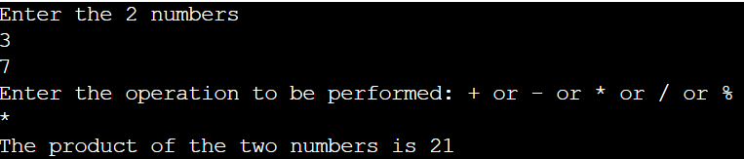

**Question 11:**

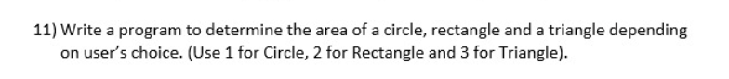

**Code:**

**#include <stdio.h>**

**void main(){**

**int r,b,h,l,t;**

**float area;**

**printf("Enter 1 for circle 2 for triangle and 3 for rectangle\n");**

**scanf("%d",&t);**

**switch(t){**

**case 1:**

**printf("Enter the radius of the circle\n");**

**scanf("%d",&r);**

**area=3.14*r*r;**

**printf("The area is %f units",area);**

**break;**

**case 2:**

**printf("Enter the base and height of the triangle\n");**

**scanf("%d %d",&b,&h);**

**area=0.5*b*h;**

**printf("The area is %f units",area);**

**break;**

**case 3:**

**printf("Enter the length and breadth of the rectangle\n");**

**scanf("%d %d",&l,&b);**

**area=b*l;**

**printf("The area is %f units",area);**

**break;**

**default:**

**printf("Invalid Input");**

**break;**

**}**

**}**

**Output:**

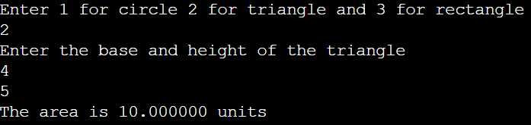

**Question 12:**

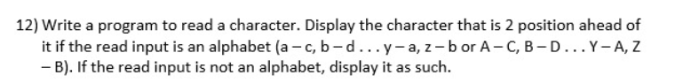

**Code:**

**#include <stdio.h>**

**void main(){**

**char t;**

**printf("Enter a character\n");**

**scanf(" %c",&t);**

**int z=t+2;**

**if(z>90){**

**z=65+z-90-1;**

**}**

**if(z>122){**

**z=97+z-122-1;**

**}**

**printf("%c",z);**

**}**

**Output:**

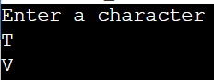

**Question 13:**

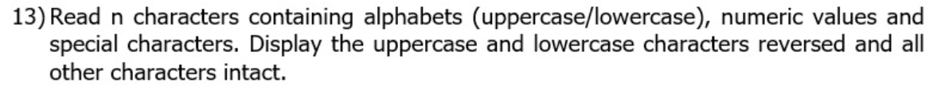

**Code:**

**#include <stdio.h>**

**int main() {**

**int n,k=0;**

**printf("Enter number of characters to be read\n");**

**scanf("%d",&n);**

**char ch;**

**line:**

**printf("Enter a character\n");**

**scanf(" %c",&ch);**

**if(ch>=65&&ch<=90){**

**int t = ch+32;**

**printf("%c\n",t);**

**k++;**

**}**

**else if(ch>=97&&ch<=122){**

**int t = ch-32;**

**printf("%c\n",t);**

**k++;**

**}**

**else{**

**printf("%c\n",ch);**

**k++;**

**}**

**if(k<n) {**

**goto line;**

**}**

**return 0;**

**}**

**Output:**

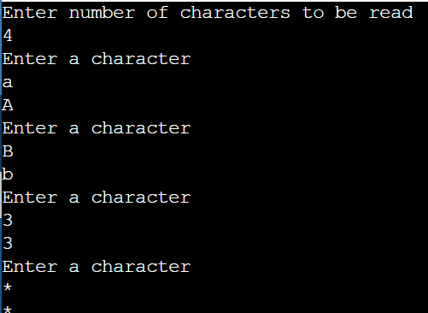

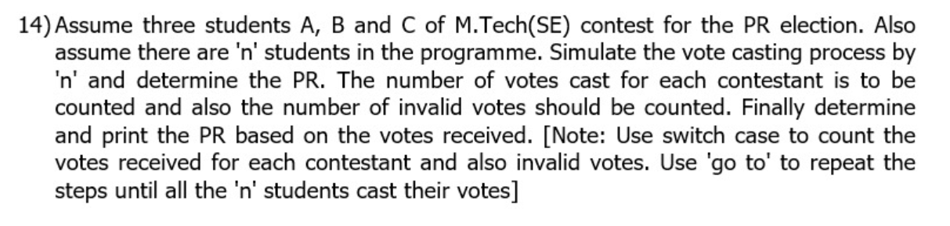**Question 14:**

**Code:**

**#include<stdio.h>**

**void main(){**

**int n,t=0,a=0,b=0,c=0,inv=0;**

**char ch;**

**printf("Enter the number of students\n");**

**scanf("%d",&n);**

**line:**

**t+=1;**

**printf("Enter 'A' to vote for candidate A\n'B' to vote for candidate A\n'C' to vote for candidate A \n");**

**scanf(" %c",&ch);**

**switch(ch){**

**case 'A':**

**a+=1;**

**break;**

**case 'B':**

**b+=1;**

**break;**

**case 'C':**

**c+=1;**

**break;**

**default:**

**inv+=1;**

**break;**

**}**

**if(t==n){**

**goto line1;**

**}**

**goto line;**

**line1:**

**if(a>b&&a>c){**

**printf("Candidate A is the PR");**

**}**

**else if(b>a&&b>c){**

**printf("Candidate B is the PR");**

**}**

**else if(c>a&&c>b){**

**printf("Candidate C is the PR");**

**}**

**else{**

**printf("No Candidate is the PR due to equal number of votes");**

**}**

**}**

**Output:**

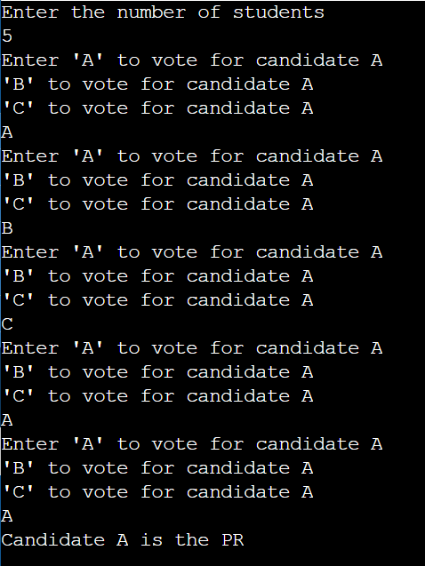

**Question 15:**

**Code:**

**#include<stdio.h>**

**void main(){**

**int n,sum=0;**

**printf("Enter the till which number you want the sum\n");**

**scanf("%d",&n);**

**for(int i=1;i<=n;i++){**

**sum+=i;**

**}**

**printf("The sum of natural numbers till %d is %d",n,sum);**

**}**

**Output:**

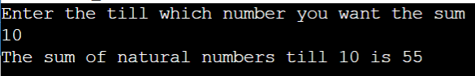

**Question 16:**

**Code:**

**#include<stdio.h>**

**void main(){**

**int n,sum=0;**

**printf("Enter the number of terms of the series\n");**

**scanf("%d",&n);**

**for(int i=1;i<=n;i++){**

**sum+=i*i;**

**}**

**printf("The sum of the series is %d",sum);**

**}**

**Output:**

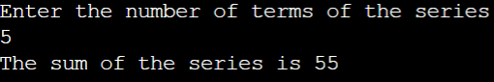

**Question 17:**



**Code:**

**#include<stdio.h>**

**void main(){**

**int n,rev=0;**

**printf("Enter the number to reverse\n");**

**scanf("%d",&n);**

**while(n!=0){**

**rev=rev*10+n%10;**

**n/=10;**

**}**

**printf("The reversed number is %d",rev);**

**}**

**Output:**

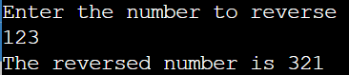

**Question 18:**

**Code:**

**#include<stdio.h>**

**void main(){**

**int n,a=0,b=1,c;**

**printf("Enter the number of values in the series\n");**

**scanf("%d",&n);**

**printf("The fibonacci series is:\n");**

**if(n==1){**

**printf("0");**

**exit(0);**

**}**

**if(n==2){**

**printf("0\t1");**

**exit(0);**

**}**

**printf("0\t1\t");**

**for(int i=1;i<=(n-2);i++){**

**c=a+b;**

**printf("%d\t",c);**

**a=b;**

**b=c;**

**}**

**}**

**Output:**

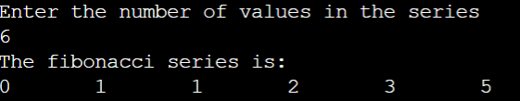

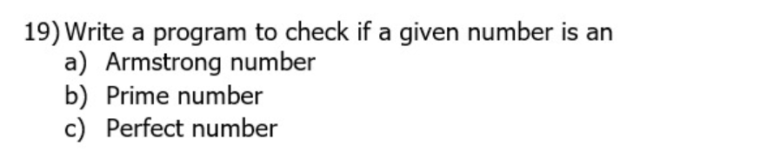**Question 19:**

**Code:**

**#include<stdio.h>**

**void main(){**

**int n,n1,sum=0,sum1=1,fac=0;**

**printf("Enter a number\n");**

**scanf("%d",&n);**

**n1=n;**

**while(n1!=0){**

**int t=n1%10;**

**sum+=t*t*t;**

**n1=n1/10;**

**}**

**if(sum==n){**

**printf("The number is an Armstrong Number\n");**

**}**

**else{**

**printf("The number is not an Armstrong Number\n");**

**}**

**sum=0;**

**if(n<2){**

**printf("The number is not prime\n");**

**}**

**else{**

**for(int i=2;i<n;i++){**

**if(n%i==0){**

**fac+=1;**

**sum1+=i;**

**}**

**}**

**if(fac>0){**

**printf("The number is not prime\n");**

**}**

**else{**

**printf("The number is prime\n");**

**}**

**}**

**if(sum1==n){**

**printf("The number is a perfect number");**

**}**

**else{**

**printf("The number is not a perfect number");**

**}**

**}**

**Output:**

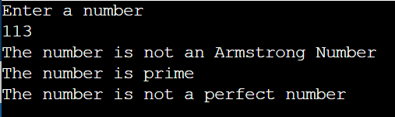

**Question 20:**

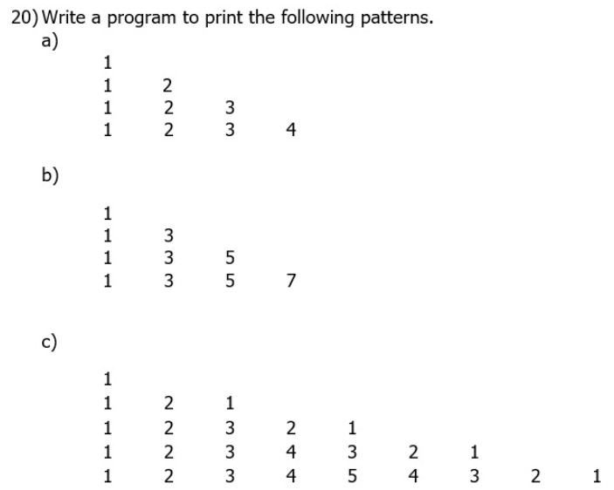

**Code:**

**#include<stdio.h>**

**void main(){**

**for(int i=1;i<=4;i++){**

**for(int j=1;j<=i;j++){**

**printf("%d\t",j);**

**}**

**printf("\n");**

**}**

**for(int i=1;i<=4;i++){**

**for(int j=1;j<=2*i-1;j+=2){**

**printf("%d\t",j);**

**}**

**printf("\n");**

**}**

**for(int i=1;i<=5;i++){**

**for(int j=1;j<=i;j++){**

**printf("%d\t",j);**

**}**

**for(int j=i-1;j>=1;j--){**

**printf("%d\t",j);**

**}**

**printf("\n");**

**}**

**}**

**Output:**

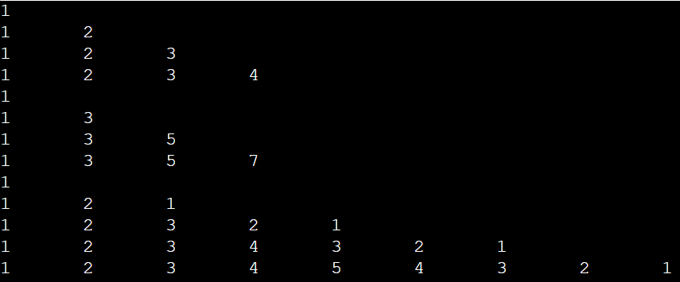

**Question 21:**

**Code:**

**#include<stdio.h>**

**void main(){**

**int n,max,min;**

**printf("Enter the number of elements in the array\n");**

**scanf("%d",&n);**

**int arr[n];**

**printf("Enter the array elements\n");**

**for(int i=0;i<n;i++){**

**scanf("%d",&arr[i]);**

**}**

**min=max=arr[0];**

**for(int i=1;i<n;i++){**

**if(arr[i]<min){**

**min=arr[i];**

**}**

**if(arr[i]>max){**

**max=arr[i];**

**}**

**}**

**printf("The minimum element is %d and the maximum element is %d",min,max);**

**}**

**Output:**

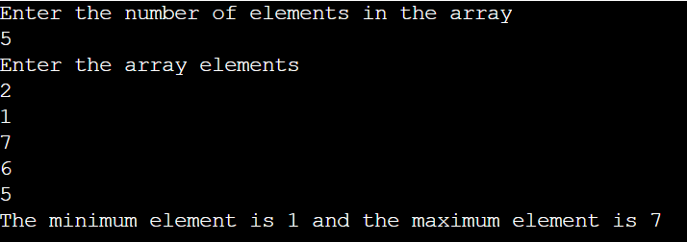

**Question 22:**

**Code:**

**#include<stdio.h>**

**void main(){**

**int n,flag=0;**

**printf("Enter the number of elements in the array\n");**

**scanf("%d",&n);**

**float arr[n],t;**

**printf("Enter the array elements\n");**

**for(int i=0;i<n;i++){**

**scanf("%f",&arr[i]);**

**}**

**printf("Enter the element to be searched\n");**

**scanf("%f",&t);**

**for(int i=0;i<n;i++){**

**if(arr[i]==t){**

**flag=1;**

**printf("The element is found at index %d",i);**

**break;**

**}**

**}**

**if(flag==0){**

**printf("Element not found");**

**}**

**}**

**Output:**

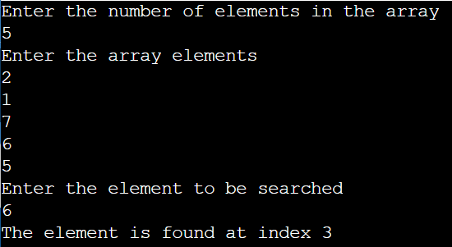

**Question 23:**



**Code:**

**#include<stdio.h>**

**void main(){**

**int w,n,t;**

**printf("Enter the size of the array\n");**

**scanf("%d",&n);**

**int arr[n];**

**int arr1[n+1];**

**printf("Enter the array elements\n");**

**for(int i=0;i<n;i++){**

**scanf("%d",&arr[i]);**

**}**

**printf("Enter the index of where the element is to be inserted\n");**

**scanf("%d",&t);**

**printf("Enter the element to be inserted\n");**

**scanf("%d",&w);**

**if(t<0){**

**printf("The array index has to be greater than or equal to 0");**

**}**

**else if(t>=n){**

**printf("The array index has to be less than %d",n);**

**}**

**else{**

**for(int i=0;i<t;i++){**

**arr1[i]=arr[i];**

**}**

**for(int i=t;i<n;i++){**

**arr1[i+1]=arr[i];**

**}**

**arr1[t]=w;**

**printf("The array after inserting the element is:\n");**

**for(int i=0;i<=n;i++){**

**printf("%d ",arr1[i]);**

**}**

**}**

**}**

**Output:**

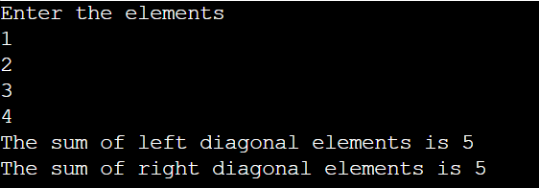

**Question 24:**

**Code:**

**#include<stdio.h>**

**void main(){**

**int m,n,sum=0,sum1=0;**

**printf("Enter number of columns\n");**

**scanf("%d",&m);**

**printf("Enter number of rows\n");**

**scanf("%d",&n);**

**int arr[m][n];**

**printf("Enter the elements\n");**

**for(int i=0;i<m;i++){**

**for(int j=0;j<n;j++){**

**scanf("%d",&arr[i][j]);**

**if(i==j){**

**sum+=arr[i][j];**

**}**

**if((i+j)==(m-1)){**

**sum1+=arr[i][j];**

**}**

**}**

**}**

**printf("The sum of left diagonal elements is %d \n",sum);**

**printf("The sum of right diagonal elements is %d",sum1);**

**}**

**Output:**



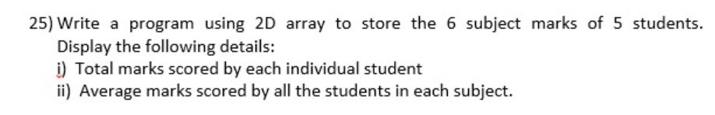**Question 25:**

**Code:**

**#include<stdio.h>**

**void main(){**

**int arr[6][5];**

**int sum=0;**

**int tsum=0;**

**for(int i=0;i<6;i++){**

**printf("Enter the subject marks in subject %d for 5 students\n",i+1);**

**for(int j=0;j<5;j++){**

**scanf("%d",&arr[i][j]);**

**}**

**}**

**for(int i=0;i<5;i++){**

**printf("Total marks of student %d is:\n",i+1);**

**for(int j=0;j<6;j++){**

**sum+=arr[j][i];**

**tsum+=arr[j][i];**

**}**

**printf("%d marks\n",sum);**

**float avg1=(float)sum/6;**

**printf("The average marks of student %d is:\n",i+1);**

**printf("%f marks\n",avg1);**

**sum=0;**

**}**

**float avg = (float) tsum/30;**

**printf("The average marks of all the students in all the subjects is %f\n",avg);**

**}**

**Output:**

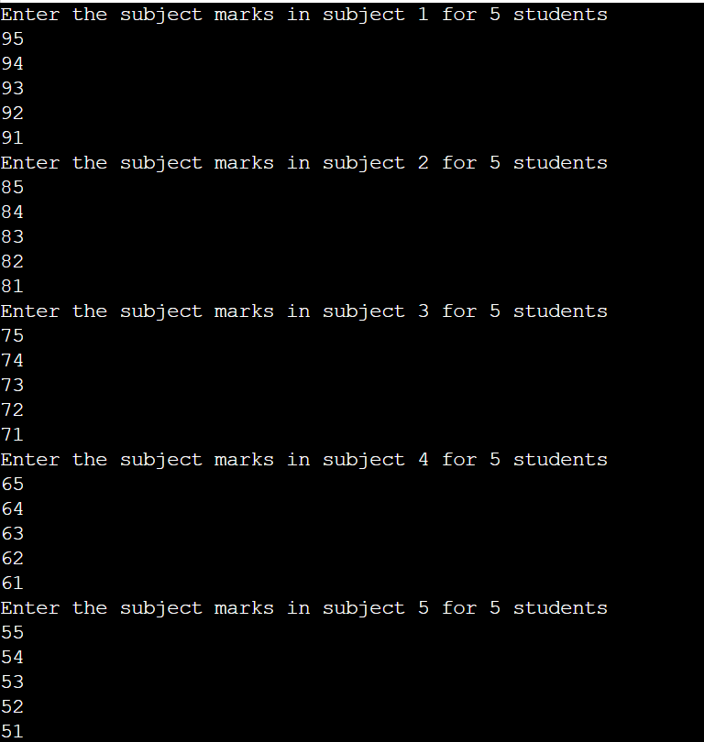

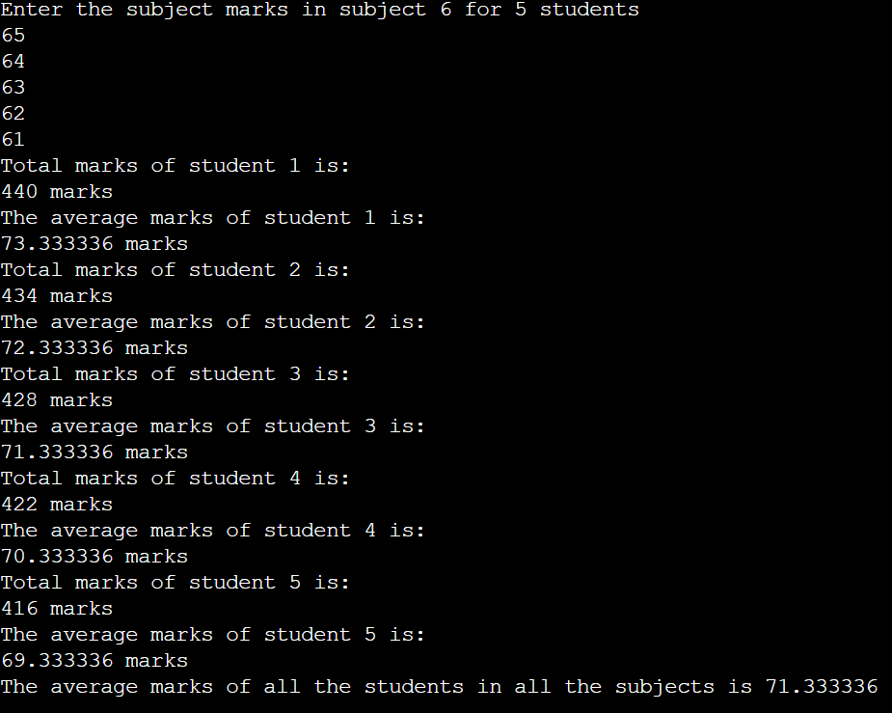

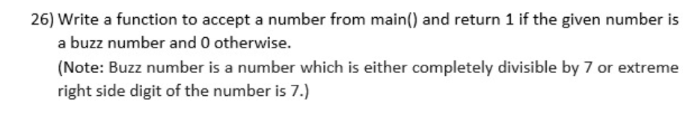**Question 26:**

**Code:**

**#include<stdio.h>**

**int buzz(int a){**

**if(a%7==0 || a%10==7){**

**return 1;**

**}**

**else{**

**return 0;**

**}**

**}**

**void main(){**

**int n;**

**printf("Enter a number \n");**

**scanf("%d",&n);**

**printf("%d",buzz(n));**

**}**

**Output:**

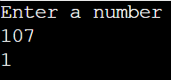

**Question 27:**

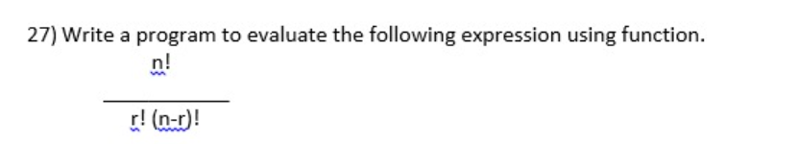

**Code:**

**#include<stdio.h>**

**int fact(int t){**

**int fact1=1;**

**for(int i=2;i<=t;i++){**

**fact1*=i;**

**}**

**return fact1;**

**}**

**void main(){**

**int n,r,x,w;**

**printf("Enter the value for n and r\n");**

**scanf("%d",&n);**

**scanf("%d",&r);**

**w=n-r;**

**x=fact(n)/(fact(w)*fact(r));**

**printf("The value is %d",x);**

**}**

**Output:**

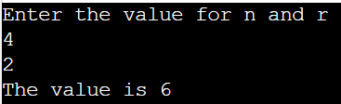

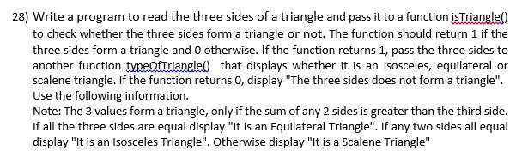**Question 28:**

**Code:**

**#include<stdio.h>**

**int isTriangle(int a,int b,int c){**

**if((a+b)>c && (b+c)>a && (a+c)>b){**

**typeOfTriangle(a,b,c);**

**return 1;**

**}**

**else{**

**printf("The sides do not form a triangle\n");**

**return 0;**

**}**

**}**

**int typeOfTriangle(int a,int b,int c){**

**if(a==b && b==c){**

**printf("It is an equilateral triangle\n");**

**}**

**else if(a==b||a==c||b==c){**

**printf("It is an isosceles triangle\n");**

**}**

**else{**

**printf("It is a scalene triangle\n");**

**}**

**}**

**void main(){**

**int a,b,c;**

**printf("Enter the sides of the triangle\n");**

**scanf("%d %d %d",&a,&b,&c);**

**isTriangle(a,b,c);**

**}**

**Output:**

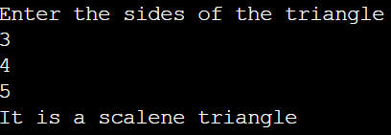

**Question 29:**

**Code:**

**#include<stdio.h>**

**void sort(int arr[],int n){**

**for(int i=0;i<n-1;i++){**

**int min=i;**

**for(int j=i+1;j<n;j++){**

**if(arr[j]<arr[min]){**

**min=j;**

**}**

**}**

**int temp=arr[i];**

**arr[i]=arr[min];**

**arr[min]=temp;**

**}**

**}**

**void main(){**

**int n;**

**printf("Enter the number of elements in the array\n");**

**scanf("%d",&n);**

**int arr[n];**

**printf("Enter the array elements\n");**

**for(int i=0;i<n;i++){**

**scanf("%d",&arr[i]);**

**}**

**sort(arr,n);**

**printf("The array in sorted form is:\n");**

**for(int i=0;i<n;i++){**

**printf("%d ",arr[i]);**

**}**

**}**

**Output:**

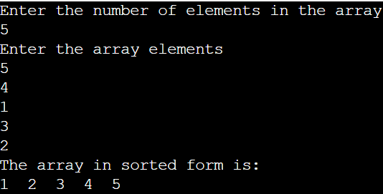

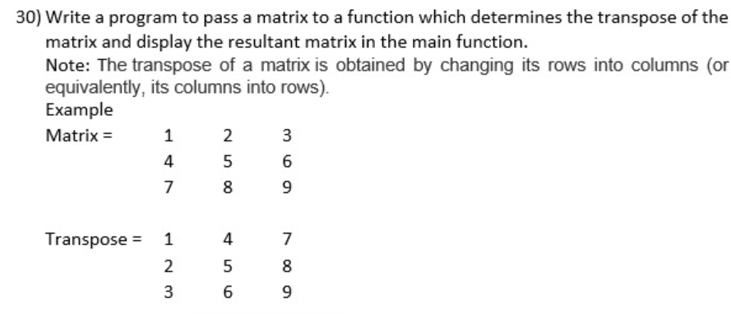**Question 30:**

**Code:**

**#include<stdio.h>**

**void main(){**

**int n;**

**printf("Enter the order of the matrix\n");**

**scanf("%d",&n);**

**int mat[n][n];**

**int tran[n][n];**

**printf("Enter the matrix elements\n");**

**for(int i=0;i<n;i++){**

**for(int j=0;j<n;j++){**

**scanf("%d",&mat[i][j]);**

**tran[j][i]=mat[i][j];**

**}**

**}**

**printf("The matrix is:\n");**

**for(int i=0;i<n;i++){**

**for(int j=0;j<n;j++){**

**printf("%d ",mat[i][j]);**

**}**

**printf("\n");**

**}**

**printf("The transposed matrix is:\n");**

**for(int i=0;i<n;i++){**

**for(int j=0;j<n;j++){**

**printf("%d ",tran[i][j]);**

**}**

**printf("\n");**

**}**

**}**

**Output:**

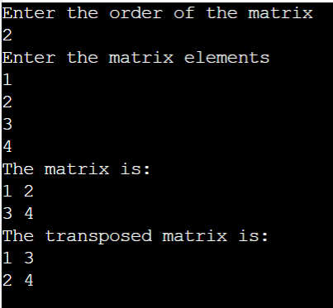

**Question 31:**

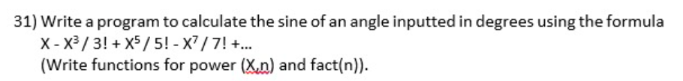

**Code:**

**#include<stdio.h>**

**float fact(int n){**

**float res=1;**

**for(int i=2;i<=n;i++){**

**res*=i;**

**}**

**return res;**

**}**

**float power(float x,float n){**

**if(n==0){**

**return 1;**

**}**

**else{**

**float res=1;**

**for(int i=0;i<n;i++){**

**res*=x;**

**}**

**return res;**

**}**

**}**

**float sine(float x, float t){**

**float res=0;**

**float k=0;**

**for(float i=1;i<=2*t-1;i+=2){**

**res+=power(-1,k)*power(x,i)/fact(i);**

**k++;**

**}**

**printf("The sine of the angle is %f",res);**

**}**

**void main(){**

**float x,t;**

**printf("Enter the angle for calculating the sine and the number of terms of the series you want\n");**

**scanf("%f",&x);**

**scanf("%f",&t);**

**sine(x,t);**

**}**

**Output:**

**Question 32:**



**Code:**

**#include<stdio.h>**

**#include<string.h>**

**void main(){**

**int n;**

**printf("Enter the length of text\n");**

**scanf("%d",&n);**

**char str[n+1];**

**printf("Enter the text\n");**

**scanf(" %[^\n]s",str);**

**for(int i=0;i<n;i++){**

**if(str[i]==' '){**

**str[i]='$';**

**}**

**}**

**printf("The updated string is %s",str);**

**}**

**Output:**

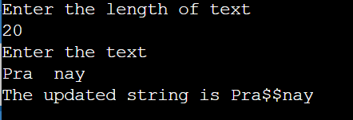

**Question 33:**



**Code:**

**#include<stdio.h>**

**#include<string.h>**

**void main(){**

**int n,u=0,l=0;**

**printf("Enter the length of text\n");**

**scanf("%d",&n);**

**char str[n+1];**

**printf("Enter the text\n");**

**scanf(" %[^\n]s",str);**

**int w = strlen(str);**

**char str1[w];**

**for(int i=0;i<w;i++){**

**int t=str[i];**

**if(t>=65 && t<=90){**

**u+=1;**

**}**

**if(t>=97 && t<=122){**

**l+=1;**

**}**

**str1[w-1-i]=str[i];**

**}**

**printf("Number of Uppercase alphabets in string is %d\n",u);**

**printf("Number of Lowercase alphabets in string is %d\n",l);**

**printf("The reversed string is: %s",str1);**

**}**

**Output:**

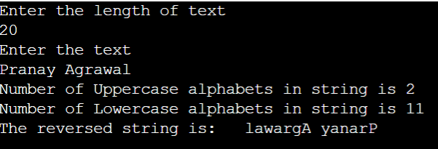

**Question 34:**

**Code:**

**#include<stdio.h>**

**struct Complex{**

**int real;**

**int imag;**

**};**

**void main(){**

**struct Complex s1;**

**struct Complex s2;**

**printf("Enter the real and imaginary part of first complex number\n");**

**scanf("%d %d",&s1.real,&s1.imag);**

**printf("Enter the real and imaginary part of second complex number\n");**

**scanf("%d %d",&s2.real,&s2.imag);**

**int t=s1.real+s2.real;**

**int t1=s1.imag+s2.imag;**

**printf("The sum of the 2 complex numbers is %d + %di",t,t1);**

**}**

**Output:**

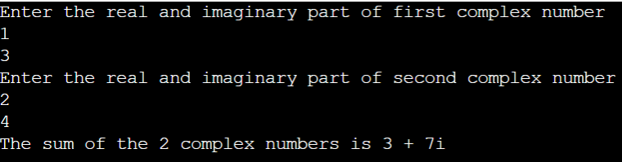

**Question 35:**

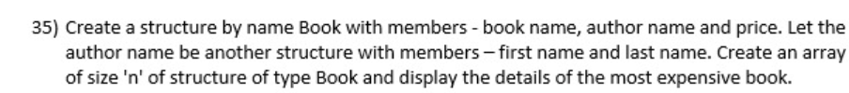

**Code:**

**#include<stdio.h>**

**struct authorName{**

**char firstName[20];**

**char lastName[20];**

**};**

**struct Book{**

**char bookName[20];**

**struct authorName authorName1;**

**int price;**

**};**

**void main(){**

**int n,maxCost=-1,t=0;**

**printf("Enter number of books\n");**

**scanf("%d",&n);**

**struct Book Books[n];**

**for(int i=0;i<n;i++){**

**printf("Enter book name\n");**

**scanf(" %[^\n]s",&Books[i].bookName);**

**printf("Enter first name of author\n");**

**scanf(" %[^\n]s",&Books[i].authorName1.firstName);**

**printf("Enter last name of author\n");**

**scanf(" %[^\n]s",&Books[i].authorName1.lastName);**

**printf("Enter price of book\n");**

**scanf("%d",&Books[i].price);**

**if(Books[i].price>maxCost){**

**maxCost=Books[i].price;**

**t=i;**

**}**

**}**

**printf("The details of the most expensive book are\n");**

**printf("Name of book is %s\n",Books[t].bookName);**

**printf("Name of author is %s %s\n",Books[t].authorName1.firstName,Books[t].authorName1.lastName);**

**printf("The price of the book is %d",Books[t].price);**

**}**

**Output:**

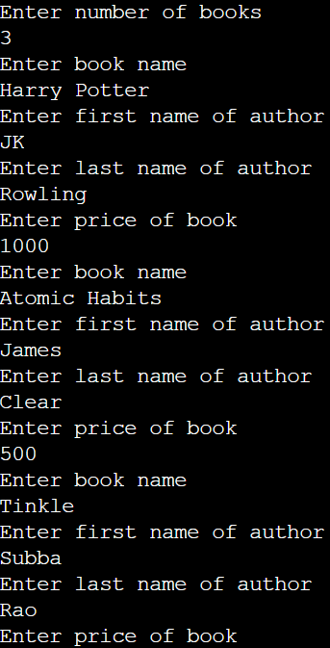

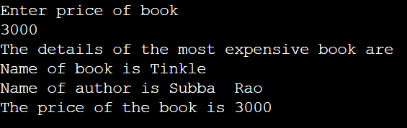

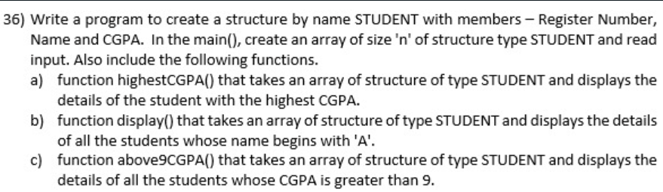**Question 36:**

**Code:**

**#include<stdio.h>**

**struct Student{**

**char regno[10];**

**char name[50];**

**float cgpa;**

**};**

**void highestCGPA(struct Student d[],int n){**

**int t=0;**

**for(int i=1;i<n;i++){**

**if(d[i].cgpa>d[t].cgpa){**

**t=i;**

**}**

**}**

**printf("The details of the student with the highest cgpa are:\n");**

**printf("\nName: %s\n",d[t].name);**

**printf("Registration No: %s\n",d[t].regno);**

**printf("The cgpa is: %f\n",d[t].cgpa);**

**}**

**void display(struct Student d[],int n){**

**int t=-1;**

**for(int i=0;i<n;i++){**

**if(d[i].name[0]=='A'||d[i].name[0]=='a'){**

**t=i;**

**}**

**}**

**if(t==-1){**

**printf("No student exists whose name starting with A\n");**

**}**

**else{**

**printf("The details of the student with name starting with A are:\n");**

**printf("Name: %s\n",d[t].name);**

**printf("Registration No: %s\n",d[t].regno);**

**printf("The cgpa is: %f\n",d[t].cgpa);**

**}**

**}**

**void above9CGPA(struct Student d[],int n){**

**printf("The details of the students whose CGPA exceeds 9 are:\n");**

**for(int i=0;i<n;i++){**

**if(d[i].cgpa>9){**

**printf("Name: %s\n",d[i].name);**

**printf("Registration No: %s\n",d[i].regno);**

**printf("The cgpa is: %f\n",d[i].cgpa);**

**printf("\n");**

**}**

**}**

**}**

**void main(){**

**int n;**

**printf("Enter the number of students\n");**

**scanf("%d",&n);**

**struct Student st[n];**

**for(int i=0;i<n;i++){**

**printf("Enter register number, name and cgpa of student %d\n",i+1);**

**scanf(" %[^\n]s",&st[i].regno);**

**scanf(" %[^\n]s",&st[i].name);**

**scanf("%f",&st[i].cgpa);**

**}**

**highestCGPA(st,n);**

**display(st,n);**

**above9CGPA(st,n);**

**}**

**Output:**

