Functional Part

Name | Apply Owner History

Identifier | xxx | IFC Release | IFC 2x3

Change Log
2005-02-02 | Created | jeffrey.wix@aec3.com
2005-08-16 | Updated to reference addresses as a functional part. | jeffrey.wix@aec3.com
2006-03-28 | Updated for presentation | jeffrey.wix@aec3.com
2008-02-10 | Updated for IFC 2x3. Concepts added. Parts linkage modified | jdw@aec3.com

Overview

This part is concerned with capturing the following ownership, history and status information:
- state information about the instance,
- the name and organization of the user that created and last modified the instance,
- the software application that created and last modified the instance,
- the date that the instance was created and last modified.

Storing the state of an object is optional, but highly recommended. State information allows applications to assert whether the object should be modified by applications that are not the object owner.

The user that creates the instance is the owner. There is nothing that prevents an application from transferring ownership, and in some cases this may be necessary. For example, an architect may create instances of air terminals for the initial layout of a ceiling grid, but an HVAC engineer will ultimately need to take ownership of these instances.

If a user makes a change to an instance, information about the user is captured. Note that only the information about the last user is stored: a historical record is not preserved. The nature (type) of change is recorded. Applications that do not own the instance should only allow changes to instances whose state is marked as READWRITE.

Application information consists of the name and version of the software application, the application developer, and the registered application identifier. The application identifier is granted by the IAI to the developer to indicate that the application has been approved by the IAI facilitated approval process.

The following diagram identifies the principal concepts used in defining an owner history.

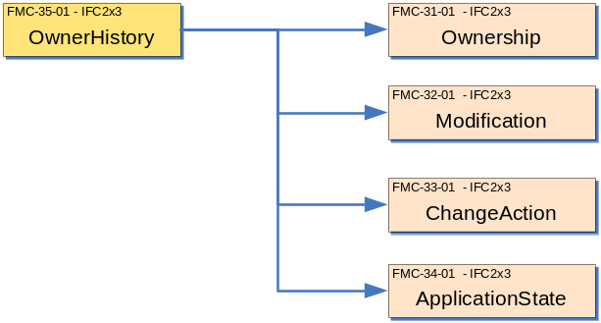

Results

Owner history for object(s) is captured.

Concept: Application
The concept of Application is used to identify the software author, application and version used to create and/or modify exchange files or objects.

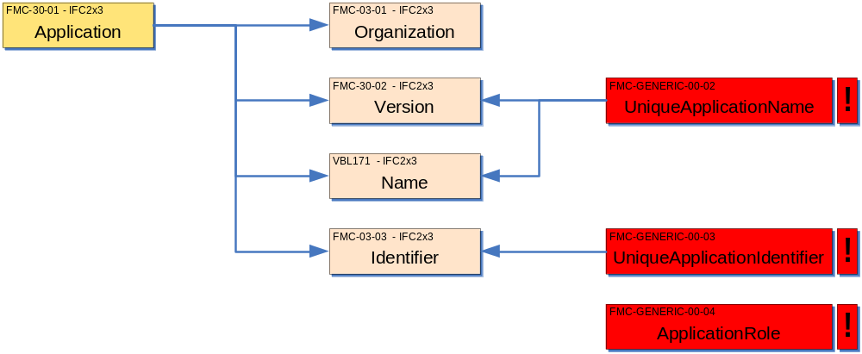

Description | Entity/Pset/Functional Part | MAN | REC | OPT
Specify the name of the developer of the application  The application developer is always an organization.Use the Name attribute | IfcApplication.ApplicationDeveloper  → fp_set_organization (name) | ✓
The role of the developer of the application should also be asserted.  For a software application the role should be set as being USERDEFINED. This means that a user defined role also must be asserted and this should be APPLICATIONDEVELOPER (since this value is not included in the predefined enumeration list) | fp_set_organization (roles) | ✓
Specify the name of the software application  This should be the full name of the software application as defined by the application developer. | IfcApplication.ApplicationFullName → IfcLabel | ✓
Set the version identifier for the software used  This is the version number of the software application as specified by the application developer. | IfcApplication.Version → IfcLabel | ✓
Specify a short identifier for the software application | IfcApplication.ApplicationIdentifier → IfcIdentifier | ✓

Concept: Ownership
The concept of Ownership determines the current owner of information to which an owner history relates. Where owner history is applied once only in a file or exchange, it may be used to identify the owner of the whole set of information. Where it is applied with greater discrimination to objects, it can define the ownership of the individual objects

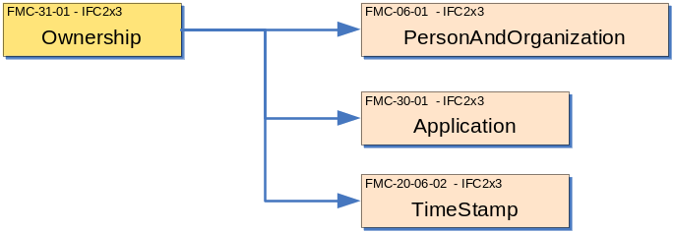

Description | Entity/Pset/Functional Part | MAN | REC | OPT
Set the owning user  The owning user is the person or organization with the current rights to change the state of the object. | IfcOwnerHistory.OwningUser → fp_set_person_and_organization (name) | ✓
Set the owning application  The owning application is the application with the current rights to change the state of the object. | IfcOwnerHistory.OwningApplication → IfcApplication | ✓
Set the creation date  Creation date is the date on which the object was first created. Note that this value is in the forms of seconds passed since 1970 and not in conventional calendar date format.  Once this value has been set, it should not be changed. | IfcOwnerHistory.CreationDate → IfcTimeStamp | ✓

Concept: Modification
The concept of Modification determines who has made a change, with which software application and when. Where owner history is applied once only in a file or exchange, it may be used to identify that a modification has been made globally. Where it is applied with greater discrimination to objects, it can define the modifications made to individual objects.

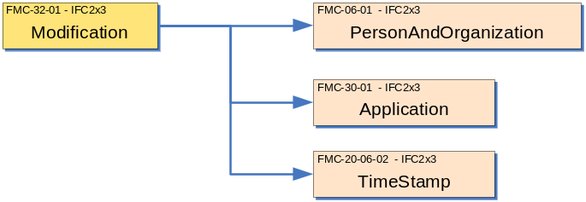

Description | Entity/Pset/Functional Part | MAN | REC | OPT
Set the user making the modification | IfcOwnerHistory.LastModifyingUser → fp_set_person_and_organization (name) | ✓
Identify the application in which the modification was made | IfcOwnerHistory.LastModifyingApplication → IfcApplication | ✓
Set the date on which the modification was made. | IfcOwnerHistory.LastModifiedDate → IfcTimeStamp | ✓
Note that at creation, modification attributes should be set to mirror the creation values.

Values will be set such that:
- LastModifyingUser = OwningUser
- LastModifyingApplication = OwningApplication
- LastModifiedDate = CreationDate

CONCEPT: ChangeAction

The concept ChangeAction is used to define the type of actions associated with changes made to an object. Note that ChangeAction is only relevant where it is to be used to identify changes made to individual objects.

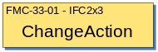

Description | Entity/Pset/Functional Part | MAN | REC | OPT
Set the value for the change action  When the object is first created, this should have the value .ADDED.  When an object is exported but has no changes made, this should have the value .NOCHANGE.  When an object is modified, this should have the value .MODIFIED.  When an object is deleted, this should have the value .DELETED. | IfcOwnerHistory.ChangeAction → IfcChangeActionEnum | ✓

CONCEPT: ApplicationState

The concept ApplicationState is used to identify the state or accessibility of an object (e.g., read/write, locked, etc.). Note that ApplicationState is only relevant where it is to be used to identify the state of individual objects.

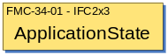

Description | Entity/Pset/Functional Part | MAN | REC | OPT
Set the value for the application state | IfcOwnerHistory.State → IfcStateEnum |  | ✓

IFC Entities Required
IfcActorRole
IfcApplication
IfcOrganization
IfcOwnerHistory
IfcPerson
IfcPersonAndOrganization

IFC Datatypes Required
IfcChangeActionEnum
IfcIdentifier
IfcLabel
IfcRoleEnum
IfcStateEnum
IfcText
IfcTimeStamp

IFC Functions Required
None

IDM Functional Parts Required
fp_set_organization
fp_set_person_and_organization

EXPRESS-G
IfcTimeStamp
INTEGER
IfcChangeActionEnum
IfcStateEnum
fp_set_organization
fp_set_person_and_organization
IfcOwnerHistory
OwningUser
OwningApplication
IfcApplication
ApplicationDeveloper
*Version
*ApplicationFullName
*ApplicationIdentifier
State
ChangeAction
LastModifiedDate
LastModifyingUser
LastModifyingApplication
CreationDate

EXPRESS
SCHEMA FP_APPLY_OWNER_HISTORY;

TYPE IfcIdentifier = STRING;
END_TYPE;

TYPE IfcLabel = STRING;
END_TYPE;

TYPE IfcTimeStamp = INTEGER;
END_TYPE;

TYPE IfcChangeActionEnum = ENUMERATION OF
(NOCHANGE,
MODIFIED,
ADDED,
DELETED,
MODIFIEDADDED,
MODIFIEDDELETED);
END_TYPE;

TYPE IfcStateEnum = ENUMERATION OF
(READWRITE,
READONLY,
LOCKED,
READWRITELOCKED,
READONLYLOCKED);
END_TYPE;

ENTITY IfcOwnerHistory;
OwningUser : IfcPersonAndOrganization;
OwningApplication : IfcApplication;
State : OPTIONAL IfcStateEnum;
ChangeAction : IfcChangeActionEnum;
LastModifiedDate : OPTIONAL IfcTimeStamp;
LastModifyingUser : OPTIONAL fp_set_person_and_organization;
LastModifyingApplication : OPTIONAL IfcApplication;
CreationDate : IfcTimeStamp;
END_ENTITY;

ENTITY IfcApplication;
ApplicationDeveloper : fp_set_organization;
Version : IfcLabel;
ApplicationFullName : IfcLabel;
ApplicationIdentifier : IfcIdentifier;
UNIQUE
UR1 : ApplicationIdentifier;
UR2 : ApplicationFullName, Version;
END_ENTITY;

ENTITY fp_set_organization;
END_ENTITY;

ENTITY fp_set_person_and_organization;
END_ENTITY;

END_SCHEMA;

Examples of Owner History

Example 1: State and Ownership
The following Part 21 data contains an example of state and ownership concepts for an IfcBuilding instance that has just been created:

#1=IFCBUILDING('WJ7yGd42kMW08n7Cp432Kr',#2,'Sample Building',$,$,$,$,$,$,$,$,$);
#2=IFCOWNERHISTORY(#3,#6,.READWRITE.,.ADDED.,87763554,#3,#6,87763554);
#3=IFCPERSONANDORGANIZATION(#4,#5,());
#4=IFCPERSON('Public','Jane','Q.',(),(),(),(),());
#5=IFCORGANIZATION($,'Architecture by Jane Q. Public, Inc.',$,(),());
#6=IFCAPPLICATION(#7,'Version 1.0','Building Architecture Toolkit','BAT1.0');
#7=IFCORGANIZATION($,'Creating Instance Software, Inc.',$,(),());

