Functional Part

Name | Define Quantity

Identifier | xxx | IFC Release | IFC 2x3

Change Log
2005-03-15 | Created | jeffrey.wix@aec3.com
2005-11-14 | Modified to show IfcQuantityXXX subtypes of IfcPhysicalSimpleQuantity | jeffrey.wix@aec3.com
2006-04-03 | Examples added | jeffrey.wix@aec3.com
2008-02-10 | Concepts added | jdw@aec3.com

Overview

The purpose of this part is to describe how a quantity that is defined by a method of measurement may be defined for an object.

‘Methods of measurement’ are frequently used as the basis on which elements may be measured for inclusion in cost or progress submissions. They may include rules that determine how the measurement should be established and the units of measure in which it should be expressed. The rules may be developed from some abstract concepts of measurement rather than actual values (such as length, area etc.) that might otherwise be physically associated with an object or that might be derived through knowledge of the geometric representation of an object.

For example, consider a straight section of pipework with a 90° bend at one end and a square tee at the other end.

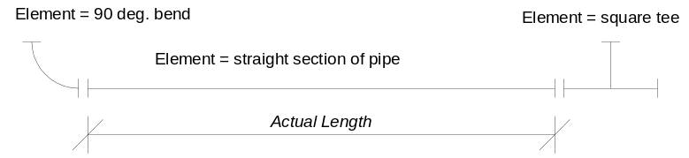

The actual length of the pipe section (as cut and fitted) is measured as the distance between each physical end. In geometric terms, it is normally measured as shown; that is the length of piping between the end of the bend to which it is connected and the end of the tee to which it is connected. The actual fitting elements can also be determined as being a tee and a bend.

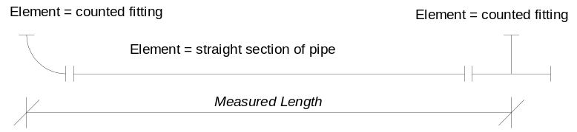

A method of measurement might however set a rule that the length should be measured as the distance between the ends of the section of pipe if they were projected to a point at which they would meet with an adjacent section of pipe. This would mean that the measured length would be greater than the actual length but would be considered satisfactory under the rules of the method of measurement for costing.

A further rule might be that instead of determining the type of each fitting, all fittings would be treated as being the same (called a ‘counted fitting’ in this example).

The information that needs to be captured for quantity definition includes:
- Method of measurement to be used for quantity definition
- Name and (if required) description of the quantity to be measured
- Named physical quantities with values and units appropriately set

Quantities are captured according to their units of measure and concepts are described for length quantities, area quantities, volume quantities, count quantities (dimensionless), weight quantities and time quantities
- Specification of objects for which the quantities are defined.

Out of scope

Additional discriminator, quality and usage attributes for complex quantities comprising sets of values from other quantity measures is currently out of scope of this part

Results

Quantities defined for objects according to a specified method of measurement.

CONCEPT: LengthQuantity

The concept LengthQuantity is used for quantity measurements that are named and expressed as length measures

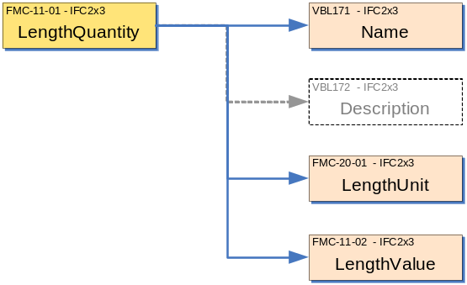

Description | Entity/Pset/Functional Part | MAN | REC | OPT
Name of the element quantity being measured.  The name should be as defined in the method of measurement or list of quantities agreed | IfcQuantityLength.Name → IfcLabel | ✓
Further explanation for the quantity as appropriate. | IfcQuantityLength.Name → IfcText |  |  | ✓
Set the unit in which the quantity is to be measured.  For length:  - the unit type should be set to .LENGTHUNIT.  - the exponent should be set to 1,0,0,0,0,0,0  - the SI unit name should be set to .METRE. and allowable prefixes are nano, milli and kilo (centi is not strictly an SI prefix but may be used)  - Imperial units are conversion based units whose name may be inch, foot, yard or mile | fp_set_unit_cobie |  | ✓
Set the measurement value of the quantity | IfcQuantityLength.LengthValue → IfcLengthMeasure | ✓

CONCEPT: AreaQuantity

The concept AreaQuantity is used for quantity measurements that are named and expressed as area measures

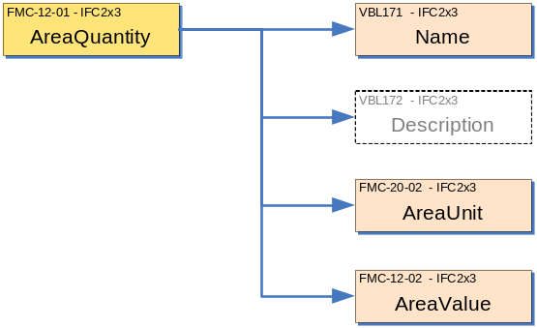

Description | Entity/Pset/Functional Part | MAN | REC | OPT
Name of the element quantity being measured.  The name should be as defined in the method of measurement or list of quantities agreed | IfcQuantityArea.Name → IfcLabel | ✓
Further explanation for the quantity as appropriate. | IfcQuantityArea.Name → IfcText |  |  | ✓
Set the unit in which the quantity is to be measured.  For area:  - the unit type should be set to .AREAUNIT.  - the exponent should be set to 2,0,0,0,0,0,0  - the SI unit name should be set to .SQUARE_METRE. There are no practicable allowable prefixes.  - SI conversion based units could be established for square_millimetre if necessary  - Imperial units are conversion based units whose name may be square_ inch, square_ foot. | fp_set_unit_cobie |  | ✓
Set the measurement value of the quantity | IfcQuantityArea.AreaValue → IfcAreaMeasure | ✓

CONCEPT: VolumeQuantity

The concept VolumeQuantity is used for quantity measurements that are named and expressed as volume measures

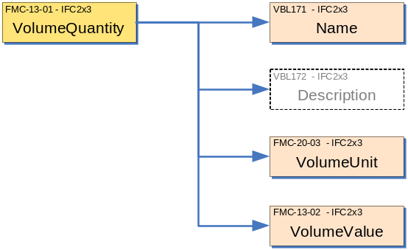

Description | Entity/Pset/Functional Part | MAN | REC | OPT
Name of the element quantity being measured.  The name should be as defined in the method of measurement or list of quantities agreed | IfcQuantityVolume.Name → IfcLabel | ✓
Further explanation for the quantity as appropriate. | IfcQuantityVolume.Name → IfcText |  |  | ✓
Set the unit in which the quantity is to be measured.  For volume:  - the unit type should be set to .VOLUMEUNIT.  - the exponent should be set to3,0,0,0,0,0,0  - the SI unit name should be set to .CUBIC_METRE. There are no practicable allowable prefixes.  - SI conversion based units could be established for cubic_millimetre if necessary  - Imperial units are conversion based units whose name may be cubic_ inch, cubic_ foot. | fp_set_unit_cobie |  | ✓
Set the measurement value of the quantity | IfcQuantityVolume.VolumeValue → IfcVolumeMeasure | ✓

CONCEPT: CountQuantity

The concept CountQuantity is used for quantity measurements that are named and expressed as count measures (which is a dimensionless number)

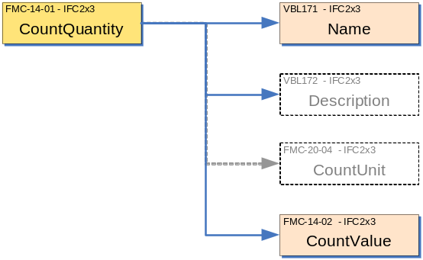

Description | Entity/Pset/Functional Part | MAN | REC | OPT
Name of the element quantity being measured.  The name should be as defined in the method of measurement or list of quantities agreed | IfcQuantityCount.Name → IfcLabel | ✓
Further explanation for the quantity as appropriate. | IfcQuantityCount.Name → IfcText |  |  | ✓
Set the unit in which the quantity is to be measured.  For count:  - Units should not be asserted | fp_set_unit_cobie | X | X | X
Set the measurement value of the quantity | IfcQuantityCount.CountValue → IfcCountMeasure | ✓

CONCEPT: WeightQuantity

The concept WeightQuantity is used for quantity measurements that are named and expressed as mass measures

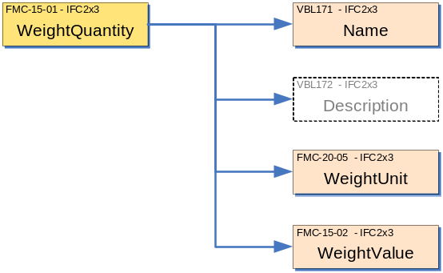

Description | Entity/Pset/Functional Part | MAN | REC | OPT
Name of the element quantity being measured.  The name should be as defined in the method of measurement or list of quantities agreed | IfcQuantityWeight.Name → IfcLabel | ✓
Further explanation for the quantity as appropriate. | IfcQuantityWeight.Name → IfcText |  |  | ✓
Set the unit in which the quantity is to be measured.  For weight:  - the unit type should be set to .MASSUNIT.  - the exponent should be set to0,1,0,0,0,0,0  - the SI unit name should be set to .GRAM. and allowable prefixes are milli and kilo  - Imperial units are conversion based units whose name may be ounce, pound. | fp_set_unit_cobie |  | ✓
Set the measurement value of the quantity | IfcQuantityWeight.WeightValue → IfcWeightMeasure | ✓

CONCEPT: TimeQuantity

The concept TimeQuantity is used for quantity measurements that are named and expressed as time measures.

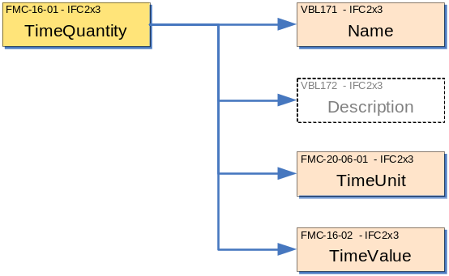

Description | Entity/Pset/Functional Part | MAN | REC | OPT
Name of the element quantity being measured.  The name should be as defined in the method of measurement or list of quantities agreed | IfcQuantityTime.Name → IfcLabel | ✓
Further explanation for the quantity as appropriate. | IfcQuantityTime.Name → IfcText |  |  | ✓
Set the unit in which the quantity is to be measured.  For time:  - the unit type should be set to .TIMEUNIT.  - the exponent should be set to0,0,1,0,0,0,0  - the SI unit name should be set to .SECOND.  - There are no practical allowable prefixes  - Conversion based units may be defined for minutes, hours, weeks, etc.. | fp_set_unit_cobie |  | ✓
Set the measurement value of the quantity | IfcQuantityTime.TimeValue → IfcTimeMeasure | ✓

CONCEPT: ComplexQuantity
This concept is currently out of scope
Description | Entity/Pset/Functional Part | MAN | REC | OPT
If the physical quantity being measured is a complex quantity:

Where a complex quantity is a set of simple quantities that all apply to a given component or aspect of the element.
Determine the set of physical quantities to be assigned using the simple quantity specifications above. | IfcPhysicalComplexQuantity.HasQuantities → IfcPhysicalSimpleQuantity |  | √
Identify the discrimination used to distinguish the complex quantity.  Examples of discriminations are 'layer', 'steel bar diameter' etc. | IfcPhysicalComplexQuantity.Discrimination → IfcLabel |  | √
Indicate a quality of the quantities that are grouped under the complex quantity | IfcPhysicalComplexQuantity.Quality → IfcLabel |  |  | √
Indicate a usage type of the quantities that are grouped under the complex quantity | IfcPhysicalComplexQuantity.Usage → IfcLabel |  |  | √

CONCEPT: ElementQuantity

The concept ElementQuantity is used to specify an overall name and method of measurement for a set of quantities and to set the dimension concept that sets out how the quantity is to be measured.

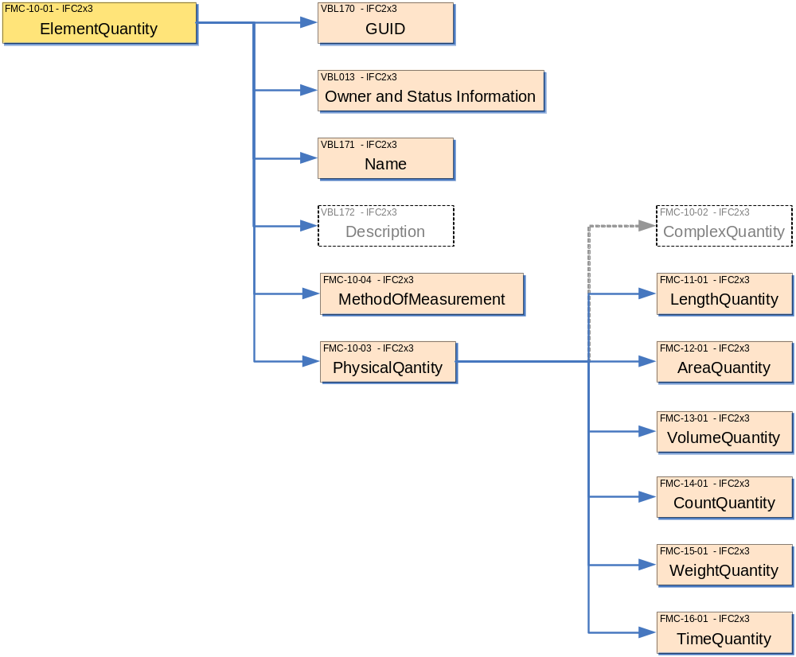

Description | Entity/Pset/Functional Part | MAN | REC | OPT
Create the occurrence (object). The software application will assign a globally unique identifier | IfcElementQuantity.GlobalId → IfcGloballyUniqueId | ✓
Assert the owner history and status of the occurrence (object) | IfcElementQuantity.OwnerHistory → fp_apply_owner_history |  | ✓
Assert a name for the quantity to be measured.  This could be a name like ‘Buildable Area’. Alternatively, it could be a more complete name that could be used as part of a description within a bill of quantities. | IfcElementQuantity.Name → IfcLabel |  |  | ✓
Set the method of measurement to be used for measuring the quantity to be defined.  The method of measurement will typically be defined as a set of measurement rules for use in a particular place. For instance, measurement of areas in the US might be measured according to the BOMA method whilst quantities for costing in the UK could be measured according to SMM6 (6th edition of the Standard Method of Measurement) | IfcElementQuantity.MethodOfMeasurement → IfcLabel |  | ✓
Describe the quantity to be measured.  This is an optional value that can be used. In the example above, the buildable area might be described as being ‘the maximum area of a site on which a building or buildings might be placed’. Descriptions can be used to further enhance information in bills of quantities. | IfcElementQuantity.Description → IfcLabel |  |  | ✓
Set the physical quantity to the element quantity.  IfcPhysicalQuantity may be a set of simple and complex quantities. At least one quantity that is either an IfcPhysicalSimpleQuantity (using IfcQuantityXXX subtypes as set out in the concepts above) or an IfcPhysicalComplexQuantity must be asserted. | IfcElementQuantity.Quantities → IfcPhysicalQuantity | ✓

CONCEPT: DefineByProperties

An IfcElementQuantity is a type of property set definition and is therefore connected to objects in the same way as for other property set definitions. This is set out by the concept DefineByProperties which is defined elsewhere in the fp_define_by_properties.

Description | Entity/Pset/Functional Part | MAN | REC | OPT
Define the occurrence of IfcElementQuantity that will relate to one or more occurrences of a subtype of IfcObject. | fp_define_by_properties | ✓

IFC Entities Required
- IfcElementQuantity
- IfcPhysicalQuantity
- IfcPhysicalComplexQuantity
- IfcPhysicalSimpleQuantity
- IfcPropertyDefinition
- IfcPropertySetDefinition
- IfcQuantityArea
- IfcQuantityCount
- IfcQuantityLength
- IfcQuantityTime
- IfcQuantityVolume
- IfcQuantityWeight
- IfcRoot

IFC Datatypes Required
- IfcAreaMeasure
- IfcCountMeasure
- IfcGloballyUniqueId
- IfcLabel
- IfcLengthMeasure
- IfcMassMeasure
- IfcText
- IfcTimeMeasure
- IfcVolumeMeasure

IFC Functions Required
- -

IFC Property Sets Required
- -

IDM Functional Parts Required
- fp_apply_owner_history
- fp_define_by_properties
- fp_unit

EXPRESS-G
(ABS)
IfcRoot
(ABS)
IfcPropertyDefinition
(ABS)
IfcPropertySetDefinition
IfcElementQuantity
MethodOfMeasurement
Quantities S
[
1
:
?
]
(ABS)
IfcPhysicalQuantity
1
*IfcPhysicalComplexQuantity
HasQuantities S
[
1
:
?
]
(INV
)
PartOfComplex S
[
0
:
1
]
Discrimination
Quality
Usage
(ABS)
IfcPhysicalSimpleQuantity
1
*IfcQuantityArea
AreaValue
*IfcQuantityCount
CountValue
*IfcQuantityLength
LengthValue
*IfcQuantityTime
TimeValue
*IfcQuantityVolume
VolumeValue
*IfcQuantityWeight
WeightValue
Name
Description
*GlobalId
Name
Description
OwnerHistory
fp_apply_owner_history
fp_define_by_properties
fp_unit
to IfcNamedUnit
Unit

EXPRESS Schema
SCHEMA FP_DEFINE_QUANTITY;

TYPE IfcAreaMeasure = REAL;
END_TYPE;

TYPE IfcCountMeasure = NUMBER;
END_TYPE;

TYPE IfcGloballyUniqueId = STRING (22) FIXED;
END_TYPE;

TYPE IfcLabel = STRING;
END_TYPE;

TYPE IfcLengthMeasure = REAL;
END_TYPE;

TYPE IfcMassMeasure = REAL;
END_TYPE;

TYPE IfcText = STRING;
END_TYPE;

TYPE IfcTimeMeasure = REAL;
END_TYPE;

TYPE IfcVolumeMeasure = REAL;
END_TYPE;

ENTITY IfcRoot
ABSTRACT SUPERTYPE;
GlobalId : IfcGloballyUniqueId;
Name : OPTIONAL IfcLabel;
Description : OPTIONAL IfcText;
OwnerHistory : fp_apply_owner_history;
UNIQUE
UR1 : GlobalId;
END_ENTITY;

ENTITY IfcPropertyDefinition
ABSTRACT SUPERTYPE
SUBTYPE OF(IfcRoot);
END_ENTITY;

ENTITY IfcPropertySetDefinition
ABSTRACT SUPERTYPE
SUBTYPE OF(IfcPropertyDefinition);
END_ENTITY;

ENTITY IfcElementQuantity
SUBTYPE OF(IfcPropertySetDefinition);
MethodOfMeasurement : OPTIONAL IfcLabel;
Quantities : SET [1:?] OF IfcPhysicalQuantity;
END_ENTITY;

ENTITY IfcPhysicalQuantity
ABSTRACT SUPERTYPE OF (ONEOF(IfcPhysicalComplexQuantity, IfcPhysicalSimpleQuantity));
Name : IfcLabel;
Description : OPTIONAL IfcText;
INVERSE
PartOfComplex : SET [0:1] OF IfcPhysicalComplexQuantity FOR HasQuantities;
END_ENTITY;

ENTITY IfcPhysicalComplexQuantity
SUBTYPE OF(IfcPhysicalQuantity);
HasQuantities : SET [1:?] OF IfcPhysicalQuantity;
Discrimination : IfcLabel;
Quality : OPTIONAL IfcLabel;
Usage : OPTIONAL IfcLabel;
WHERE
WR21 : SIZEOF(QUERY(temp <* HasQuantities | SELF :=: temp)) = 0;
END_ENTITY;

ENTITY IfcPhysicalSimpleQuantity
ABSTRACT SUPERTYPE OF (ONEOF(IfcQuantityArea, IfcQuantityCount, IfcQuantityLength, IfcQuantityTime, IfcQuantityVolume, IfcQuantityWeight))
SUBTYPE OF(IfcPhysicalQuantity);
Unit : OPTIONAL fp_unit;
END_ENTITY;

ENTITY IfcQuantityArea
SUBTYPE OF(IfcPhysicalSimpleQuantity);
AreaValue : IfcAreaMeasure;
WHERE
WR21 : NOT(EXISTS(SELF\IfcPhysicalSimpleQuantity.Unit)) OR
(SELF\IfcPhysicalSimpleQuantity.Unit.UnitType = IfcUnitEnum.AREAUNIT);
WR22 : AreaValue >= 0;
END_ENTITY;

ENTITY IfcQuantityCount
SUBTYPE OF(IfcPhysicalSimpleQuantity);
CountValue : IfcCountMeasure;
WHERE
WR1 : CountValue >= 0;
END_ENTITY;

ENTITY IfcQuantityLength
SUBTYPE OF(IfcPhysicalSimpleQuantity);
LengthValue : IfcLengthMeasure;
WHERE
WR21 : NOT(EXISTS(SELF\IfcPhysicalSimpleQuantity.Unit)) OR
(SELF\IfcPhysicalSimpleQuantity.Unit.UnitType = IfcUnitEnum.LENGTHUNIT);
WR22 : LengthValue >= 0;
END_ENTITY;

ENTITY IfcQuantityTime
SUBTYPE OF(IfcPhysicalSimpleQuantity);
TimeValue : IfcTimeMeasure;
WHERE
WR21 : NOT(EXISTS(SELF\IfcPhysicalSimpleQuantity.Unit)) OR
(SELF\IfcPhysicalSimpleQuantity.Unit.UnitType = IfcUnitEnum.TIMEUNIT);
WR22 : TimeValue >= 0;
END_ENTITY;

ENTITY IfcQuantityVolume
SUBTYPE OF(IfcPhysicalSimpleQuantity);
VolumeValue : IfcVolumeMeasure;
WHERE
WR21 : NOT(EXISTS(SELF\IfcPhysicalSimpleQuantity.Unit)) OR
(SELF\IfcPhysicalSimpleQuantity.Unit.UnitType = IfcUnitEnum.VOLUMEUNIT);
WR22 : VolumeValue >= 0;
END_ENTITY;

ENTITY IfcQuantityWeight
SUBTYPE OF(IfcPhysicalSimpleQuantity);
WeightValue : IfcMassMeasure;
WHERE
WR21 : NOT(EXISTS(SELF\IfcPhysicalSimpleQuantity.Unit)) OR
(SELF\IfcPhysicalSimpleQuantity.Unit.UnitType = IfcUnitEnum.MASSUNIT);
WR22 : WeightValue >= 0;
END_ENTITY;

ENTITY fp_apply_owner_history;
END_ENTITY;

ENTITY fp_define_by_properties;
END_ENTITY;

ENTITY fp_unit;
END_ENTITY;

END_SCHEMA;

Examples of Quantities

Example 1: Setting the length of electrical cables

In the example, cables and cores are geometrical represented as a simple line in the drawing. These are intended to signify connections between components and do not necessarily represent actual routes that cables/cores would actually take.

Each electrical connection occurrence is here modelled as an IfcFlowSegment that is defined by type as a cable segment. In the example, particular properties of the segment are not elaborated. The occurrences here reference the cable route 1 → 2 → 3 in the diagram.
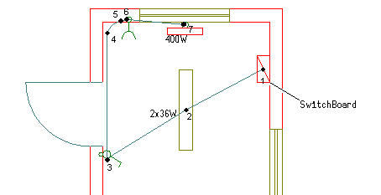
A
B

Measurement of the flow segment may be undertaken in various ways. For this example, two measurement are shown.
- Measurement A is taken in the direct line 1 – 2 – 3 with allowance made for drop at each point.
- Measurement B is taken from point 1, rising up and then travelling orthogonally across the space to the mid point and then to the light where it drops to 2. This is repeated to connect to 3.

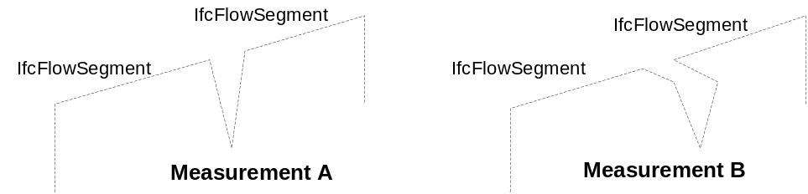
For the purposes of the example, method of measurement A is shown as MoM-A with a length value of 5m for each part (i.e. two flow segments sharing the same quantity measurement).

#100 = IFCOWNERHISTORY ( … );
#200 = IFCORGANIZATION ($,’IAI’,$,$,$);
#300 = IFCSIUNIT (.LENGTHUNIT.,$,.METRE.,#301);
#301 = IFCDIMENSIONALEXPONENTS (1,0,0,0,0,0,0);

#500 = IFCFLOWSEGMENT ('gabcdeghijklmnopqrst500',#100,’Cable Segment’,$,$,$,$,$);
#501 = IFCFLOWSEGMENT ('gabcdeghijklmnopqrst501',#100,’Cable Segment’,$,$,$,$,$);

#600 = IFCELEMENTQUANTITY ('gabcdeghijklmnopqrst600',#100,$,$,’MoM-A’,(#601));
#601 = IFCQUANTITYLENGTH (‘Cable length’,’Most direct route’,#300,5.0);

#700 = IFCRELDEFINESBYPROPERTIES ('gabcdeghijklmnopqrst700',#100,$,$,(#500,#501),#600);

Method of measurement B is shown as MoM-B with a length value of 6.4m for the first segment and 6.7m for the second segment.

#100 = IFCOWNERHISTORY ( … );
#200 = IFCORGANIZATION ($,’IAI’,$,$,$);
#300 = IFCSIUNIT (.LENGTHUNIT.,$,.METRE.,#301);
#301 = IFCDIMENSIONALEXPONENTS (1,0,0,0,0,0,0);

#500 = IFCFLOWSEGMENT ('gabcdeghijklmnopqrst500',#100,’Cable Segment’,$,$,$,$,$);
#501 = IFCFLOWSEGMENT ('gabcdeghijklmnopqrst501',#100,’Cable Segment’,$,$,$,$,$);

#600 = IFCELEMENTQUANTITY ('gabcdeghijklmnopqrst600',#100,$,$,’MoM-A’,(#601));
#601 = IFCQUANTITYLENGTH (‘Cable length’,’Most direct route’,#300,6.4);
#610 = IFCELEMENTQUANTITY ('gabcdeghijklmnopqrst610',#100,$,$,’MoM-A’,(#611));
#611 = IFCQUANTITYLENGTH (‘Cable length’,’Most direct route’,#300,6.7);

#700 = IFCRELDEFINESBYPROPERTIES ('gabcdeghijklmnopqrst700',#100,$,$,(#500),#600);
#701 = IFCRELDEFINESBYPROPERTIES ('gabcdeghijklmnopqrst701',#100,$,$,(#501),#610);

