Functional Part

Name | Represent Bounding Box

Identifier | xxx

Change Log
2005-07-23 | Created | jeffrey.wix@jwix.co.uk

Overview

Identifies the information requirements for provision of a bounding box representation.

A bounding box is a shape representation that can be used to identify the 3 dimensional box that would exactly contain the extents of the physical product being represented. It may be used as minimal geometric representation for any geometrically represented object. Every semantic object having a physical extent might have a minimum default representation of a bounding box.

The extents of the bounding box are determined as positive lengths. This means that the origin point of the bounding box is set at one corner and the coordinates axes are oriented so that all dimensions are measured as positive values. The values that determine the bounding box are the length (measured along the X axis), width (measured along the Y axis) and the height or depth (measured along the Z axis).
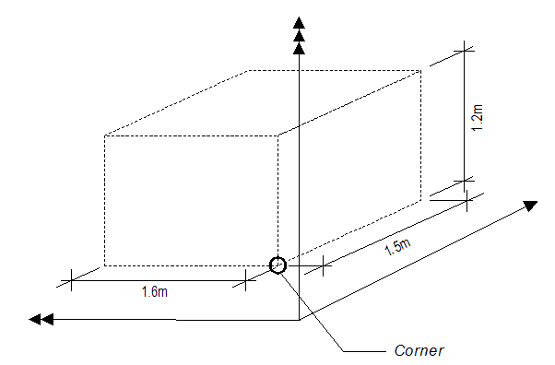

Results

Specification of a bounding box is established.

Description | Entity/Pset/Functional Part | MAN | OPT
Determine the product for which the bounding box representation is to be defined
Establish the X, Y and Z dimensions for the bounding box | IfcBoundingBox.XDim  → IfcPositiveLengthMeasure  IfcBoundingBox.YDim  → IfcPositiveLengthMeasure  IfcBoundingBox.ZDim  → IfcPositiveLengthMeasure | √
Locate the corner point of the bounding box | IfcBoundingBox.Corner  → fp_represent_cartesian_point | √
The space dimensionality for the point is derived from the number of coordinates specified.  For a bounding box, the value of this attribute is always set to 3. | IfcBoundingBox.Dim → INTEGER = 3 | √

IFC Entities Required
- IfcBoundingBox
- IfcGeometricRepresentationItem
- IfcRepresentationItem

IFC Datatypes Required
- IfcDimensionCount
- IfcPositiveLengthMeasure
- IfcLengthMeasure

IFC Functions Required
- -

IDM Functional Parts Required
- fp_represent_cartesian_point

EXPRESS-G
(ABS)
IfcGeometricRepresentationItem
(ABS)
IfcRepresentationItem
IfcBoundingBox
XDim
YDim
ZDim
(DER) Dim
fp_represent_cartesian_point
Corner
to IfcCartesianPoint

EXPRESS Schema
SCHEMA FP_REPRESENT_BOUNDING_BOX;

TYPE IfcDimensionCount = INTEGER;
WHERE
WR1 : { 0 < SELF <= 3 };
END_TYPE;

TYPE IfcLengthMeasure = REAL;
END_TYPE;

TYPE IfcPositiveLengthMeasure = IfcLengthMeasure;
WHERE
WR1 : SELF > 0;
END_TYPE;

ENTITY IfcGeometricRepresentationItem
ABSTRACT SUPERTYPE
SUBTYPE OF(IfcRepresentationItem);
END_ENTITY;

ENTITY IfcRepresentationItem
ABSTRACT SUPERTYPE;
END_ENTITY;

ENTITY IfcBoundingBox
SUBTYPE OF(IfcGeometricRepresentationItem);
XDim : IfcPositiveLengthMeasure;
YDim : IfcPositiveLengthMeasure;
ZDim : IfcPositiveLengthMeasure;
Corner : fp_represent_cartesian_point;
DERIVE
Dim : IfcDimensionCount := 3;
END_ENTITY;

ENTITY fp_represent_cartesian_point;
END_ENTITY;

END_SCHEMA;

