Functional Part

Name | Represent Cartesian Point

Identifier | xxx

Change Log
2005-05-17 | Created | jeffrey.wix@jwix.co.uk

Overview

Identifies the information requirements for provision of a Cartesian point.

A Cartesian point is identified by 2 or 3 coordinates depending on whether the space dimensionality is set to a value of 2 or 3.

Results

Specification of a point is established.

Description | Entity/Pset/Functional Part | MAN | OPT
Set the coordinate values for the point.  Coordinate[1] is the X coordinate, Coordinate[2] is the Y coordinate, and Coordinate[3] is the Z coordinate  At least one coordinate value must be set for a Cartesian point. However, 2 values is more normal (for 2 dimensional space) and 3 is generally expected within an IFC context (for 3 dimensional space). | IfcCartesianPoint.Coordinates → IfcLengthMeasure | √
The space dimensionality for the point is derived from the number of coordinates specified. | IfcCartesianPoint.Dim | √

IFC Entities Required
- IfcCartesianPoint
- IfcGeometricRepresentationItem
- IfcPoint
- IfcRepresentationItem

IFC Datatypes Required
- IfcDimensionCount
- IfcLengthMeasure

IFC Functions Required
- -

IDM Functional Parts Required
- -

EXPRESS-G
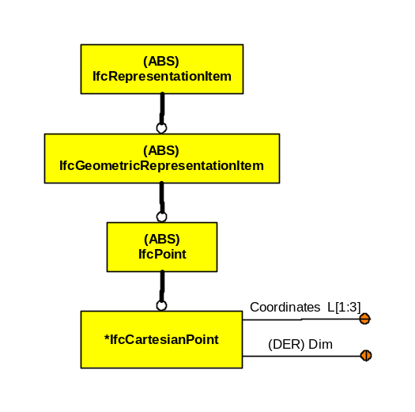

EXPRESS Schema
SCHEMA FP_REPRESENT_CARTESIAN_POINT;

TYPE IfcDimensionCount = INTEGER;
WHERE
WR1 : { 0 < SELF <= 3 };
END_TYPE;

TYPE IfcLengthMeasure = REAL;
END_TYPE;

ENTITY IfcGeometricRepresentationItem
ABSTRACT SUPERTYPE
SUBTYPE OF(IfcRepresentationItem);
END_ENTITY;

ENTITY IfcRepresentationItem
ABSTRACT SUPERTYPE;
END_ENTITY;

ENTITY IfcCartesianPoint
SUBTYPE OF(IfcPoint);
Coordinates : LIST [1:3] OF IfcLengthMeasure;
DERIVE
Dim : IfcDimensionCount := HIINDEX(Coordinates);
WHERE
WR1 : HIINDEX(Coordinates) >= 2;
END_ENTITY;

ENTITY IfcPoint
ABSTRACT SUPERTYPE
SUBTYPE OF(IfcGeometricRepresentationItem);
END_ENTITY;

END_SCHEMA;

