Functional Part

Name | Represent Polyline

Identifier | xxx

Change Log
2005-05-17 | Created | jeffrey.wix@jwix.co.uk

Overview

Identifies the information requirements for the provision of a polyline.

A polyline is a line consisting of segments, each segment occurring between successive points soecified for the polyline. For a polyline comprising N points, there are N-1 segments.

Results

Specification of a list of points that define a polyline.

Description | Entity/Pset/Functional Part | MAN | OPT
Set the coordinate values for each of the points in the polyline.  Coordinate[1] is the X coordinate, Coordinate[2] is the Y coordinate, and Coordinate[3] is the Z coordinate | IfcCartesianPoint.Coordinates → IfcLengthMeasure | √
The space dimensionality for each point is derived from the number of coordinates specified. | IfcCartesianPoint.Dim | √
The points that define the polyline are specified as a list in the order of occurrence.  There must be at least two points to specify a polyline. | IfcPolyline.Points → IfcCartesianPoint | √
The space dimensionality for the polyline is derived from dimensional context of the polyline (2 or 3 dimensional).  This attribute is inherited from the IfcCurve supertype. | IfcPolyline.Dim | √

IFC Entities Required
- IfcBoundedCurve
- IfcCartesianPoint
- IfcCurve
- IfcGeometricRepresentationItem
- IfcPoint
- IfcPolyline
- IfcRepresentationItem

IFC Datatypes Required
- IfcDimensionCount
- IfcLengthMeasure

IFC Functions Required
- -

IDM Functional Parts Required
- -

EXPRESS-G

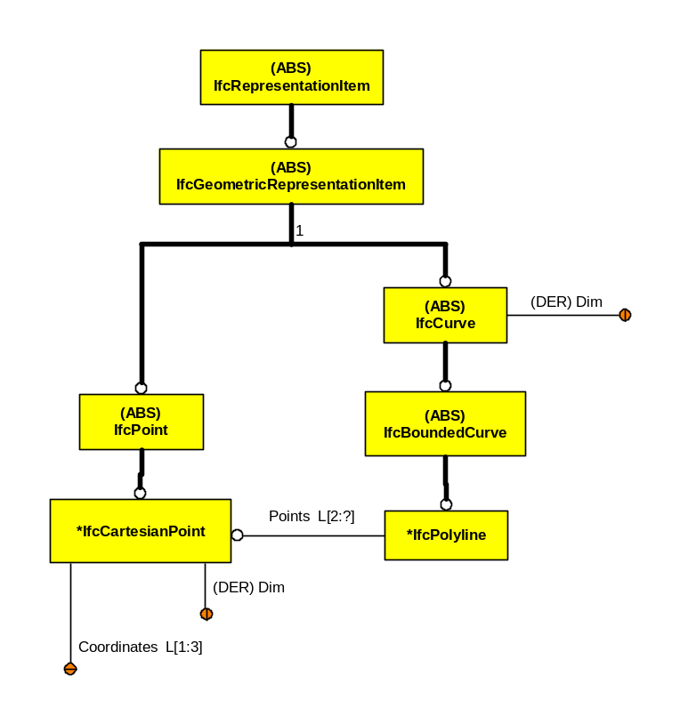

EXPRESS Schema
SCHEMA FP_REPRESENT_POLYLINE;

TYPE IfcDimensionCount = INTEGER;
WHERE
WR1 : { 0 < SELF <= 3 };
END_TYPE;

TYPE IfcLengthMeasure = REAL;
END_TYPE;

ENTITY IfcGeometricRepresentationItem
ABSTRACT SUPERTYPE OF (ONEOF(IfcCurve, IfcPoint))
SUBTYPE OF(IfcRepresentationItem);
END_ENTITY;

ENTITY IfcRepresentationItem
ABSTRACT SUPERTYPE;
END_ENTITY;

ENTITY IfcCartesianPoint
SUBTYPE OF(IfcPoint);
Coordinates : LIST [1:3] OF IfcLengthMeasure;
DERIVE
Dim : IfcDimensionCount := HIINDEX(Coordinates);
WHERE
WR1 : HIINDEX(Coordinates) >= 2;
END_ENTITY;

ENTITY IfcPoint
ABSTRACT SUPERTYPE
SUBTYPE OF(IfcGeometricRepresentationItem);
END_ENTITY;

ENTITY IfcCurve
ABSTRACT SUPERTYPE
SUBTYPE OF(IfcGeometricRepresentationItem);
DERIVE
Dim : IfcDimensionCount := IfcCurveDim(SELF);
END_ENTITY;

ENTITY IfcBoundedCurve
ABSTRACT SUPERTYPE
SUBTYPE OF(IfcCurve);
END_ENTITY;

ENTITY IfcPolyline
SUBTYPE OF(IfcBoundedCurve);
Points : LIST [2:?] OF IfcCartesianPoint;
WHERE
WR41 : SIZEOF(QUERY(Temp <* Points | Temp.Dim <> Points[1].Dim)) = 0;
END_ENTITY;

END_SCHEMA;

