Functional Part

Name | Select Date Time

Identifier | xxx | IFC Release | IFC 2x2 Addendum 1

Change Log
2005-07-27 | Created | jeffrey.wix@aec3.com
2006-03-28 | Updated for presentation | jeffrey.wix@aec3.com

Overview

Provides the means for specifying date/time values to attributes.

Date/time values may be defined for:
- Date only
  - Date values may be specified using year, month, date attributes up to IFC 2x3.
  - Date values are extended to deal with historical and approximate dating from IFC 2x4.
- Time only
  - Time values can be set in local time and can include offset from coordinated universal time (Greenwich Mean Time) and daylight saving offset.
- Both date and time

Results

Specifies date and/or time.

Description | Entity/Pset/Functional Part | MAN | REC | OPT
Select whether date or time or date and time is to be used | IfcDateTimeSelect | ✓
If date is selected
Set the year component | IfcCalendarDate.YearComponent → IfcYearNumber |  | ✓
Set the month component  Values of month component are restricted to integer values between 1 and 12. A WHERE rule checks the validity on the month component. | IfcCalendarDate.MonthComponent → IfcMonthInYearYearNumber |  | ✓
Set the day component  Values of day component are restricted to integer values according to the month and whether or not the year is a leap year. A function checks the validity of the day component. | IfcCalendarDate.DayComponent → IfcDayInMonthNumber |  | ✓
If time is selected
Set the hour component  Values of hour component are restricted to integer values between 0 and 23. A WHERE rule checks the validity of the hour component. | IfcLocalTime.HourComponent → IfcHourInDay |  | ✓
Set the minute component  Values of minute component are restricted to integer values between 0 and 59. A WHERE rule checks the validity of the minute component. | IfcLocalTime.MinuteComponent →IfcMinuteInHour |  | ✓
Set the second component  Values of second component are restricted to integer values between 0 and 59. A WHERE rule checks the validity of the second component. | IfcLocalTime.SecondComponent → IfcSecondInMinute |  | ✓
Set the extent of the daylight saving offset | IfcLocalTime.DaylightSavingOffset → IfcDaylightSavingHour |  | ✓
Set the time zone in which the local time occurs | IfcLocalTime.Zone → IfcCoordinatedUniversalTimeOffset |  | ✓
Set the hour offset from coordinated universal time | IfcCoordinatedUniversalTimeOffset.HourOffset → IfcHourInDay | ✓
Set the minute offset from coordinated universal time | IfcCoordinatedUniversalTimeOffset.MinuteOffset → IfcMinuteInHour |  | ✓
Set the sense (ahead or behind) of the offset from coordinated universal time | IfcCoordinatedUniversalTimeOffset.Sense → IfcAheadOrBehind |  | ✓
If date and time is selected
Assert the date as elaborated in the date selection above | IfcDateAndTime.DateComponent → IfcCalendarDate | ✓
Assert the time as elaborated in the time selection above | IfcDateAndTime.TimeComponent → IfcLocalTime | ✓

IFC Entities Required
- IfcCalendarDate
- IfcLocalTime
- IfcCoordinatedUniversalTimeOffset
- IfcDateAndTime

IFC Datatypes Required
- IfcDayInMonthNumber
- IfcDaylightSavingHour
- IfcHourInDay
- IfcMinuteInHour
- IfcMonthInYearNumber
- IfcSecondInMinute
- IfcYearNumber
- IfcAheadOrBehind

IFC Functions Required
- IfcLeapYear
- IfcValidCalendarDate
- IfcValidTime

IFC Property Sets Required
- -

IDM Functional Parts Required
- -

EXPRESS-G
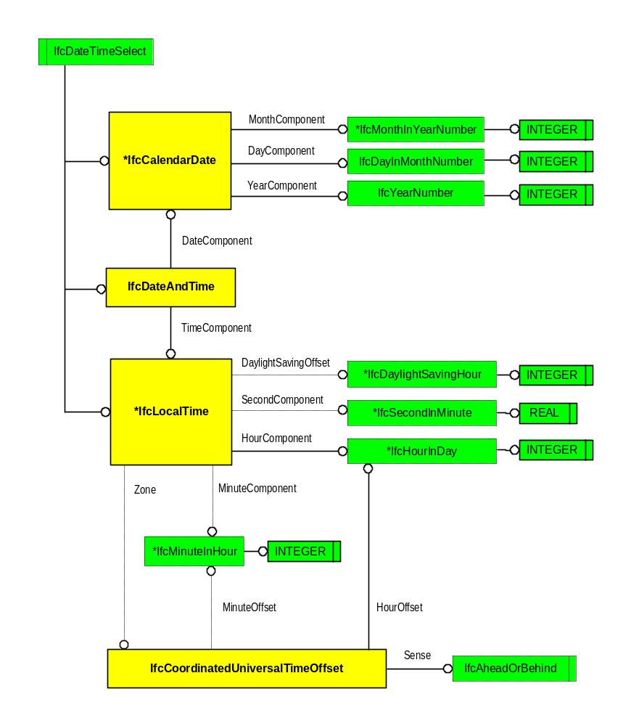

EXPRESS Schema
SCHEMA FP_SELECT_DATE_TIME;

TYPE IfcDayInMonthNumber = INTEGER;
END_TYPE;

TYPE IfcDaylightSavingHour = INTEGER;
WHERE
WR1 : { 0 <= SELF <= 2 };
END_TYPE;

TYPE IfcHourInDay = INTEGER;
WHERE
WR1 : { 0 <= SELF < 24 };
END_TYPE;

TYPE IfcMinuteInHour = INTEGER;
WHERE
WR1 : {0 <= SELF <= 59 };
END_TYPE;

TYPE IfcMonthInYearNumber = INTEGER;
WHERE
WR1 : { 1<= SELF <= 12 };
END_TYPE;

TYPE IfcSecondInMinute = REAL;
WHERE
WR1 : { 0 <= SELF < 60 };
END_TYPE;

TYPE IfcYearNumber = INTEGER;
END_TYPE;

TYPE IfcAheadOrBehind = ENUMERATION OF
(AHEAD,
BEHIND);
END_TYPE;

ENTITY IfcCalendarDate;
DayComponent : IfcDayInMonthNumber;
MonthComponent : IfcMonthInYearNumber;
YearComponent : IfcYearNumber;
WHERE
WR21 : IfcValidCalendarDate (SELF);
END_ENTITY;

ENTITY IfcLocalTime;
HourComponent : IfcHourInDay;
MinuteComponent : OPTIONAL IfcMinuteInHour;
SecondComponent : OPTIONAL IfcSecondInMinute;
Zone : OPTIONAL IfcCoordinatedUniversalTimeOffset;
DaylightSavingOffset : OPTIONAL IfcDaylightSavingHour;
WHERE
WR21 : IfcValidTime (SELF);
END_ENTITY;

ENTITY IfcCoordinatedUniversalTimeOffset;
HourOffset : IfcHourInDay;
MinuteOffset : OPTIONAL IfcMinuteInHour;
Sense : IfcAheadOrBehind;
END_ENTITY;

ENTITY IfcDateAndTime;
DateComponent : IfcCalendarDate;
TimeComponent : IfcLocalTime;
END_ENTITY;

FUNCTION IfcValidCalendarDate
(Date : IfcCalendarDate) : LOGICAL;
IF NOT ({1 <= Date.DayComponent <= 31}) THEN
RETURN(FALSE);
END_IF;
CASE Date.MonthComponent OF
4 : RETURN({ 1<= Date.DayComponent <= 30});
6 : RETURN({ 1<= Date.DayComponent <= 30});
9 : RETURN({ 1<= Date.DayComponent <= 30});
11 : RETURN({ 1<= Date.DayComponent <= 30});
2 :
BEGIN
IF (IfcLeapYear(Date.YearComponent)) THEN
RETURN({ 1<= Date.DayComponent <= 29});
ELSE
RETURN({ 1<= Date.DayComponent <= 28});
END_IF;
END;
OTHERWISE : RETURN(TRUE);
END_CASE;
END_FUNCTION;

FUNCTION IfcValidTime
(Time: IfcLocalTime) : BOOLEAN;
IF EXISTS (Time.SecondComponent) THEN
RETURN (EXISTS (Time.MinuteComponent));
ELSE
RETURN (TRUE);
END_IF;
END_FUNCTION;

FUNCTION IfcLeapYear
(Year : IfcYearNumber)
:BOOLEAN;

IF ((((Year MOD 4) = 0) AND ((Year MOD 100) <> 0)) OR
((Year MOD 400) = 0)) THEN
RETURN(TRUE);
ELSE
RETURN(FALSE);
END_IF;
END_FUNCTION;

END_SCHEMA;

