Functional Part

Name | Set Address

Identifier | xxx | IFC Release | IFC 2x3

Change Log
2005-02-28 | Created | jeffrey.wix@aec3.com
2006-03-10 | Updated for presentation. Data types added | jeffrey.wix@aec3.com
2008-02-09 | Name changed to ‘set_address’. Updated for FM/COBIE project requirements | jdw@aec3.com
Overview
In the context of its use within IFC at present, an address may be defined as ‘the place where a person or organization can be found or communicated with’ (http://wordnet.princeton.edu/perl/webwn?s=address). There are many other definitions of address that can be found but this is the most general. It allows for the specification of more detailed concepts as described below.
A communications address is either a postal address for written communications or one of several telecommunications addresses for electronic communications.
All of the attributes of an address are optional. A rule within the schema does require that at least one attribute of the total set must be applied. Within this functional part, addresses are separated into the concepts of postal and telecommunications addresses and for each, attributes are recommended to be specifically asserted.
Results
Results in the postal address (address [postal]), telecommunications addresses (address [telecommunication]) or both (address [*])

CONCEPT: PostalAddress
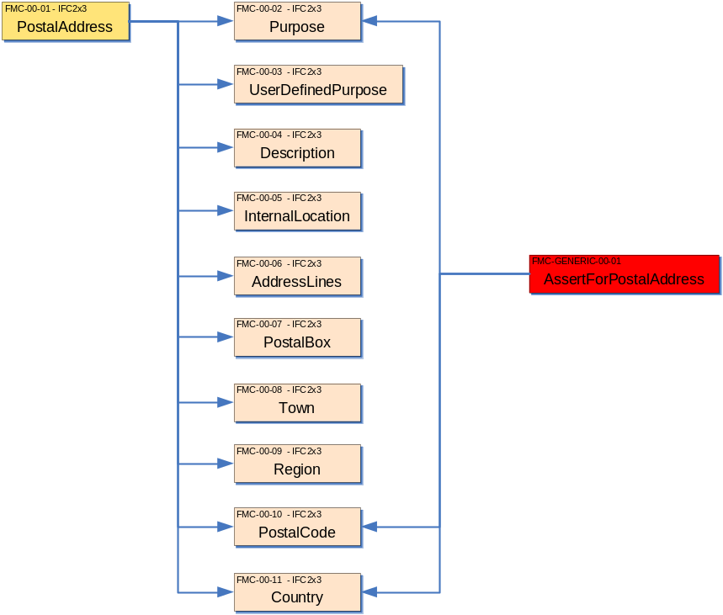

Information Needed | Entity/Pset/Functional Part | MAN | REC | OPT
Select a purpose for which the address is used.  Selection should be from the set of predefined values that describe the place for which the address is given in the context of the actor. This enables selection of HOME,/ OFFICE / SITE / DISTRIBUTIONPOINT. If the required selection is not available, then the value is set to USERDEFINED and the user defined purpose value set (see below) | IfcPostalAddress.Purpose → IfcAddressTypeEnum |  | ✓
Set the address lines that can be used to capture the address point.  Multiple address lines can be used to identify such things as building name, street number and name etc. Particular lines are not specifically set to attributes. Internal conventions within an organization or project may establish such settings. | IfcPostalAddress.AddressLines → IfcLabel |  | ✓
Set the postal code used by the postal authority to uniquely locate an address or group of addresses.  May also be termed zip code. | IfcPostalAddress.PostalCode → IfcLabel |  | ✓
Set a name for the town | IfcPostalAddress.Town → IfcLabel |  | ✓
Set a name for the country | IfcPostalAddress.Country → IfcLabel |  | ✓
The user defined purpose is only asserted if the identified purpose of the address is set to USERDEFINED  Generally, it is expected that the user defined option will be selected since the range of choices given for the address purpose is limited. For normal usage purposes, it is recommended that a standard set of named address purposes are defined and used consistently. | IfcPostalAddress.UserDefinedPurpose → IfcLabel |  |  | ✓
Set an internal location component of the address.  This might include such items as office number, floor number, suite number etc. where a single building utilizes several addresses for postal purposes. An example might be #08-26 meaning office 26 on the 8th floor.  The internal location is always given as a single value. | IfcPostalAddress.InternalLocation → IfcLabel |  |  | ✓
Set a postal box identifier that may be used as an alternative location identifier to the address lines. | IfcPostalAddress.PostalBox → IfcLabel |  |  | ✓
Set a name for the region.  This may be a county, department, state or other regional identifier. Several regional identifiers may be used (county, state) but they should all be included within a single value. | IfcPostalAddress.Region → IfcLabel |  |  | ✓

CONCEPT: TelecommunicationsAddress
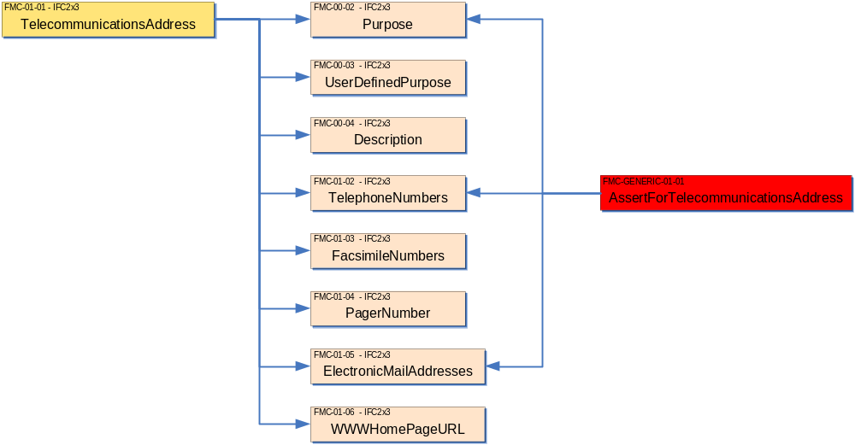

Information Needed | Entity/Pset/Functional Part | MAN | REC | OPT
Set the telephone numbers that may be used for contact purposes.  Multiple numbers can be specified but the type of the telephone number (landline, mobile, VoIP, home, office etc) is not identified. | IfcTelecomAddress.TelephoneNumbers → IfcLabel |  |  | ✓
Set a number for a paging device that may be used. | IfcTelecomAddress.PagerNumber → IfcLabel |  |  | ✓
Set the facsimile (Fax) numbers that may be used for contact purposes.  Multiple numbers can be specified but the type of the number (home, office etc) is not identified. | IfcTelecomAddress.FacsmileNumbers → IfcLabel |  |  | ✓
Set the electronic mail addresses (Email) that may be used for contact purposes.  Multiple addresses can be specified. Each email address must be complete with a fully qualified domain name (as in ‘john.smith@somewhere.good.uk’). The type of the address (home, office etc) is not identified. | IfcTelecomAddress.ElectronicMailAddresses → IfcLabel |  |  | ✓
Set a web address for information. | IfcTelecomAddress.WWWHomePageURL → IfcLabel |  |  | ✓

IFC Entities Required
- IfcAddress
- IfcPostalAddress
- IfcTelecomAddress
IFC Datatypes Required
- IfcAddressTypeEnum
- IfcLabel
- IfcText
IFC Functions Required
- -
IFC Property Sets Required
- -
IDM Functional Parts Required
- -

(ABS)
*IfcAddress
1
*IfcPostalAddress
InternalLocation
IfcLabel
STRING
AddressLines L[1:?]
PostalBox
Town
Region
PostalCode
Country
*IfcTelecomAddress
TelephoneNumbers L[1:?]
FacsimileNumbers L[1:?]
PagerNumber
ElectronicMailAddresses L[1:?]
WWWHomePageURL
Purpose
IfcAddressTypeEnum
Description
IfcText
STRING
UserDefinedPurpose

EXPRESS Schema
SCHEMA FP_ADDRESS;
TYPE IfcAddressTypeEnum = ENUMERATION OF
(OFFICE,
SITE,
HOME,
DISTRIBUTIONPOINT,
USERDEFINED);
END_TYPE;

TYPE IfcLabel = STRING;
END_TYPE;

TYPE IfcText = STRING;
END_TYPE;

ENTITY IfcAddress
ABSTRACT SUPERTYPE OF (ONEOF(IfcPostalAddress, IfcTelecomAddress));
Purpose : OPTIONAL IfcAddressTypeEnum;
Description : OPTIONAL IfcText;
UserDefinedPurpose : OPTIONAL IfcLabel;
WHERE
WR1 : (NOT(EXISTS(Purpose))) OR
((Purpose <> IfcAddressTypeEnum.USERDEFINED) OR
((Purpose = IfcAddressTypeEnum.USERDEFINED) AND
EXISTS(SELF.UserDefinedPurpose)));
END_ENTITY;

ENTITY IfcPostalAddress
SUBTYPE OF(IfcAddress);
InternalLocation : OPTIONAL IfcLabel;
AddressLines : OPTIONAL LIST [1:?] OF IfcLabel;
PostalBox : OPTIONAL IfcLabel;
Town : OPTIONAL IfcLabel;
Region : OPTIONAL IfcLabel;
PostalCode : OPTIONAL IfcLabel;
Country : OPTIONAL IfcLabel;
WHERE
WR1 : EXISTS (InternalLocation) OR
EXISTS (AddressLines) OR
EXISTS (PostalBox) OR
EXISTS (PostalCode) OR
EXISTS (Town) OR
EXISTS (Region) OR
EXISTS (Country);
END_ENTITY;

ENTITY IfcTelecomAddress
SUBTYPE OF(IfcAddress);
TelephoneNumbers : OPTIONAL LIST [1:?] OF IfcLabel;
FacsimileNumbers : OPTIONAL LIST [1:?] OF IfcLabel;
PagerNumber : OPTIONAL IfcLabel;
ElectronicMailAddresses : OPTIONAL LIST [1:?] OF IfcLabel;
WWWHomePageURL : OPTIONAL IfcLabel;
WHERE
WR1 : EXISTS (TelephoneNumbers) OR
EXISTS (PagerNumber) OR
EXISTS (FacsimileNumbers) OR
EXISTS (ElectronicMailAddresses) OR
EXISTS (WWWHomePageURL);
END_ENTITY;

END_SCHEMA;

