Functional Part

Name | Set Organization

Identifier | xxx | IFC Release | IFC 2x3

Change Log
2005-11-15 | Created | jeffrey.wix@aec3.com
2008-02-09 | Concepts added. Examples included. | jdw@aec3.com
Overview
This functional part defines a named and structured grouping that has a corporate identity. It may be used to describe a whole organization such as a company. Alternatively, it may be used to describe a particular unit within an organization such as a division, a department, a working group etc. Additionally, the relationship between organization groupings and with the whole organization can be described.
The Organization concept is used to capture information about a single organization unit including:
- Name (by which it is normally known)
- Identifier (which could be an industrial code or a departmental reference)
- A description that provides further information about the nature of the organization may be given but this is not necessary
- Address(es) at which the organization is located. One or more addresses may be used

The roles played (or filled) by an organization in the project are defined in the ActorRole concept; information includes
- A list of the roles played (one or more roles can be defined)
- A description for each role may be given but this is not necessary

The relationship between units of an organization is determined through the OrganizationRelationship concept in which the information captured includes:
- The parent (or relating) organization unit
- The children (or related) organization units
- The name of the relationship
- A description that provides further information about the nature of the relationship may be given but this is not necessary

For further information concerning address options including postal and telecommunications addresses, refer to the functional part fp_address.
Results
Declares the existence of an organization, its location(s) and the role(s) it plays on a project

CONCEPT: Organization

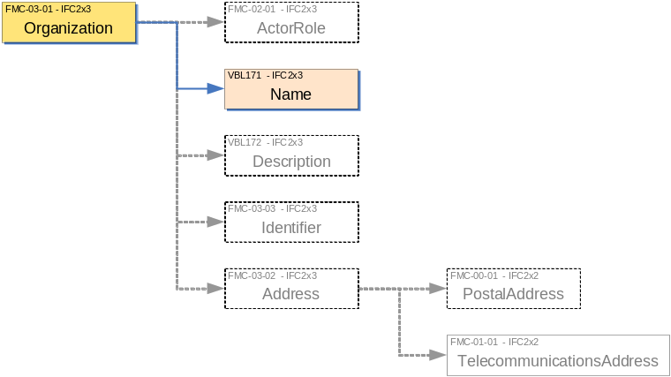

Description | Entity/Pset/Functional Part | MAN | REC | OPT
Set the organization name | IfcOrganization.Name → IfcLabel | ✓
Provide a description about the nature of the organization | IfcOrganization.Description → IfcText |  |  | ✓
Set an identifier for the organization | IfcOrganization.Id → IfcIdentifier |  |  | ✓
Identify the address(es) at which the organization is located | IfcOrganization.Addresses → fp_address |  | ✓
Assign the role(s) to the organization | IfcOrganization.Roles → IfcActorRole |  | ✓

CONCEPT: ActorRole

Description | Entity/Pset/Functional Part | MAN | REC | OPT
Set the name of the role being played.  A predefined list of possible role names is provided. Selection can be from this list or a user defined role selected. | IfcActorRole.Role → IfcRoleEnum | ✓
Set the name of the user defined role  If a user defined role is selected from the previous step, then a name must be assigned by the user to the role. This is enforced by a WHERE rule. | IfcActorRole.UserDefinedRole → IfcLabel |  |  | ✓
Provide a description about the role | IfcActorRole.Description → IfcText |  |  | ✓
Assign the role(s) to the organization | IfcOrganization.Roles → IfcActorRole |  | ✓

CONCEPT: OrganizationRelationship

Description | Entity/Pset/Functional Part | MAN | REC | OPT
Determine the organization that will act as the parent in the hierarchy | IfcOrganizationRelationship.RelatingOrganization → IfcOrganization | ✓
Determine the organization(s) that will act as the child(ren) in the hierarchy | IfcOrganizationRelationship.RelatedOrganizations → IfcOrganization | ✓
Set the organization relationship name | IfcOrganizationRelationship.Name → IfcLabel | ✓
Provide a description about the nature of the organizational relationship | IfcOrganizationRelationship.Description → IfcText |  |  | ✓

IFC Entities Required
- IfcActorRole
- IfcOrganization
- IfcOrganizationRelationship
IFC Datatypes Required
- IfcIdentifier
- IfcLabel
- IfcRoleEnum
- IfcText
IFC Functions Required
- -
IFC Property Sets Required
- -
IDM Functional Parts Required
- fp_address

IfcOrganization
Id
Name
Description
Roles L[1:?]
*
IfcActorRole
Role
IfcRoleEnum
UserDefinedRole
Description
Addresses L[1:?]
(INV) OfOrganization S[0:?]
(INV) IsRelatedBy S[0:?]
_
RelatedOrganizations S{1:?]
IfcOrganizationRelationship
Name
Description
_
RelatingOrganization
(INV) Relates S[0:?]
fp_address
to IfcAddress
EXPRESS Schema
SCHEMA FP_SET_ORGANIZATION;
TYPE IfcRoleEnum = ENUMERATION OF
(SUPPLIER,
MANUFACTURER,
CONTRACTOR,
SUBCONTRACTOR,
ARCHITECT,
STRUCTURALENGINEER,
COSTENGINEER,
CLIENT,
BUILDINGOWNER,
BUILDINGOPERATOR,
MECHANICALENGINEER,
ELECTRICALENGINEER,
PROJECTMANAGER,
FACILITIESMANAGER,
CIVILENGINEER,
COMISSIONINGENGINEER,
ENGINEER,
OWNER,
CONSULTANT,
CONSTRUCTIONMANAGER,
FIELDCONSTRUCTIONMANAGER,
RESELLER,
USERDEFINED);
END_TYPE;

TYPE IfcLabel = STRING;
END_TYPE;

TYPE IfcIdentifier = STRING;
END_TYPE;

TYPE IfcText = STRING;
END_TYPE;

ENTITY IfcOrganization;
Id : OPTIONAL IfcIdentifier;
Name : IfcLabel;
Description : OPTIONAL IfcText;
Roles : OPTIONAL LIST [1:?] OF IfcActorRole;
Addresses : OPTIONAL LIST [1:?] OF fp_address;
INVERSE
IsRelatedBy : SET OF IfcOrganizationRelationship FOR RelatedOrganizations;
Relates : SET OF IfcOrganizationRelationship FOR RelatingOrganization;
END_ENTITY;

(* inverse from IfcPersonAndOrganization omitted in Conceptual Part *)

ENTITY IfcActorRole;
Role : IfcRoleEnum;
UserDefinedRole : OPTIONAL IfcLabel;
Description : OPTIONAL IfcText;
WHERE
WR1 : (Role <> IfcRoleEnum.USERDEFINED) OR
((Role = IfcRoleEnum.USERDEFINED) AND
EXISTS(SELF.UserDefinedRole));
END_ENTITY;

ENTITY IfcOrganizationRelationship;
Name : IfcLabel;
Description : OPTIONAL IfcText;
RelatingOrganization : IfcOrganization;
RelatedOrganizations : SET [1:?] OF IfcOrganization;
END_ENTITY;

ENTITY fp_address;
INVERSE
OfOrganization : SET OF IfcOrganization FOR Addresses;
END_ENTITY;

END_SCHEMA;
Examples of Organization
Example 1: Setting the Organization Name and Role
This example identifies ACE Construction, an organization that describes itself as a leading construction company. It will play the role of contractor on the project based on its office whose postal address is PO Box 9999, Thatcham, Berkshire RG18 99ZZ, UK.

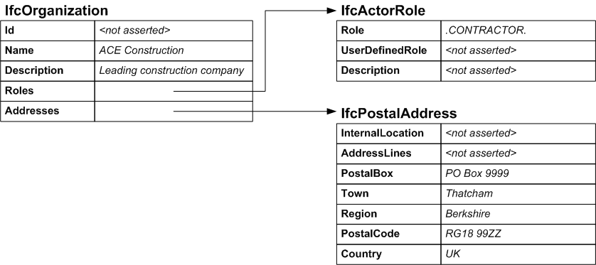

/* identifying the organization */
#100=IFCORGANIZATION($,’ACE Construction’,’Leading construction company’,(#200),(#300);

/* specifying the role of the organization */
#200=IFCACTORROLE(.CONTRACTOR.,$,$);

/* the postal address of the organization*/
#300=IFCPOSTALADDRESS($,$,’PO Box 9999’,’Thatcham’,’Berkshire’,’RG18 99ZZ’,’UK’);

Example 2: Establishing the Organization Relationship
In this example, the planning and construction departments of ACE Construction are identified within the organization hierarchy for the project. Each department is located at the same address as the parent. Note that, in this case, roles are not asserted for the departments.

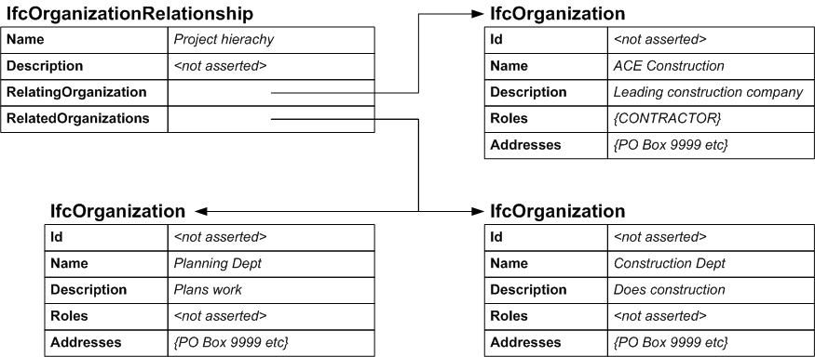

/* identifying the organization */
#100=IFCORGANIZATION($,’ACE Construction’,’Leading construction company’,(#200),(#300));
#101=IFCORGANIZATION($,’Planning Dept’,$,$,(#300));
#102=IFCORGANIZATION($,’Construction Dept’,$,$,(#300));

/* specifying the role of the organization */
#200=IFCACTORROLE(.CONTRACTOR.,$,$);

/* the postal address of the organization*/
#300=IFCPOSTALADDRESS($,$,’PO Box 9999’,’Thatcham’,’Berkshire’,’RG18 99ZZ’,’UK’);

/* establishing the organization hierarchy */
#400=IFCORGANIZATIONRELATIONSHIP(‘Project hierachy’,$,#100,(#101,#102));

