Functional Part

Name | Set Person

Identifier | xxx | IFC Release | IFC 2x3

Change Log
2008-02-09 | Created | jdw@aec3.com

Overview

This functional part defines a named person that will be an actor on the project and the roles that he/she will play or fulfil on the project.

The Person concept is used to capture information about a single person including:
- Name (by which he/she is normally known)
- Identifier (which could be a social security number or driving licence identifier)
- A description that provides further information about the person may be given but this is not necessary
- Address(es) at which the person is located. One or more addresses may be used

The roles played (or filled) by a person in the project are defined in the ActorRole concept; information includes
- A list of the roles played (one or more roles can be defined)
- A description for each role may be given but this is not necessary

For further information concerning address options including postal and telecommunications addresses, refer to the functional part fp_address.

Results

Declares the existence of a person, his/her location(s) and the role(s) played on a project

CONCEPT: Person

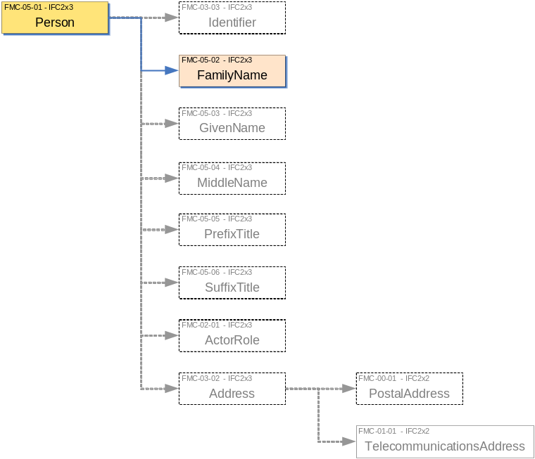

Description | Entity/Pset/Functional Part | MAN | REC | OPT
Set an identifier for the person | IfcPerson.Id → IfcIdentifier |  |  | ✓
Set the family name of the person | IfcPerson.FamilyName → IfcLabel | ✓
Set the given name of the person | IfcPerson.GivenName → IfcLabel |  |  | ✓
Set the middle names of the person | IfcPerson.MiddleNames → IfcLabel |  |  | ✓
Set the prefix titles of the person  Prefix titles are items such as Mr., Mrs., Dr., etc. | IfcPerson.PrefixTitles → IfcLabel |  |  | ✓
Set the suffix titles of the person  Suffix titles are items such as qualifications e.g. B.Sc., Ph.D.,C.Eng., institutional memberships e.g. MASHRAE etc. | IfcPerson.SuffixTitles → IfcLabel |  |  | ✓
Identify the address(es) at which the person is located | IfcPerson.Addresses → fp_address |  | ✓
Assign the role(s) to the person | IfcPerson.Roles → IfcActorRole |  | ✓

CONCEPT: ActorRole
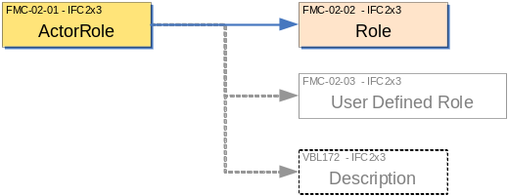

Description | Entity/Pset/Functional Part | MAN | REC | OPT
Set the name of the role being played.  A predefined list of possible role names is provided. Selection can be from this list or a user defined role selected. | IfcActorRole.Role → IfcRoleEnum | ✓
Set the name of the user defined role  If a user defined role is selected from the previous step, then a name must be assigned by the user to the role. This is enforced by a WHERE rule. | IfcActorRole.UserDefinedRole → IfcLabel |  |  | ✓
Provide a description about the role | IfcActorRole.Description → IfcText |  |  | ✓
Assign the role(s) to the person | IfcPerson.Roles → IfcActorRole |  | ✓

IFC Entities Required
- IfcActorRole
- IfcPerson

IFC Datatypes Required
- IfcIdentifier
- IfcLabel
- IfcRoleEnum
- IfcText

IFC Functions Required
- -

IFC Property Sets Required
- -

IDM Functional Parts Required
- fp_address

EXPRESS Schema
SCHEMA FP_SET_PERSON;
*IfcActorRole
Role
IfcRoleEnum
UserDefinedRole
Description
*IfcPerson
Id
FamilyName
GivenName
MiddleNames L[1:?]
PrefixTitles L[1:?]
SuffixTitles L[1:?]
Roles L[1:?]
TYPE IfcRoleEnum = ENUMERATION OF
(SUPPLIER,
MANUFACTURER,
CONTRACTOR,
SUBCONTRACTOR,
ARCHITECT,
STRUCTURALENGINEER,
COSTENGINEER,
CLIENT,
BUILDINGOWNER,
BUILDINGOPERATOR,
MECHANICALENGINEER,
ELECTRICALENGINEER,
PROJECTMANAGER,
FACILITIESMANAGER,
CIVILENGINEER,
COMISSIONINGENGINEER,
ENGINEER,
OWNER,
CONSULTANT,
CONSTRUCTIONMANAGER,
FIELDCONSTRUCTIONMANAGER,
RESELLER,
USERDEFINED);
END_TYPE;

TYPE IfcLabel = STRING;
END_TYPE;

TYPE IfcIdentifier = STRING;
END_TYPE;

TYPE IfcText = STRING;
END_TYPE;

ENTITY IfcPerson;
Id : OPTIONAL IfcIdentifier;
FamilyName : OPTIONAL IfcLabel;
GivenName : OPTIONAL IfcLabel;
MiddleNames : OPTIONAL LIST [1:?] OF IfcLabel;
PrefixTitles : OPTIONAL LIST [1:?] OF IfcLabel;
SuffixTitles : OPTIONAL LIST [1:?] OF IfcLabel;
Roles : OPTIONAL LIST [1:?] OF IfcActorRole;
Addresses : OPTIONAL LIST [1:?] OF fp_address;

END_ENTITY;

(* inverse from IFC omitted in Conceptual Part *)

ENTITY IfcActorRole;
Role : IfcRoleEnum;
UserDefinedRole : OPTIONAL IfcLabel;
Description : OPTIONAL IfcText;
WHERE
WR1 : (Role <> IfcRoleEnum.USERDEFINED) OR
((Role = IfcRoleEnum.USERDEFINED) AND
EXISTS(SELF.UserDefinedRole));
END_ENTITY;

ENTITY fp_set_address;
INVERSE
OfPerson : SET OF IfcPerson FOR Addresses;
END_ENTITY;

END_SCHEMA;

Examples of Organization

Example 1: Setting the Person Name and Role

This example identifies Dr. Keith Michel Manuel Witherspoon B.Sc. MASHRAE, a fictitious person. He will play the user defined role of expert geological specialist on the project . He is personally based at PO Box 9999, Thatcham, Berkshire RG18 99ZZ, UK.

/* identifying the person */
#100=IFCPERSON($,’Witherspoon’,’Keith’,(‘Michel’,’Manuel’),(‘Dr’),(‘B.Sc’,’MASHRAE’),(#200),(#300);

/* specifying the role of the person */
#200=IFCACTORROLE(.USERDEFINED.,’EXPERT’,’Geological specialist’);

/* the postal address of the person */
#300=IFCPOSTALADDRESS($,$,’PO Box 9999’,’Thatcham’,’Berkshire’,’RG18 99ZZ’,’UK’);

