Functional Part

Name | Set Person And Organization

Identifier | xxx | IFC Release | IFC 2x3

Change Log
2008-02-10 | Created | jdw@aec3.com

Overview

This functional part defines a combination of named person and a named organization as an actor on the project and the roles that this combination actor will play or fulfil on the project.

The PersonAndOrganization concept is used simply to capture the relationship between a person and an organization:
- The person
- The organization

The roles played (or filled) by the person and organization relationship in the project are defined in the ActorRole concept; information includes
- A list of the roles played (one or more roles can be defined)
- A description for each role may be given but this is not necessary

Results

Declares the existence of a person, his/her location(s) and the role(s) played on a project

CONCEPT: PersonAndOrganization

The concept PersonAndOrganization is used to identify the relationship between a person and an organization.

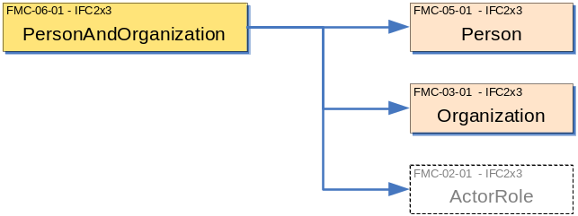

Description | Entity/Pset/Functional Part | MAN | REC | OPT
Specify the person in the person/organization relationship  See also fp_set_person | IfcPersonAndOrganization.ThePerson → IfcPerson | ✓
Specify the organization in the person/organization relationship  See also fp_set_organization | IfcPersonAndOrganization.TheOrganization → IfcOrganization | ✓

CONCEPT: ActorRole

The ActorRole concept identifies the roles that may be held by an organization and a person acting in common.

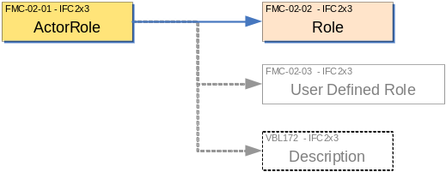

Description | Entity/Pset/Functional Part | MAN | REC | OPT
Set the name of the role being played.  A predefined list of possible role names is provided. Selection can be from this list or a user defined role selected. | IfcActorRole.Role → IfcRoleEnum | ✓
Set the name of the user defined role  If a user defined role is selected from the previous step, then a name must be assigned by the user to the role. This is enforced by a WHERE rule. | IfcActorRole.UserDefinedRole → IfcLabel |  |  | ✓
Provide a description about the role | IfcActorRole.Description → IfcText |  |  | ✓
Assign the role(s) to the person/organization | IfcPersonAndOrganization.Roles → IfcActorRole |  | ✓

IFC Entities Required
- IfcActorRole
- IfcOrganization
- IfcPerson
- IfcPersonAndOrganization

IFC Datatypes Required
- IfcIdentifier
- IfcLabel
- IfcRoleEnum
- IfcText

IFC Functions Required
- -

IFC Property Sets Required
- -

IDM Functional Parts Required
- fp_set_person
- fp_set_organization

IfcOrganization
(fp_set_organization)
*IfcActorRole
Role
IfcRoleEnum
UserDefinedRole
Description
*IfcPerson
(fp_set_person)
(INV) EngagedIn S[0:?]
ThePerson
IfcPersonAnd
Organization
TheOrganization
(INV) Engages S[0:?]
Roles L[1:?]
*

EXPRESS Schema
SCHEMA FP_SET_PERSON;
TYPE IfcRoleEnum = ENUMERATION OF
(SUPPLIER,
MANUFACTURER,
CONTRACTOR,
SUBCONTRACTOR,
ARCHITECT,
STRUCTURALENGINEER,
COSTENGINEER,
CLIENT,
BUILDINGOWNER,
BUILDINGOPERATOR,
MECHANICALENGINEER,
ELECTRICALENGINEER,
PROJECTMANAGER,
FACILITIESMANAGER,
CIVILENGINEER,
COMISSIONINGENGINEER,
ENGINEER,
OWNER,
CONSULTANT,
CONSTRUCTIONMANAGER,
FIELDCONSTRUCTIONMANAGER,
RESELLER,
USERDEFINED);
END_TYPE;

TYPE IfcLabel = STRING;
END_TYPE;

TYPE IfcIdentifier = STRING;
END_TYPE;

TYPE IfcText = STRING;
END_TYPE;

ENTITY IfcOrganization;
Id : OPTIONAL IfcIdentifier;
Name : IfcLabel;
Description : OPTIONAL IfcText;
Roles : OPTIONAL LIST [1:?] OF IfcActorRole;
Addresses : OPTIONAL LIST [1:?] OF fp_address;
INVERSE
IsRelatedBy : SET OF IfcOrganizationRelationship FOR RelatedOrganizations;
Relates : SET OF IfcOrganizationRelationship FOR RelatingOrganization;
Engages : SET OF IfcPersonAndOrganization FOR TheOrganization;
END_ENTITY;

ENTITY IfcPerson;
Id : OPTIONAL IfcIdentifier;
FamilyName : OPTIONAL IfcLabel;
GivenName : OPTIONAL IfcLabel;
MiddleNames : OPTIONAL LIST [1:?] OF IfcLabel;
PrefixTitles : OPTIONAL LIST [1:?] OF IfcLabel;
SuffixTitles : OPTIONAL LIST [1:?] OF IfcLabel;
Roles : OPTIONAL LIST [1:?] OF IfcActorRole;
Addresses : OPTIONAL LIST [1:?] OF fp_address;
INVERSE
EngagedIn : SET OF IfcPersonAndOrganization FOR ThePerson;
WHERE
WR1 : EXISTS(FamilyName) OR EXISTS(GivenName);

END_ENTITY;

ENTITY IfcPersonAndOrganization;
ThePerson : IfcPerson;
TheOrganization : IfcOrganization;
Roles : OPTIONAL LIST [1:?] OF IfcActorRole;
END_ENTITY;

ENTITY IfcActorRole;
Role : IfcRoleEnum;
UserDefinedRole : OPTIONAL IfcLabel;
Description : OPTIONAL IfcText;
WHERE
WR1 : (Role <> IfcRoleEnum.USERDEFINED) OR
((Role = IfcRoleEnum.USERDEFINED) AND
EXISTS(SELF.UserDefinedRole));
END_ENTITY;

ENTITY fp_set_person;
END_ENTITY;

ENTITY fp_set_organization;
END_ENTITY;

END_SCHEMA;

