**숙박 WebSite 만들기**

main.html

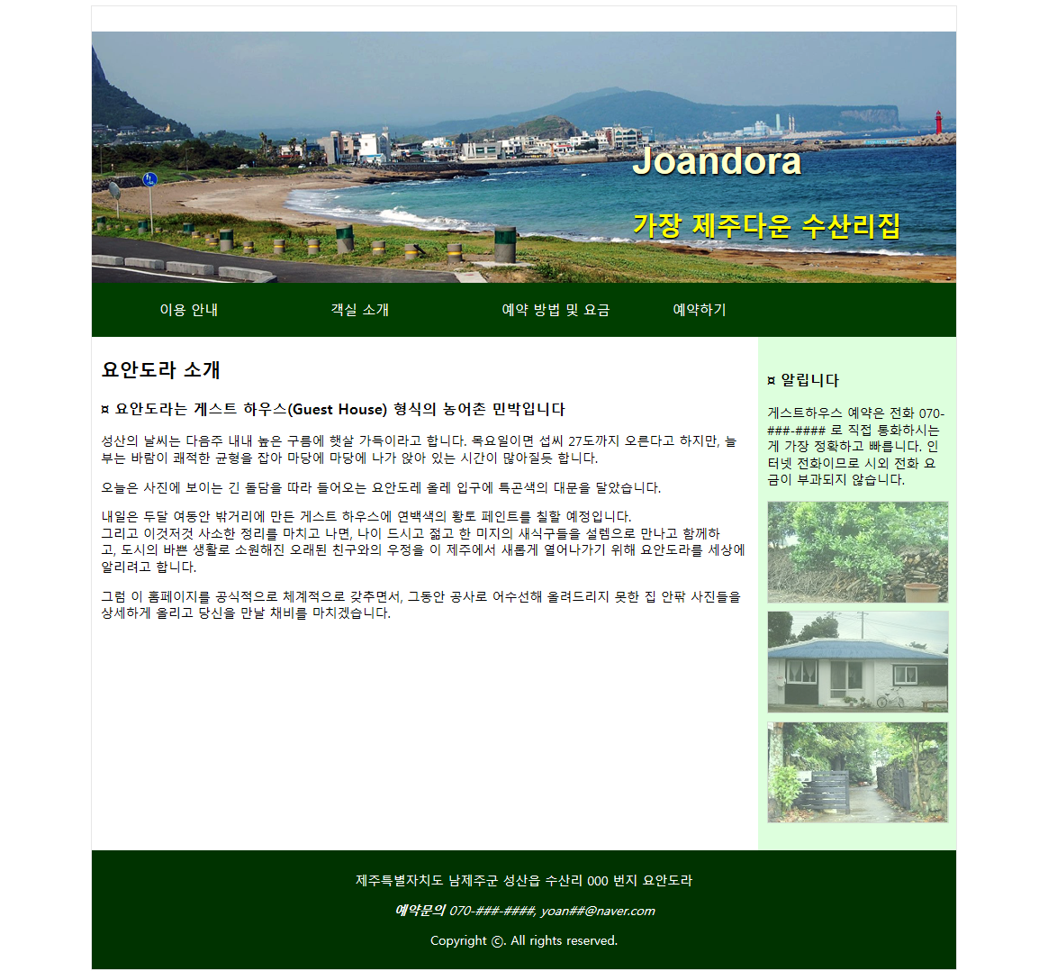

style.css

|  |
| --- |
| @charset *"utf-8"*;  **body** {  font: *14px* *맑은* *고딕*;  }  **a** **img** {  border: *none*;  }  **a***:link* {  color: *#42413C*;  }  **a***:visited* {    }  **a***:hover***,** **a***:active***,** **a***:focus* {  }  *.container* {  width: *960px*;  margin : *0* *auto*;  background-color:*#fff*;  border:*1px* *solid* *#E7E7E7*  }  **header** {    }  **header** **hgroup**{  }  **hgroup** **h1**{    **hgroup** **h2**{  font-size:*2em*;  color:*#FF0*;  text-shadow:*0px* *1px* *1px* *#000*;  }  **h1** {  font-family: *Arial,* *Helvetica,* *sans-serif*;  }  **h4** {  text-size:*12px*;  color:*#FF3300*;  }  *.navi*{  background:*#003E00*;  margin-top:*-15px*;  width:*960px*;  height:*60px*;  }  *.navi* **ul**{  list-style: *none*;  height:*40px*;  padding-top:*10px*;  padding-bottom:*5px*;  }  *.navi* **ul** **li** {    font-size:*15px*;  }  *.navi* **a,** *.navi* **a***:visited* {  padding: *10px* *5px* *5px* *35px*;  color:*#fff*;  width: *150px*;  text-decoration: *none*;  }  *.navi* **a***:hover***,** *.navi* **a***:active***,** *.navi* **a***:focus* {  text-shadow:*0px* *2px* *2px* *#000*;  color:*#FC0*;  }  *.sidebar1* {  width: *200px*;  height:*550px*;  background-color:*#DFD*;  padding-top:*20px*;  padding-left:*10px*;  padding-right:*10px*;  }  *.sidebar1* **img** {    }  *.sidebar1* **img***:hover*{    }  *.content* {  width: *720px*;  }  **footer** {  padding: *10px* *0*;  background-color:*#030*;  color:*#fff*;    }  **header,** **section,** **footer,** **aside,** **article,** **figure** {    }  *.banner* {  margin: *0* *10px* *15px* *10px*;  padding:*0*;  } |

이용안내(desk.html)

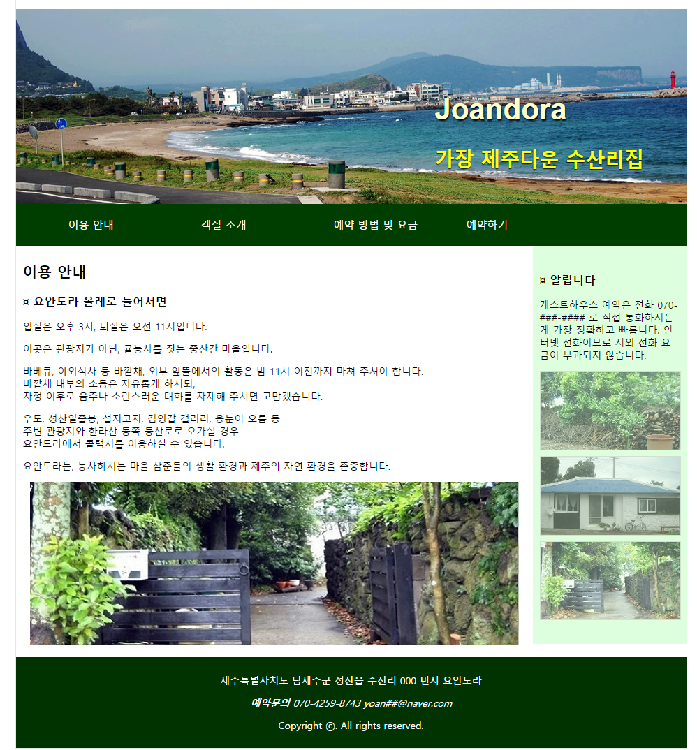

|  |
| --- |
| <!doctype html>  <html>  <head>  <meta charset=*"utf-8"*>  <title>요안도라</title>  </head>  <body>  <div class=*"container"*>    </div>  </body>  </html> |

객실소개(room.html)

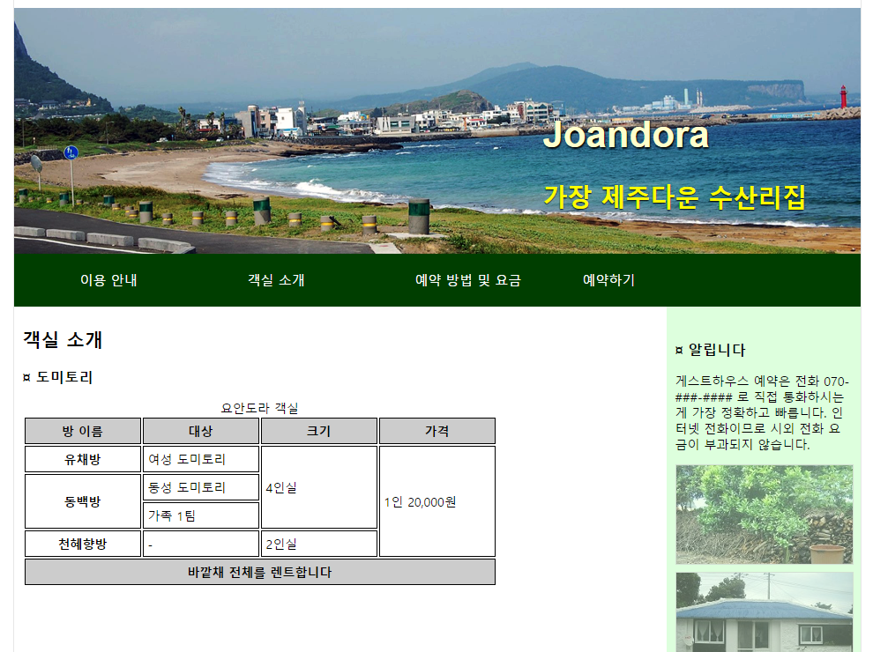



|  |
| --- |
| <!doctype html>  <html>  <head>  <meta charset=*"utf-8"*>  <title>요안도라</title>  <link href=*"style.css"* rel=*"stylesheet"* type=*"text/css>*  </head>  <body>  <div class=*"container"*>    </div>  </body>  </html> |