📱 09 · Low-Fidelity & High-Level (Hi-Fi) Interactive Prototypes
ReRouteHer — AI-Powered Skill Readiness & Career Re-entry Platform
Course / Team Code: 5120-TM07
Figma Canvas: https://www.figma.com/design/wwl5kUAg2RJF8anRURdf1n/5120-TM07
Live Interactive Prototype: https://prototype.curl.my/
GitHub Repositories: ryus0006/rerouteher-ui & ncm233/reroutehers-prototype

1. Executive Summary & Prototyping Objectives
Returning to formal employment after a prolonged caregiving career break is fraught with severe emotional and cognitive hurdles: returners frequently experience imposter syndrome, struggle to articulate their transferable capabilities, and encounter a "wall of 20+ overwhelming job requirements" on traditional job boards.
ReRouteHer addresses this gap through an empathy-led, data-backed career re-entry readiness engine. The prototyping phase followed an iterative double-diamond design lifecycle, progressing from conceptual low-fidelity (Lo-Fi) structural wireframes to a high-level, interactive high-fidelity (Hi-Fi) prototype.
2. Low-Fidelity (Lo-Fi) Prototypes & Wireframe Architecture
2.1 Design Rationale & Information Hierarchy
The initial low-fidelity wireframes established the foundational four-step sequential journey, deliberately stripping away visual embellishments to validate three core design hypotheses:
- Zero-Friction Intake: Eliminating multi-page tedious questionnaires in favor of an automated 2-step input (CV document parsing + natural language career break description).
- Reflective vs. Exploratory Separation: Separating the historical baseline (Skill Snapshot — where she is coming from) from the aspirational target (Target Role & Gap — where she wants to aim).
- Anti-Overwhelm Focus: Guaranteeing a strict maximum cap of 3 actionable focus areas, replacing demoralizing comprehensive requirement checklists.
2.2 Screen-by-Screen Lo-Fi Breakdown
Stage | Lo-Fi Screen Name | Key Functional Modules & Layout Strategy | User Experience Intent
01 | Landing Page | • Minimalist top navigation with brand mark  • Hero header with bold value proposition  • Prominent primary CTA button ('Start Your Journey')  • 3-column value cards (Break Experience, Weighted Score, Top 3 Focus) | Instills immediate confidence and sets clear expectations of zero manual friction.
02 | Profile & Experience Intake | • Drag-and-drop CV upload dropzone (PDF/DOCX)  • Duration selector (0.5 to 15 years)  • Free-text multi-line textarea with example suggestion chips | Bypasses repetitive form fields, allowing returners to express real-world experiences in their own words.
03 | Baseline Skill Snapshot | • Non-locking 'Background Baseline' header  • Two-column skill container: Extracted CV Skills vs. Reframed Break Skills  • O*NET crosswalk indicator badge | Validates both professional achievements and caregiving competencies on an equal footing.
04 | Target Role & Gap Analysis | • Interactive target role selector tabs  • Semicircular readiness gauge displaying current baseline %  • Capped Top 3 focus areas with projected readiness boost tags  • 'Explore Upskilling Paths' CTA | Replaces failure anxiety with an actionable, bite-sized growth plan.

3. High-Fidelity (Hi-Fi) Interactive Prototype (Direct Prototype Captures)
The high-fidelity prototype transforms the validated wireframes into a soothing, empowering, state-of-the-art interactive web application. Below are direct, unedited high-resolution captures of the live prototype implementation.
3.1 Design System & Visual Tokens
Token Name | Hex Code | Tailwind / CSS Var | Semantics & Psychological Function
Primary Blush Pink | #DE8BA8 | --pink-500 | Metamorphosis, empathy, primary gradient CTA button
Soft Lavender | #B4A2D4 | --violet-400 | Transmutation, cognitive calming, ethereal depth
Periwinkle Blue | #7E92CA | --blue-600 | Trust, professional stability, technical skill tags
Mint Green | #337857 | --mint-600 | O*NET validated break achievements, high confidence badge
Amber Gold | #96540D | --amber-700 | Priority focus area uplift badges (+% gain)
Midnight Ink | #262B4A | --ink | High-contrast primary typography & UI structure
Frosted Canvas | #FCF8FA | --grad-soft | Multi-stop ethereal soft gradient page background

3.2 Direct Screen Captures & Interactive Specifications
Screen 1 · Landing Page (E1)
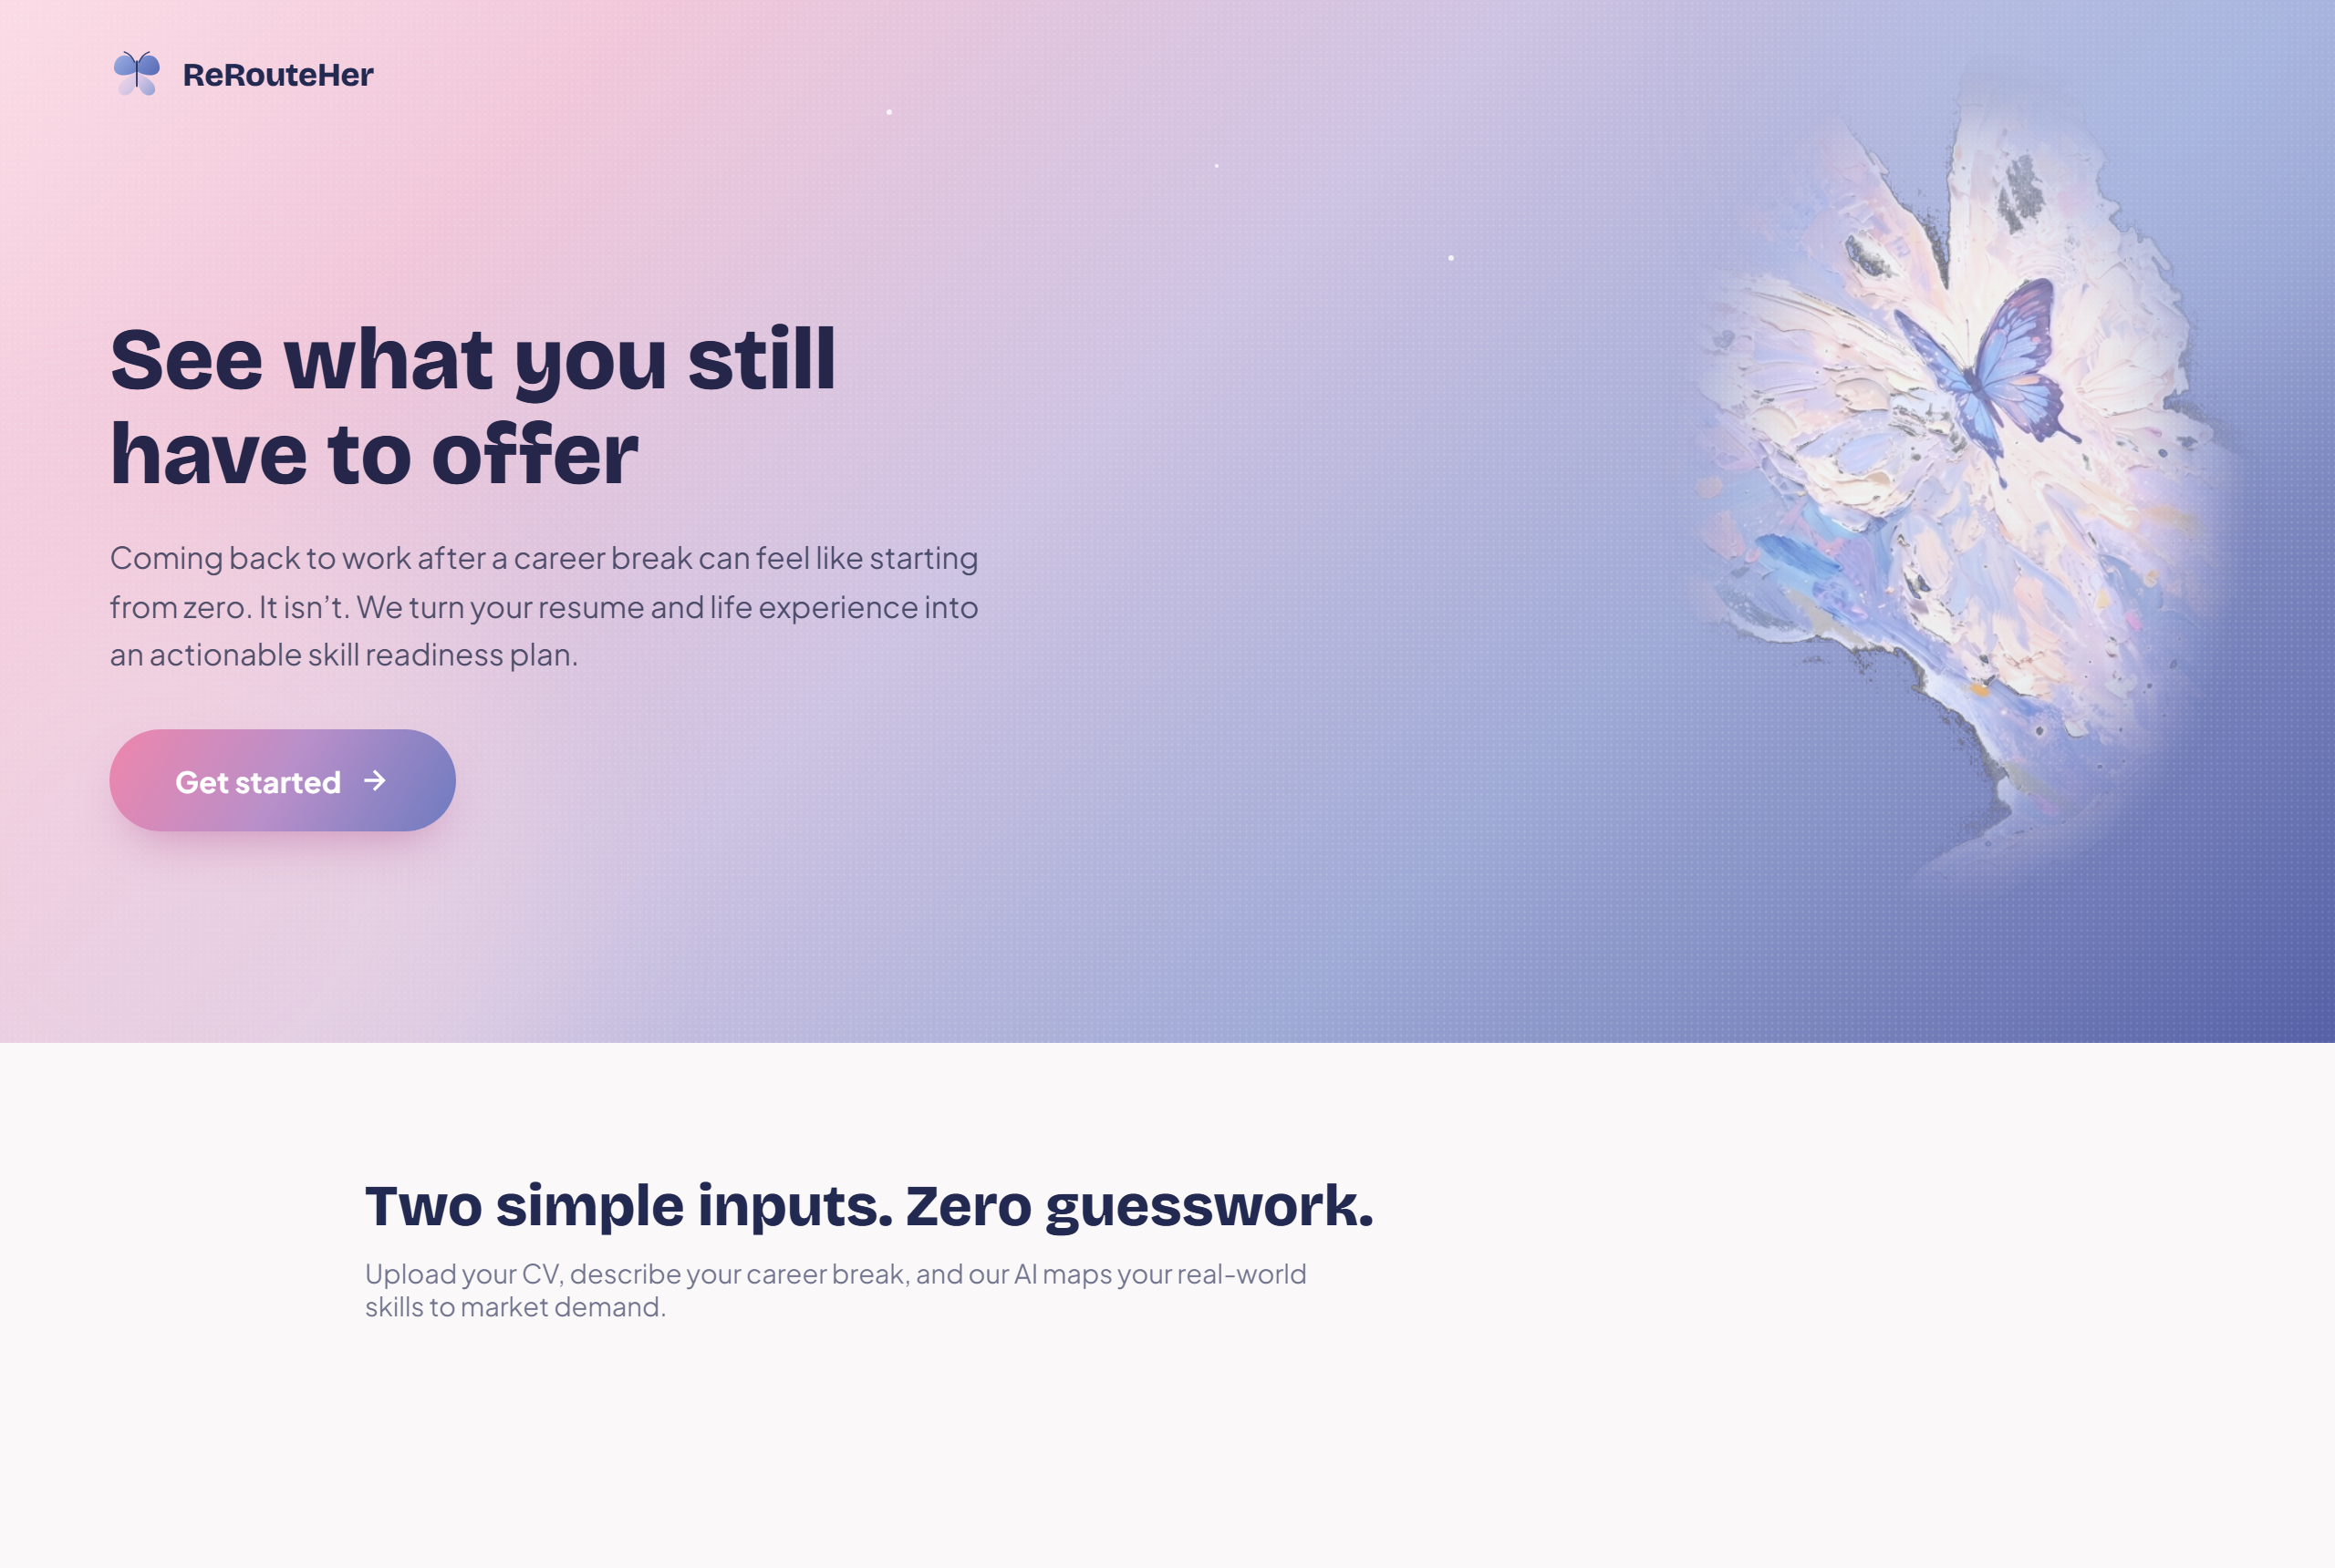
Figure 1: Direct Capture — ReRouteHer Landing Page (E1) with Hero Butterfly Artwork & 3-Step Journey Rail
- Hero Artwork: Ethereal multi-layered butterfly oil painting with radial alpha-mask gradient blending (85% opacity).
- Journey Rail: 3-step interactive visual progress stepper (Upload CV ➔ Describe Break ➔ See Fit & Top Gaps).
- Parallax Dynamics: Smooth GSAP orbital physics and soft floating star highlights.
Screen 2a · Step 1: Upload CV (E2a)
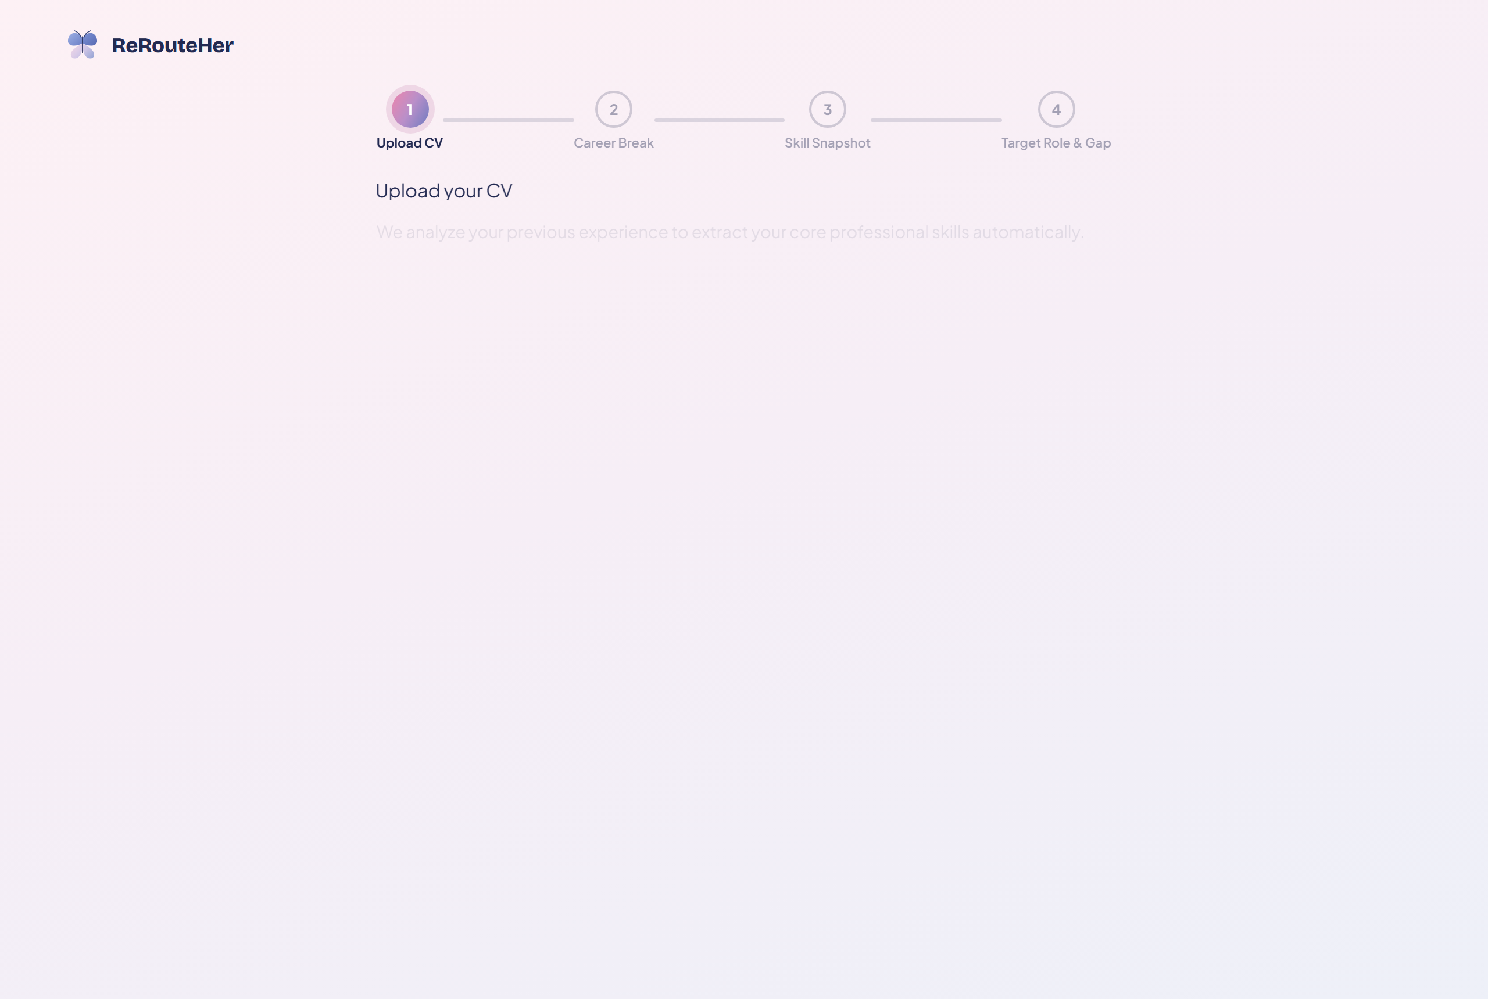
Figure 2: Direct Capture — Step 1: Upload CV (E2a) Drag-and-Drop Dropzone & Sample Resumes
- File Dropzone: Drag-and-drop file upload supporting .pdf and .docx (up to 10MB) with instant client-side verification.
- 1-Click Sample CV Loaders: Pre-configured analyst and designer sample resumes for immediate friction-free evaluation.
Screen 2b · Step 2: Career Break Intake (E2b)
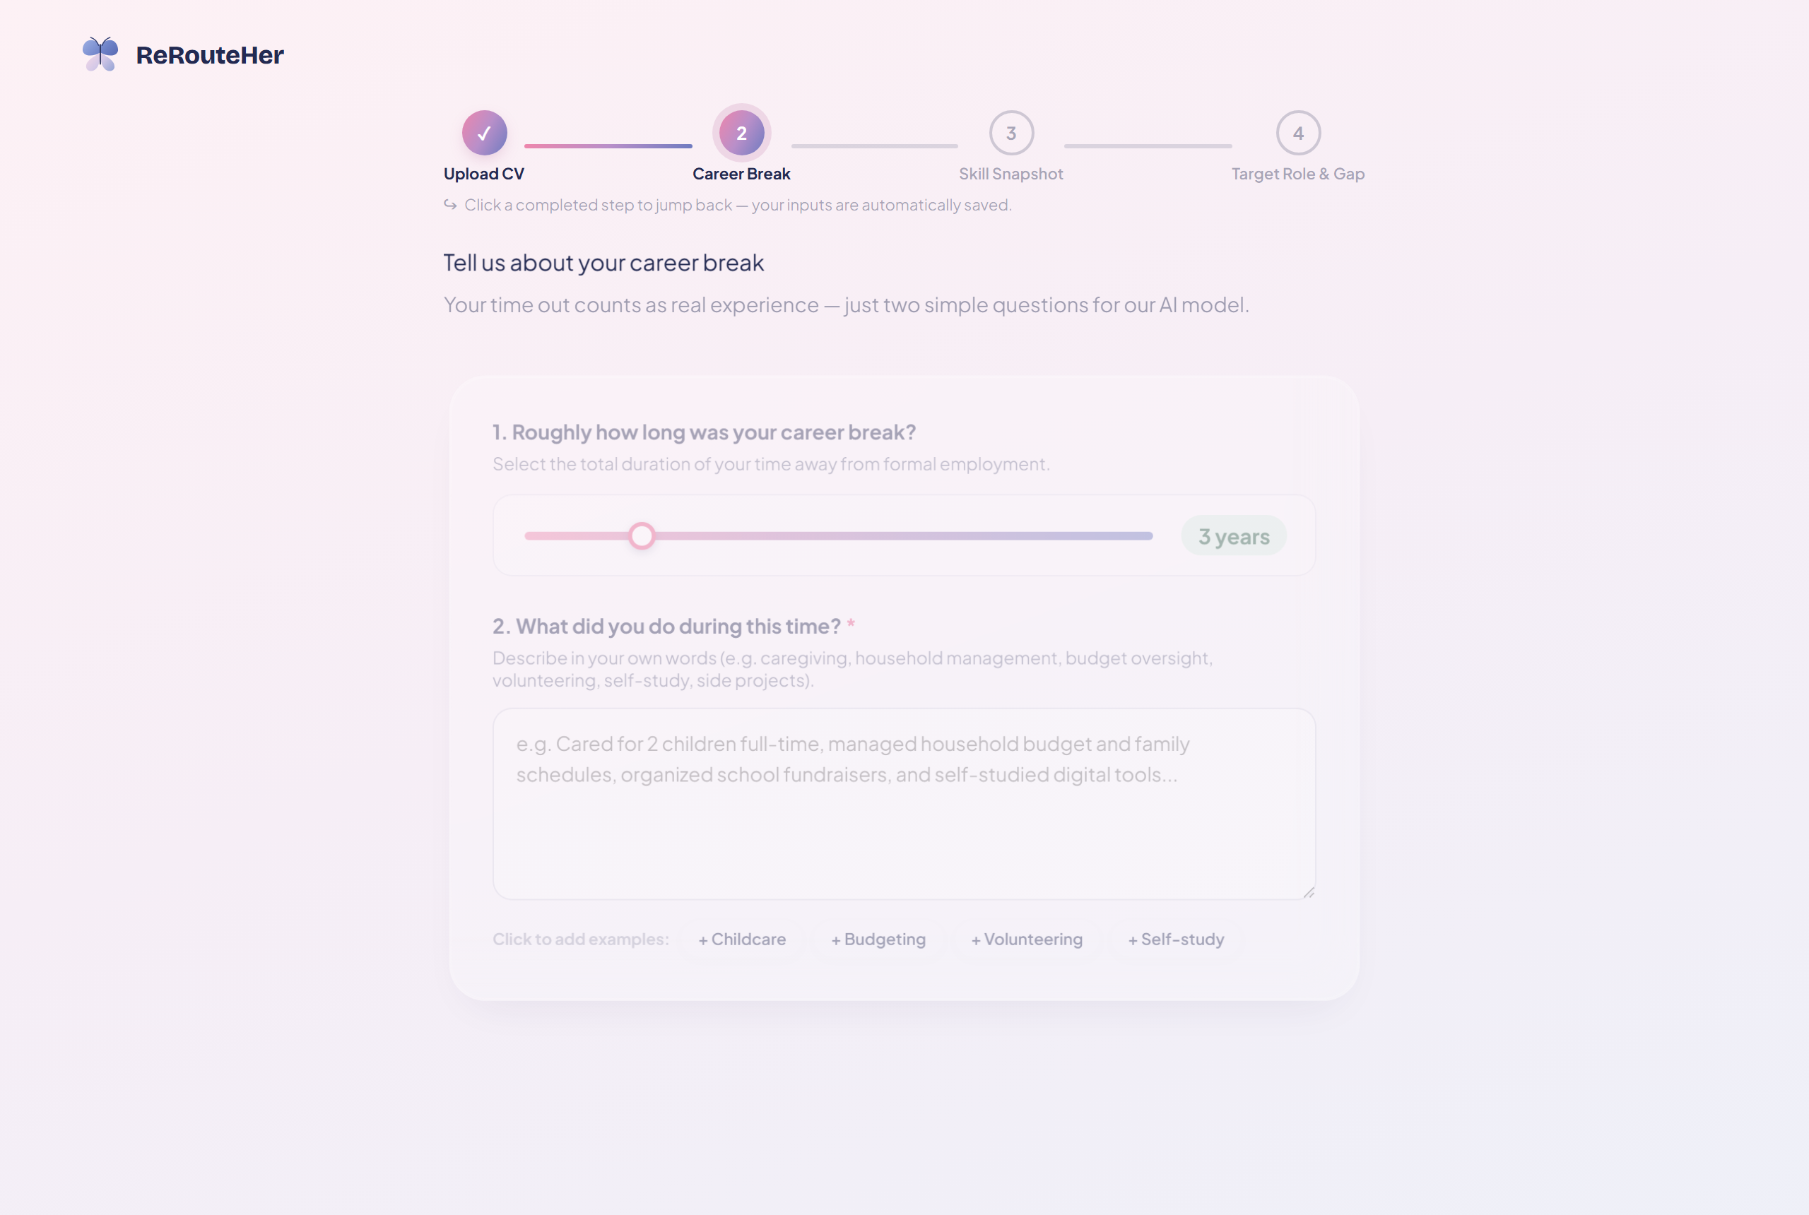
Figure 3: Direct Capture — Step 2: Career Break Intake (E2b) Duration Slider & Natural Language Textarea
- Duration Slider: Intuitive range slider (0.5 to 15 years) with dynamic mint tag preview.
- Natural Language Textarea: Free-text input capturing caregiving, budgeting, volunteering, and self-study, accompanied by 4 one-tap example tags (+Childcare, +Budgeting, +Volunteering, +Self-study).
Screen 3 · Step 3: Skill Snapshot Baseline (E3)
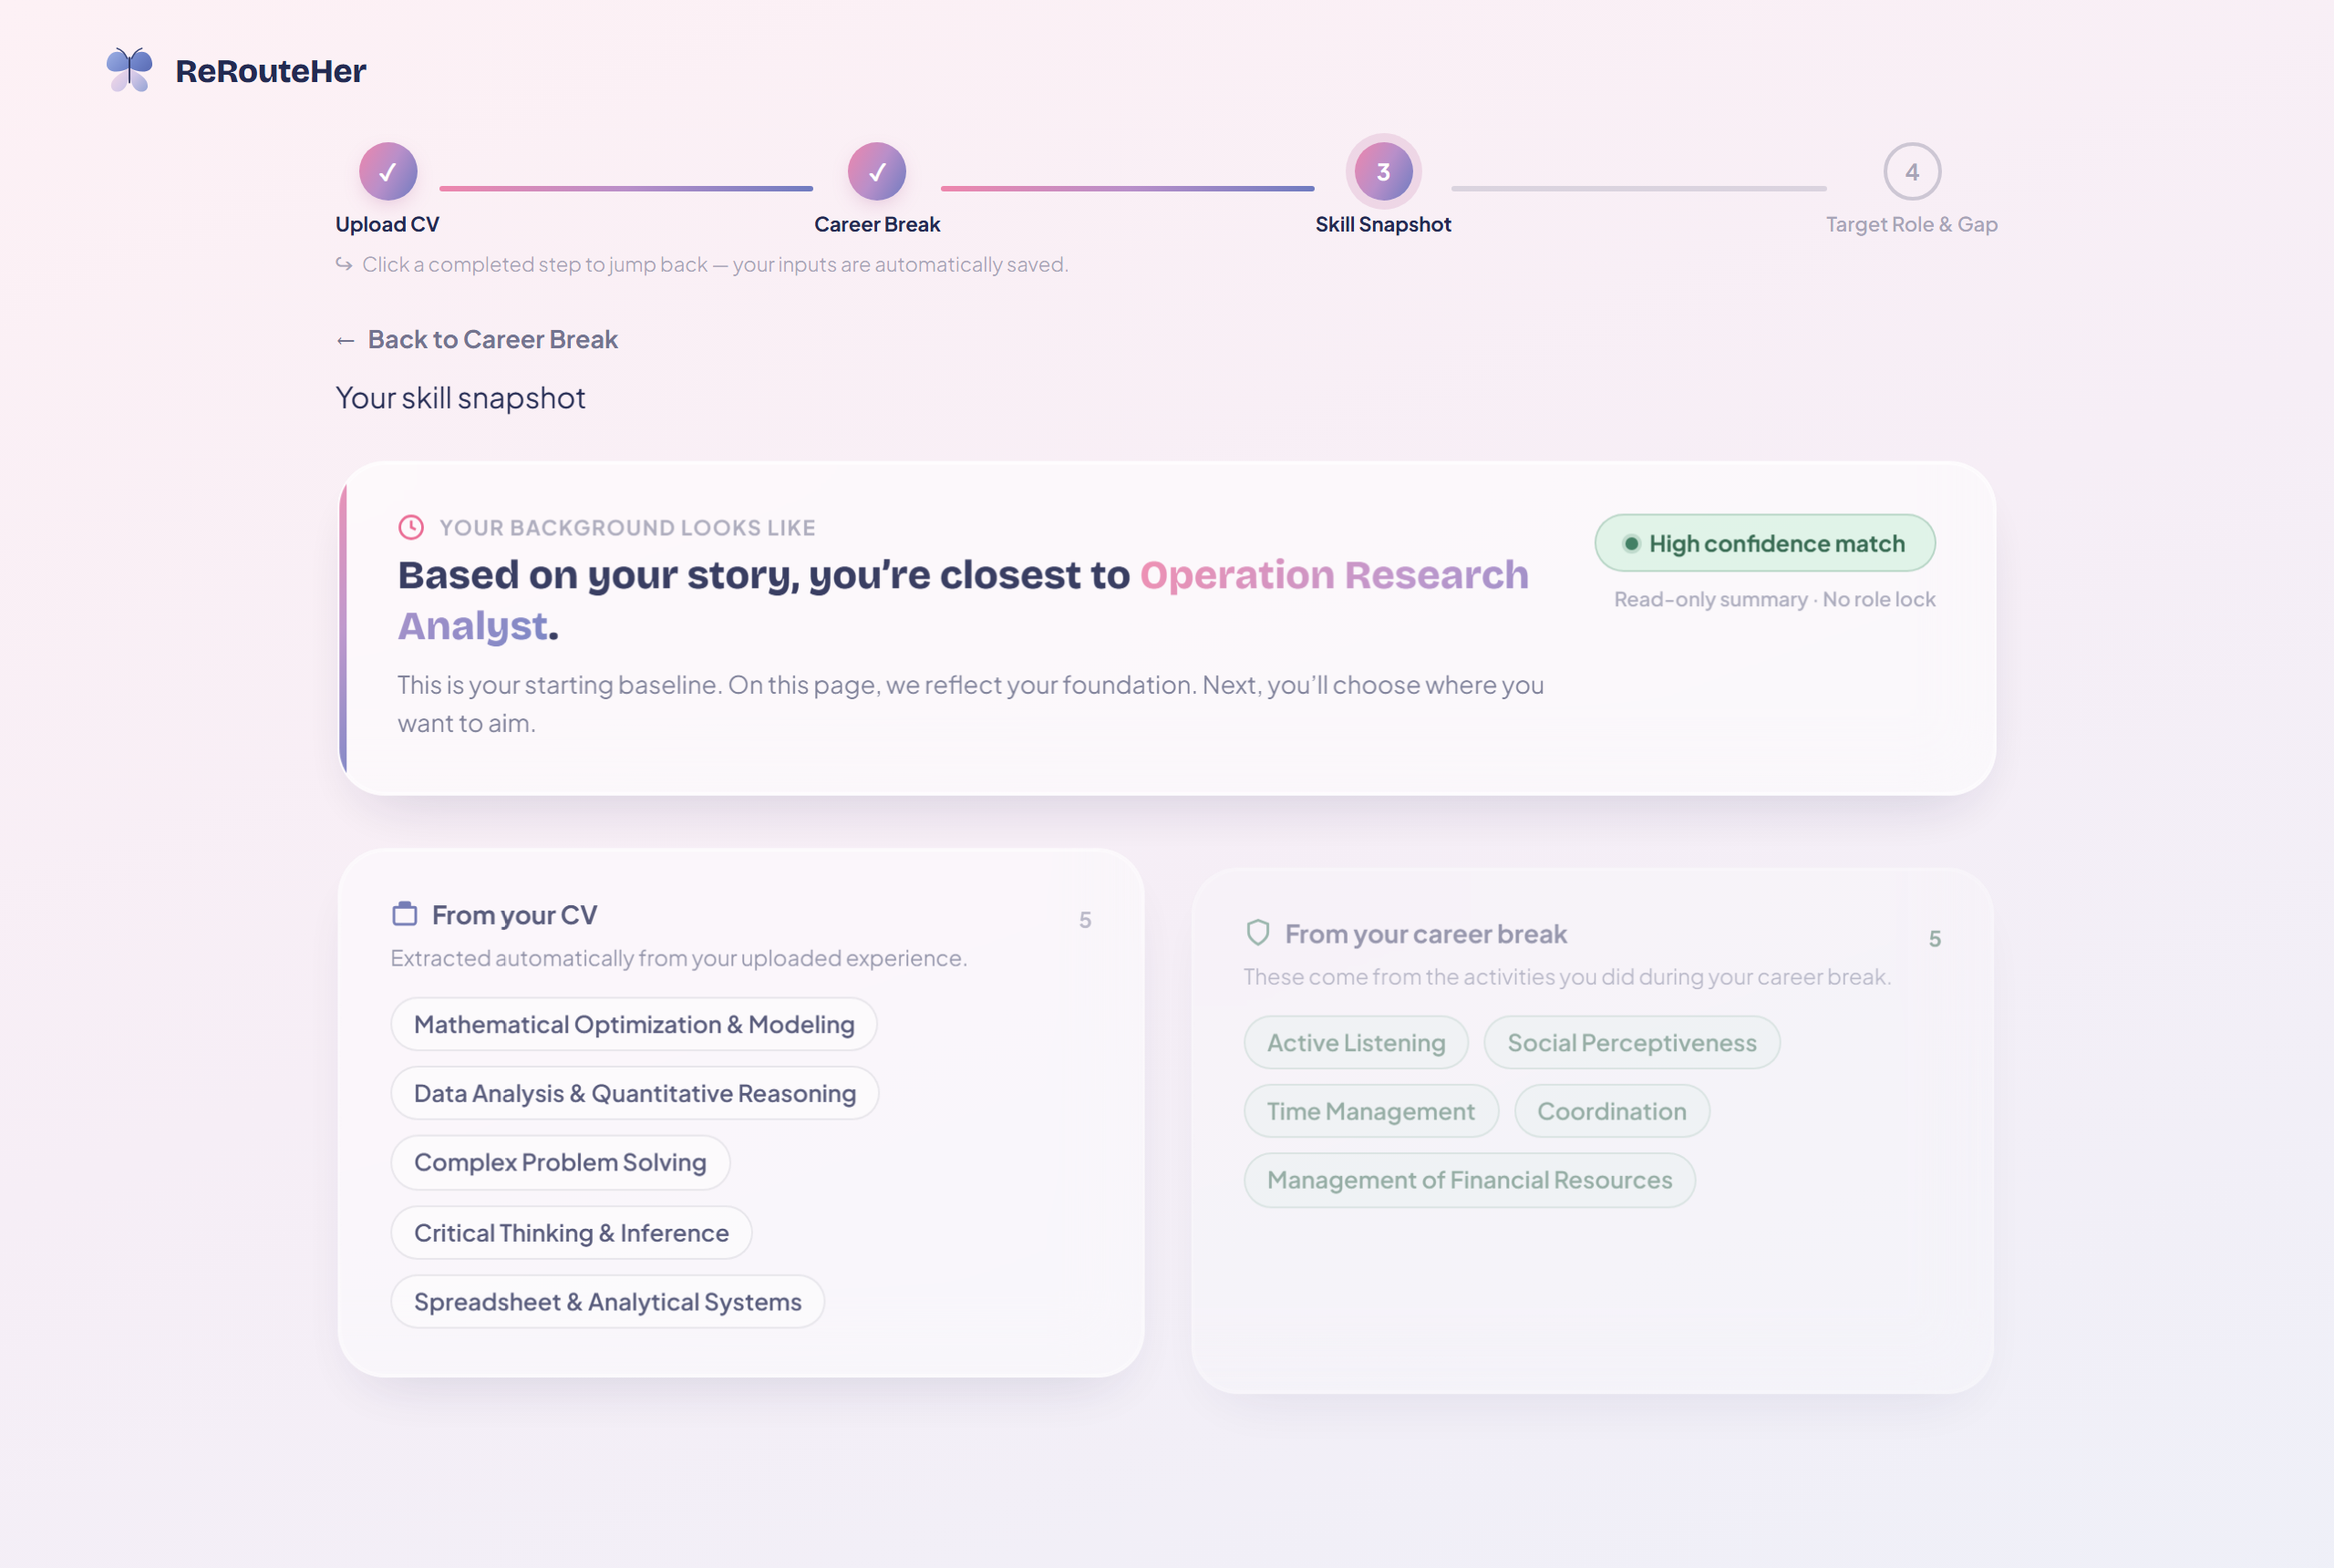
Figure 4: Direct Capture — Step 3: Skill Snapshot Baseline (E3) Occupation Baseline & Two-Column Skill Inventory
- Occupation Baseline Line: Features an explicit headline based on the backend reranker: 'Based on your story, you're closest to Operation Research Analyst' with a 'High confidence match' mint badge.
- From your CV: Extracted career competencies rendered as compact pill chips ('SkillChip') with hover evidence tooltips and a 'Show all / Show fewer' collapse toggle.
- From your career break: O*NET-reframed domestic and community skills (Active Listening, Social Perceptiveness, Time Management, Coordination, Management of Financial Resources).
- O*NET Crosswalk Bridge: Informational banner illustrating automated NLP translation from everyday tasks to US Dept. of Labor taxonomies.
Screen 4 · Step 4: Target Role & Gap Analysis (E4)
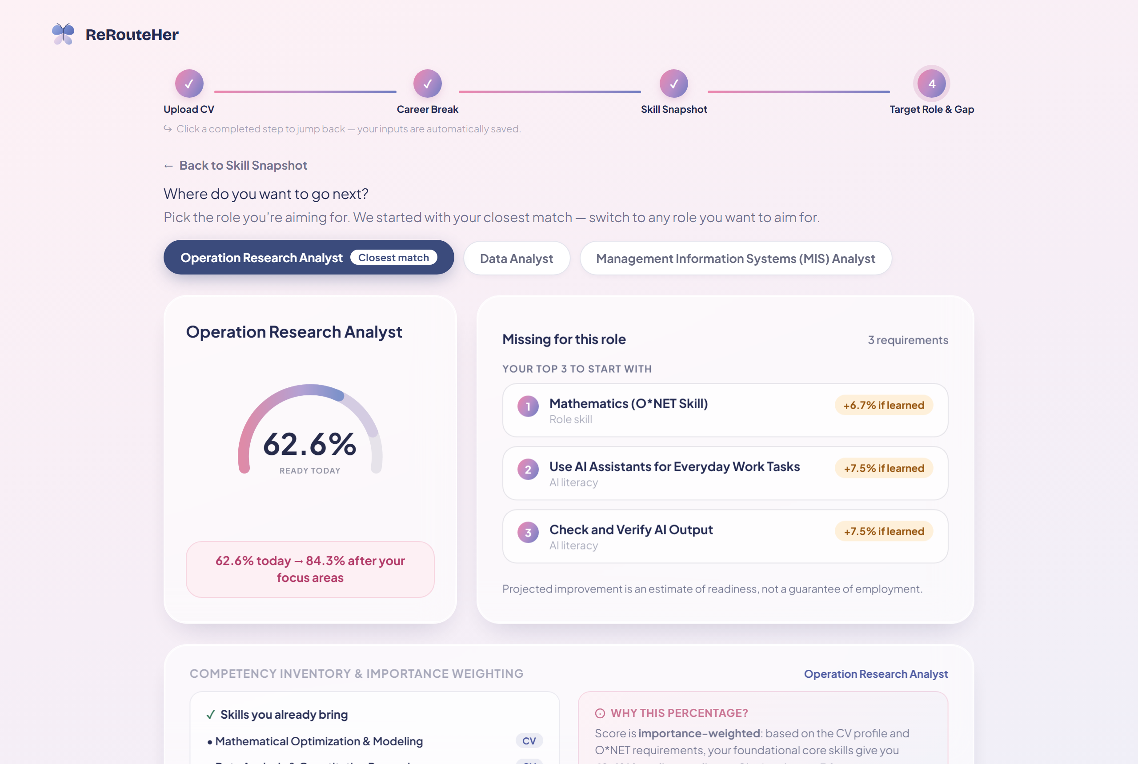
Figure 5: Direct Capture — Step 4: Target Role & Gap Analysis (E4) 62.6% Readiness Gauge & Top 3 Priority Focus Areas
- Interactive Role Selector Pills: Operation Research Analyst (Closest match — active), Data Analyst, Management Information Systems (MIS) Analyst.
- 210° Arc Readiness Gauge: Dynamic SVG sweep gauge indicating '62.6% READY TODAY' paired with a projected readiness card: '62.6% today → 84.3% after your focus areas'.
- Missing for this role (Capped Top 3 Focus Areas): 1. Mathematics (O*NET Skill) [+6.7%], 2. Use AI Assistants for Everyday Work Tasks [+7.5%], 3. Check and Verify AI Output [+7.5%].
- Importance-Weighted Formula Card: Transparently explains the scoring mechanism to demystify readiness percentages.
Screen 4 (Variant) · Target Role Switching (Data Analyst)
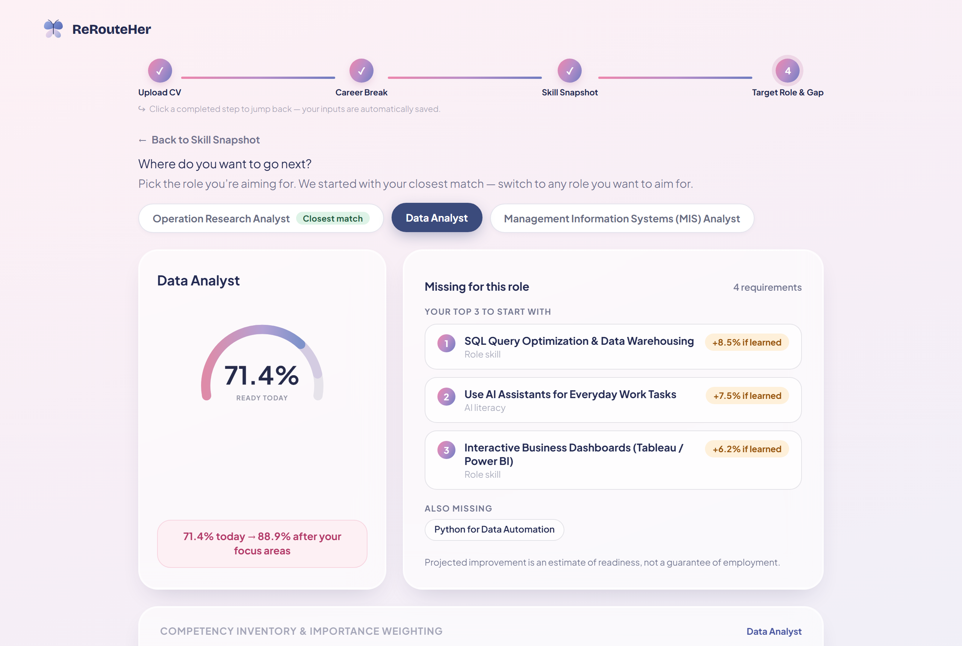
Figure 6: Direct Capture — Target Role Variant Switching to Data Analyst (71.4% Baseline ➔ 88.9% Target)
- Dynamic Live Recalculation: Demonstrates instant recalculation when switching to Data Analyst (71.4% Baseline ➔ 88.9% Target) with tailored focus areas (SQL Optimization, AI Assistants, Tableau/Power BI).

4. Usability Testing & Iterative Design Refinement Log
Iteration Phase | Identified User Pain Point / Feedback | Implemented Design Solution in Hi-Fi Prototype
Lo-Fi Concept | Generic role selection felt restrictive and forced returners into boxes prematurely. | Introduced the Read-Only Skill Snapshot step as a reflective baseline before prompting role selection.
Initial Hi-Fi (v1.0) | AI literacy skills flooded the focus list, crowding out essential domain technical skills. | Engineered the pickFocusAreas algorithm: guarantees 1 AI-literacy slot and reserves remaining slots for core domain role skills.
User Feedback (v1.1) | Long CV skill lists created vertical scrolling clutter and cognitive fatigue. | Created compact pill chips ('SkillChip') with hover evidence tooltips and a 'Show all / Show fewer' collapse toggle.
Team Review (v2.0) | Perceived disconnect between raw skill count (e.g. 7 of 10) and percentage readiness (62.6%). | Added the Importance-Weighted Formula Card, clearly explaining weighting factors and O*NET skill benchmarks.

5. Deliverable Links & Interactive Prototype Access
🌐 Live Deployed Prototype URL: https://prototype.curl.my/
🎨 Figma Interactive Design Canvas: https://www.figma.com/design/wwl5kUAg2RJF8anRURdf1n/5120-TM07?node-id=0-1&t=8vvvEvjkLIAUzMhL-1
💻 Local Development & Execution Commands:
• Install dependencies: npm install
• Start development server: npm run dev (http://localhost:5173)
• Run unit test suite: npm run test:unit (26 passing tests)

