Title
Real-time interaction promotes coordination in social dilemmas by strengthening reciprocity

Abstract
Collective action often unfolds in real time, yet most research has examined either simultaneous or sequential decision-making with fixed order. How endogenous decision timing shapes cooperation remains unclear. Here, we investigate this question using one-shot Prisoner’s Dilemma games under three timing structures: simultaneous, exogenously sequential, and real-time interaction. Across two preregistered experiments (N = 750), real-time interaction produced the highest rate of mutual cooperation. Contrary to our initial prediction, this advantage did not arise from increased first-mover cooperation. Instead, second movers reciprocated cooperation more strongly when move order was endogenously determined. To explain this pattern, we develop a game-theoretic model with belief-based reciprocity. The model shows that endogenous timing makes early cooperation rarer but more informative, strengthening its function as a signal of cooperative intent. Observing such voluntary early actions leads others to infer stronger reciprocity and respond in kind. These findings demonstrate that real-time interaction promotes coordination not by increasing prosociality per se, but by changing the informational content of actions. By making cooperation more credible, endogenous timing helps groups overcome strategic uncertainty in social dilemmas.

Introduction
Collective action, ranging from informal reading groups to revolutionary movements and international treaties, provides a canonical example of a social dilemma. Although collective efforts can generate benefits for all members, individuals often have little incentive to cooperate because they can enjoy these benefits regardless of their own contribution (Kollock, 1998; Olson, 1974; Ostrom, 2015). Nevertheless, decades of behavioral research have shown that a substantial share of people are conditional cooperators, who are willing to cooperate if others do the same (Cartwright, 2018; Fischbacher et al., 2001; Mori et al., 2024). The prevalence of such individuals means that collective outcomes depend critically on how cooperation is initiated. Early cooperation may beget further cooperation, whereas early defection may discourage it. Indeed, individuals’ beliefs about others’ cooperation are critical when decisions are made simultaneously (Mori et al., 2024; Vives & FeldmanHall, 2018), and early movers’ decisions can shape collective outcomes when decisions are made sequentially (Clark & Sefton, 2001; Gächter & Renner, 2018).
However, real-world collaboration rarely fits neatly into either simultaneous or sequential decisions with a fixed order. Instead, collective efforts often unfold in real time, where individuals can decide when to commit. This creates an endogenous decision order that may fundamentally affect the success or failure of collective actions. Two features of such settings are particularly important. First, individuals are free to choose when to act. Second, once announced publicly, earlier commitments are irreversible. Together, these features turn decision timing into a potentially strategic variable. Individuals may act early to influence others’ decisions, wait to observe others’ moves, or ignore timing altogether.
As an illustrative example, consider international climate negotiations in which countries can publish emissions-reduction pledges at any time before a deadline (Falkner, 2016; Hale, 2020). In the run-up to the 2015 Paris Agreement, early pledges by the EU, the US, and China triggered a cascade of further commitments, culminating in broad participation. By contrast, during the 2020 update round, early momentum was largely absent, and eventual commitments remained limited. In both cases, the outcome hinged critically on whether and when some countries committed first while bearing the risk that others might not follow.
However, despite the strategic significance of decision timing, empirical investigations of its dynamics in social dilemmas remain surprisingly scarce. Some game-theoretic studies have modelled the strategic use of timing decisions in multi-stage game paradigms (Abe et al., 2014; Arbak & Villeval, 2013; Nosenzo & Sefton, 2011), and we extend these ideas in our own model below. Yet these models have not been directly tested or linked to behavioral data in real-time settings. Consequently, it remains empirically unclear whether individuals treat decision timing as a strategic variable in real-time social dilemmas and how this shapes collective outcomes.
To investigate how real-time interaction transforms the collective action problem, we examine one-shot Prisoner’s Dilemma games under three timing structures: simultaneous (SM), exogenously sequential (SQ), and real-time (RT). In SM, both players make decisions simultaneously. In SQ, players are exogenously assigned to be first or second movers and decide sequentially. In RT, both players share a time window in which they can decide at any moment. The player who commits earlier becomes the first mover, rendering the decision order endogenous.
We predicted that RT would yield more mutual cooperation than both SM and SQ, driven by a higher rate of first-mover cooperation. In the simultaneous setting (SM), players cannot condition their choice on their partner’s action, leaving conditional cooperators to rely solely on prior beliefs about whether their partner will cooperate. Sequential timing (SQ) alleviates this problem because a first mover who commits to cooperation can elicit reciprocal cooperation from a conditionally cooperative second mover, albeit at the risk of exploitation. In SQ, however, this risk falls on a randomly assigned first mover regardless of their dispositions. In real time (RT), by contrast, players who are more willing to take this risk may become first movers. Because players reluctant to lead can simply wait, those who commit early should disproportionately be cooperators, as early defection is unlikely to induce cooperation from second movers. Moreover, because only one such individual is needed within a pair, even a modest individual-level propensity to lead with cooperation can translate into a higher probability of first-mover cooperation at the pair level, yielding greater mutual cooperation than in both SM and SQ.
Across two experiments, real-time interaction indeed yielded the highest rate of mutual cooperation: nearly two-thirds of pairs cooperated in RT, compared with roughly half in SQ and less than a third in SM. We also observed clear evidence of strategic behavior, with many participants deliberately delaying their decisions. However, contrary to our prediction, first-mover cooperation rates did not differ between RT and SQ. Instead, RT’s advantage was driven by second movers reciprocating cooperation more faithfully than in SQ.
To explain these patterns, we develop a game-theoretic model based on belief-dependent reciprocity. The model assumes that the strength of a player’s reciprocal preference depends on beliefs about the partner’s reciprocity. In RT, where decision order is endogenous, committing early to cooperation entails forgoing the option to wait and observe the partner’s decision. First-mover cooperation in RT is therefore more informative about a player’s reciprocal intent than cooperation by an assigned first mover in SQ. Observing such voluntary early cooperation provides stronger grounds for inferring that the partner intends to reciprocate, increasing the second mover’s willingness to respond in kind. In this way, endogenous timing makes first-mover cooperation both more demanding and more informative, amplifying its function as a social signal. This mechanism provides a coherent account of the experimental findings, which cannot be explained by models based on homo economicus or purely outcome-based reciprocity.
These findings have implications for how groups overcome strategic uncertainty and achieve cooperation in the absence of enforcement. Because many real-world interactions unfold in real time, temporal structure is not merely incidental but can facilitate coordination by enabling voluntary early actions to credibly signal cooperative intent and elicit cooperation from partners who might otherwise remain cautious. Rather than reducing incentives to defect, effective mechanism design may instead rely on preserving conditions under which early commitments are voluntary and publicly observable, allowing cooperation to become self-reinforcing even in one-shot interactions, where enforcement is absent.
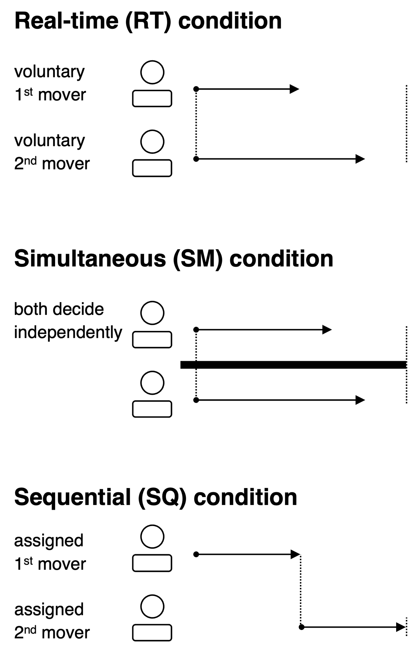
Figure 1. Illustration of the three time structures and the decision-making positions they create. In the real-time (RT) setting, players share a time window and make decisions that are immediately visible to their partner. In the simultaneous (SM) setting, decisions are revealed only after the full time window has elapsed, forcing players to act independently. In the sequential (SQ) setting, players are assigned as either first or second movers and make decisions in that order.

Results

Paradigm
We first report results from two preregistered behavioral experiments using one-shot Prisoner’s Dilemma (PD) games as a canonical model of collective action problems. Players were paired and each began with an endowment of 100 monetary units (MUs). In the PD game, players engaged in a joint project in which each player could either invest (cooperate) their 100 MUs or keep (defect) them. If a player invested 100 MUs, the amount was multiplied by 1.5, yielding 100 MUs for the partner and returning 50 MUs to the investing player.
A critical aspect of the experiment was the manipulation of the game’s time structure in three ways (Figure 1): real-time (RT), simultaneous (SM), and sequential (SQ). In the RT condition, pairs shared a 60-second window during which each player could commit to their decision at any time. Each player could make only one decision, and decisions were reveled immediately upon commitment. The SM condition was identical to RT, except that both players’ decisions were revealed only after the full 60 seconds had elapsed. In the SQ condition, participants were exogenously assigned to be either first or second movers. First movers had an initial 60-second window to decide, after which second movers were given another 60-second window after observing the first mover’s decision.
Crucially, these different time structures create distinct decision-making positions. In SM, all players are in identical positions: they form beliefs about their partners and decide independently, as no player can observe the partner’s decision before acting. In contrast, pairs in SQ and RT have a decision order. In SQ, this order is exogenously assigned by the experimenter, creating “assigned” first and second movers. In RT, because players choose when to commit, the decision order emerges endogenously, resulting in “voluntary” first and second movers.
We conducted two waves of preregistered experiments with a total of 750 US-resident, English-speaking participants recruited online through Prolific Academic. Each participant was randomly assigned to one of the three time-structure conditions and played a one-shot PD game with another participant. In addition to the PD game, participants completed two incentivized tasks measuring preferences for risk and for the distribution of goods, as well as surveys assessing psychological traits (see SI for details). In the main text, we report results from the second, main experiment (N=600). Results from the pilot experiment (N=150), which yielded largely identical patterns, are reported in the Supporting Information (SI).
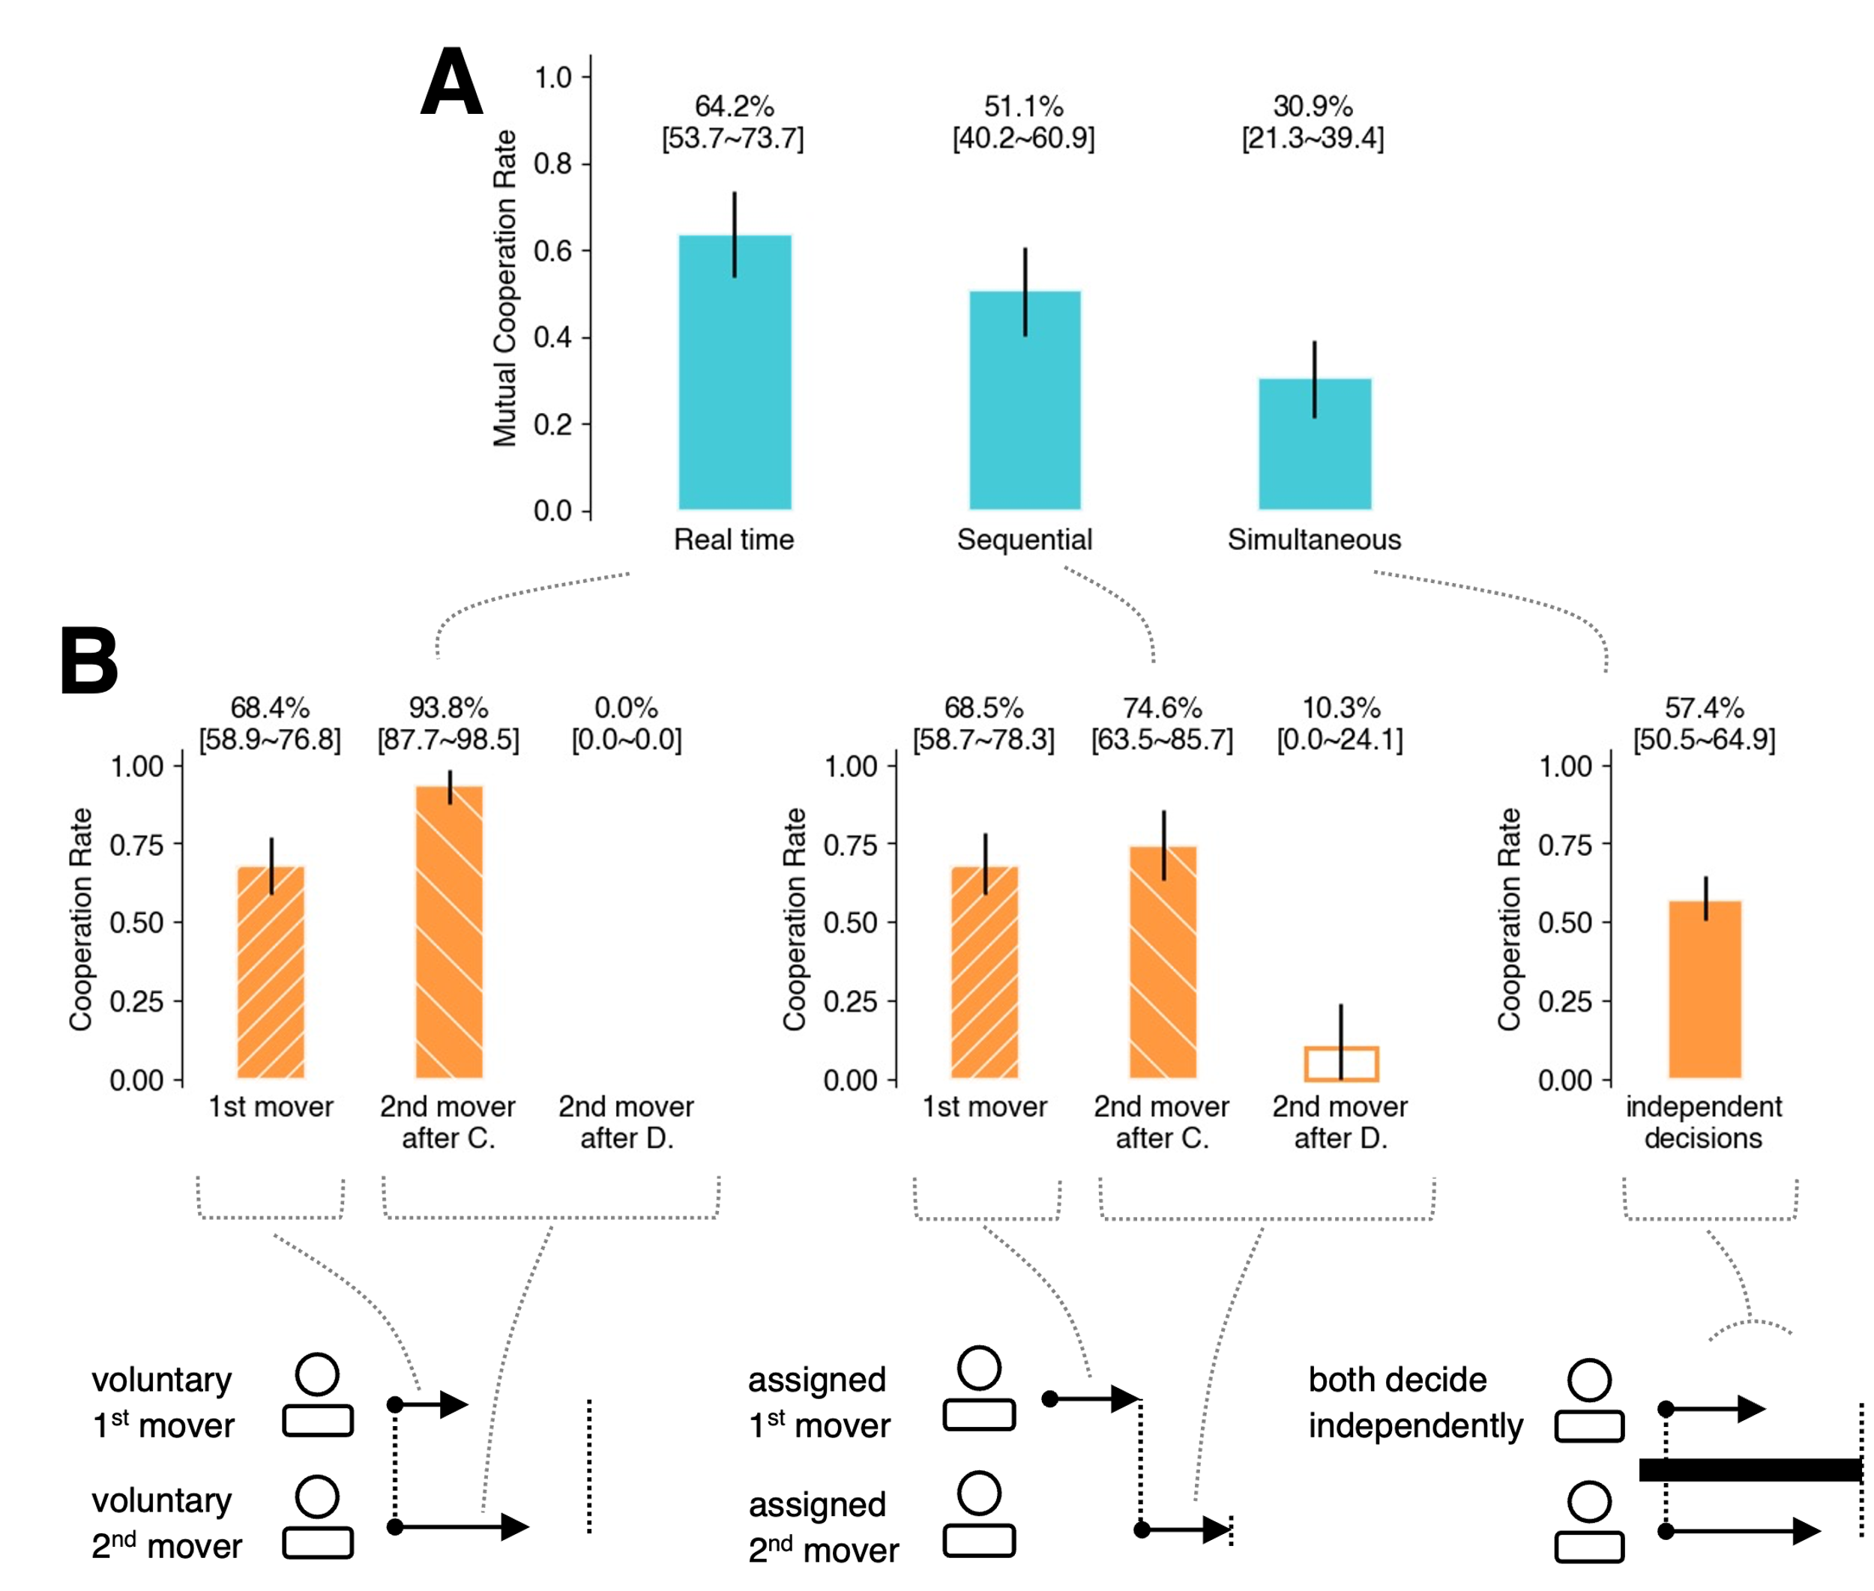
Figure 2. (A) Pair-level mutual cooperation rates by condition. (B) Individual-level cooperation rates by condition and decision-making position. Decision-making positions differ across conditions: voluntary first and second movers in RT, assigned first and second movers in SQ, and independent decisions in SM. For second movers, cooperation rates are shown separately depending on whether they observed cooperation or defection by the first mover.

Real-time interaction increases mutual cooperation
As predicted, real-time interaction (RT) yielded the highest rate of mutual cooperation (i.e., both players choosing to cooperate), with 64.2% (95% CI [53.7, 73.7]) of pairs achieving mutual cooperation (Fig. 2A). In the SQ and SM conditions, 51.1% (95% CI [40.2, 60.9]) and 30.9% (95% CI [21.3, 39.4]) of pairs achieved mutual cooperation, respectively.
Figure 2B shows individual-level cooperation rates in each condition and decision-making position. In the SM (simultaneous) condition, 57.4% (95% CI [50.5, 64.9]) of participants chose to cooperate. This relatively high rate may reflect the mild free-riding incentive (MPCR = 0.5) and the framing of the interaction as a group project. Notably, however, even with this high individual cooperation rate, fewer than one-third of pairs achieved mutual cooperation (Fig. 2A). This follows directly from the simultaneous aggregation of independent decisions, where mutual cooperation requires two independent realizations of cooperative beliefs and choices.
In the SQ and RT conditions, pairs could coordinate through sequential decisions. As a result, both first-mover cooperation rates and second-mover reciprocation rates exceeded the independent baseline observed in SM. Contrary to our initial conjecture, however, first-mover cooperation rates were indistinguishable between RT and SQ (68.4% (95% CI [58.9, 76.8]) in RT; 68.5% (95% CI [58.7, 78.3]) in SQ). We originally expected that endogenous ordering in RT would favor higher first-mover cooperation because players unwilling to bear the risk of leading could simply wait, but this prediction was not supported.
Instead, second movers reciprocated substantially more often in the RT condition than in SQ. When observing first-mover cooperation, voluntary second movers in RT reciprocated cooperation in 93.8% of cases (95% CI [87.7, 98.5]), whereas assigned second movers in SQ did so in 74.6% of cases (95% CI [63.5, 85.7]) (Fig. 2B). Because first-mover cooperation rates were nearly identical across conditions (68.4% in RT; 68.5% in SQ), this stronger reciprocity among second movers directly contributed to the higher pair-level mutual cooperation rate observed in RT (64.2%) compared to SQ (51.1%) (Fig. 2A).
To further examine differences in decision dynamics across conditions, we analyze the distribution of first-mover decision times.
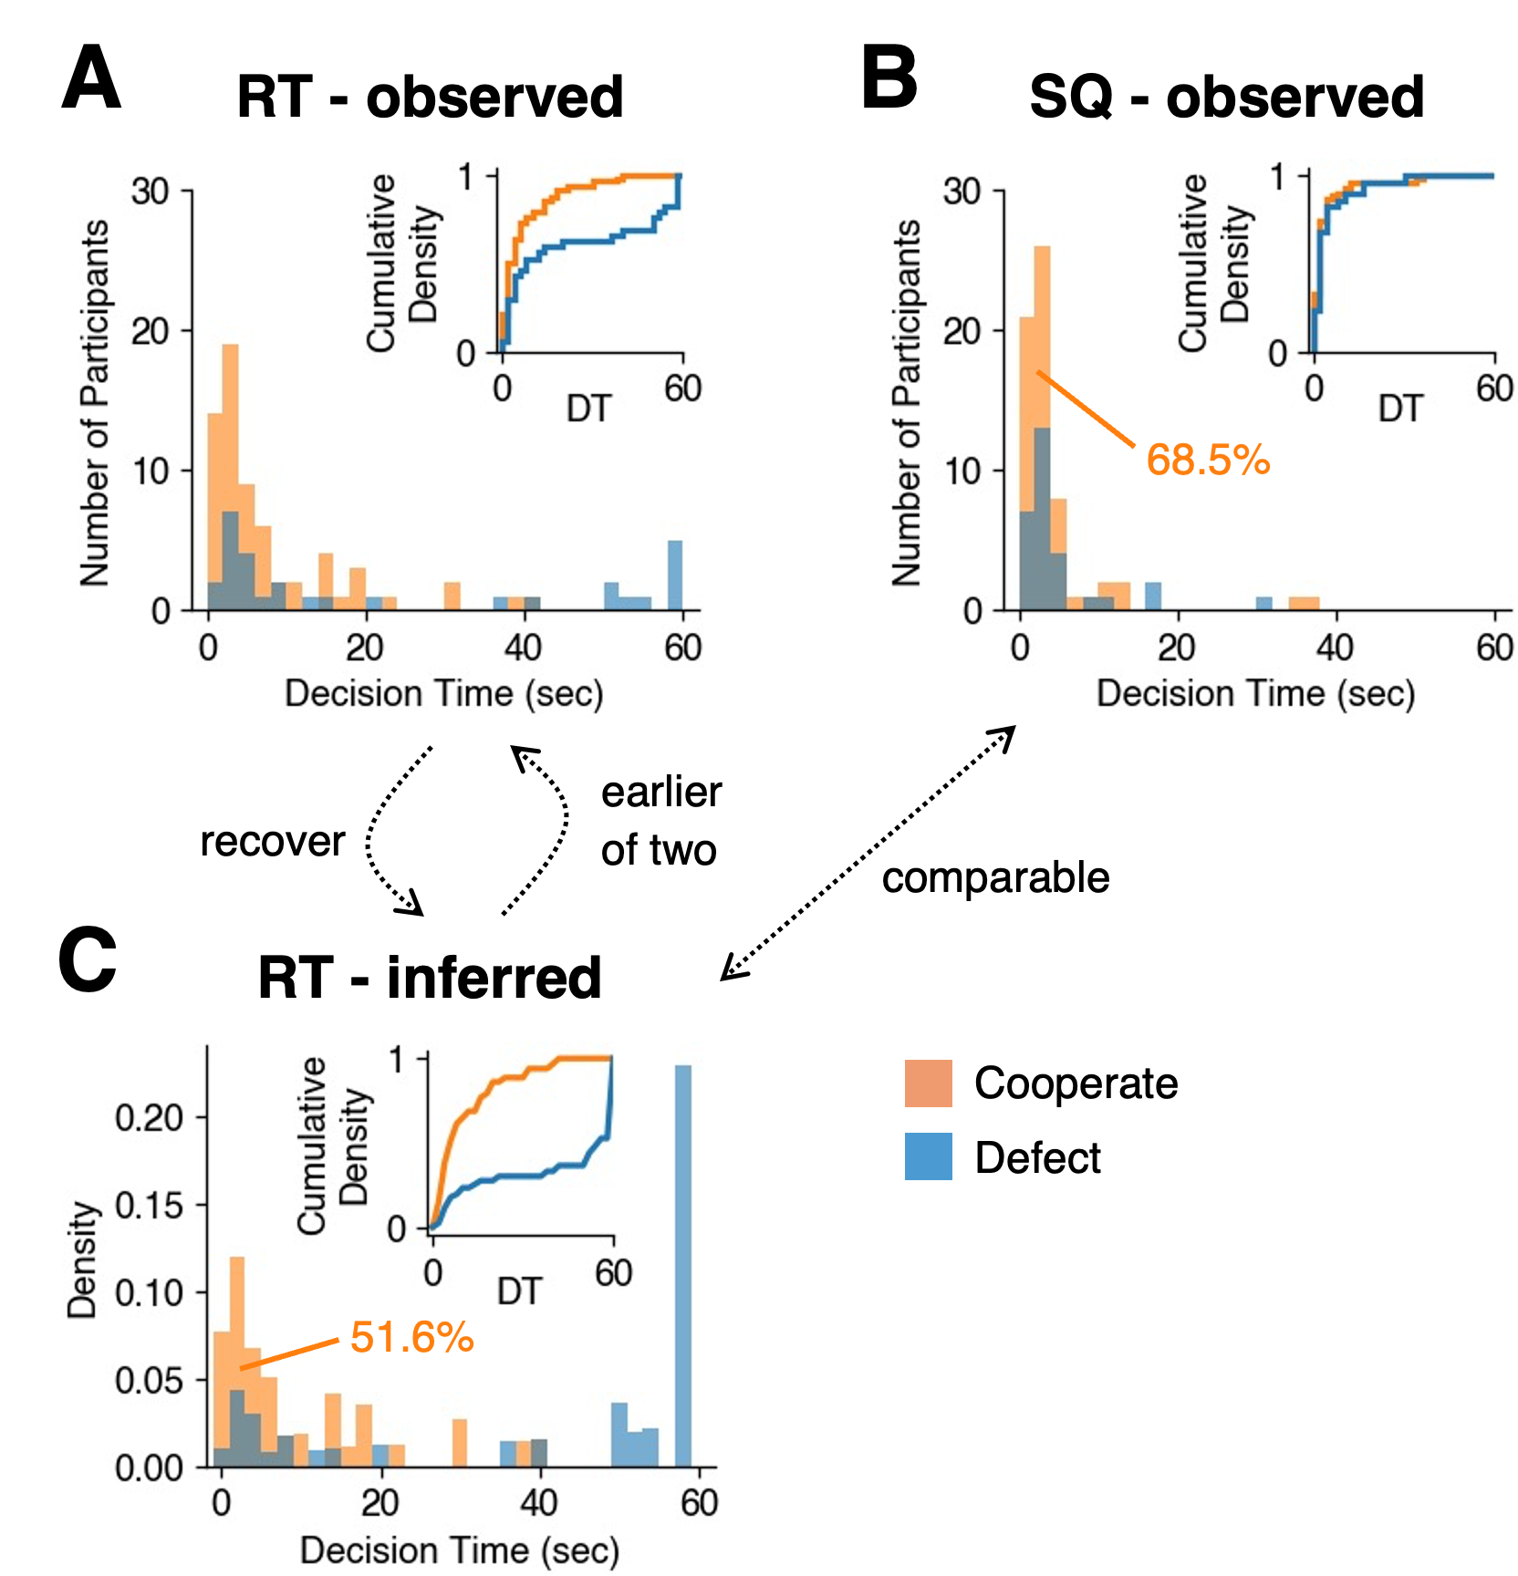
Figure 3. Observed and inferred first-mover decisions in the RT and SQ conditions. (A) Observed decision-time distribution of voluntary first movers in RT, defined as the earlier decision within each pair. (B) Observed decision-time distribution of assigned first movers in SQ. (C) Recovered potential decision-time distribution of voluntary first-mover decisions in RT, obtained by inverting the earlier-of-two sampling process (details in Methods and the SI). Histograms show the number (Panels A and B) and density (Panel C) of participants by decision time (seconds), plotted separately for cooperation (orange) and defection (blue). Insets show the corresponding cumulative distribution functions, with cooperation and defection normalized separately.

Strategic timing in real-time interaction
Figure 3 shows the observed decision-time distributions of first movers in both conditions (A: voluntary first movers in RT; B: assigned first movers in SQ), categorized by cooperation (orange) or defection (blue). Within the 60-second window, decision times generally exhibit a single early peak, except for first-mover defections in RT, which show an additional peak at the very end (Fig. 3A, blue), suggesting that, in some RT pairs, neither player volunteered as the first mover for an extended period of time, with one player eventually defecting near the deadline. This pattern provides a behavioral signature of strategic delay, where players exploit the flexibility of decision timing by postponing defection.
Importantly, the observed distributions in the two conditions (Fig. 3A, B) are not directly comparable. In the SQ condition, the distribution reflects all randomly assigned first-mover decisions, which form an unbiased sample of the entire player population. In contrast, the RT condition reflects only the earlier decisions observed within each pair. For RT, we therefore infer the latent distribution of potential first-mover decisions that would occur if their partner did not act before them and they ultimately became the first mover.
We define each participant’s potential voluntary first-mover decision as the choice and decision time they would realize if their partner did not act before them and they ended up committing first. Under this definition, the observed first-mover decision time in RT (Fig. 3A) corresponds to the earlier of two independent draws from the potential decision-time distribution within a pair. This relationship allows us to infer the underlying potential distribution (see Methods for details of the inference procedure).
According to the recovered potential distribution (Fig. 3C), two observations are noteworthy. First, potential first-mover cooperators in RT tended to decide relatively early, with nearly all cooperative decisions occurring before 45 seconds at the latest. In contrast, potential first-mover defectors were more dispersed in their decision timing: approximately two-thirds of potential defections occurred after 45 seconds, producing a modal peak near the deadline.
Second, only 51.6% of the population would cooperate as first movers in RT (Fig. 3C). This rate is lower than the corresponding cooperation rate among assigned first movers in SQ (68.5%; Fig. 3B).
These patterns indicate that flexibility in decision timing under RT has double-edged effects on first-mover behavior. Compared with the SQ baseline (Fig. 3B), RT allows potential defectors to delay their commitment and avoid the first-mover role. At the same time, some potential cooperators also delay their decisions and ultimately shift toward defection rather than leading with cooperation.
How do these two effects jointly shape the observed first-mover cooperation rate in RT? Under RT, the observed first mover in each pair is whoever acts earlier. Because potential cooperators tend to decide early while many potential defectors delay (Fig. 3C), cooperators are disproportionately likely to become the voluntary first mover. At the same time, however, the pool of potential cooperators becomes smaller in RT than under SQ (Figs. 3B & 3C). These two opposing forces jointly shape the observed first-mover cooperation rate, thereby producing a level comparable to that in SQ (Fig. 2B).

Second movers in RT vs. SQ
We next examine second movers, who reciprocated more strongly in RT than in SQ (93.8% vs. 74.6%; Fig. 2B). Given that first-mover cooperation rates were nearly identical across conditions, this difference contributed directly to the higher rate of mutual cooperation in RT (64.2%) than in SQ (51.1%; Fig. 2A).
In principle, the difference in reciprocity could reflect either a within-individual change or a between-individual compositional difference. Under the within-individual account, the same person reciprocates cooperation more readily when acting as a voluntary second mover in RT than as an assigned second mover in SQ. Under the between-individual (compositional) account, more prosocial individuals disproportionately end up as second movers in RT through self-selection. Although we cannot directly distinguish these possibilities because no participant experienced both conditions, we find little support for the latter, compositional account. Voluntary second movers in RT and assigned second movers in SQ showed nearly identical social value orientation (SVO) scores (Mann–Whitney U test: U = 4223, two-sided p = .689). SVO captures how much individuals weight others’ outcomes relative to their own. The similarity between the two groups indicates that second movers in RT were not systematically more prosocial than those in SQ. This pattern suggests that the stronger reciprocity in RT is more likely to reflect a within-individual increase in responsiveness to voluntary first-mover cooperation, rather than a difference in who becomes a second mover.
Summary and transition to the model
In summary, the behavioral experiments show that real-time interaction produces the highest level of mutual cooperation in Prisoner’s Dilemma games. However, contrary to our initial conjecture, this advantage does not arise from increased first-mover cooperation. Instead, it stems from substantially stronger reciprocity among second movers. These findings raise two key questions. First, why does real-time interaction not increase first-mover cooperation despite removing the obligation to move first? Second, why does it still increase second-mover reciprocity? To address these questions, we develop a game-theoretic model that accounts for both patterns through a single mechanism—belief-dependent reciprocity (full derivations in SI 3).
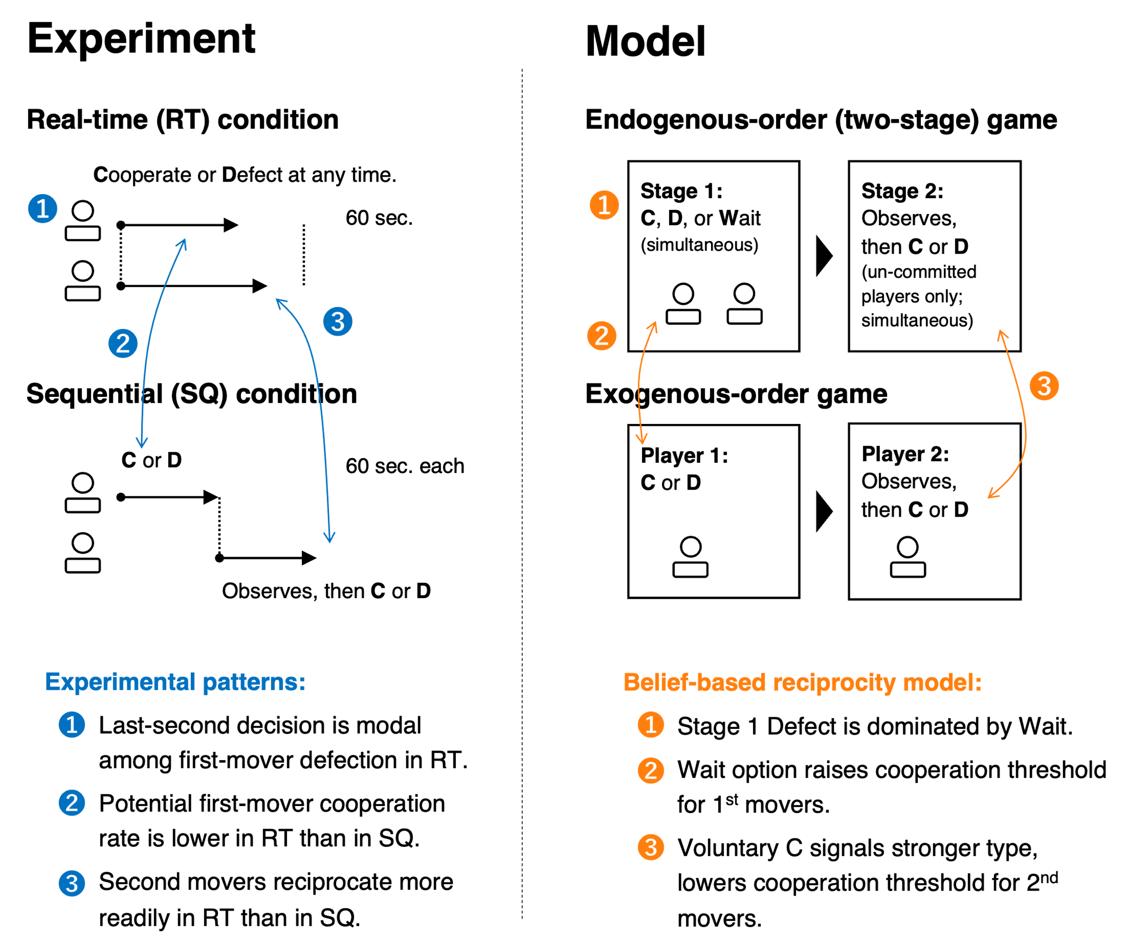
Figure 4. Mapping between experimental conditions and the theoretical model. (Left) Experimental design. In the RT condition, both players can cooperate or defect at any time within a 60-second window, and decisions are immediately revealed to the partner. In the SQ condition, one player is assigned to move first with 60 seconds, after which the second mover has 60 seconds to decide after observing the first mover’s choice. Numbered annotations in blue highlight three key empirical patterns (see main text). (Right) Theoretical model. The endogenous-order game consists of two stages. In Stage 1, both players simultaneously choose Cooperate (C), Defect (D), or Wait (W). If exactly one player chooses a non-wait action (C or D) in Stage 1, that action is immediately committed, and the other player observes it before deciding in Stage 2. If both choose non-wait actions in Stage 1, one action is randomly selected to be implemented, and the other player then chooses between C or D in Stage 2. If both choose Wait, they choose between C and D simultaneously in Stage 2. The exogenous-order game corresponds to the SQ condition, in which Player 1 is assigned to move first. Numbered annotations in orange indicate how the belief-based reciprocity model accounts for each empirical pattern (see main text).

Game-theoretic account: belief-based reciprocal preference model
Our goal is to develop a model that captures the strategic features of real-time interaction and accounts for the key empirical patterns observed in our experiments. To this end, we introduce a two-stage game with endogenous decision timing and incorporate belief-based reciprocal preferences, which together generate equilibrium behavior consistent with the data.
To model real-time interaction, we employ a two-stage variant of the Prisoner’s Dilemma (Fig. 4 upper right). In Stage 1, both players simultaneously choose Cooperate (C), Defect (D), or Wait (W). If exactly one player chooses C or D while the other chooses W, that action is immediately committed. If both players choose C or D in Stage 1, one action is randomly selected to be implemented (while the other remains uncommitted), reflecting the feature that perfectly simultaneous actions are effectively negligible in continuous time. In Stage 2, any player whose action has not yet been committed observes the committed action (if any) and then chooses C or D. This structure captures the defining feature of real-time interaction: decision order is endogenous and determined by who commits first. For comparison, we also consider an exogenous-order game corresponding to the SQ condition, in which players are assigned to move first or second, (Fig. 4 middle right).
Critically, we assume that players differ in their degree of reciprocal preference, captured by a continuously distributed parameter $θ_{i}≥0$ (interpreted as a player’s type). A higheri $θ_{i}$ indicates that player i places greater weight on the partner’s payoff when the partner cooperates. In our model, this weight is further modulated by player i’s belief about ϕiJthe partner’s jreciprocal type, denoted by ϕiJ. The utility of player $i$ is therefore given by:
$$U_{i}\left(a_{i},a_{j};θ_{i}\right)=\left\{\begin{aligned} π_{i}\left(a_{i},a_{j}\right)+θ_{i}ϕ_{ij}π_{j}\left(a_{i},a_{j}\right) & if a_{j}=C \\ π_{i}\left(a_{i},a_{j}\right) & if a_{j}=D\end{aligned}\right., \#\left(1\right)$$
where $a_{i}$ and $a_{j}$ denote the actions of player $i$ and $j$, and $π_{i}$ and $π_{j}$ are their respective material payoffsϕiJijθj. Before observing any action of the partner, the belief ϕiJ corresponds to the population mean of θi and is common across players. After observing the partner’s behavior, beliefs are updated through inference: cooperation indicates a higher reciprocal type, whereas defection indicates a lower one. Thus, beliefs about the partner’s type play a central role in shaping reciprocal responses.
θifθ, so players face strategic uncertainty about whether their partner is sufficiently reciprocal to cooperateϕiJijθjϕij=θfθdθiϕijiϕijjiϕijθ
As a benchmark, if all players are purely self-interested ($θ_{i}=0$ for all $i$), the model predicts mutual defection in both endogenous- and exogenous-order games. Hence, other-regarding preferences are necessary to account for the cooperative behavior observed in the experiments.
For tractability, we focus on threshold equilibria in which players’ decisions depend on whether their reciprocal preference $θ_{i}$ exceeds certain critical values. This allows us to characterize equilibrium behavior in terms of cutoff strategies over types (see SI 3 for full derivations).
The model yields three main results that correspond directly to the empirical findings (Fig. 4).
First, in the endogenous-order game, committing to defection in Stage 1 is weakly dominated by waiting (Proposition 1). Waiting preserves the option to condition one’s action on the partner’s behavior, thereby retaining strategic flexibility. In contrast, early defection irrevocably eliminates this option without any compensating benefit whenever there is a positive probability of partner cooperation. As a result, rational players delay defection. This prediction aligns with the empirical finding that last-second decisions are modal among potential first-mover defections in RT.
Second, committing to first-mover cooperation is more demanding under endogenous order than under exogenous order (Proposition 2). In the endogenous-order game, players can wait and potentially respond as second movers, which provides a viable alternative to acting early. Volunteering to cooperate in Stage 1 therefore requires that a player’s reciprocal preference exceeds a higher threshold than cooperating as an assigned first mover. This result matches the empirical pattern that the potential first-mover cooperation rate is lower in RT than in SQ.
θ1stθi≥θ1stθ1stendo>θ1stexo≈51.62%,Fig. 3D≈68.5%
Third, and most importantly, the higher threshold for early cooperation implies that it is chosen by a more selective subset of players. Observing such behavior therefore provides stronger evidence that the partner has a high reciprocal disposition. This inference increases the observer’s belief ϕ2nd, 1st, which in turn lowers the threshold for reciprocation and makes second movers more likely to cooperate (Proposition 3). This result aligns with the empirical finding that second-mover reciprocation is substantially higher in RT than in SQ, despite similar distributions of prosocial preferences (as measured by SVO) across conditions.
By contrast, under outcome-based reciprocity, responses depend solely on observed actions rather than inferred intentions. As a result, the informational content of cooperation does not vary across timing structures, and such models cannot account for the enhanced second-mover reciprocity observed under endogenous timing.
Overall, the model shows that endogenous timing transforms cooperation into a signal whose credibility depends on its opportunity cost. Voluntary early cooperation thus functions as a credible signal of cooperative intent, strengthening belief-based reciprocity and amplifying mutual cooperation. At the same time, the model captures the strategic use of delay, highlighting how flexibility in decision timing jointly shapes behavior and inference.θ2ndθi≥θ2nd150+θ2ndϕ2nd, 1st∙150≥ 200+θ2ndϕ2nd, 1st∙50θ2nd=12ϕ2nd, 1stϕ2nd, 1stθϕ2nd, 1stθ2ndendo<θ2ndexoϕ2nd, 1stθ1stθ2ndendo<θ2ndexo
ϕij1θ2ndendo=θ2ndexo; Propositioθ1stendo>θ1stexo

Discussion
Real-time interaction changes not only when decisions are made, but what those decisions communicate. Across two experiments, we show that allowing individuals to choose when to act increases mutual cooperation in social dilemmas. Crucially, this effect does not arise because more individuals choose to lead with cooperation. Instead, real-time interaction amplifies the informational value of early cooperation, strengthening others’ willingness to reciprocate.
This finding highlights a fundamental but often overlooked feature of social interaction: decision timing is itself a strategic variable. When move order is endogenous, individuals can avoid the risks of leading by waiting. Those who nevertheless act early therefore reveal stronger cooperative intent, making early cooperation a more credible signal.
Our behavioral results and game-theoretic model jointly illuminate the mechanism underlying the transformation. Endogenous timing raises the threshold for first-mover cooperation, making it rarer, but this rarity increases its informativeness. As a result, second movers respond more strongly. Real-time interaction thus promotes coordination not by increasing prosocial preferences per se, but by changing the informational content of actions. This mechanism cannot be captured by outcome-based reciprocity, which depends only on realized actions rather than inferred intentions.
This perspective complements prior work on cooperation in continuous-time settings. In environments where actions can be adjusted repeatedly, individuals can respond immediately to others’ behavior, reducing the risk of unilateral exploitation (Duffy et al., 2007; Friedman & Oprea, 2012; Kurzban et al., 2001; Oprea et al., 2014). Friedman & Oprea (2012), for example, analyzed the continuous-time Prisoner’s Dilemma, where participants could continuously adjust their choices. Because players can respond immediately to each other’s actions, this setting allows them to deter defection dynamically. By contrast, our design isolates a strict one-shot environment with a single, irreversible commitment. In such settings, real-time interaction does not reduce the cost of cooperation but instead enhances its signaling value. These findings indicate that real-time interaction facilitates cooperation through distinct mechanisms depending on whether actions are reversible or committed.
Our findings also relate to recent work on collective problem solving in real time (Kuroda et al., 2025; Tump et al., 2020, 2022). In these studies, individuals face cognitive tasks in which each decision generates informational externalities for others, and collective outcomes depend on how information cascades unfold over time. For example, Tump et al. (2020) show that group accuracy depends critically on whether more accurate individuals decide earlier. In contrast, our study examines a social dilemma characterized by payoff externalities, where strategic considerations play a central role. While prior work on collective problem solving has largely abstracted away from strategic timing, our results show that individuals actively use timing as a strategic variable, shaping collective outcomes through belief-based inference. Extending these perspectives—for example, by incorporating strategic waiting into models of informational cascades—remains an important direction for future research.
These insights have practical implications for institutional design. If many individuals are conditional cooperators (Bowles, 2016; Fehr & Schmidt, 1999; Kosfeld, 2020), then, as Ostrom (2000, p.138) noted, a central challenge is how to design institutions that allow potential cooperators to signal one another. Our results suggest that real-time interaction can serve precisely this function. Preserving voluntary and observable early commitment, rather than eliminating risk altogether, may be particularly effective in fostering cooperation.
This logic is vividly illustrated in real-world cases of social entrepreneurship. Successful social entrepreneurs often act as voluntary first movers, committing resources to collective goals under substantial uncertainty. At first glance, such behavior appears risky, as early actors face the possibility of being exploited if others fail to follow. However, our results suggest that this risk-taking can be understood as a strategic investment.
Historically, for example, early microfinance initiatives, most notably the Grameen Bank, demonstrated that lending without collateral could succeed when initial commitments signaled trust and elicited reciprocal repayment (Armendariz & Morduch, 2010; Yunus, 2003). More broadly, social entrepreneurship has often been driven by actors who commit to unproven models of collective value creation, thereby catalyzing broader participation (Bornstein, 2007; Mair & Martí, 2006). In this sense, social entrepreneurs may succeed not despite taking risks, but because those risks make their commitment credible.
More generally, our findings suggest that the effectiveness of leadership in collective action depends not only on who leads, but on how and when leadership is exercised. Voluntary early action can function as a powerful coordination device when it credibly signals cooperative intent, helping explain why some groups and organizations succeed in overcoming social dilemmas while others fail.
Finally, we note several limitations of our study and directions for future research. First, our between-subjects design captures how individuals naturally respond to different time structures, but within-subject designs could more directly test how the same individuals adapt their strategies. Second, our binary-action framework abstracts away from graded or reversible contributions, which may interact with timing in complex ways. Third, it remains an open question to what extent this signaling mechanism sustains cooperation over longer interactions and in larger groups. In such settings, early cooperation may invite strategic exploitation, raising the question of how cooperative momentum can be maintained once established. Understanding how such cooperative cascades can be sustained over time is an important direction for future research.
In sum, real-time interaction promotes coordination by transforming the informational content of actions. When individuals can choose when to act, early cooperation becomes a credible signal of intent that actions under assigned orders cannot convey. By tightening the link between action and inferred intent, real-time interaction amplifies reciprocity and helps groups overcome strategic uncertainty in social dilemmas.

Methods
Main Experiment.
The experiment employed a one-shot Prisoner’s Dilemma (PD) game as the main task. Participants were explicitly informed that they were paired with another real human participant taking part in the experiment at the same time, and all interactions were anonymous. The PD payoff matrix was identical across conditions. Participants chose between Cooperate (C) and Defect (D), with point outcomes given by (C, C) = (150, 150), (C, D) = (50, 200), (D, C) = (200, 50), and (D, D) = (100, 100).
We manipulate the temporal structure of interaction in a between-subject design. Participants were assigned to one of three conditions: real-time (RT), simultaneous (SM), or sequential (SQ). In the RT condition, each pair was given a 60-second decision window during which either participant could choose C or D at any moment. Once a participant made a decision within this window, it was immediately communicated to the partner and could not be revised. Participants were instructed that if neither participant made a decision within 60 seconds, both would be prompted to decide simultaneously at the end of the time limit without observing the partner’s choice. In practice, however, no pairs delayed their decisions beyond the 60-second window (i.e., at least one player made a decision within 60 seconds in every pair). In the SM condition, the interface and time window were identical, but no decisions were revealed during the 60 seconds. Participants’ choices were collected independently and revealed only after the time limit elapsed, rendering the interaction equivalent to a standard simultaneous PD. In the SQ condition, the experimenter exogenously assigned first- and second-mover roles. The first mover had the 60-second time window to decide, after which the second mover had an additional 60 seconds to decide after observing the first mover’s choice.
To eliminate unrelated incentives to finish the experiment early, we required participants in all conditions to wait until the full 60 seconds had elapsed before proceeding, even if all decisions had been completed sooner. Before playing the PD, participants received condition-specific instructions and completed a comprehension check. Only those who answered all questions correctly proceeded to the main task.
After completing the PD, participants completed additional incentivized economic measures and a post-experimental questionnaire. These measures included Social Value Orientation (SVO), elicited using the Slider Measure (Murphy et al., 2011). In this task, participants made a series of choices over how to allocate money between themselves and another participant, allowing us to quantify the extent to which individuals prioritize their own payoffs versus those of others on a continuous scale. The full list of questionnaire measures is reported in the Supplementary Information 1.
We preregistered hypotheses comparing conditions in terms of pair-level mutual cooperation rates, individual cooperation rates by decision-making position, and the distribution of decision times of first movers. These included voluntary first movers in RT, assigned first movers in SQ, and nominal first movers in SM. We planned to recruit 600 English-speaking U.S. participants via Prolific, with 200 participants per condition. After excluding participants who dropped out before completing the full procedure, the final sample comprised 190 participants, or 95 pairs, in RT, 184 participants, or 92 pairs, in SQ, and 188 participants, or 94 pairs, in SM. Participants received a £6 fixed participation fee plus a performance-based bonus proportional to the points they earned in the PD or in other incentivized tasks selected at random. The median completion time was 45 minutes, and the average total payment was £10.5.

Method for potential-decision inference in the RT condition.
In the real-time condition, what we directly observe as first-mover decisions are the choices and decision times of the earlier player within each pair. Importantly, this does not imply that only a subset of participants intended to be a first-mover decision. In principle, every participant could have become a voluntary first mover, because everyone had the opportunity to commit at any point during the real-time window. However, if a participant’s partner happened to decide earlier, that participant could no longer be a first mover, and their would-be first-mover choice and decision time are not observable for the experimenter. Consequently, the observed first-mover data in the RT condition (Fig. 3A) reflect only the earlier decision from each pair, while the other participant’s potential timing as a first mover remains latent.
We therefore estimate these latent potential decisions. We define each participant’s potential voluntary first-mover decision as the choice and decision time they would realize if their partner never acted earlier and they were eventually forced to commit first. Under this definition, the observed first-mover decision time in RT corresponds to the earlier of two independent draws from the potential decision-time distribution within a pair. This relationship allows us to infer the underlying potential distribution, as described below.
We first compute the empirical distribution of observed first-mover decision times in RT, $F_{obs}\left(t\right)≡P(decision time≤t)$. We then recover the potential distribution $F_{potential}\left(t\right)$ by exploiting the minimum-of-two relationship implied by the observation process, $F_{obs}\left(t\right)=1-{\left(1-F_{potential}\left(t\right)\right)}^{2}$, and inverting it to obtain $F_{potential}\left(t\right)=1-\sqrt{1-F_{obs}\left(t\right)}$. This yields the reconstructed distribution of decision times that we would have observed if all participants had decided as endogenous first movers.
Finally, we estimate the contents (i.e., whether it is cooperation or defection) of these potential decisions by integrating the observed cooperation rate conditioned on decision time $p\left(C ∣ t\right)$ with respect to the reconstructed distribution $F_{potential}\left(t\right)$ (or its derivative). This is justified because $p\left(C ∣ t\right)$ is independent of the observation process that determines which player becomes the observed first mover, which depends only on relative decision timing within the pair. See Fig. 3C for the recovered potential decision-time distribution of voluntary first-mover decisions in RT

Reference
- Abe, K., Kobayashi, H., & Suehiro, H. (2014). Leadership in the prisoner’s dilemma with inequity-averse preferences. Discussion Papers. https://ideas.repec.org//p/kbb/dpaper/2014-09.html
- Arbak, E., & Villeval, M.-C. (2013). Voluntary leadership: motivation and influence. Social Choice and Welfare, 40(3), 635–662.
- Armendariz, B., & Morduch, J. (2010). The economics of microfinance (2nd ed.). MIT Press.
- Bornstein, D. (2007). How to change the world: Social entrepreneurs and the power of new ideas (2nd ed.). Oxford University Press.
- Bowles, S. (2016). The moral economy: Why good incentives are no substitute for good citizens. Yale University Press.
- Cartwright, E. (2018). A survey of belief-based guilt aversion in trust and dictator games. Journal of Economic Behavior & Organization, 167, 430–444.
- Clark, K., & Sefton, M. (2001). The sequential prisoner’s dilemma: Evidence on reciprocation. Economic Journal (London, England), 111(468), 51–68.
- Duffy, J., Ochs, J., & Vesterlund, L. (2007). Giving little by little: Dynamic voluntary contribution games. Journal of Public Economics, 91(9), 1708–1730.
- Falkner, R. (2016). The Paris Agreement and the new logic of international climate politics. International Affairs, 92(5), 1107–1125.
- Fehr, E., & Schmidt, K. M. (1999). A Theory of Fairness, Competition, and Cooperation. The Quarterly Journal of Economics, 114(3), 817–868.
- Fischbacher, U., Gächter, S., & Fehr, E. (2001). Are people conditionally cooperative? Evidence from a public goods experiment. Economics Letters, 71(3), 397–404.
- Friedman, D., & Oprea, R. (2012). A Continuous Dilemma. The American Economic Review, 102(1), 337–363.
- Gächter, S., & Renner, E. (2018). Leaders as role models and ‘belief managers’ in social dilemmas. Journal of Economic Behavior & Organization, 154, 321–334.
- Hale, T. (2020). Catalytic cooperation. Global Environmental Politics, 20(4), 73–98.
- Kollock, P. (1998). Social dilemmas: The anatomy of cooperation. Annual Review of Sociology, 24(1), 183–214.
- Kosfeld, M. (2020). The role of leaders in inducing and maintaining cooperation: The CC strategy. The Leadership Quarterly, 31(3), 101292.
- Kuroda, K., Tump, A. N., & Kurvers, R. H. J. M. (2025). Individual differences in speed-accuracy trade-off influence social decision-making in dyads. Proceedings. Biological Sciences, 292(2051), 20251077.
- Kurzban, R., McCabe, K., Smith, V. L., & Wilson, B. J. (2001). Incremental commitment and reciprocity in a real-time public goods game. Personality & Social Psychology Bulletin, 27(12), 1662–1673.
- Mair, J., & Martí, I. (2006). Social entrepreneurship research: A source of explanation, prediction, and delight. Journal of World Business, 41(1), 36–44.
- Mori, R., Hanaki, N., & Kameda, T. (2024). An outside individual option increases optimism and facilitates collaboration when groups form flexibly. Nature Communications, 15(1), 1–13.
- Murphy, R. O., Ackermann, K. A., & Handgraaf, M. J. J. (2011). Measuring Social Value Orientation. Judgment and Decision Making, 6(8), 771–781.
- Nosenzo, D., & Sefton, M. (2011). Endogenous move structure and voluntary provision of public goods: Theory and experiment. Journal of Public Economic Theory, 13(5), 721–754.
- Olson, M. (1974). The logic of collective action: Public goods and the theory of groups, second printing with a new preface and appendix. Harvard University Press.
- Oprea, R., Charness, G., & Friedman, D. (2014). Continuous time and communication in a public-goods experiment. Journal of Economic Behavior & Organization, 108, 212–223.
- Ostrom, E. (2000). Collective action and the evolution of social norms. The Journal of Economic Perspectives: A Journal of the American Economic Association, 14(3), 137–158.
- Ostrom, E. (2015). Governing the commons: The evolution of institutions for collective action: The evolution of institutions for collective action. Cambridge University Press.
- Tump, A. N., Pleskac, T. J., & Kurvers, R. H. J. M. (2020). Wise or mad crowds? The cognitive mechanisms underlying information cascades. Science Advances, 6(29), eabb0266.
- Tump, A. N., Wolf, M., Romanczuk, P., & Kurvers, R. H. J. M. (2022). Avoiding costly mistakes in groups: The evolution of error management in collective decision making. PLoS Computational Biology, 18(8), e1010442.
- Vives, M.-L., & FeldmanHall, O. (2018). Tolerance to ambiguous uncertainty predicts prosocial behavior. Nature Communications, 9(1), 2156.
- Yunus, M. (2003). Banker to the poor: Micro-lending and the battle against world poverty. PublicAffairs.

