Musical Preference in Nonhuman Primate
Ryuichi Hamakawa
The State University of New York at Stony Brook

Abstract
Past work from study fields such as psychology and neuroscience has reported that human music can bring the human-like emotional reaction to nonhuman species. The presented hypothetical study report presents a cross-sectional experimental study report on the effect of the environmental influence on musical preference in nonhuman primates. The results part is cut/shortened because the report is hypothetical. A two-way analysis of variance of the main effects of three different breeds of nonhuman primate and three different musical stimuli on the musical preference in nonhuman primates was done. The preference for musical stimuli was measured by observing the mean response time of each subject primate group to each musical stimulus. The expected results show a significant main effect of both breed type and stimuli type on the mean response time to each musical stimulus. The results of the presented study suggest possibilities of advanced interacting methodologies with other nonhuman species via musical techniques, which contributes to fields such as psychology study, animal study, and animal-music study.

Musical Preference in Nonhuman Primate
Introduction
Human beings have invented different ways of creating and composing sound ever since the first musical activities in Africa (Price, 2013). However, human beings are not alone when it comes to enjoying music (Novak & Suomi, 1988). While it is no question that animals do enjoy sound as well as human beings, what about the preference for it? Do other species share the same musical preference forming process with human beings? If so, where does that universal influence for our musical preference come from? The answer will bring us not only one but countless possibilities of better relationships between human beings and other species.
Human music has a strong connection with where they live, and instruments also differentiate their features by the environment in a way such as wooden material differs by location. Living in the same environment, similar social animals such as primates should be able to receive the same influence on their musical preference forming process. A former study has suggested that the forming of music preference in mammals is strongly affected by the surrounding environment (Mingle et al., 2014). This study also suggested that acoustic world music was preferred over non-acoustic robotic sounds among monkeys, which is probably caused by the familiarity with the sound. However, some studies reported different results with different nonhuman primate groups. Some nonhuman primates detect fewer components and some others detect more (Honing, Merchant, Haden, Prado & Bartolo, 2012). Thus, it is important to focus on the common sound components to compare the music preference among the subjects. Hinds and Purcell (2007) have shown that the change of physical status within different primates may vary depending on the ecology of the subject and its childhood experience, such as growing up in a noisy environment would cause a different preference for sound loudness. The influence from the environment on different nonhuman species can cause different biological reactions such as heart rate, mean blood pressure, and body temperature under the same environment (Hinds and Purcell, 2007). With former studies mentioned above, the next question is how to effectively observe this difference? It is now the time to find out how the musical preference of nonhuman primates is affected by the surrounding environment.
Two variables, what type of music (stimulus) and what type of the environment (environmental influence) were measured, and the measured outcome was the subject's most preferred stimulus. The most preferred stimulus was measured based on the total average reaction time to each stimulus. Subjects were expected to show the highest mean response time to the music stimulus from the same origins.
Method
Participants
Participants included 15 hominoid nonhuman primates (six males, nine females) in total, all of them were healthy native adult individuals. All the subject primates were recruited from habitats of each breed (Africa, China, and Sumatra). Subjects were separated into three groups of five, and each group consisted of five individuals (two males, three females) from three different breeds; Bonobofrom Africa, Hylobatidaefrom India and China area, and Siamangfrom Sumatra area. The number of the subjects and the sex ratio of each breed group were fixed due to the consideration of the tension between male subjects (Clutton-Brock & Huchard, 2013). Samuels and Henrickson (1988) also reported that group housing where primates can perform highly complex social interactions can cause serious fights. The mean age was 12.1 (SD= 2.2), and potential subjects were excluded before the study if they were pregnant, deaf, or cognitively impaired. These three breeds were chosen for its habitats since three different locations bring three different styles of world music, which was important for stimulus designing. Proper food and care such as entertaining items were given during the study.
Materials
To measure the environmental influence on the forming of music preference in nonhuman primates, the time spent on different location and behaviours of the subjects were measured with video recordings. The study room was designed to be an environment where subjects can spend time without distraction with replication of natural environments such as dirt floor, outdoor temperature, and sunlight as the only light source (Novak & Suomi, 1988). The amount of time spent on different locations and their behaviours were recorded by hidden cameras which were built in walls. Hidden cameras were chosen under consideration of keeping the artificial materials in the study room minimal; although proper food and care were given during the study, interactions between researchers and the subjects were also controlled to minimal. The study room was live streamed from hidden cameras to the researcher’s monitoring screen. The research team used three timers (to two decimal places) to measure the total minutes spent in each area. According to a former study, sleeping or napping seen among mammalian animals can be related to a mentally relaxed status (Miyazaki, Liu & Hayashi, 2017). Thus, the behavioural measurement for the presented study was designed to confirm any actions such as sleeping or napping during the session. Confirmation of sleeping or napping was collected by the monitoring of subjects.
Three different stimuli were played constantly from three equally distanced corners at the same time, from one hour after the sunrise until the sunset. The volume of the stimulus was set loud enough for primates to hear from at least six meters away with a maximal sound intensity level of 45 dB and a minimal sound intensity level of 35 dB (maximal at closest to the speaker and minimal at approximately six meters away from the speaker). Former studies have shown that the sound components of the stimulus strongly influence the result, thus, stimuli were designed to be acoustic. Instruments used for each stimulus are specified (one instrument for one stimulus). The instruments for each breed's habitat regions were Djembe, a hand drum from Africa (Price, 2013), Qin, a traditional Chinese string instrument (Waltham, Yang Lan, & Koster., 2016), and Gamelan Gongs, a traditional Javanese music gongs. Each of these instruments as part of its body made of natural materials, which influences the tone of the sound of the instrument greatly.
All three different stimuli shared the same control on their intensity and tone. With consideration of results from former studies, the stimulus was designed to be a relatively soft sound (40dB) with white noise applied to diminish the unnecessary differences in the tones. The softer sound was chosen because the lower intensity is preferred over higher intensity (90dB<), and the white noise was applied since overly varied tones could become extraneous variables (Koda et al., 2013). With two out of three sound components controlled, pitch remained untouched since pitch changes were needed to structure melody lines. Each stimulus was designed and recorded by volunteer musicologists and musicians from the Department of Music at Stony Brook University.
Procedure
Following an initial meeting for each primate to get used to other individuals from the same breed groups, each breed group was transported to the study location, Stony Brook University facility. First, subjects were assigned to spend approximately twelve hours (one hour before sunrise to one hour after sunset) in the study room in turn. Subjects were allowed to spend their time freely in the study room. Behaviours were recorded without any emergencies such as serious fights and other fatal matters. Proper food care and entertainment items were provided. Then, each breed group was exposed to three different stimuli from three equally distanced corners with speakers built in each. Supported by a former study report, Great apes universally build nests in which to sleep at night and sometimes during the day (Fruth, Tagg, and Stewart., 2018). The recording of each breed group continued until one hour after the sunset, which was the time for primates to find a comfortable place and sleep. The recording stopped one hour after the sunset, and each subject primate was given back to the providers.
Results
The breed of the nonhuman primate subjects (IV₁) and the type of music stimuli(IV₂) were measured. The mean age of the subjects was 11.2 years old (SD=1.26). The conducted study indicated that all of the subjects from each breed group were able to finish the study, detect all three stimuli, and take short naps. The study showed that each breed group spent most of their time, which includes their short napping time, in where the stimulus which shares the same origin was played. At corner 1(C1), where the Djembe stimulus was being played, Bonobo group(M=524, SD=5.07) showed the preference and spent the most of their time there (See Figure 1 and Table 1 for full information). As well as the Hylobatidae group, Siamang group(M=135, SD=1.34) spent less time at C1. Sleep or napping activity at this location was only confirmed with Bonobo group. Next, Bonobo group(M=113, SD=3.22) spent less time than other two breed groups at C2 where Qin stimulus was given. Hylobatidae group(M=437, SD=1.89) on the other hand spent most of their time at this location. Siamang group(M=146, SD=5.74) spent relatively less time at this location, yet showed interest. Sleep or napping activities were seen only in the Hylobatidae group. At the C3, where Gamelan Gongs stimulus was given, Bonobo group(M=113, SD=3.40) showed their least interest and spent less time. Hylobatidae group(M=181, SD=5.76)spent more time at C3 than Bonobo group but no the most out of three. Siamang group(M=439, SD=5.03) spent their most time here, and also more than the other two groups.
Inferential Statistic
A two-way between-subjects analysis of variance (two-way ANOVA) was used to check for the main effect on the musical preference of nonhuman primates. The main effect of interest in the presented study were the possible effect of the stimuli and the breed types on the musical preference in nonhuman primates. There was a significant main effect of the stimuli, F(2,12)=x.xx, P<.xx., such that each primate group reacted differently to each stimulus.
The significance of the main effect of breed type was also confirmed, F(2,12)=x.xx, p<.xx., such that each primates group prefered music from each of their own origin over music from other regions. A significant interaction effect such that primates reacted differently depending on the type of stimuli and the breed type, F(x,x)=x.xx, p<.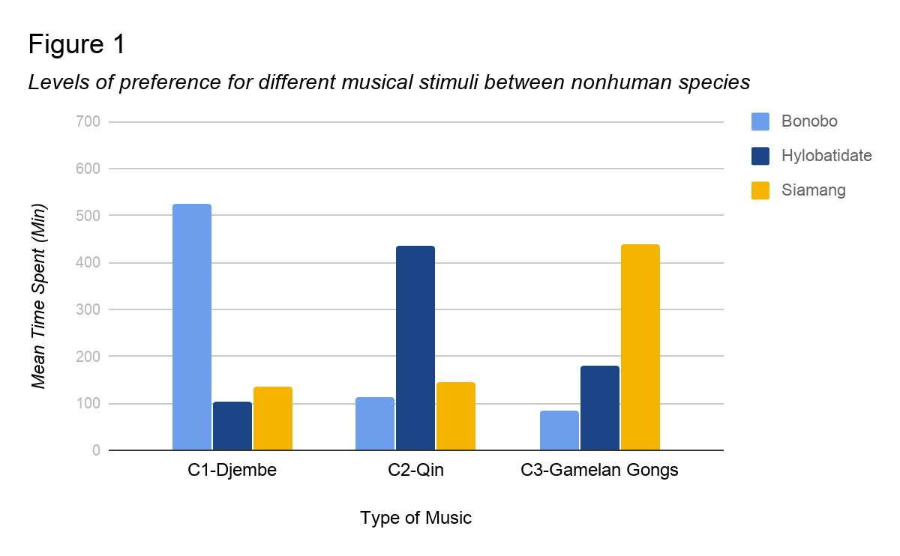

Table 1
Mean response time of each breed group on each stimulus location.
 | Bonobo | Hylobatidate | Siamang
C1-Djembe | 524 | 102 | 135
C2-Qin | 113 | 437 | 146
C3-Gamelan Gongs | 83 | 181 | 439

Discussion
The purpose of this study was to test how environmental influence can affect the forming of musical preference in nonhuman primates. I hypothesized that the environmental influence (factors) on the forming of musical preference in human is common in nonhuman primates, in a sense of biological and contextual perception. In other words, I expected the nonhuman primates would prefer musical stimuli with more familiar environmental factors in its sound components. In the presented study, each breed group showed a significant preference for the matched musical stimulus. The hypothesis was supported by the presented study with the significance of the presented study result.
One supportive strength of the presented study was the stimuli which were designed to be more than just a sound but an actual musical experience while with its sound components controlled to prevent EVs. The stimulus designing based on acoustic world music was effective, and the result was consistent with those of Mingle et al. (2014). Through controlling each component, the designed stimuli were not only acoustic world music but also able to provide specific degrees of each component. The presented study indicated that sounds with its loudness between 35dB to 45dB were effective possibly because it was about the same loudness of sounds in nature such as forests and plains. Including the stimuli mentioned above, the experiment environment was designed to minimize unwanted EVs and to maximize the expected significance of the result. Pre-study EV prediction included EVs such as the visual effect of artificial objects in the environment and aggression between males caused by unbalanced sex ratio within the study group.
The stimuli and the experiment environment supported the reliability of the presented results effectively, yet there were limitations such as animal experiment policy limitations. Whether it is allowed to scan the selected animal’s brain through methods such as MRI and PET would be a possible problem in future studies at the neural level. Thus, to find out more detailed brain activity of the subject, the selection of experimental technique will be important and significant. Another part of the room to be improved for the future research, different components such as the timbre of the musical stimuli shall be focused for a broader understanding of the role of each sound component in the musical perception. For instance, designing musical stimuli while focusing on the timbre difference between each stimulus can be a new angle to approach the environmental factors in a musical experience. It is because of the timbre differences created by the material differences between the instruments directly function as different environmental factors of musical experience.
The results of the study were significant in the sense of showing the underlying environment influence on musical preference forming and possible new study goals. Further understanding of common traits within musical activity and perception in human and nonhuman species shall reveal the essential borderline between human music and nature music. Also, it will contribute to fields such as animal treatment and music technology for communication between species.

Reference
Clutton‐Brock, T. H., & Huchard, E. ( 2013). Social competition and selection in males and females. Philosophical Transactions of the Royal Society B: Biological Sciences,368, 20130074–20130074.
Fruth, B. B. I. F. ac. u., Tagg, N., & Stewart, F. (2018). Sleep and nesting behavior in primates: A review. American Journal of Physical Anthropology, 166(3), 499–509
Hand, R. (2018). Schools and families as institutions of learning in Central Javanese gamelan. Ethnomusicology Forum, 27(1), 68–87
Hinds, S. B., Raimond, S., & Purcell, B. K. (2007). The effect of harp music on heart rate, mean blood pressure, respiratory rate, and body temperature in the African green monkey. Journal of Medical Primatology, 36(2), 95–100.
Honing, H., Merchant, H., Háden, G. P., Prado, L., & Bartolo, R. (2012). Rhesus Monkeys (Macaca mulatta) Detect Rhythmic Groups in Music, but Not the Beat. PLoS ONE, 7(12), 1–10.
Koda, H., Basile, M., Olivier, M., Remeuf, K., Nagumo, S., Blois-Heulin, C., & Lemasson, A. (2013). Validation of an auditory sensory reinforcement paradigm: Campbell’s monkeys (Cercopithecus campbelli) do not prefer consonant over dissonant sounds.Journal of Comparative Psychology, 127(3), 265–271.
Mingle, M. E., Eppley, T. M., Campbell, M. W., Hall, K., Horner, V., & de Waal, F. B. M. (2014). Chimpanzees prefer African and Indian music over silence. Journal of Experimental Psychology: Animal Learning and Cognition, 40(4), 502–505.
Novak, M. A., & Suomi, S. J. (1988). Psychological well-being of primates in captivity. American Psychologist, 43(10), 765–773.
Price, T. Y. . (2013). Rhythms of Culture: Djembe and African Memory in African-American Cultural Traditions. Black Music Research Journal, 33(2), 227–247
Samuels, A., & Henrickson, R. V. (1983). Outbreak of severe aggression in captive Macaca mulatta. American Journal of Primatology, 5(3), 277–281.
Waltham, C., Yang Lan, & Koster, E. (2016). An acoustical study of the qin. Journal of the Acoustical Society of America,139(4), 1592–1600

