MP3 Report
Ryan Walters
Garrett Haynes

Introduction
In this machine problem, we implemented a fork in order to create a client and server process from within a single program. The client and server established a channel based on the provided library. The client then sent requests of various formats to the server, which responded to these requests according to instructions in the dataserver.cpp file. In the first part of the machine problem, we measured the run time for sending requests along with the run time to perform the logic associated with the request response. Details on this are included in the Procedure section of this report. In the second part of the machine problem, we created a program that parsed various process data on a given process ID and output the data to the user. Details on this implementation are also included in the Procedure section of this report.

Procedure
In the first part of the machine problem, we were tasked with running the dataserver program from within the client program. We accomplished this using fork and making a system call to run dataserver from the child process. In the parent process, we continued the logic originally described in client.cpp. In order to measure the time it takes to send a request and receive a response, we used the chrono library. We took the system time before the request and subtracted it from the system time after the request which gave us the total time. We then timed the request logic using local functions. This allowed us to figure out which part of the total time was spent performing the request logic and which part was spent in transit. We found it to be much faster to do local function logic instead of sending the request via the channel. The results of our work are described in the Results section of this report.

In the second part of the machine problem, we were tasked with developing a program that would output information on a process ID supplied by the user. DESCRIBE PART TWO HERE.

Work Separation
Both Ryan and Garrett performed equal work when completing this machine problem. Ryan focused on the first part along with the report. Garrett focused on the second part of the machine problem. Both partners assisted each other on their respective parts and participated equally.

Results
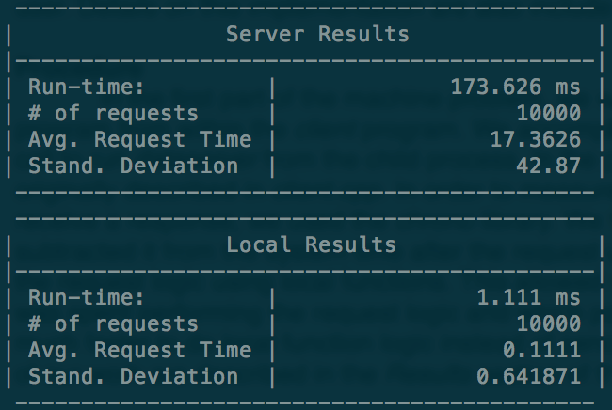
In the first part, we collected run-time information on 10,000 requests to the server as well as local requests. The program output is shown below:
The top table lists the data collected on requests sent to the dataserver. The total run-time was 173.626 millisecond. In 10,000 requests, the average request time(the time to send a request and receive a response) was found to be 17.3626 microsecond. The standard deviation for this data was found to be 42.87 microseconds.

The bottom table lists the data collected when using local functions to handle requests. As can be seen, it is a fraction of the time it takes to handle requests with a server. The difference in time is due to the time in “transit” in the channel. This includes all of the time the request spends between the client and dataserver.

In the second part, LIST FINDINGS FROM SECOND PART.

Analysis
In this machine problem, we found that almost all of the time it takes to send a request and receive a response is due to the wait time spent between the client and dataserver. Because of this, we can conclude the best way to speed up the response time is to find the bottleneck of transit and speed this up as much as possible. One theory we had is there is a bottleneck in the time it takes to read and write channel data. This could possibly be improved by integrating faster hardware the offers better I/O performance.

Conclusion
There were no questions included in the handout that required further explanation.

