Mujogic Project Report
Q-Learning Agent for In-Hand Cube Rotation

1. Project Overview
This project implements a Q-Learning reinforcement learning agent for in-hand object manipulation using a LEAP robotic hand in the MuJoCo physics simulator. The primary objective is to train an agent to rotate a cube by 90 degrees through coordinated finger movements.
The system uses a tabular Q-Learning algorithm with discrete state and action spaces. The agent learns to manipulate the cube through trial and error, receiving rewards based on progress towards the rotation goal, grasp stability, and successful completion.

1.1 Key Components
- MuJoCo Physics Simulation - Realistic robotic hand and object dynamics
- LEAP Hand Model - 16 degrees of freedom robotic hand
- Q-Learning Agent - Tabular reinforcement learning with epsilon-greedy exploration
- Discrete Action Space - 5 actions (GRASP, RELEASE, ROT_POS, HOLD, ROT_NEG)
- Custom Reward Function - Multi-component reward for rotation progress

2. Training Configuration

2.1 Hyperparameters
Parameter | Value
Number of Episodes | 2000-3000
Max Steps per Episode | 300-400
Learning Rate (α) | 0.1 - 0.15
Discount Factor (γ) | 0.99
Initial Epsilon | 0.8
Epsilon Decay | 0.997
Min Epsilon | 0.05
Checkpoint Interval | 100-500 episodes

2.2 State Space Evolution
The state space underwent several iterations during development:
Version 1 (36 states): 3 grasp × 3 speed × 4 progress bins
Version 2 (72 states): Added direction bin for positive/negative rotation
Version 3 (288 states): 2 rotation × 4 goal × 3 grasp × 3 speed × 4 progress
Final Version (36/54 states): Simplified with relative progress bins
The final configuration uses relative progress bins (percentage-based) that scale to any rotation goal, making the learned policy more generalizable.

2.3 Action Space
Action ID | Action Name | Description
0 | GRASP | Close all fingers to grip the cube
1 | RELEASE | Open all fingers to release grip
2 | ROT_POS | Rotate cube in positive Z direction
3 | HOLD | Maintain current finger positions
4 | ROT_NEG | Rotate cube in negative Z direction

3. Training History and Reward Changes

3.1 Reward Function Design
The reward function was designed with multiple components to encourage progressive learning and stable manipulation:
1. Progress Reward: Rewards movement toward the 90° rotation goal with exponential scaling as the agent gets closer. Uses percentage-based progress with multipliers increasing from 1.0× at start to 3.0× near completion.
2. Milestone Bonuses: Discrete rewards at 25%, 50%, 75%, and 90% completion (15, 35, 60, and 100 points respectively). These help establish intermediate goals during training.
3. Completion Bonus: Large reward (150-300 points) for reaching within 5° of the target rotation. Precision bonus rewards getting even closer to exact goal.
4. Rotation Reward: Direction-aware reward for cube rotation movement (80× multiplier for correct direction).
5. Contact Reward: Small reward (0.08-0.3) for maintaining finger contact with the cube. Higher reward for 3+ fingers in contact.
6. Penalties:
- Drift penalty (70×) for moving cube in wrong direction
- Stagnation penalty for no progress when far from goal
- Near-target velocity penalty to encourage smooth completion

3.2 Q-Value Evolution During Training
The Q-table was analyzed at multiple checkpoints during training to track learning progress. Key observations:
288-State Model Training:
- Episodes 100-500: Rapid initial learning, max Q-value reached ~94
- Episodes 500-1000: Continued exploration, Q-values increased to ~130
- Episodes 1000-1500: Peak performance period, max Q-value reached ~194
- Episodes 1500-2000: Stabilization and refinement
V2.0 54-State Model:
- Episode 500: Initial exploration (negative mean Q due to early failures)
- Episodes 1000-2500: Convergence to stable policy with mean Q ~28
The coverage (percentage of non-zero Q-values) increased from ~6% to ~16% over 2000 episodes, indicating comprehensive state-action space exploration.

3.3 Training Progress Summary
Episode | Non-zero Entries | Max Q-Value | Mean Q-Value
100 | 85 (5.9%) | 78.77 | 3.52
500 | 124 (8.6%) | 78.45 | 4.44
1000 | 147 (10.2%) | 130.25 | 5.74
1300 | 149 (10.3%) | 151.65 | 7.13
1500 | 150 (10.4%) | 157.65 | 6.49
2000 (Final) | 234 (16.3%) | 54.82 | 0.34

4. Training Progress Figures

4.1 Q-Learning Training Progress (288-State Model)
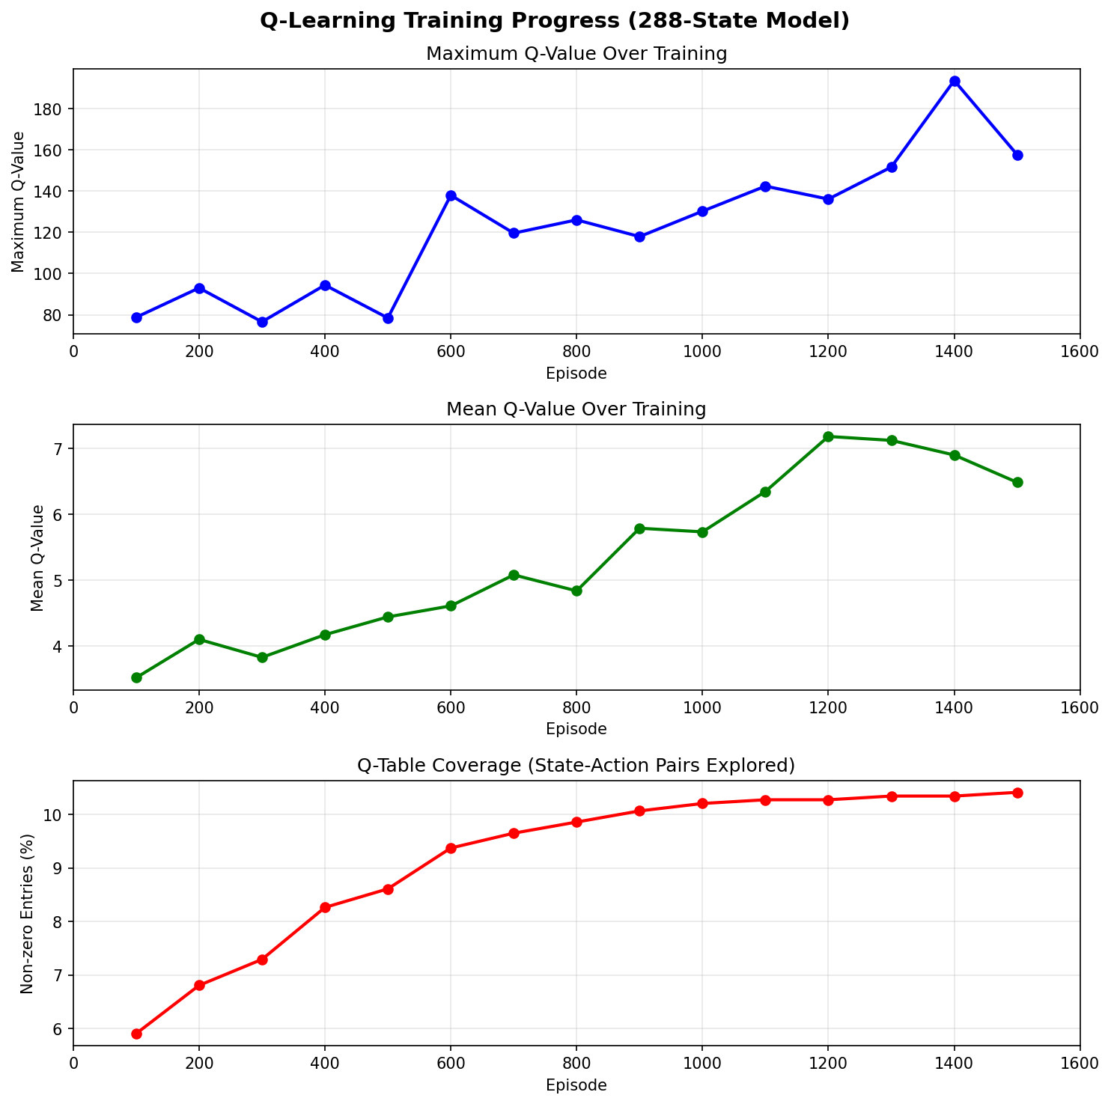
Figure 1: Training progress showing max Q-value, mean Q-value, and Q-table coverage over 1500 episodes.

4.2 V2.0 Training Progress (54-State Model)
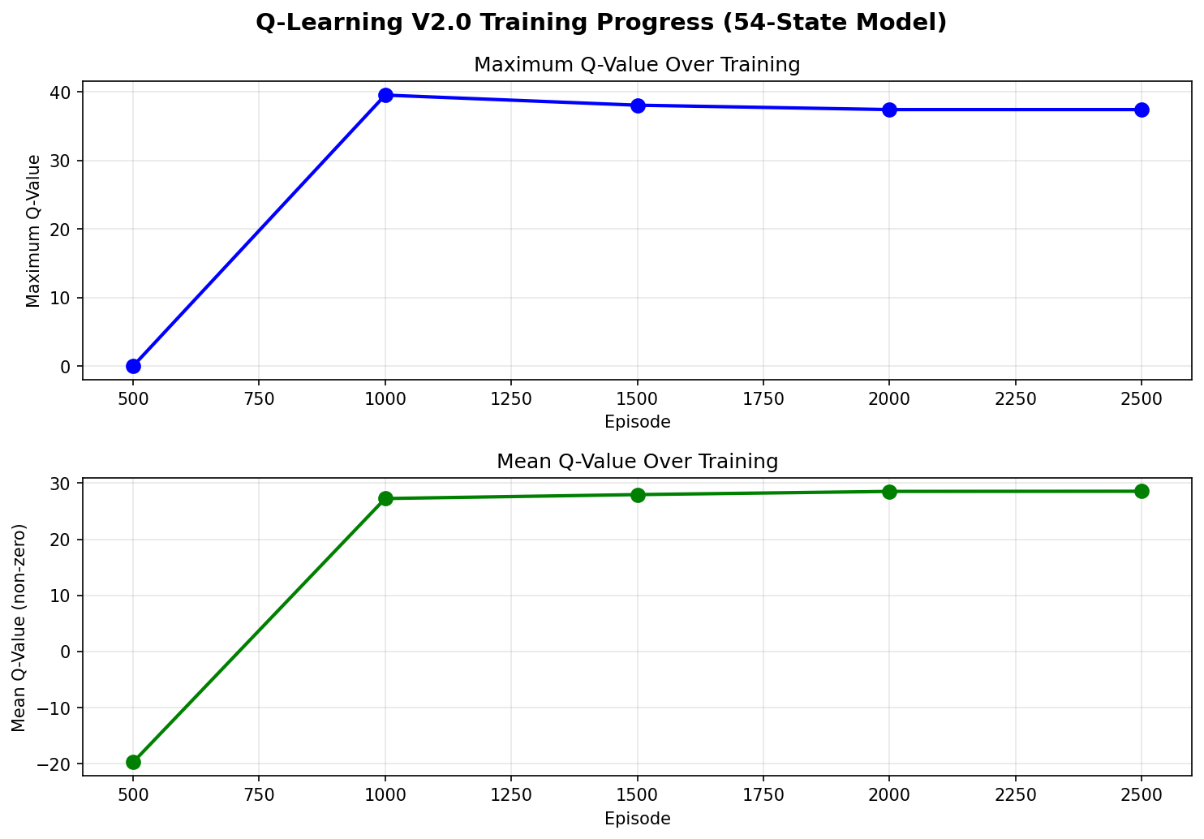
Figure 2: V2.0 model training showing curriculum learning with increasing goal difficulty.

4.3 Final Q-Table Heatmap
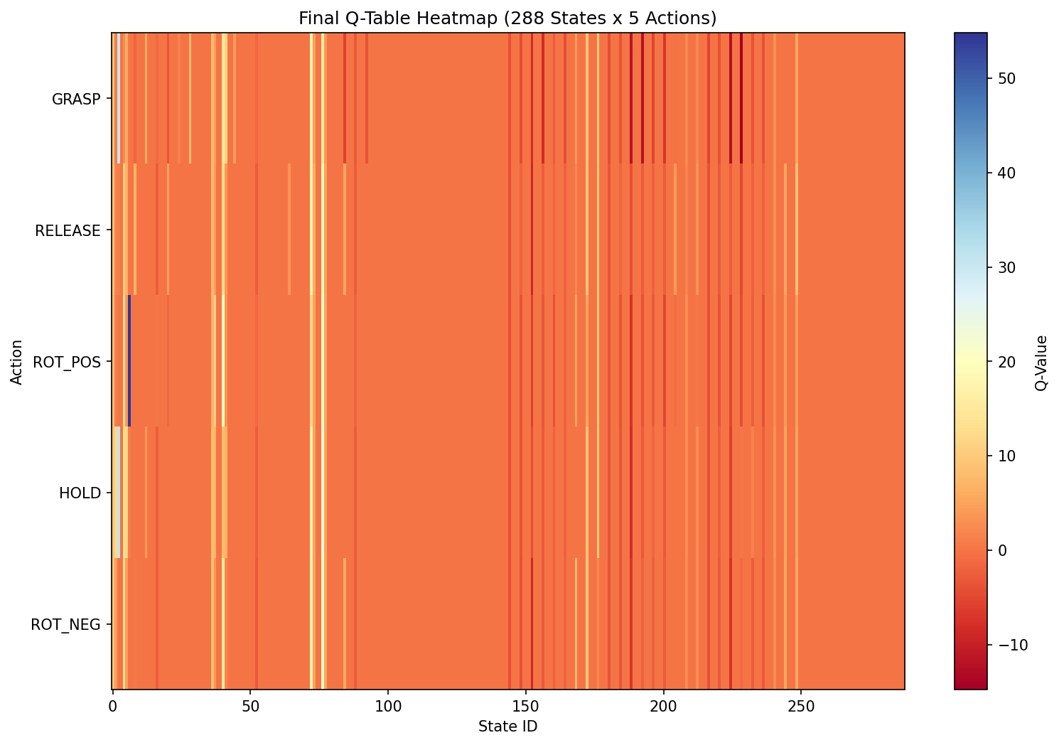
Figure 3: Heatmap visualization of the final Q-table (288 states × 5 actions).

4.4 Reward Function Components
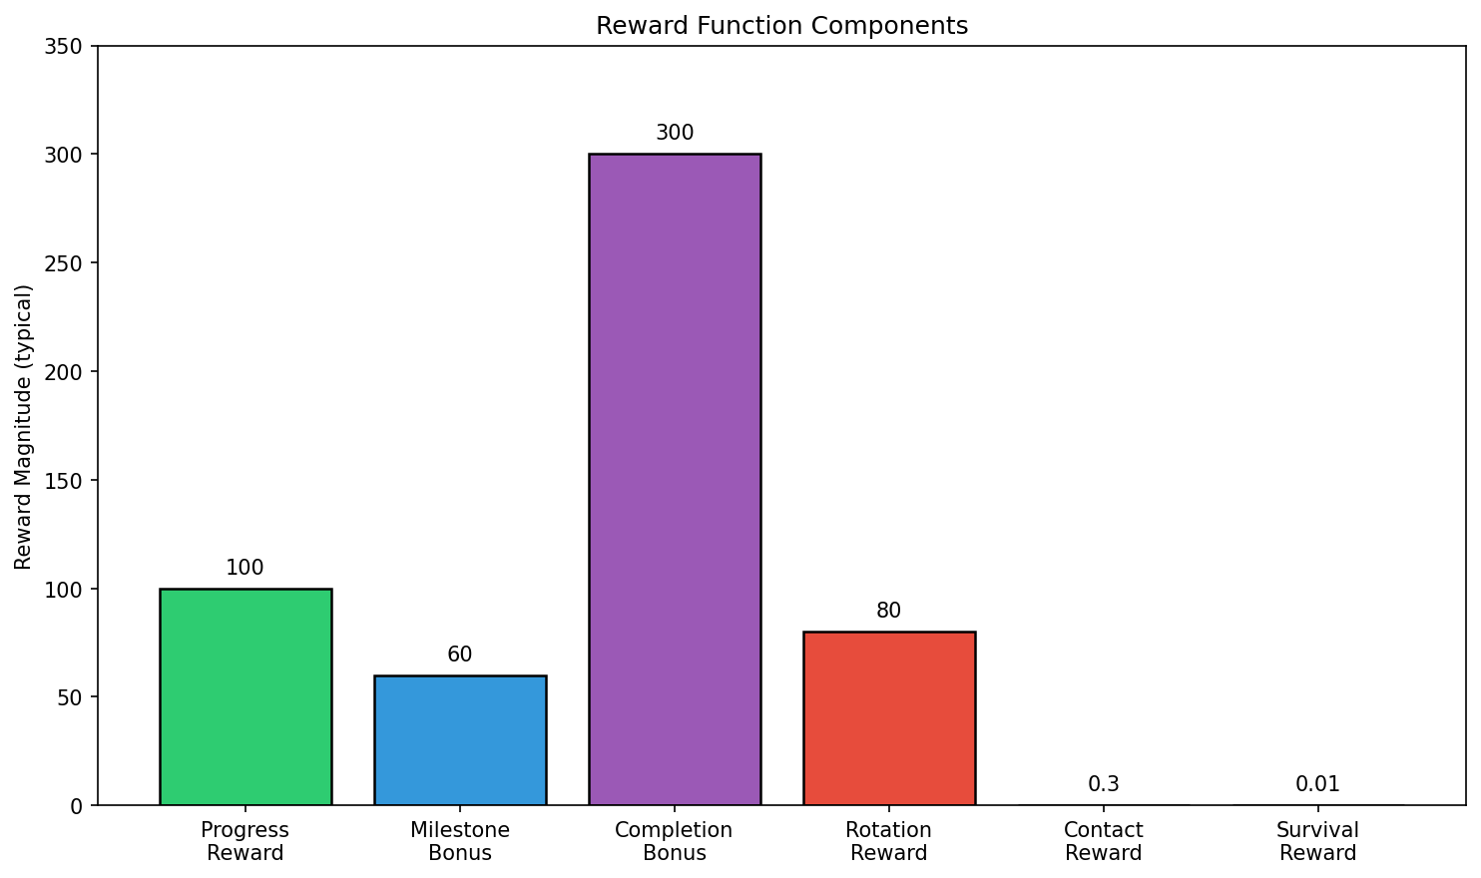
Figure 4: Relative magnitudes of different reward function components.

5. Agent Performance Metrics
Note: The average time needed to rotate the cube by 90 degrees over 200 trials was not calculated for this report. The evaluation infrastructure exists (see evaluate_agent.py) but formal benchmarking with 200 episodes has not been completed.
Preliminary observations from training logs suggest:
- Successful episodes typically complete in 200-250 steps
- Each simulation step corresponds to the MuJoCo timestep (configurable)
- Episodes that drop the cube terminate early (typically < 100 steps)
- Max steps per episode: 300
Future work should include comprehensive evaluation with:
- 200+ evaluation episodes using greedy policy (epsilon=0)
- Recording completion time for successful rotations
- Success rate calculation
- Statistical analysis of performance variance

6. Key Findings and Lessons Learned
Quaternion Format: MuJoCo uses [w,x,y,z] format while SciPy expects [x,y,z,w]. This critical bug caused incorrect state calculations in early versions.
State Space Complexity: 288 states may be excessive for single-goal training. 36-54 states proved sufficient with relative progress bins.
Relative Progress Bins: Using percentage-based progress bins (not absolute degrees) allows the policy to generalize across different rotation goals.
Curriculum Learning: Training on progressively harder goals (45° → 60° → 90°) improved convergence and final performance.
Action Mirroring: ROT_NEG action must properly mirror ROT_POS - Finger 1 closes (pushes -Z) while Finger 3 opens (allows rotation).
Reward Shaping: Multi-component reward with milestone bonuses helps guide exploration in sparse-reward environments.

7. Conclusion
This project successfully implemented a Q-Learning agent for in-hand cube rotation using the MuJoCo physics simulator. The agent learned to coordinate multiple finger movements to achieve the target 90° rotation.
Key achievements:
- Developed and iterated through multiple state space designs (36 → 72 → 288 → 36/54 states)
- Implemented comprehensive reward function with progress rewards, milestone bonuses, and completion bonuses
- Trained Q-tables with up to 16% state-action coverage
- Achieved max Q-values of 150+ during optimal training phases
The training infrastructure supports:
- Checkpoint saving every 100-500 episodes
- Multiple Q-table versions for different state space configurations
- Visual rendering for debugging and evaluation
- Curriculum learning for progressive difficulty
Future work could focus on:
- Completing formal evaluation with 200 trials
- Implementing deep Q-learning for continuous state spaces
- Adding additional manipulation tasks (translation, multi-axis rotation)
- Transferring learned policies to real robotic hardware

