Introducing Pottery Place

A community-driven, ceramics haven

#### By Person Date

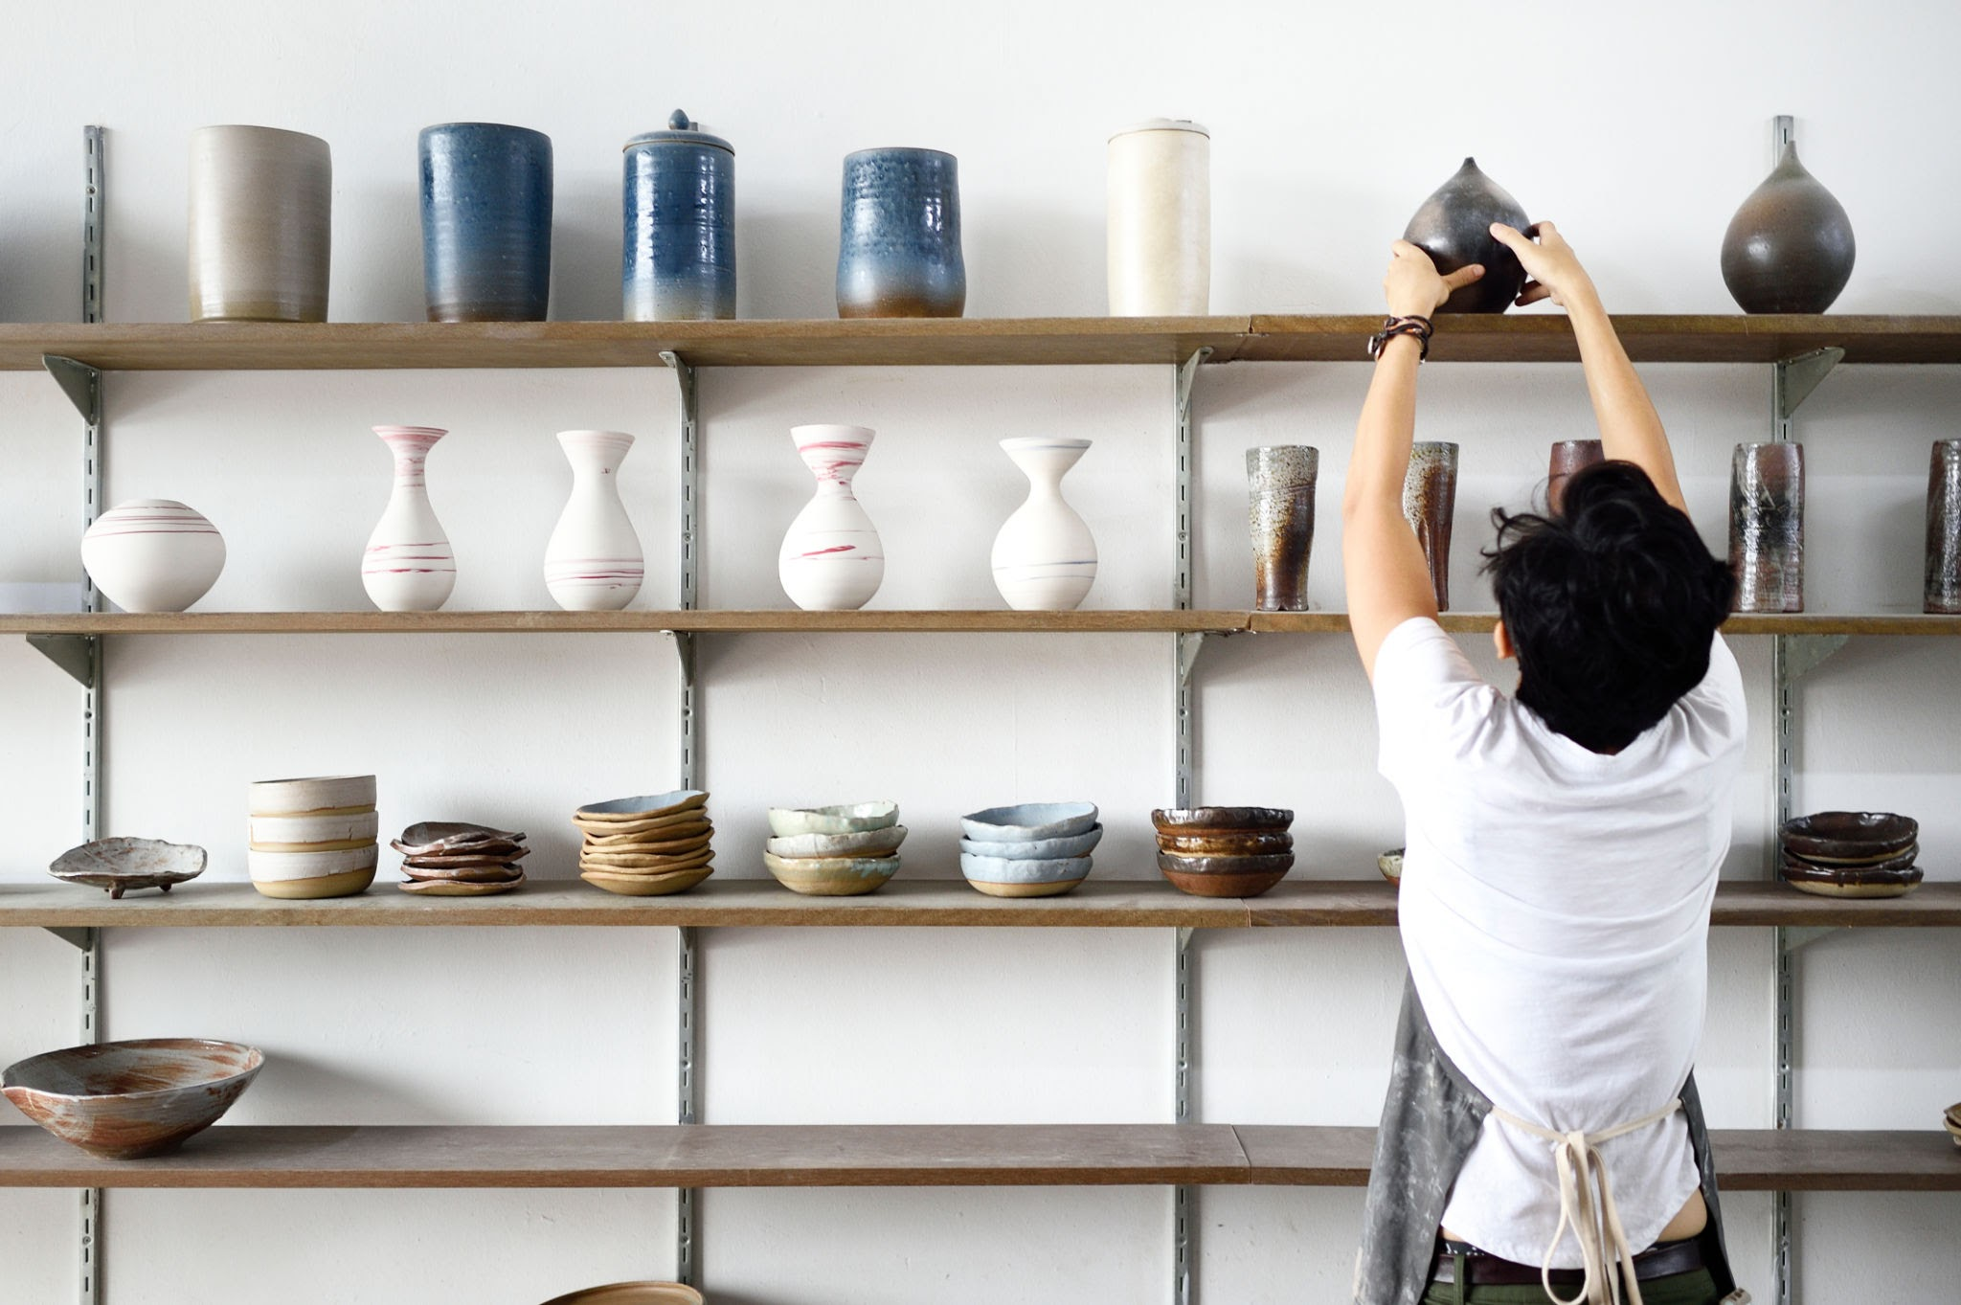

The gallery wall. Photo credit: Person

### Pottery Place is finally open!

I made my first ceramic teapot when I was 8. It was pale blue, round, and the size of a peach. Then I made another. It was brown and diamond-shaped. Then I made another. And another. Soon, I had a collection of mini teapots lining my bookshelf. I had trouble focusing on traditional academics, but when my hands were on a pottery reel, I’d get lost in the moment and create for hours at a time. I was a perfectionist, but never cared whether my creations were perfectly formed or beautifully flawed.

There’s something about the ability to take raw materials and transform them into something tangible and meaningful. I discovered endless possibilities emerge when creativity meets clay and fire. My head feels lighter and I can be in the moment focusing only on what’s in front of me.

Now, I want to share this experience with others by opening Pottery Place. It is more than a business; it's a community where people can disconnect from the daily grind, connect with their creativity, and discover the joy of shaping their own narratives through clay.

# Our studio

| Teapots, cups and other pottery items on wooden shelf in pottery studio |  | Senior woman artist making clay bowl on pottery wheel in pottery studio. |
| --- | --- | --- |
| The little things matter |  | Made with care |
| We take pride in using high-quality materials and time-honored techniques to create pottery that is both durable and aesthetically pleasing. |  | Our artisans put love and care into every piece they create. They aren’t just making ceramics; they’re sharing a piece of themselves through their work. |

## “Pottery is about patience and resilience. Each spin of the wheel is a lesson in adapting to change and finding beauty in imperfection.”

#### — Person, Renowned ceramics artist

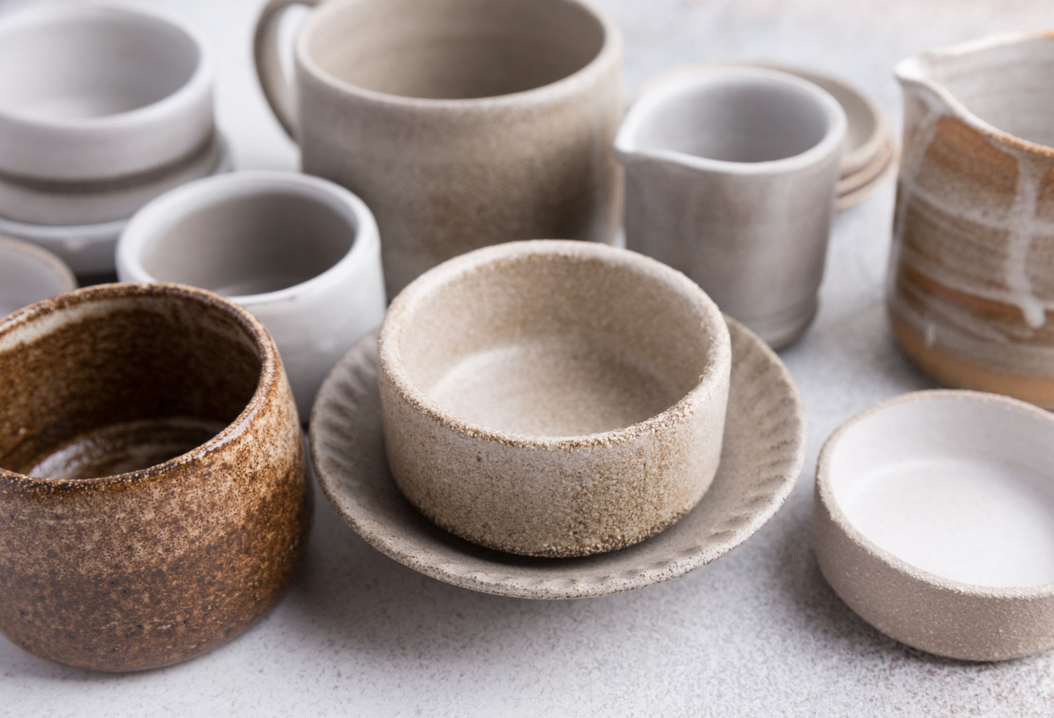

Currently available at the studio. Photo credit: Person

# Our products

Every piece tells a story. From the moment the clay is wedged to the final glaze firing, each step in the process is undertaken with meticulous care. Our team of skilled artisans and dedicated apprentices work together to create unique pieces that reflect the beauty of handmade craftsmanship.

What we offer:

* Artisanal tableware: Elevate your dining experience with our collection of elegant plates, bowls, mugs, and serveware
* Home decor: Discover a curated selection of vases, planters, and decorative pieces that enrich your home with warmth and character
* Bespoke creations: Let us bring your vision to life with a commissioned piece made just for you

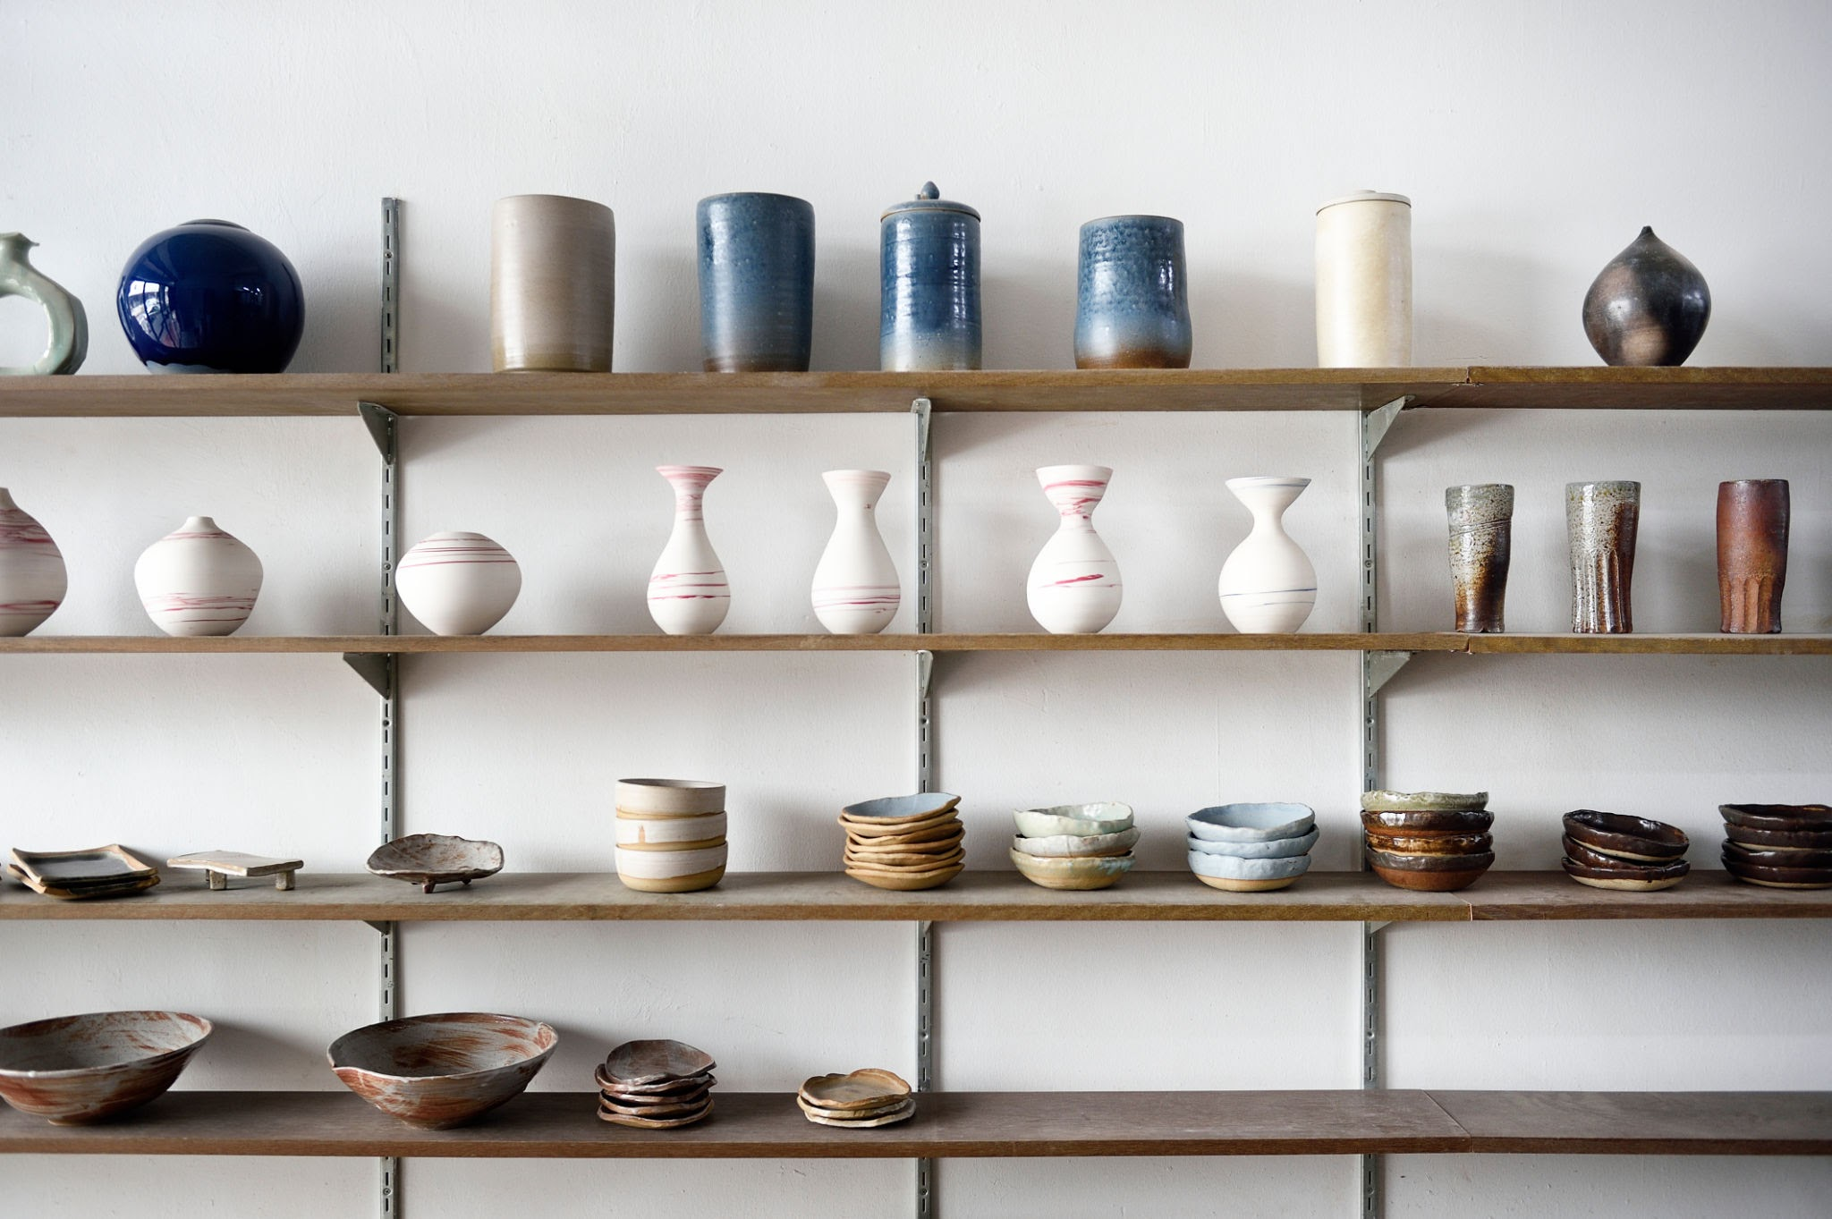

Goods for the home, by our artisans. Photo credit: Person

# Community and craft

At Pottery Place, we believe in the power of art to bring people together. That might mean finding the perfect piece to complete your family home, or connecting with classmates while creating your own masterpieces.

We currently offer three classes in the studio to help you experience the joy and community of ceramics.

### Introduction to hand-building

Learn the basics of hand-building in a fun, supportive environment.

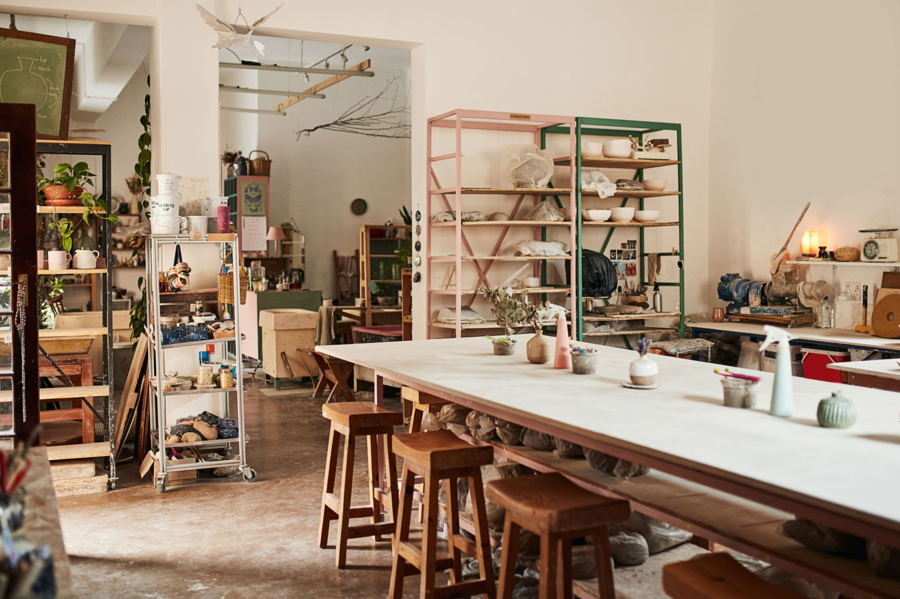

### Wheel-throwing for beginners

Get comfortable on the wheel with this introductory class, no experience necessary.

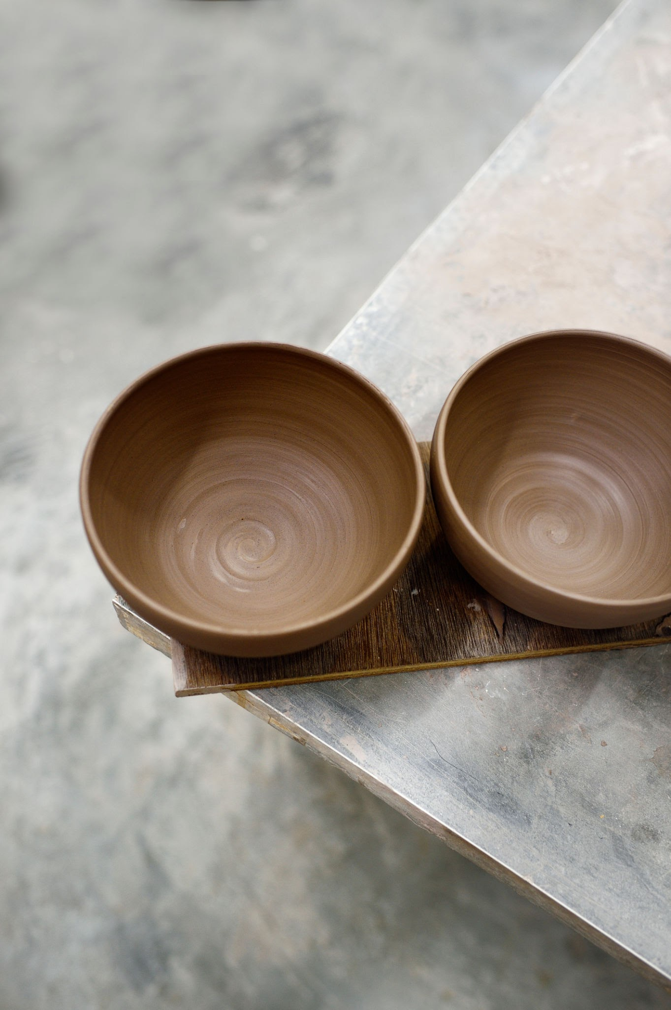

### Intermediate wheel

Improve your wheel-throwing skills and try more advanced projects in this intermediate class. You must complete Wheel 1 before enrolling.

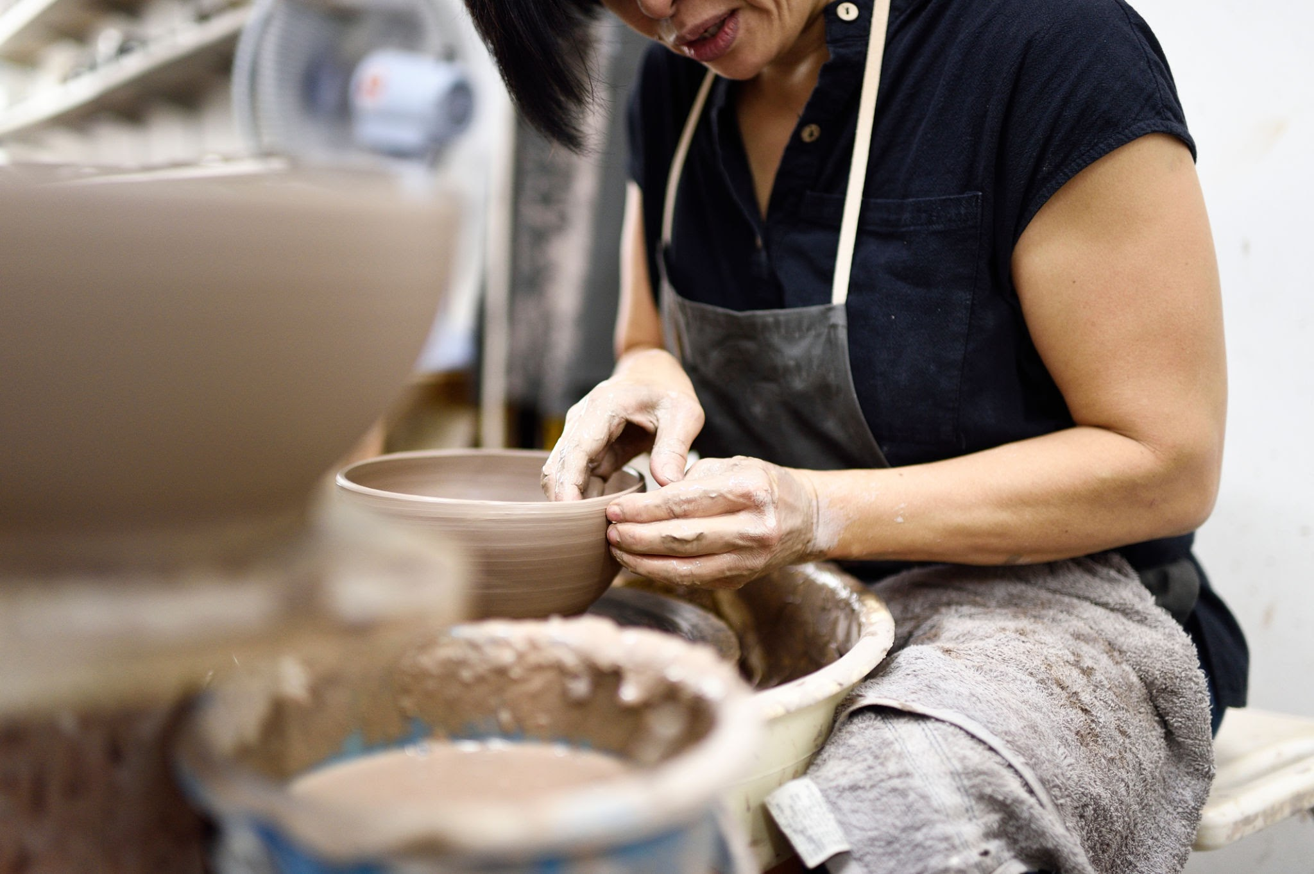

We invite you to join our growing community of ceramic enthusiasts. Visit our studio, attend a workshop, or explore our collection online. Follow us on social media to stay updated on our latest creations, upcoming events, and special promotions.

Thank you for being a part of our story. Let's create something beautiful together. Learn more

# Share & follow

### For any inquiries, please contact:

Person

Email

Website

YouTube