Deloitte.
WRITE AN EFFECTIVE PROMPT

A prompt is the instruction, question or request you give an AI tool. The clearer your prompt, the easier it is for the AI to understand what you need and produce a useful response. You do not need a perfect formula. You just need enough direction to remove guesswork.

Use the GCSE framework
GCSE stands for Goal, Context, Source and Expectations. Think of these as layers in a cake: each one adds useful information and helps the AI produce a response that is more accurate, relevant and fit for purpose.
Goal  What outcome do you want? | Context  What background information should the AI know?
Source  What information should the AI use? | Expectations  What format, style or level of detail do you want?

SIMPLE ANALOGY  Build your prompt like a layered cake  Each GCSE element adds something important. Layer them together to give the AI a clearer brief and create a response that is richer, more relevant and fit for purpose. | 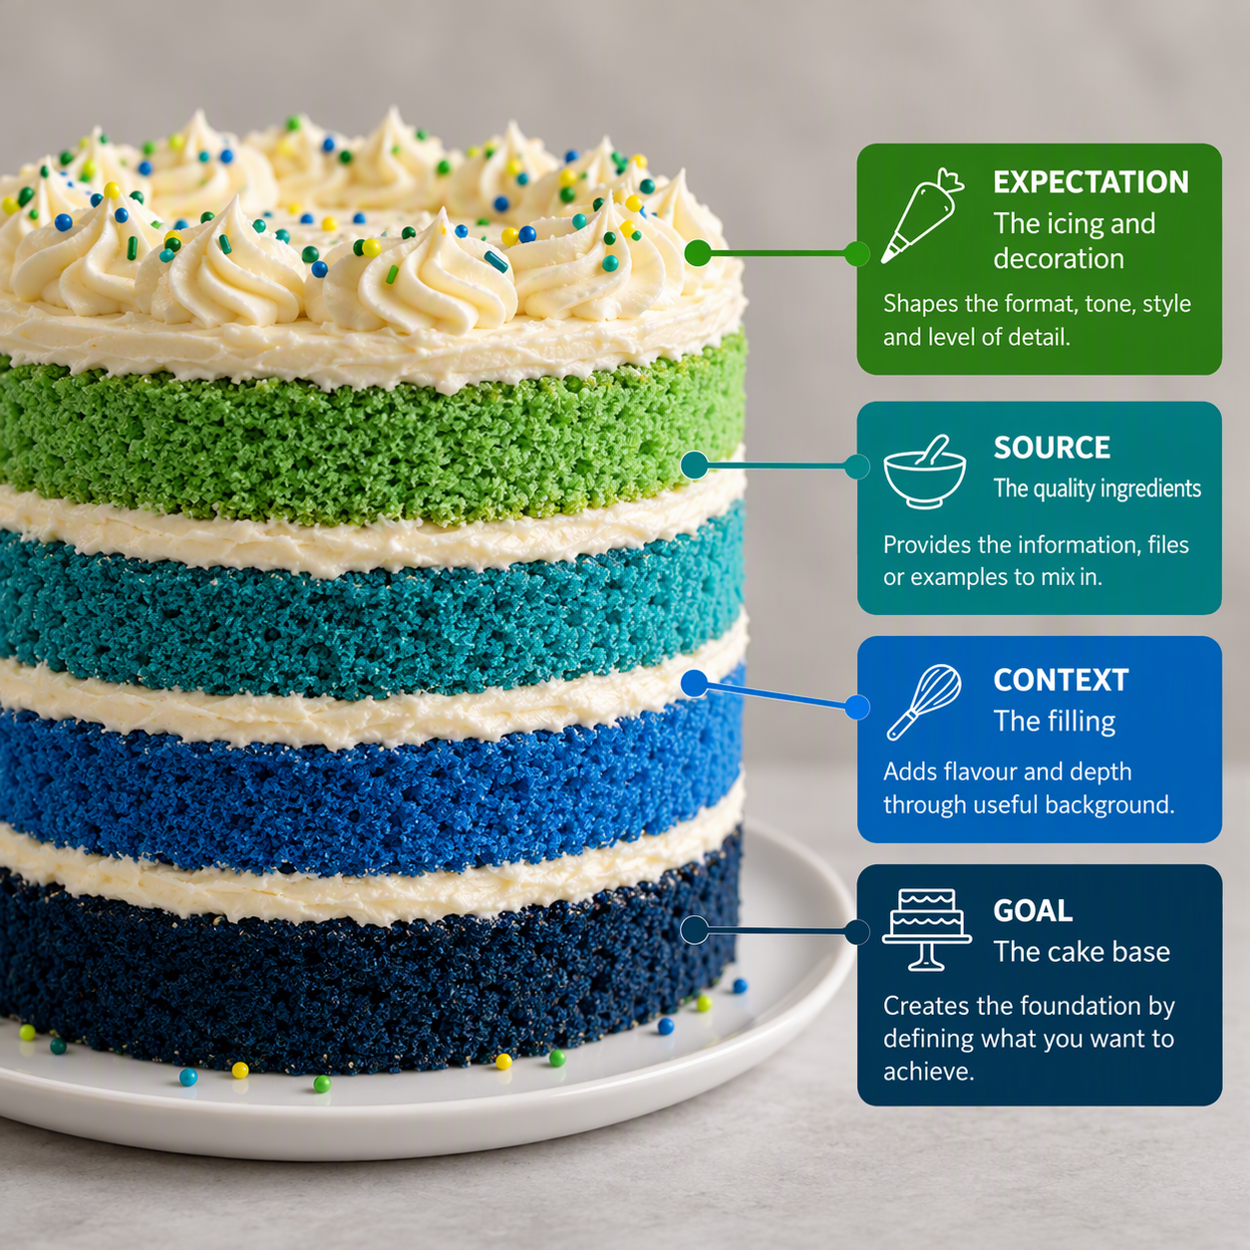

See the difference
Compare the prompts below to see how each GCSE layer makes the request clearer and more specific.
Less effective prompt  Summarise this report. | More effective prompt using GCSE  Goal: Help me prepare for a client meeting.  Context: I am meeting with the client’s CFO to discuss the findings.  Source: Use the attached report only.  Expectation: Create a one-page executive summary covering the key findings, risks, opportunities and three questions I should ask.

Your prompt does not need to be perfect. Clear instructions, relevant context and useful source material matter more than following a rigid formula. If the response misses the mark, adjust one GCSE element and try again. For example, add more context, specify a source or clarify the format you need.
Try it yourself: Practice writing clear, descriptive prompts with the Say What You See activity.
Say What You See — Google Arts & Culture

