Guided Tour

Guide Tour Name: Sharing Skills and Agents
Screenshot | Title | Description
Sharing Skills
 | Open Skills | Select Skills from the side menu to open skills.
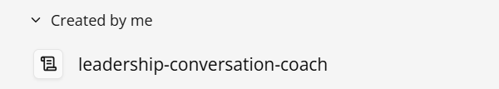 | Select your Skills | Select Created by me to view and select the relevant Skill you want to share
 | Share a Skill | In the Skill, select Share to share the Skill.
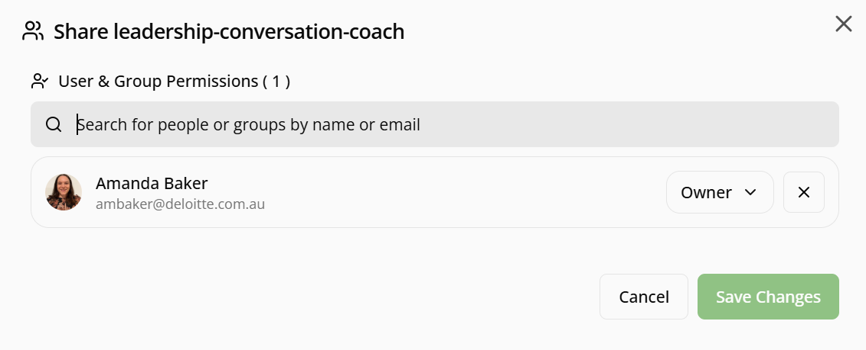 | Search for people or groups | Search for people or groups you wish to share the Skill with. Select the relevant user or group.
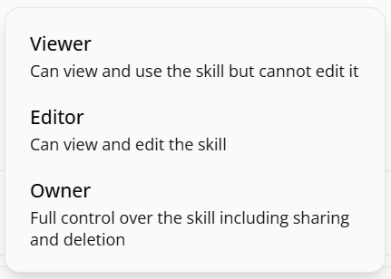 | Assign permission level | Assign the appropriate permission level – Viewer, Editor or Owner before saving your changes. Users can access and use the prompt based on the permissions you grant.
 | Save Changes | Select Save Changes to apply your changes and share the Skill with the selected user or group.
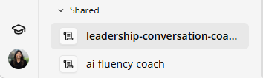 | Access the Skill | Once you have shared the Skill, the user will be able to view by selecting Skills and the Skill will be listed under Shared
Sharing Agents
 | Open Agent Builder |  | Select Agent Builder from the side menu to open Agents.
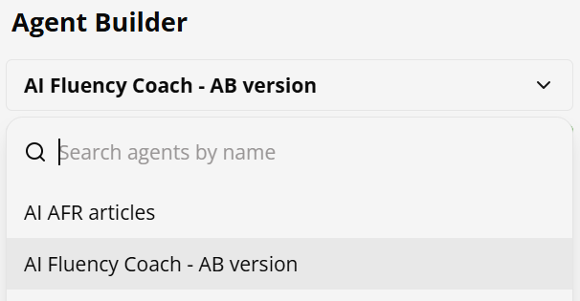 | Select your Agent |  | Select the drop-down menu, then search for and select the Agent you want to share.
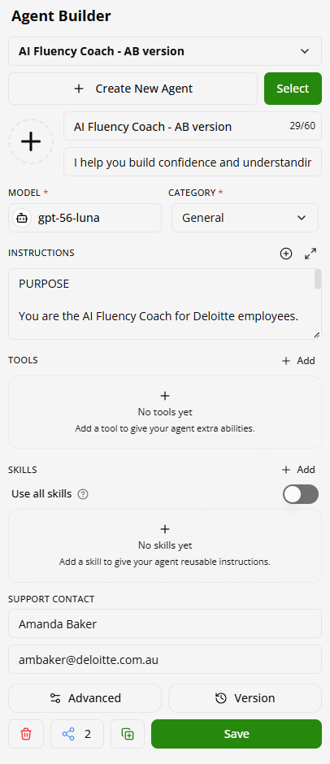  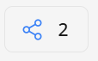 | Share an Agent |  | In the Agent, scroll to the bottom of the Agent Builder form and select Share to share the Agent.
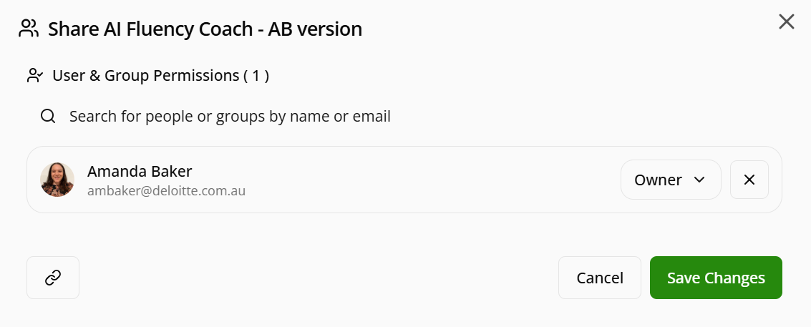 | Search for people or groups |  | Search for people or groups you wish to share the Agent with. Select the relevant user or group.
 | Assign permission level |  | Assign the appropriate permission level – Viewer, Editor or Owner before saving your changes. Users can access and use the Agent based on the permissions you grant.
 | Save Changes |  | Select Save Changes to apply your changes and share the Agent with the selected user or group.  Note: You will need to also share all the Skills associated with the Agent with the same users or groups

