Deloitte.
HOW TO BUILD A SKILL

A skill packages instructions, reference material and optional supporting files so MyAssist can complete a repeatable task in a consistent way.

CHOOSE HOW TO BUILD YOUR SKILL
Write skill instructions  Build directly in MyAssist | Build directly in MyAssist by adding a name, description and Markdown instructions. This is a good option for a straightforward skill that does not need supporting files.
Upload a skill  Package supporting material | Create the skill as a structured folder containing a required SKILL.md file and any supporting folders, then compress the folder as a ZIP file for upload. Use this option when the skill relies on references, templates, assets or scripts.
Use MyAssist to help  Draft or strengthen the skill | Use the MyAssist Skill Builder skill (myassist-skill-builder) to develop a first draft including creating the SKILL.md file, or the Skill Refiner skill (myassist-skill-refiner) to review and strengthen an existing skill. Check and tailor the result before creating or uploading it.

PLAN THE SKILL BEFORE YOU BUILD
1 | Define the outcome  State the task the skill should complete and the value it should provide.
2 | Set the trigger  Explain when the skill should be used and, where useful, when it should not be used.
3 | Identify the inputs  List what the user must provide, such as an audience, topic, source file or preferred format.
4 | Design the workflow  Break the task into clear steps and decision points. Tell the skill when to ask for missing information rather than guessing.
5 | Describe the output  Specify the structure, tone, level of detail and any mandatory sections or templates.
6 | Add guardrails  Include source boundaries, quality checks, privacy considerations and constraints that keep the response fit for purpose.
7 | Test and refine  Try realistic scenarios, including incomplete or ambiguous requests, then adjust the instructions where results vary.

WRITE EFFECTIVE INSTRUCTIONS IN MARKDOWN
Markdown is a lightweight way to structure plain text. It helps distinguish headings, steps, examples and rules without complex formatting. Use headings to separate ideas, numbered lists for ordered workflows, bullet lists for options or checks, and bold text sparingly to emphasise important labels. Keep each instruction specific and testable. You can use the following template to help you structure your SKILL.md file <insert SKILL.md template>

PREPARE THE UPLOAD FILE STRUCTURE

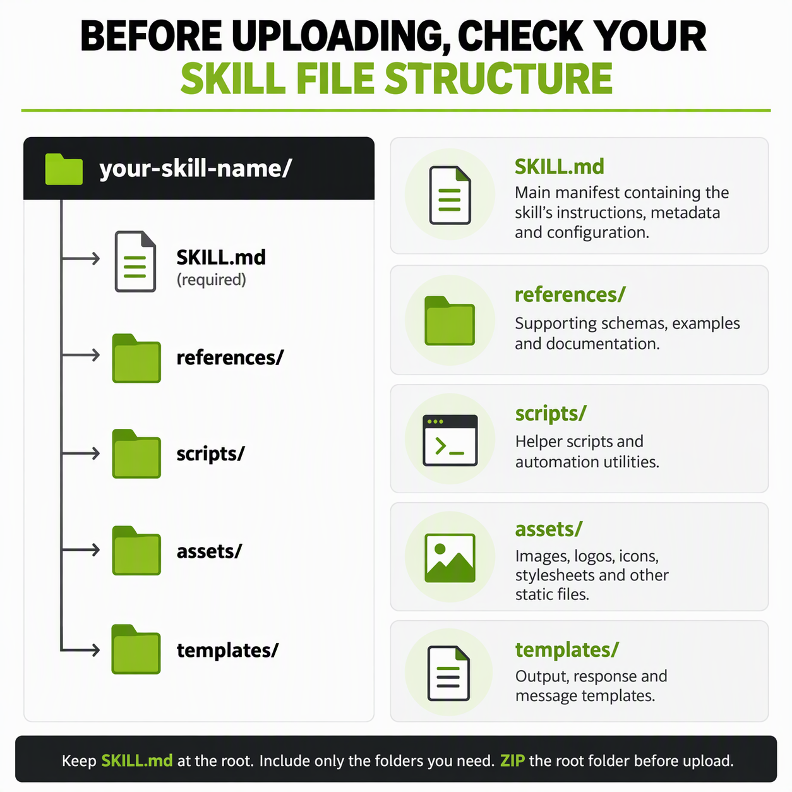

ZIP AND UPLOAD THE SKILL
1 | Open the root folder and confirm that SKILL.md is directly inside it.
2 | Check that file names and folder names exactly match any paths used in SKILL.md.
3 | Remove drafts, duplicate files and anything the skill does not need.
4 | Compress the root folder into a single .zip file. When the ZIP is opened, it should contain one skill folder with SKILL.md and any optional supporting folders inside it.
5 | In MyAssist, open Skills, choose Upload a Skill, select the ZIP file and follow the prompts to validate and create the skill.
6 | Test the uploaded skill with representative requests and refine the instructions or package if the results are inconsistent.

Guided Tour

Guide Tour Name: How to build a skill
Screenshot | Title | Description
Write Skill instructions
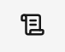 | Open Skills | Select Skills from the side menu to open Skills.
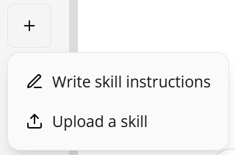 | Select Write skill instructions | Select Write skill instructions
 | Add a Skill name | Enter a short, descriptive name using lowercase words seperated by hypens  Example: brand-guidelines
 | Add a Skill description | Briefly describe what the skill does and where it can be used.  Example: Apply brand guidelines to presentations and documents.
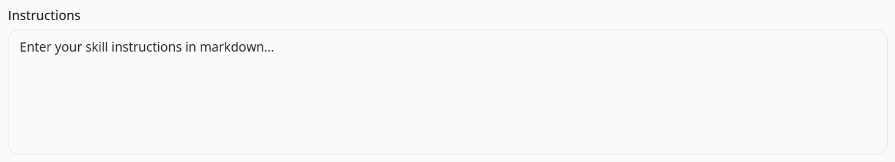 | Prompt Instructions - add custom variable content | Define how the skill should work using Markdown. Complete each section of the template, including its purpose, when to use it, required inputs, two-step workflow, expected outputs, response guidelines, ground rules, and constraints. Replace all placeholder text and remove any guidance or examples that are not needed.  Template: <insert link to SKILL.md>  Tip: You may wish to work with Copilot or MyAssist to refine your Skill.
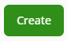 | Create Skill | Select Create to create the Skill
Upload Skill instructions
 | Open Skills | Select Skills from the side menu to open Skills.
 | Select Upload a Skill | Select Upload a Skills
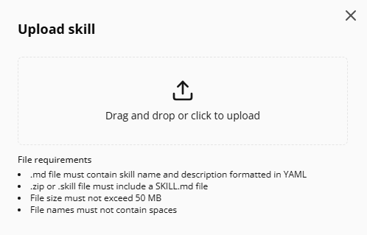 | Upload your skill | Select Upload skill and navigate to your skill’s root folder. The system validates the folder structure and SKILL.md content before publishing.  Note: For guidance on how to structure your SKILL.md file and folder structure, refer to the relevant article in the MyAssist Academy.

