Final Blueprint - Day 2: Architecture & Implementation Evolution

Global Fintech Company
Ricardo Zengin - Solutions ArchitectPerceptiva (Kong Partner)
September 17, 2026

Table of Contents
- Global Fintech Company
- 1. Introduction
- 2. Business Alignment & Objectives
  - Current Landscape
  - Implemented State (Day 2)
- 3. Delivery Roadmap (12-Week Plan)
- 4. Principles
- 5. Technology Landscape and Solution Overview
  - Architecture Diagram
  - Logical and Physical Topology
- 6. Certificates, Keys and Secrets
- 7. API Security and Access
- 8. Observability
- 9. Platform Ops & API Ops
- 10. Developer Experience
- 11. High Availability and Sizing
- 12. Kong Launch Playbook Alignment
  - Evolution Summary

1. Introduction
The purpose of this document is to detail the evolution of the Initial Blueprint (Day 1), moving from the architectural proposal to the real technical implementation of the solution using Kong Konnect, Kubernetes, APIOps, and Terraform.

2. Business Alignment & Objectives

Current Landscape
- Highly siloed operations between Credit Cards, Loans, and Personal Banking units.
- Legacy core systems causing bottlenecks and high latency.
- Security concerns regarding data exfiltration when using public LLMs for AI initiatives.

Implemented State (Day 2)
- Decentralized autonomy: Each BU manages its own APIs via GitOps using decK.
- High performance: Implemented caching strategies and isolated transactional vs. AI traffic at the Data Plane level.
- Zero-trust security: Centralized OIDC with Keycloak for partners, and strict PII redaction using ai-prompt-guard for AI endpoints.

3. Delivery Roadmap (12-Week Plan)
Roadmap for delivering a production-ready platform (Gantt Chart representation):
Phase / Activity | Weeks 1-3 | Weeks 4-6 | Weeks 7-9 | Weeks 10-12
Discovery & Foundation (Konnect, SSO, EKS) | 🟩
MVP Implementation (Data Planes, OIDC, AI Proxy) |  | 🟩
APIOps & CI/CD (GitOps, decK, Dev Portal) |  |  | 🟩
Go-Live & Shakedown (Migration, Testing, Rollout) |  |  |  | 🟩

4. Principles
- Architecture principles: Microservices architecture, elastic scaling, fault tolerance.
- Security principles: Encrypt at rest and in transit, zero-trust for external consumers, protect LLM access.

5. Technology Landscape and Solution Overview

Architecture Diagrams

Requirements Mapping
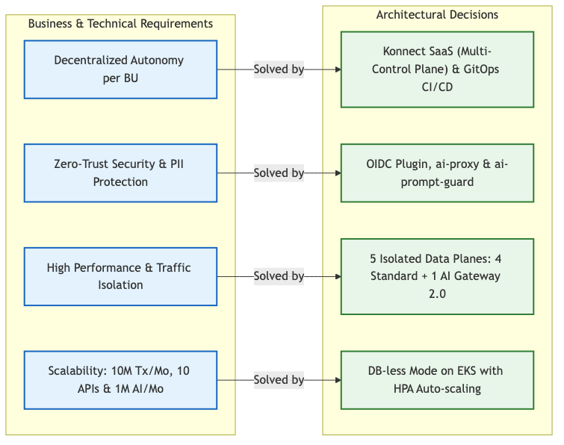
Requirements Mapping

Control Plane & Data Plane Topology
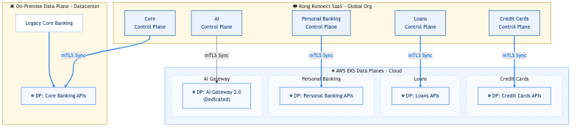
Architecture Diagram

Logical and Physical Topology
- Control Plane (Kong Konnect SaaS): Multiple logical Control Planes configured for segmentation (RZE-Core Banking, RZE-Credit Cards, RZE-Loans, RZE-Personal Banking, RZE-AI-Gateway-2.0).
- Data Plane (Execution Layer):
  - AWS EKS Cloud Data Planes: The APIs for Credit Cards, Loans, Personal Banking, and the dedicated AI Gateway 2.0 are deployed natively within a managed AWS EKS Kubernetes cluster.
  - On-Premise Data Plane: The Legacy Core Banking APIs are managed through an isolated Data Plane running on-premise in a traditional Datacenter, ensuring secure and direct access to legacy systems without exposing them directly to the cloud.

6. Certificates, Keys and Secrets
- Certificates: Each DP securely connects to its respective CP in Konnect using mTLS (anchored certificates locally generated by Terraform).
- Secrets Management: Kong centralizes AI provider credentials (e.g., OPENAI_API_KEY) securely via Konnect’s AI Gateway configurations, preventing leaks to end clients.

7. API Security and Access
- Client Authentication: OIDC (via Keycloak) implemented for Machine-to-Machine (client_credentials) flows in the Core Banking CP.
- Advanced Traffic Management:
  - Rate Limiting Advanced: Deployed in Credit Cards to protect /transactions.
  - Web Application Firewall (WAF): Simulated via ip-restriction in Personal Banking.
  - Data Masking: request-transformer implemented for obfuscating PCI-DSS sensitive data.
- AI Security: ai-prompt-guard acts as a cognitive firewall blocking PII and injection attempts on the fly.

8. Observability
- Native Telemetry: The global opentelemetry plugin was activated declaratively.
- Backend: Traces and metrics are exported directly to Signoz, allowing unified correlation of logs, metrics, and security blocks across all Data Planes in real-time.

9. Platform Ops & API Ops
- GitOps Monorepo: Configurations reside in gitops-monorepo/kong-config/ organized by BU.
- Tooling: decK (Declarative Configuration for Kong) is used to synchronize states (deck gateway diff/sync).
- Infrastructure Automation: Terraform is used to provision Control Planes and the Developer Portal automatically (main.tf, portal.tf).

10. Developer Experience
- Developer Portal: A unified Developer Portal (RZE-FinTech-Portal) was provisioned via Terraform.
- API Catalog Strategy: 10 APIs were uploaded to the internal Next-Gen Catalog, but only authorized external APIs (e.g., Accounts, Transactions, Open Banking Consent) were exposed on the external portal for Fintech onboarding.
- Mock Services: Local httpbin upstreams allow developers to test auth and rate-limiting policies predictably without hitting legacy backends.

11. High Availability and Sizing
- Data Plane Isolation: Transactional traffic and AI token processing are completely physically and logically separated to guarantee zero interference during traffic spikes.
- Canary Releases: Upstreams were configured with multiple targets and weight-based routing to allow safe and progressive API deployments.

12. Kong Launch Playbook Alignment
This Blueprint has been implemented adhering to the 6 core pillars of the Kong Launch Playbook MVP architecture:
- Resilient: 5 distinct Control Planes and isolated Data Planes ensure complete traffic isolation.
- Reliable: DB-less mode ensures Data Planes continue serving traffic even if connectivity to Konnect is lost.
- Observable: Telemetry endpoints are fully configured and exported to Signoz.
- Well Architected: Built on IaC (Terraform) and Declarative Configs (decK).
- Adheres to best practices: 100% adoption of APIOps, completely eliminating manual UI configuration for APIs.
- Focuses on a small scope initial API: The MVP successfully scoped Accounts, Transactions, and AI Fraud endpoints.

Evolution Summary
We transitioned from a static architectural design (Day 1) to a living platform, highly automated via GitOps/APIOps and Infrastructure as Code, where security, traffic management, and the consumption of Artificial Intelligence models are centralized, but API governance is distributed and managed autonomously by each BU.

