Computer Networks – Lab 1
Rohan G
CS22B1093

Q1)
ifconfig – configure network

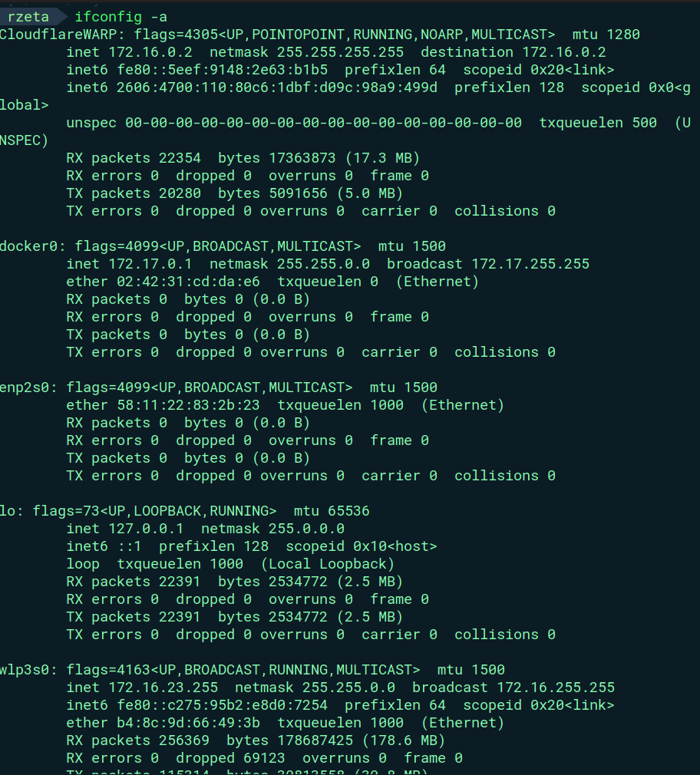
-a == display all interfaces

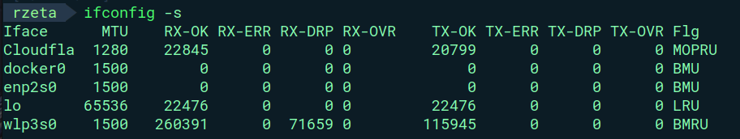
-s == display in short version

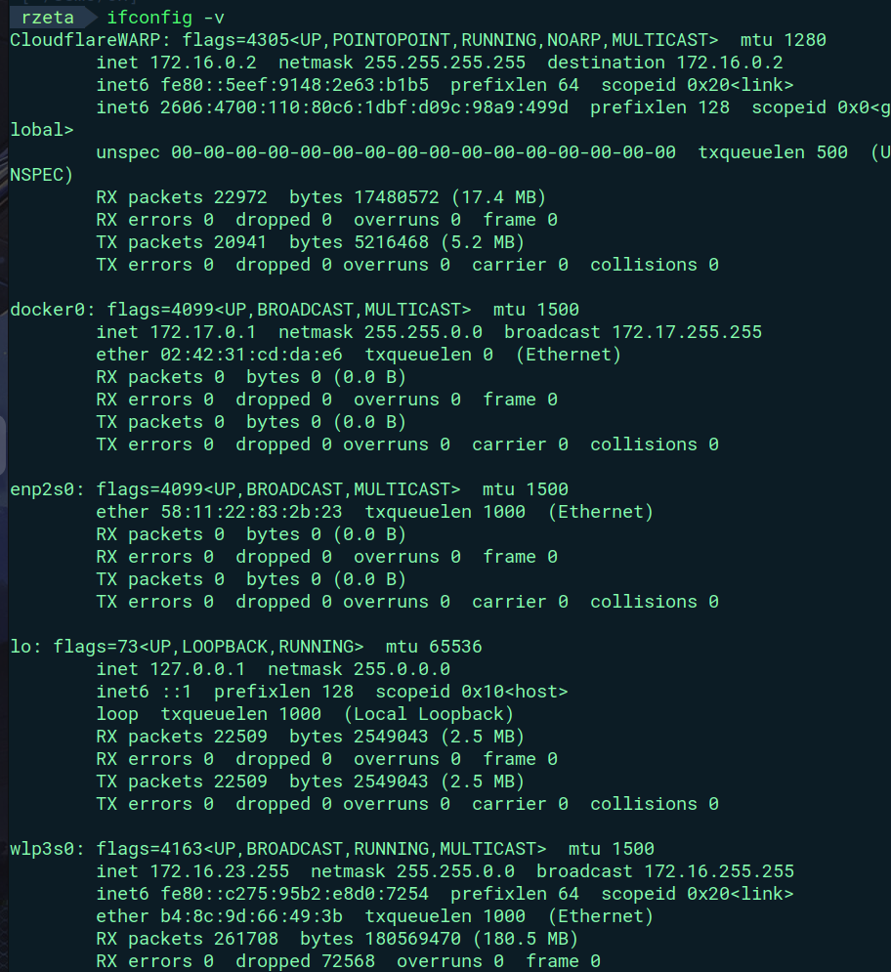
-v == verbose

Q2)
ping – test connectivity by sending ICMP echo requests
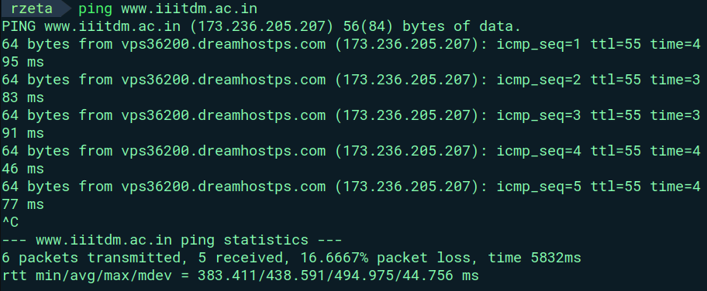
ICMP - Internet Control Message Protocol
-4 == IPv4
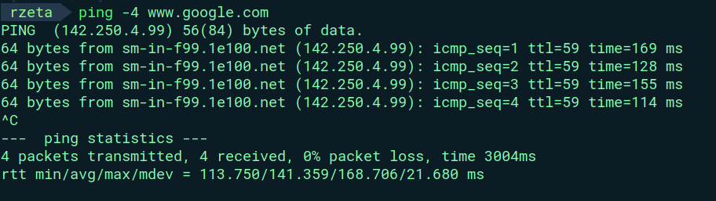
-6 == IPv6

When internet is turned off – showing network is unreachable

Q3)

traceroute – print the route trace to host

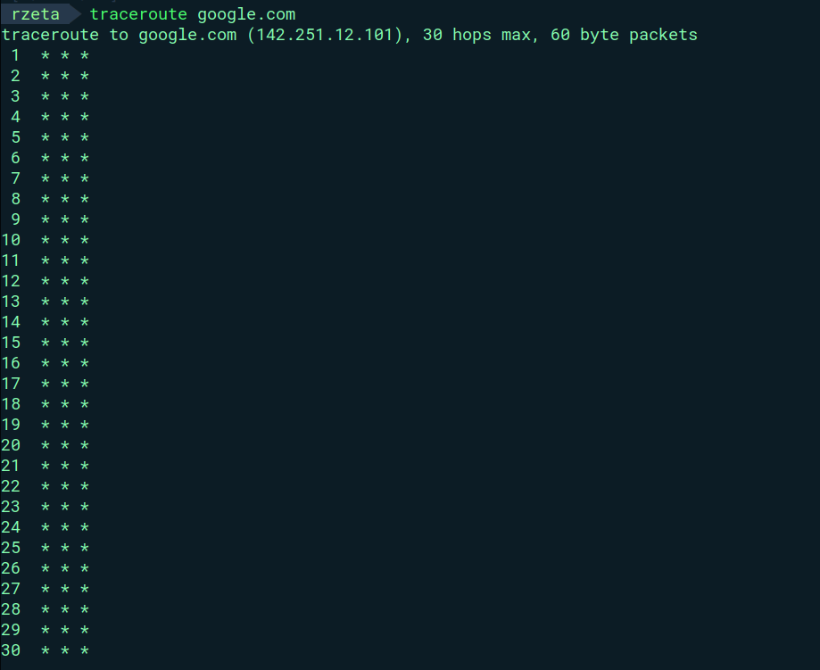
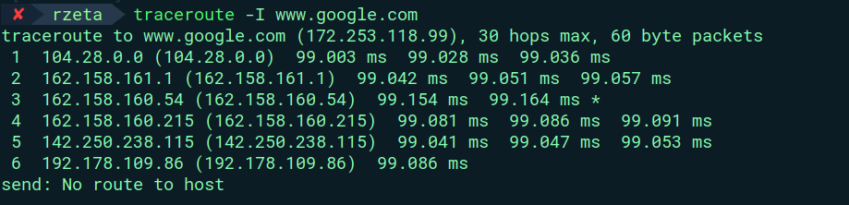
-I == ICMP requests
hops == the movement of data between two network devices

-d == socket debugging

Q4)
netstat – prints details about network connections , routing tables
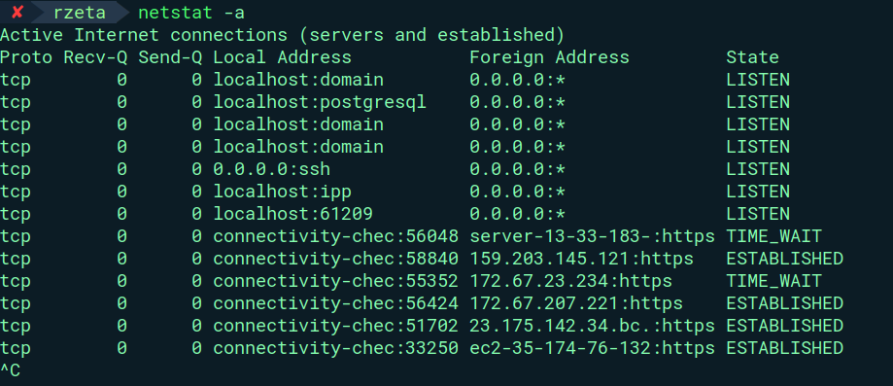
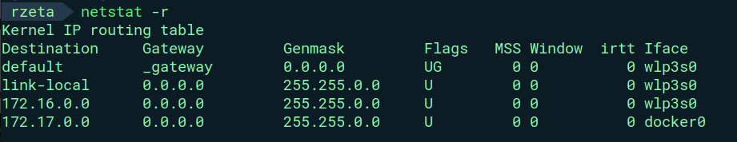
-r == routing table

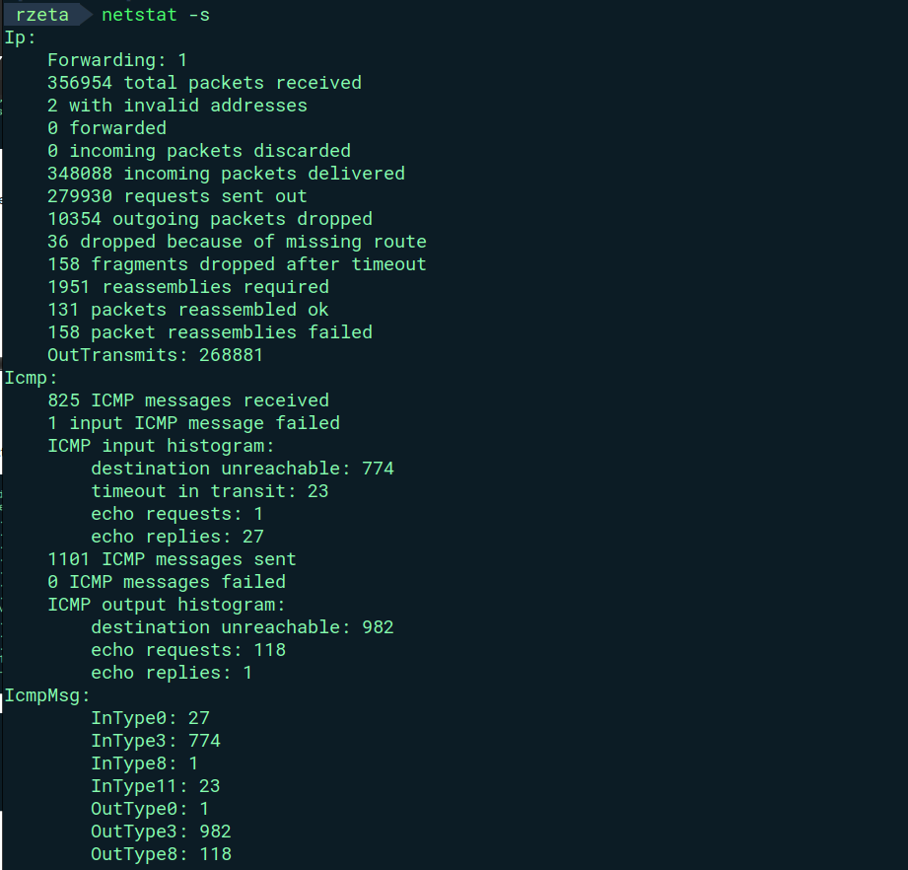
-s == statistics of each protocol

Q5)

nslookup – lookup DNS(Domain Name Services)
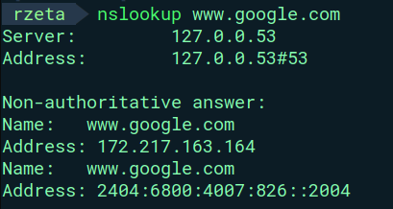
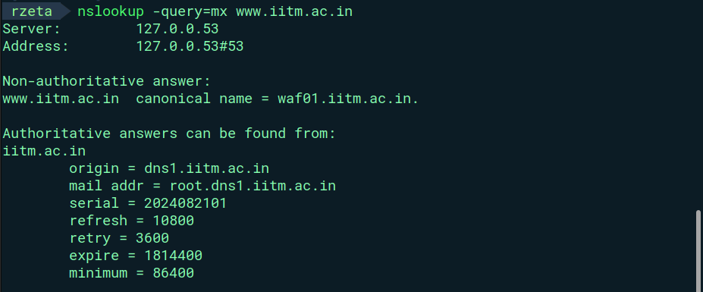
-query=mx == used to determine mail servers responsible for receiving mail

Q6)

arp – manipulate arp cache

ARP - Address Resolution Protocol , created when an IP address is resolved to a MAC address
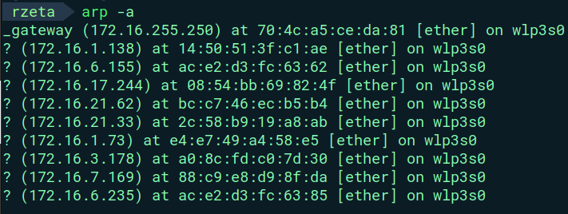
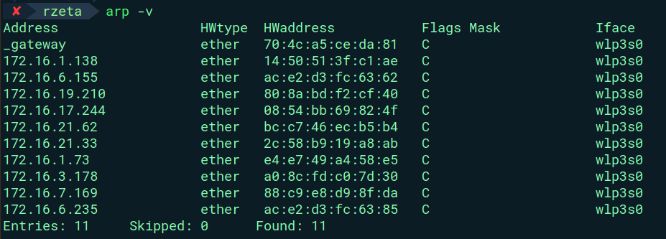
-v == verbose
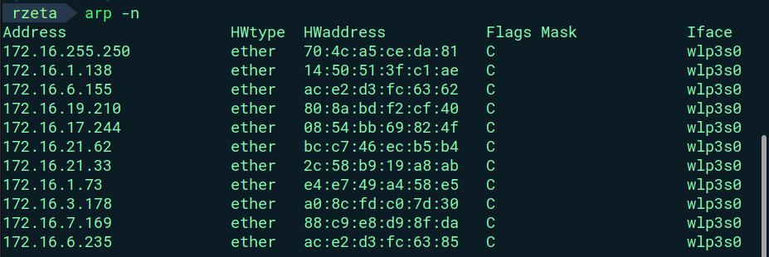
-n == in form of numerical addresses

Q7)
route – manipulate routing tables
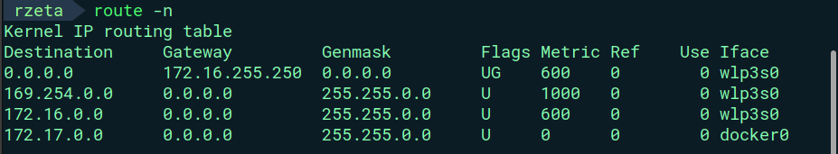
routing tables - data table stored in a router or a network host that lists the routes
-n == show numerical addresses
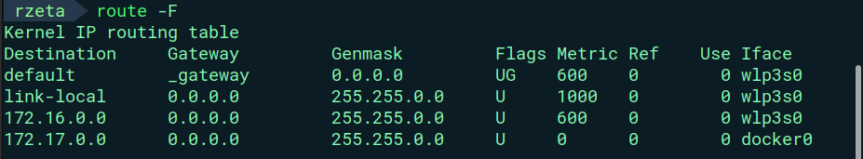
-F == operate on the kernel's FIB (Forwarding Information Base) routing
table (default)

Q8)

ip – shows routing , devices , interfaces

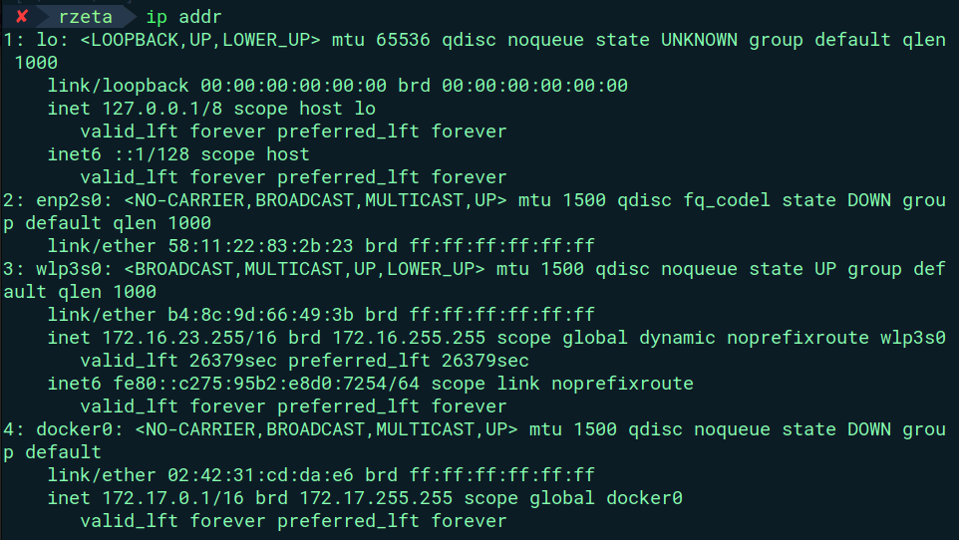
ip addr – ip addresses of the host system
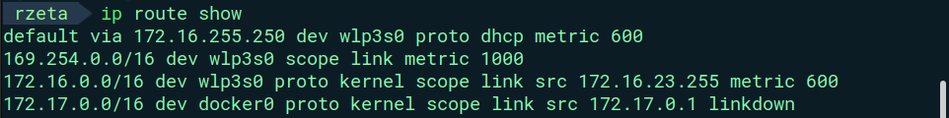
ip route show == current routing table

Q9)

hostname – system’s host name
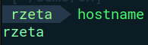
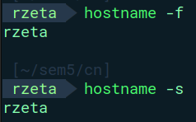
-f == fullname

-s == shortform

Q10)

whois - client for the whois directory service

whois searches for the object in the RFC 3912 database . whois command tries to reach ARPANET host
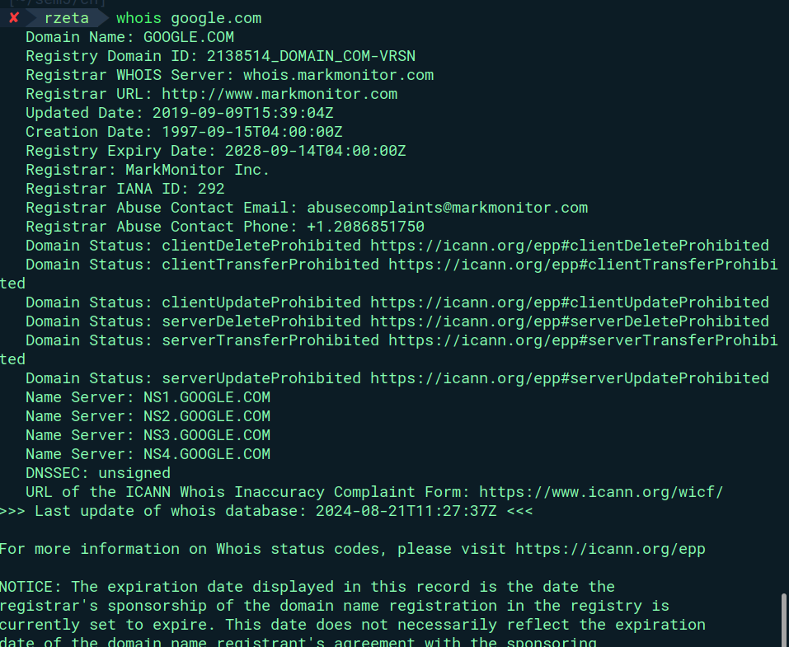

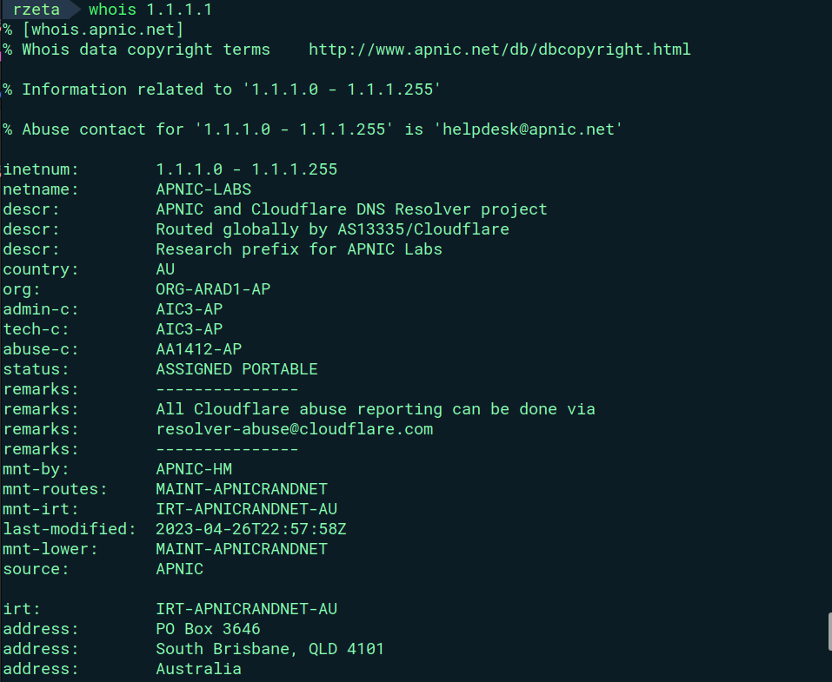
Q11)

ftp – file transfer protocol
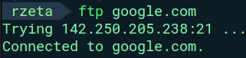

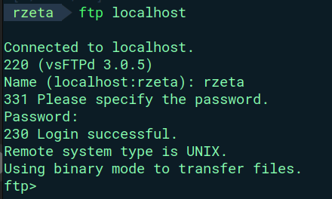

Q12)

scp – OpenSSH file copy
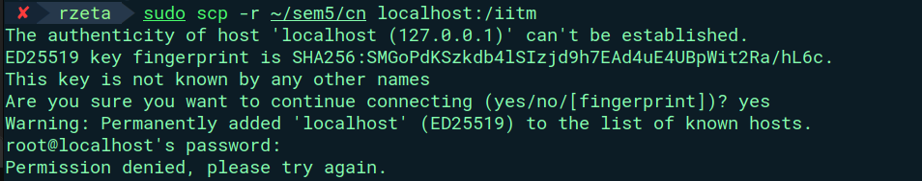

Q13)

curl – transfer a URL ( uniform resource locator )

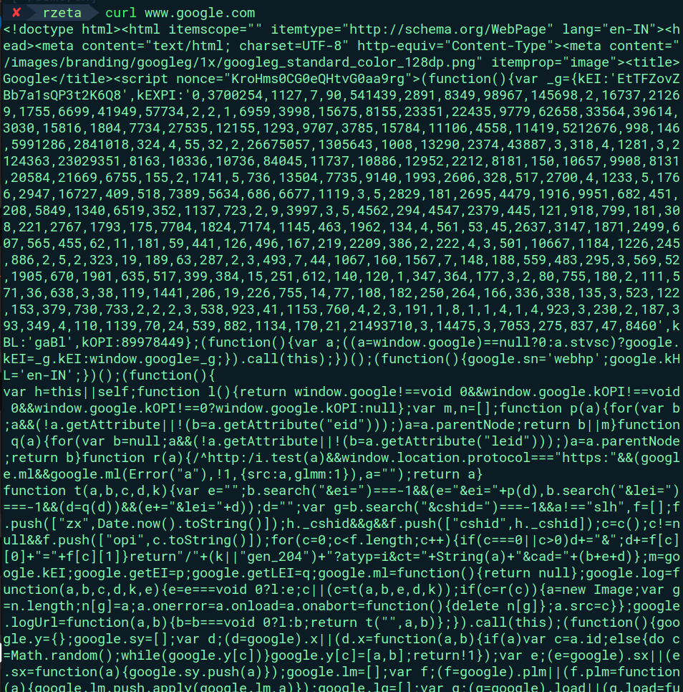

wget – network downloader

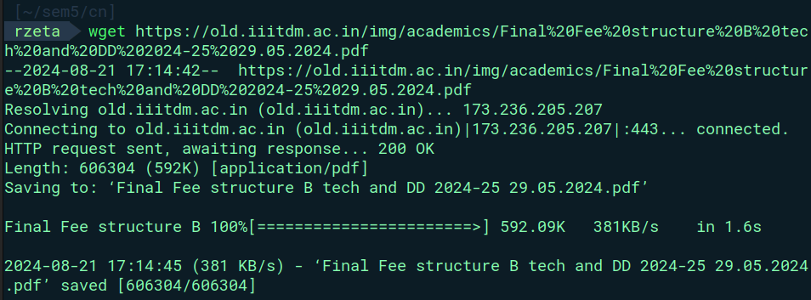
Q14)

telnet – connect two network devices using TELNET protocol

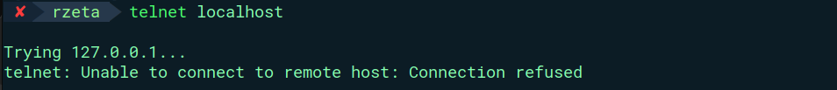
ssh -

Terminal 1 -
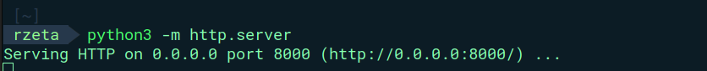
Terminal 2 -
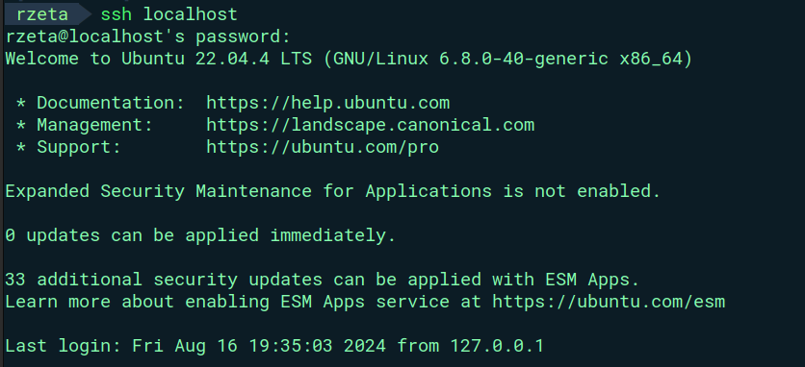

Advanced Commands -

Q1)

tcpdump – dumps traffic on a network

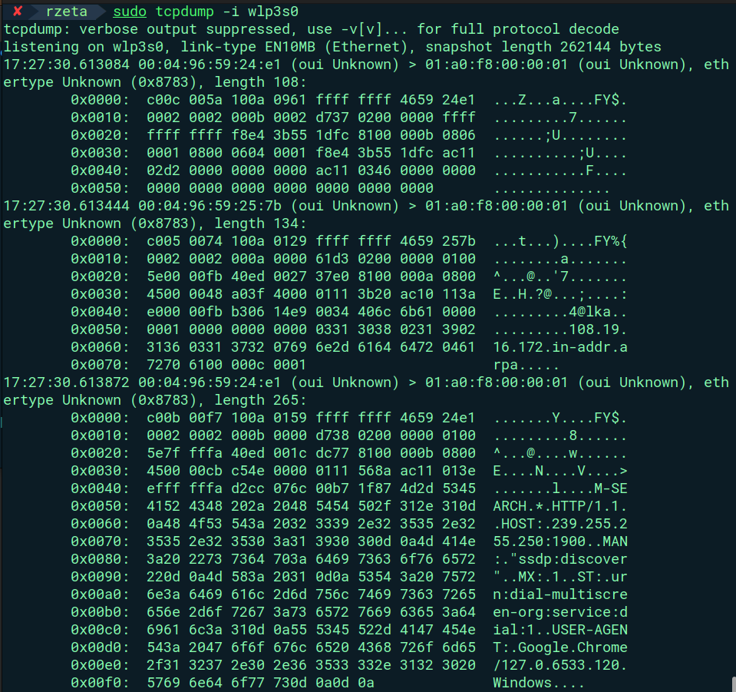
wireshark – interactive dumping and analyzing of networks
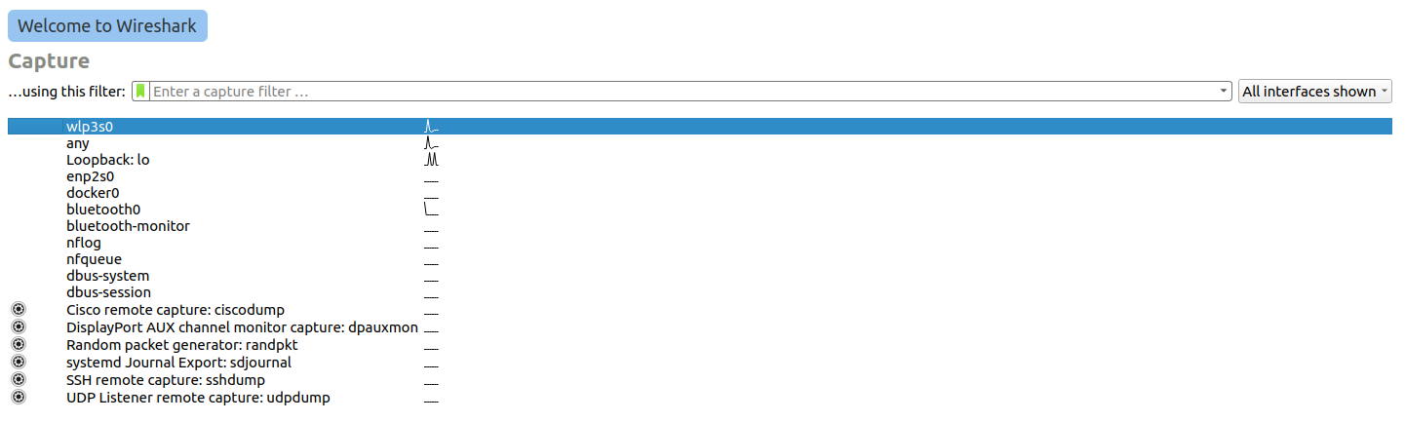

Q2)

iftop – displays the bandwidth usage

-i == interface
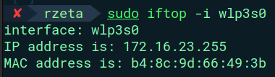

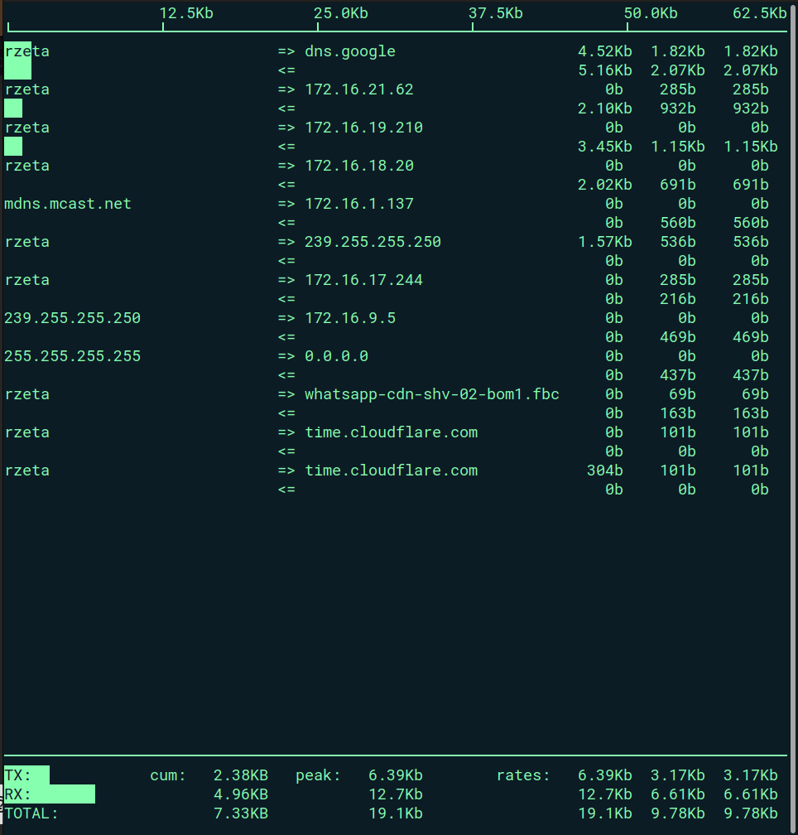

Q3)

mtr – network diagnostics tool

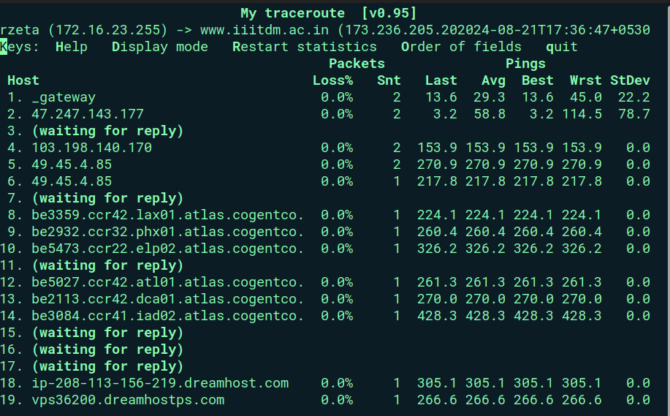
Q4)
iwconfig – configure wireless network interfaces

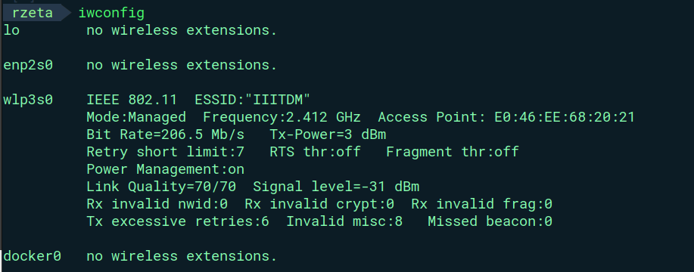

Q5)

dig – DNS lookup utility

-x == gets simplified reverse lookup

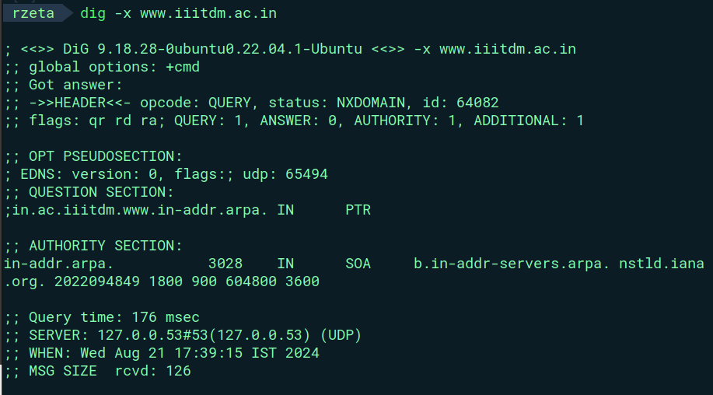
Q6)

ss – utility to investigate sockets

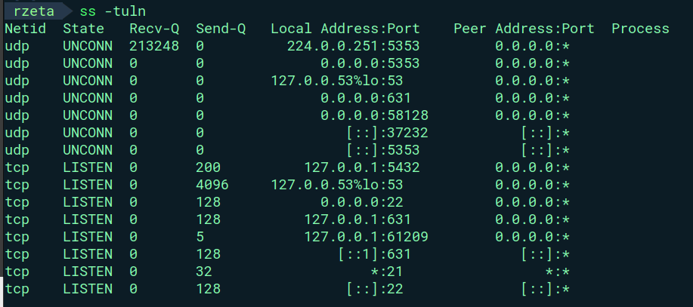
Q7)

tracepath – traces path to network host , better than traceroute since it doesn’t require sudo privileges

