COMPUTER NETWORKS
LAB 2
ROHAN G
CS22B1093

Q1)
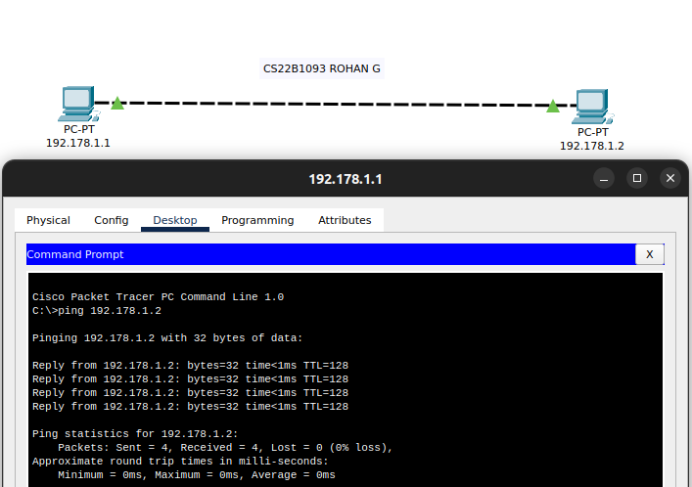

We have connected two PC’s which are connected with each other with help of copper cross over cable . The two PC’s have been assigned with IP’s 192.178.1/2 respectively.

Q2)

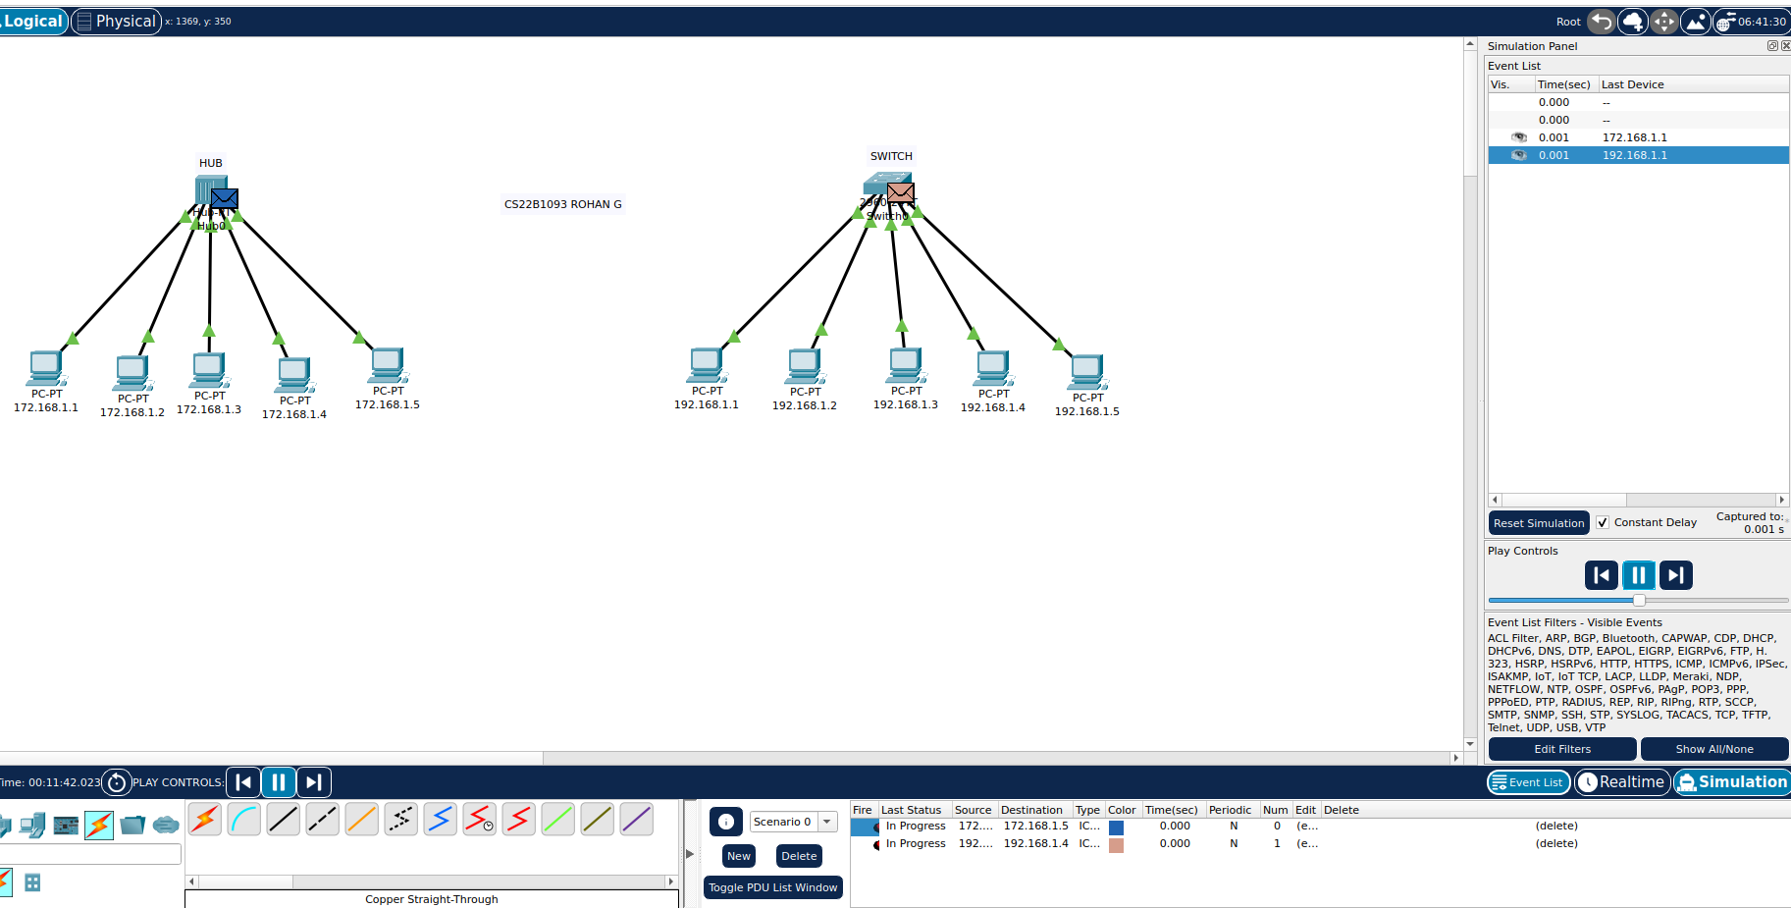
We have connected 5 PC’s to both hub and switch , with the PC’s connected to hub having IP’s 172.168.1.[1-5] and the PC’s connected to switch having IP’s 192.168.1.[1-5].

Hub is cheaper compared to switch but also slower than switch as hubs use half-duplex connection whereas switch use half/full-duplex connection and hence are faster.
Hub sends the packet from sender to all the other devices connected to it , whereas switch only sends the packet to the respective receiver and not all the devices connected to the switch.

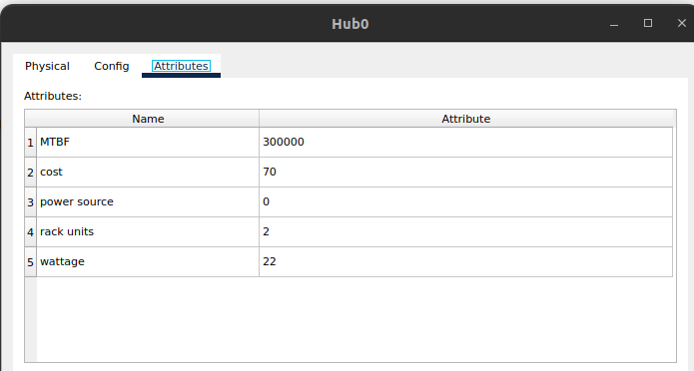
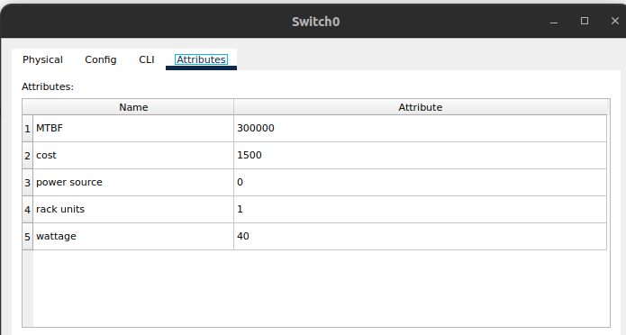
Attributes of Hub
Attributes of Switch
Both the switch and hubs use Star Topology to connect to the devices connected to it.
We use copper straight through wires to connected the devices , switch and the hub.

Q3)

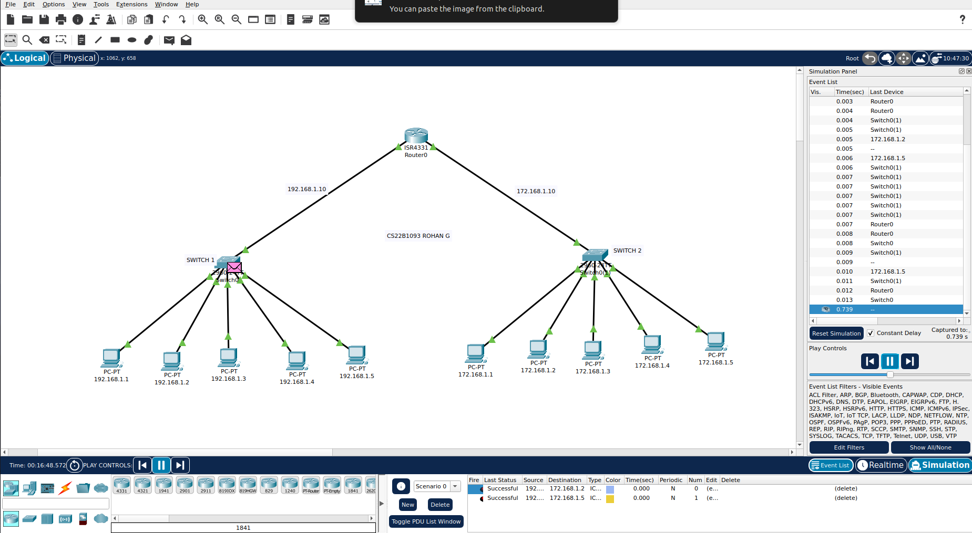
We have connected two LANs(each having 5 end devices to a switch). The two different LANs with help of their gateways they communicate with the router and can communicate with each other.

Switches are used to connect network devices in the same network Class.
Routers are used to connect network devices in different network Classes.

Q4)

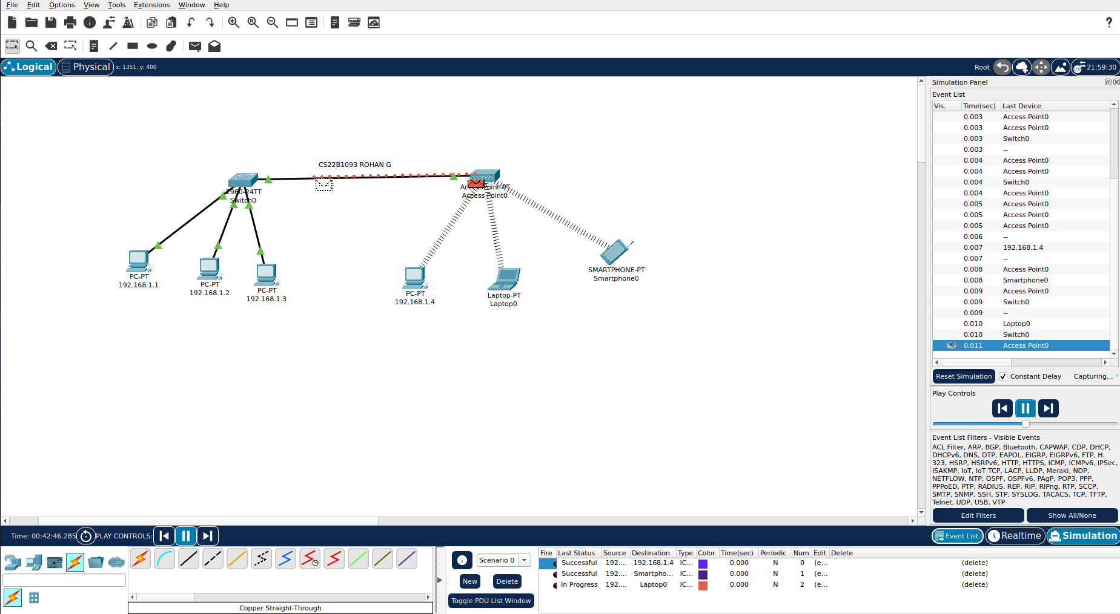
We have made 2 LAN networks , one wireless and one wired with 3 devices each and have connected the wireless and the wired LAN through help of straight through cable. The packet simulation is simulated as above.
Access point - a networking hardware device that allows other Wi-Fi devices to connect to a wired network or wireless network

Q5)
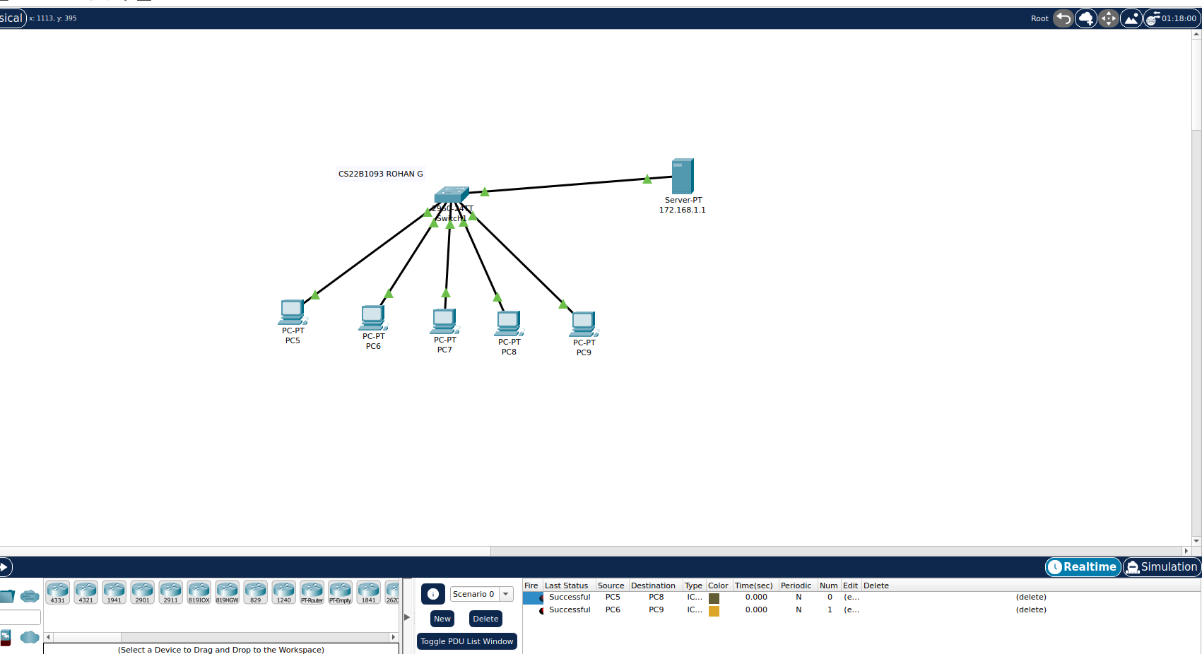

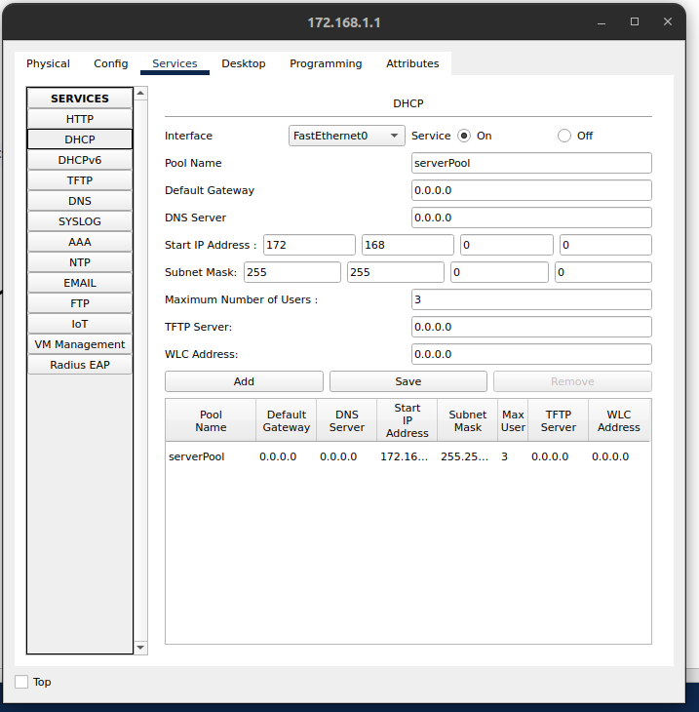

DHCP – Dynamic Host Configuration Protocol
We allotted the IP’s to 3 devices out of 5 using DHCP from the server connected to the hub. If PC’s count > 3 , we get DHCP failed APIPA error occurring.

