COMPUTER NETWORKS
LAB – 3
ROHAN G
CS22B1093
Q1)
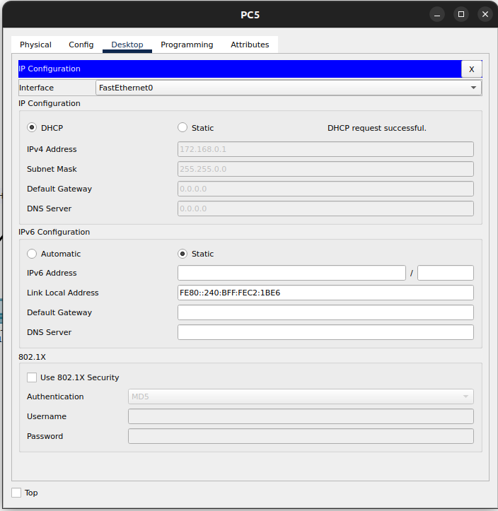
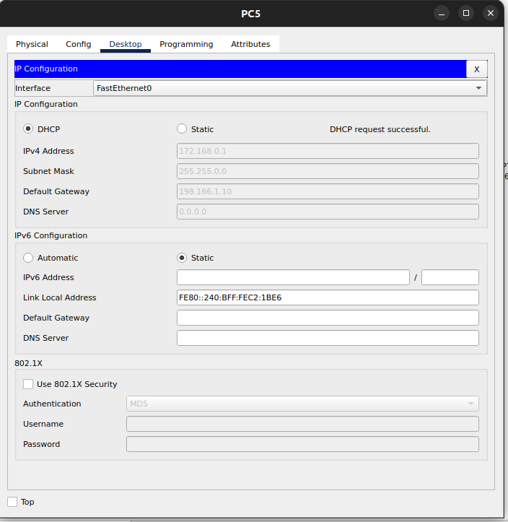

PC getting assigned IP by DHCP server . Before and after configuring subnets.
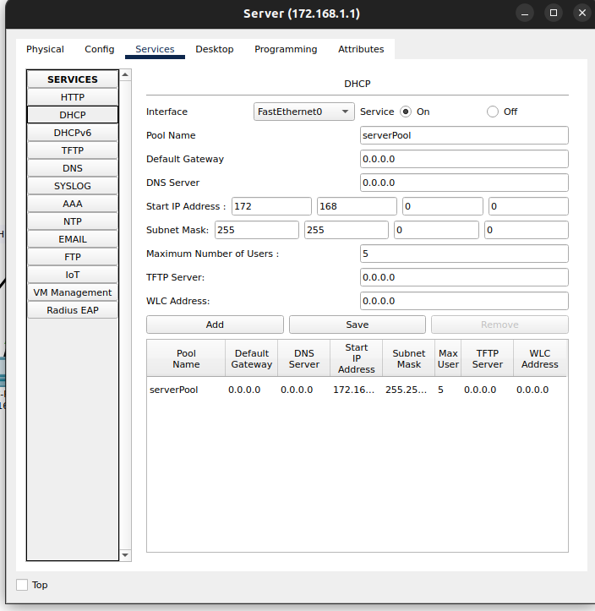

DHCP Server Configuration

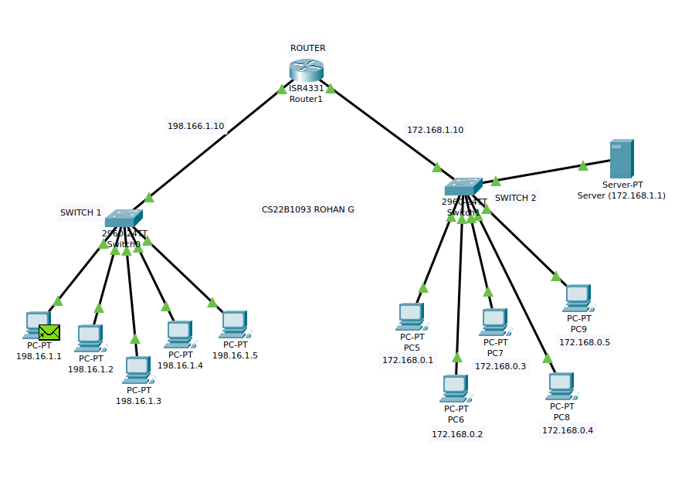

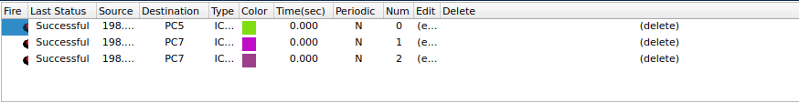
Entire Network , with one LAN PC’s getting assigned IP’s through DHCP server

Packet transmission between different PC’s

Q2)
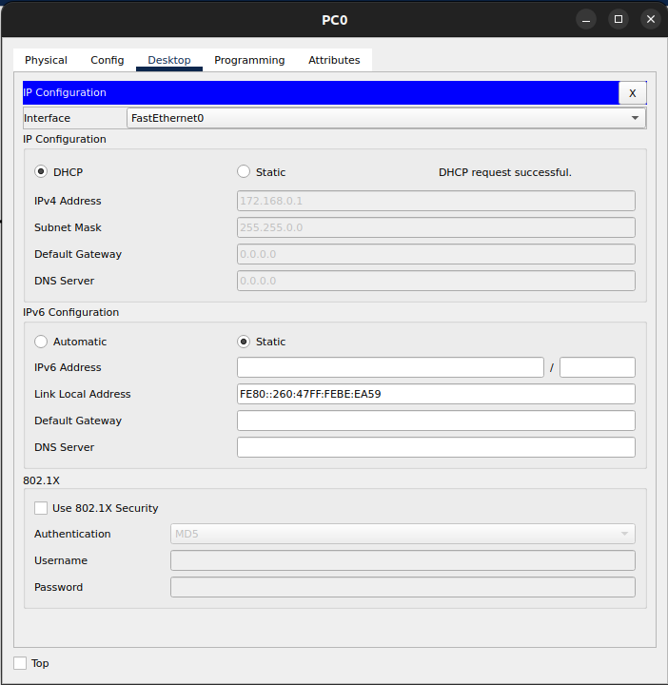

Wired LAN PC’s IP Configuration through DHCP

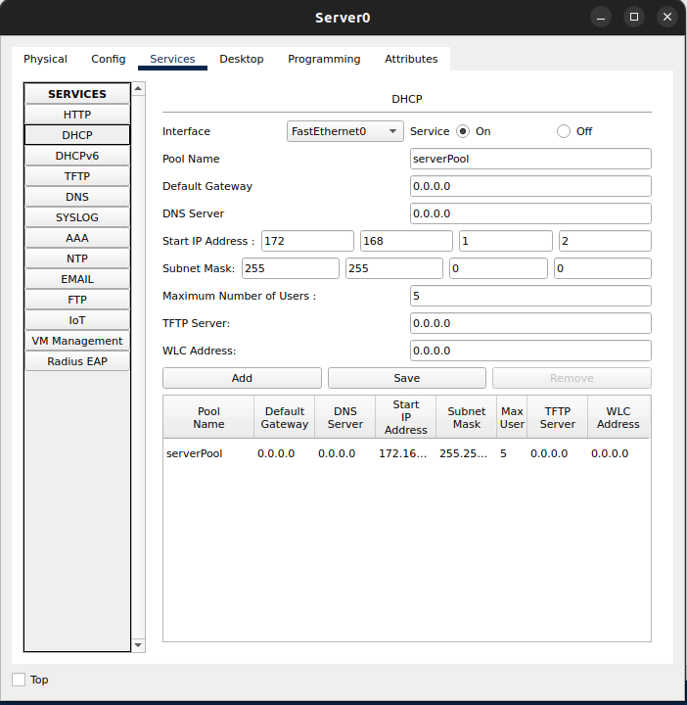

DHCP Server Configuration

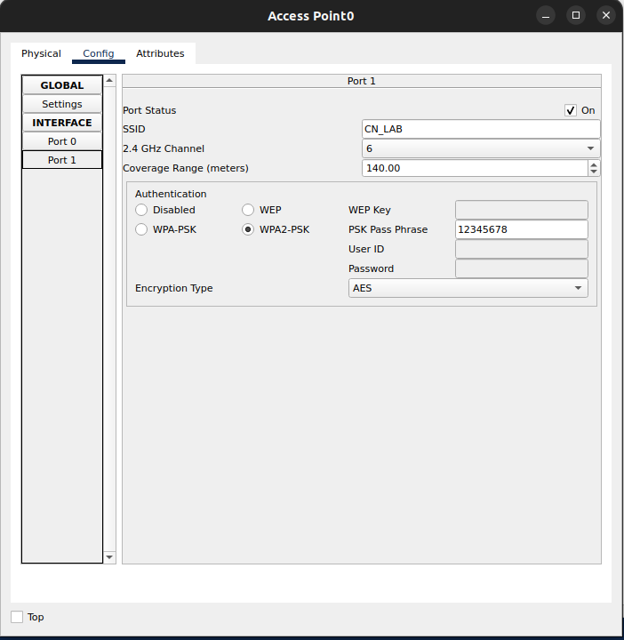

Setting the Access Point to WPA2-PSK
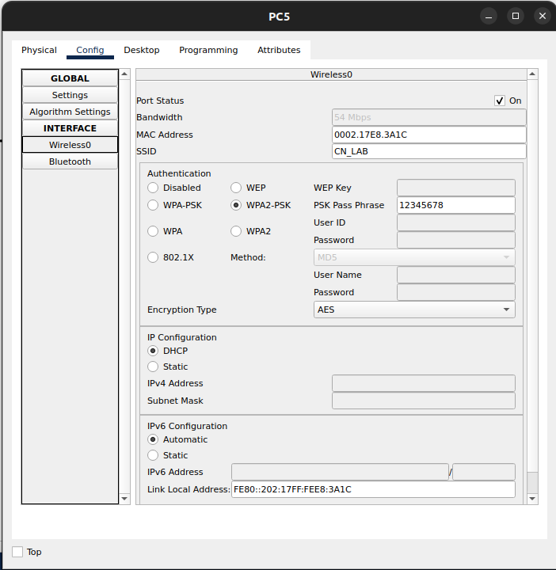
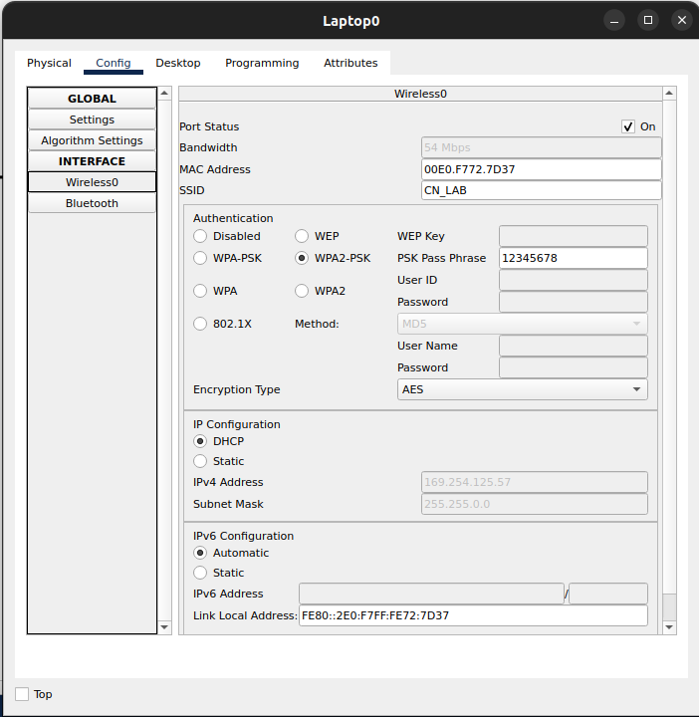
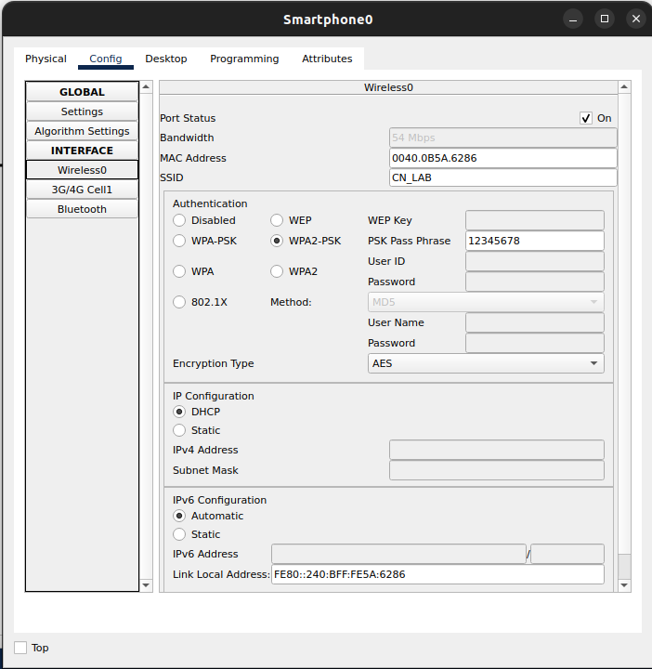

Wireless Configuration of 3 different devices connected to the Wireless LAN
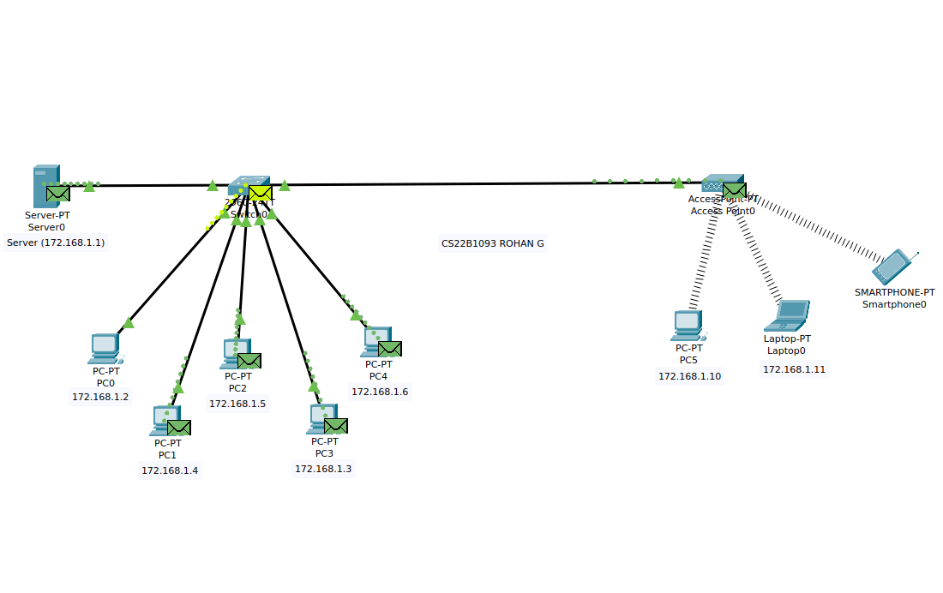

Entire Network , with wired LAN network being assigned IP’s through DHCP server.

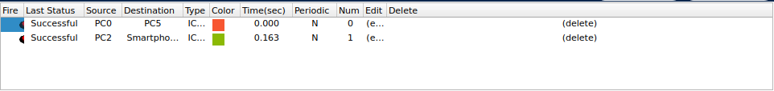
Packet Transmission between the different devices in the network

Q3)
//CS22B1093
//ROHAN G

#include <stdio.h>
#include <stdlib.h>

#define MAX_INPUT 50
#define MAX 200

char *string_to_stuffed(char *arr)
{
char *stuffed = (char *)malloc(sizeof(char) * MAX);
int count = 0;
int i = 0, j = 0;

stuffed[j++] = '0';
for (int k = 0; k < 6; k++) {
stuffed[j++] = '1';
}
stuffed[j++] = '0';

for (int z = 0; arr[z] != '\0'; z++) {
if (arr[z] == '1') {
count++;
stuffed[j++] = '1';
if (count == 5) {
stuffed[j++] = '0';
count = 0;
}
} else {
stuffed[j++] = '0';
count = 0;
}
}

stuffed[j++] = '0';
for (int k = 0; k < 6; k++) {
stuffed[j++] = '1';
}
stuffed[j++] = '0';

stuffed[j] = '\0';
printf("Stuffed string: %s\n", stuffed);
return stuffed;
}

char *stuffed_to_string(char *stuffed)
{
char *output = (char *)malloc(sizeof(char) * MAX_INPUT);
int count = 0;
int j = 0;

int i = 8;

while (stuffed[i] != '\0') {
if (stuffed[i] == '1') {
count++;
output[j++] = '1';
if (count == 5) {
i++;
count = 0;
}
} else {
output[j++] = '0';
count = 0;
}
i++;
}

output[j] = '\0';

output[j - 7] = '\0';

printf("Unstuffed string: %s\n", output);
return output;
}

int main()
{
char arr[MAX_INPUT];
printf("Enter the string: ");
scanf("%s", arr);

printf("Input string: %s\n", arr);

char *stuffed = string_to_stuffed(arr);
char *output = stuffed_to_string(stuffed);

free(stuffed);
free(output);
return 0;
}

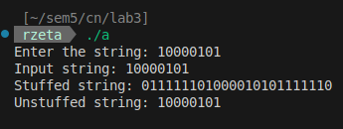
T1:

T2:
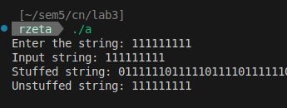

T3:
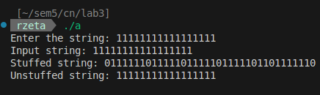

T4:
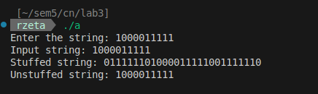

T5:
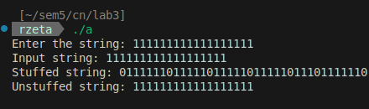

Q4)
//CS22B1093
//ROHAN G

#include <stdio.h>
#include <string.h>

#define DIVISOR "10000111"
#define DIVISOR_LENGTH 8

char dataToSend[28];
char crcValue[28];
char generatorPolynomial[DIVISOR_LENGTH + 1] = DIVISOR;

int originalDataLength, i, j;

void performXOR();
void computeCRC();
void verifyReceivedData();

void performXOR() {
for (j = 1; j < DIVISOR_LENGTH; j++)
crcValue[j] = ((crcValue[j] == generatorPolynomial[j]) ? '0' : '1');
}

void computeCRC() {
for (i = 0; i < DIVISOR_LENGTH; i++)
crcValue[i] = dataToSend[i];

do {
if (crcValue[0] == '1')
performXOR();

for (j = 0; j < DIVISOR_LENGTH - 1; j++)
crcValue[j] = crcValue[j + 1];

crcValue[j] = dataToSend[i++];
} while (i <= originalDataLength + DIVISOR_LENGTH - 1);
}

void verifyReceivedData() {
printf("\nEnter the received data: ");
scanf("%s", dataToSend);
printf("Data received: %s", dataToSend);
computeCRC();

for (i = 0; (i < DIVISOR_LENGTH - 1) && (crcValue[i] != '1'); i++);

if (i < DIVISOR_LENGTH - 1)
printf("\nError detected\n\n");
else
printf("\nNo error detected\n\n");
}

int main() {
printf("Enter data to be transmitted: ");
scanf("%s", dataToSend);

originalDataLength = strlen(dataToSend);

for (i = originalDataLength; i < originalDataLength + DIVISOR_LENGTH - 1; i++)
dataToSend[i] = '0';
dataToSend[i] = '\0';

printf("Data padded with %d zeros: %s", DIVISOR_LENGTH - 1, dataToSend);

computeCRC();
printf("\nCRC: %s", crcValue);

for (i = originalDataLength; i < originalDataLength + DIVISOR_LENGTH - 1; i++)
dataToSend[i] = crcValue[i - originalDataLength];
dataToSend[i] = '\0';

printf("\nFinal data to be sent: %s", dataToSend);

verifyReceivedData();

return 0;
}
T1:
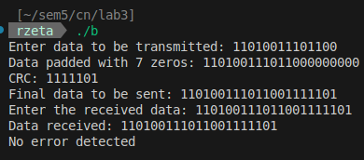

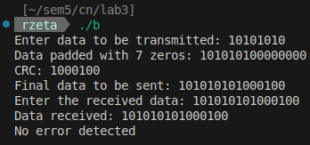
T2:
T3:
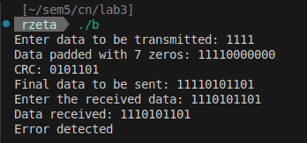
Error as received data is not same as sent data

T4:
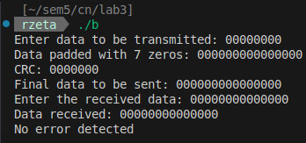
T5:
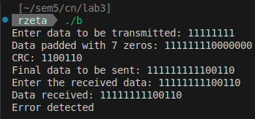
Error as received data is not same as sent data
Q5)
//CS22B1093
//ROHAN G

#include <stdio.h>
#include <string.h>

#define POLY_LENGTH strlen(generatorPolynomial)

char dataToSend[28];
char crcValue[28];
char generatorPolynomial[10];

int originalDataLength, i, j;

void performXOR();
void computeCRC();
void verifyReceivedData();

void performXOR() {
for (j = 1; j < POLY_LENGTH; j++)
crcValue[j] = ((crcValue[j] == generatorPolynomial[j]) ? '0' : '1');
}

void computeCRC() {
for (i = 0; i < POLY_LENGTH; i++)
crcValue[i] = dataToSend[i];

do {
if (crcValue[0] == '1')
performXOR();

for (j = 0; j < POLY_LENGTH - 1; j++)
crcValue[j] = crcValue[j + 1];

crcValue[j] = dataToSend[i++];
} while (i <= originalDataLength + POLY_LENGTH - 1);
}

void verifyReceivedData() {
printf("\nEnter the received data: ");
scanf("%s", dataToSend);
printf("Data received: %s", dataToSend);
computeCRC();

for (i = 0; (i < POLY_LENGTH - 1) && (crcValue[i] != '1'); i++);

if (i < POLY_LENGTH - 1)
printf("\nError detected\n\n");
else
printf("\nNo error detected\n\n");
}

int main() {
printf("Enter data to be transmitted: ");
scanf("%s", dataToSend);
printf("\nEnter the Generator Polynomial: ");
scanf("%s", generatorPolynomial);

originalDataLength = strlen(dataToSend);

for (i = originalDataLength; i < originalDataLength + POLY_LENGTH - 1; i++)
dataToSend[i] = '0';
dataToSend[i] = '\0';

printf("Data padded with %ld zeros: %s", POLY_LENGTH - 1, dataToSend);

computeCRC();
printf("\nCRC : %s", crcValue);

for (i = originalDataLength; i < originalDataLength + POLY_LENGTH - 1; i++)
dataToSend[i] = crcValue[i - originalDataLength];
dataToSend[i] = '\0';

printf("\nFinal data to be sent: %s", dataToSend);

verifyReceivedData();

return 0;
}
T1:
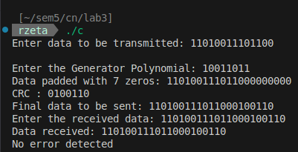
T2:
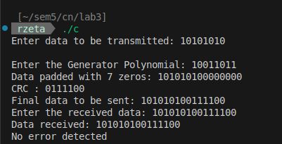

T3:
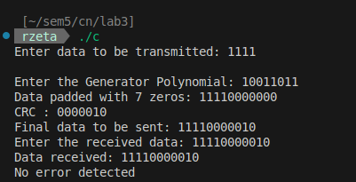
T4:
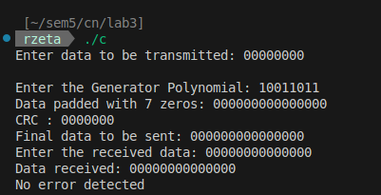
T5:
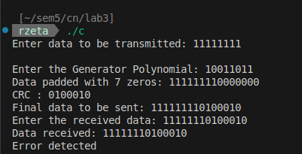
Error as received data is not same as sent data

