COMPUTER NETWORKS
LAB – 4
ROHAN G
CS22B1093
Q1)

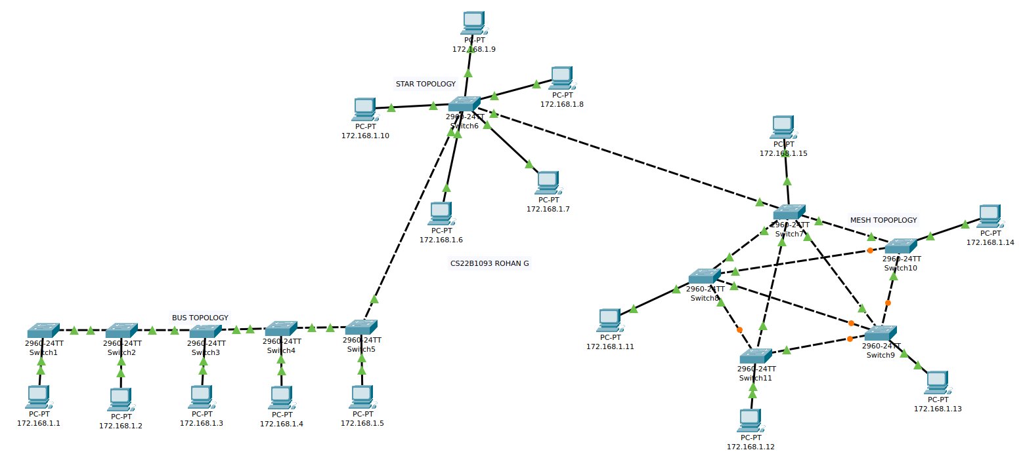
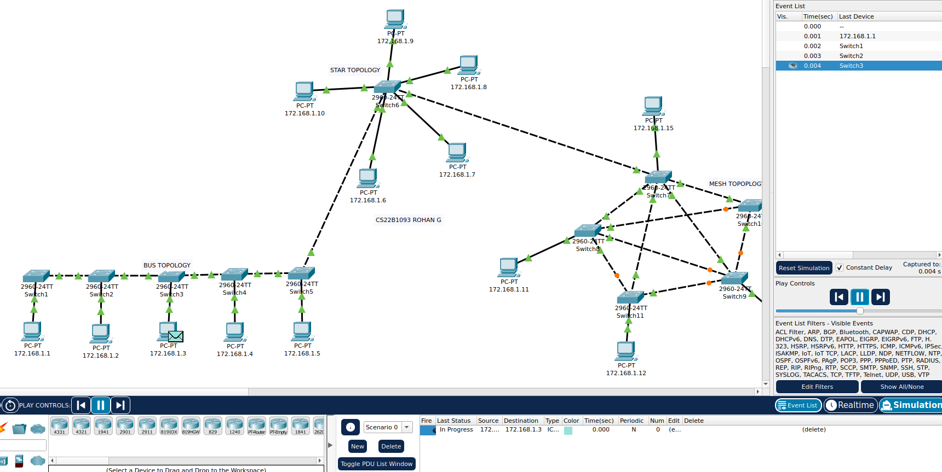
Intra Bus Topology Packet Transmission(172.168.1.1 – 172.168.1.3)

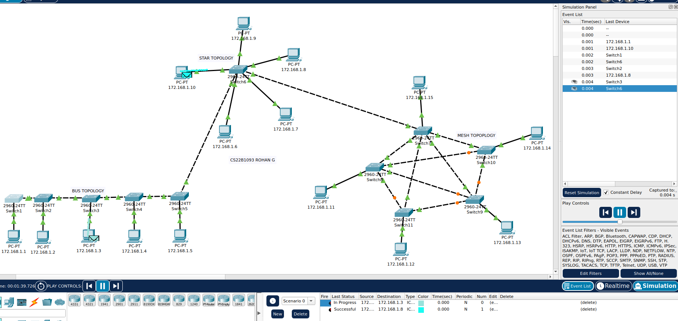
Intra Star Topology Packet Transmission (172.168.1.10 – 172.168.1.8)
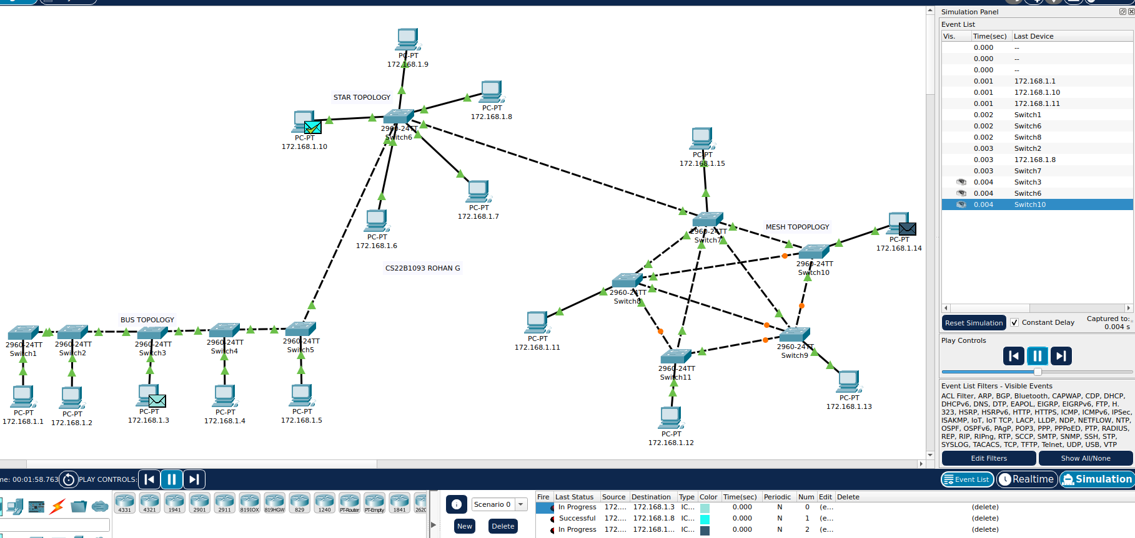
Intra Star Topology Packet Transmission(172.168.1.11 – 172.168.1.14)

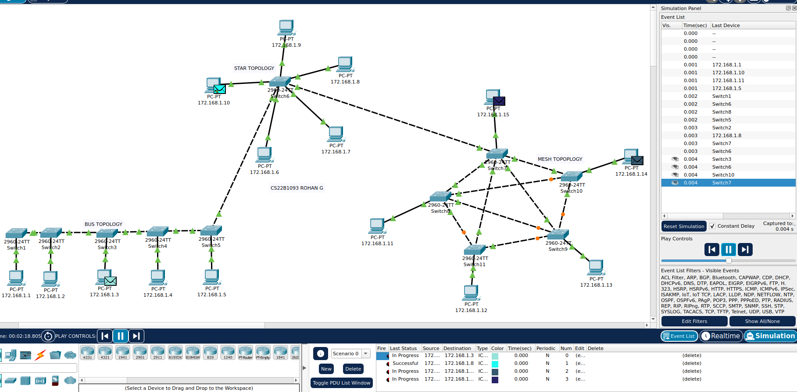
Inter Topology Packet Transmission (172.168.1.5 (Bus Topology) – 172.168.1.15(Mesh Topology))

iii)

Bus Topology -
Performance – Performance reduces as number of users and data transmission at same time increases and has limited bandwidth.

Fault Tolerance – Single break or issue in the network causes the whole network collapse and hence the network stops working.

Star Topology -
Performance – Better in performance compared to Bus topology has it has better bandwidth and can scale to more number of users compared to Bus topology.

Fault Tolerance – Has more fault tolerance if there is a breakage or failure between the switch/hub and the connected network device , but the hub/central switch plays a critical role and failure in it causes the whole network to collapse and stop working.

Mesh Topology -
Performance – Highest performance compared to other two with high bandwidth and low latency due to direct connection between the connected devices in the network.

Fault Tolerance – Has the highest fault tolerance compared two the other two , has a lot of reliability as failure in one of the links , the network still functions . But it is expensive to set it up.

Q2)

I) TCP -

TCP Server -
//CS22B1093 ROHAN G

#include <netinet/in.h>
#include <stdio.h>
#include <stdlib.h>
#include <string.h>
#include <sys/socket.h>
#include <unistd.h>

#define PORT 8080

int main()
{
int server_fd, new_socket;
struct sockaddr_in address;

char buffer[1024] = {0};
char *hello = "Hello from server";
socklen_t addrlen = sizeof(address);

//create a socket file descriptor
server_fd = socket(AF_INET, SOCK_STREAM, 0);

if (server_fd == -1) {
perror("socket failed");
exit(EXIT_FAILURE);
}

//define the server address
address.sin_family = AF_INET;
address.sin_addr.s_addr = INADDR_ANY;
address.sin_port = htons(PORT);

//bind the socket
if (bind(server_fd, (struct sockaddr *)&address, sizeof(address)) < 0) {
perror("bind failed");
exit(EXIT_FAILURE);
}

//listen for connections
if (listen(server_fd, 3) < 0) {
perror("listen");
close(server_fd);
exit(EXIT_FAILURE);
}

printf("TCP Server is running and waiting for messages...\n");

//accept connection
new_socket = accept(server_fd, (struct sockaddr *)&address, &addrlen);

if(new_socket < 0) {
perror("Connection acceptance failed");
close(server_fd);
exit(EXIT_FAILURE);
}

//read message from client
read(new_socket, buffer, 1024);
printf("Client: %s\n", buffer);

//send message to client
send(new_socket, hello, strlen(hello), 0);
printf("Message sent to client\n");

//close the socket
close(new_socket);
close(server_fd);

}
TCP Client -
//CS22B1093 ROHAN G

#include <arpa/inet.h>
#include <netinet/in.h>
#include <stdio.h>
#include <stdlib.h>
#include <string.h>
#include <sys/socket.h>
#include <unistd.h>

#define PORT 8080

int main()
{
int sock = 0;
struct sockaddr_in serv_addr;
char *message = "Hello from client";
char buffer[1024] = {0};

//create a socket file descriptor
sock = socket(AF_INET, SOCK_STREAM, 0);
if(sock == -1) {
perror("Socket creation failed");
exit(EXIT_FAILURE);
}

//define the server address
serv_addr.sin_family = AF_INET;
serv_addr.sin_port = htons(PORT);

//convert IPv4 and IPv6 addresses from text to binary form
if(inet_pton(AF_INET, "127.0.0.1", &serv_addr.sin_addr) <= 0) {
perror("Invalid address/Address not supported");
close(sock);
exit(EXIT_FAILURE);
}

//connect to the server
if(connect(sock, (struct sockaddr *)&serv_addr, sizeof(serv_addr)) < 0) {
perror("Connection failed");
close(sock);
exit(EXIT_FAILURE);
}

//send message to server
send(sock, message, strlen(message), 0);
printf("Message sent to server\n");

//read message from server
read(sock, buffer, 1024);
printf("Server: %s\n", buffer);

//close the socket
close(sock);
return 0;
}

Terminal – 1:
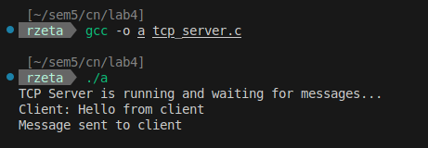
Terminal – 2:
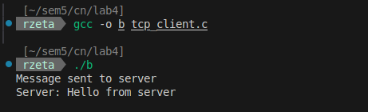

II)UDP

UDP Server -
// CS22B1093 ROHAN G

#include <arpa/inet.h>
#include <netinet/in.h>
#include <stdio.h>
#include <stdlib.h>
#include <string.h>
#include <sys/socket.h>
#include <unistd.h>

#define PORT 8080
#define BUFFER_SIZE 1024

int main() {
int sockfd;
char buffer[BUFFER_SIZE];
struct sockaddr_in serv_addr, client_addr;
socklen_t addr_len;

// Create socket
sockfd = socket(AF_INET, SOCK_DGRAM, 0);
if (sockfd == -1) {
perror("Socket creation failed");
exit(EXIT_FAILURE);
}

// Define server address
memset(&serv_addr, 0, sizeof(serv_addr));
serv_addr.sin_family = AF_INET; // IPv4
serv_addr.sin_addr.s_addr = INADDR_ANY; // Accept any IP
serv_addr.sin_port = htons(PORT); // Port

// Bind the socket to the server address
if (bind(sockfd, (const struct sockaddr *)&serv_addr, sizeof(serv_addr)) < 0) {
perror("Bind failed");
close(sockfd);
exit(EXIT_FAILURE);
}

printf("UDP Server is running and waiting for messages...\n");

addr_len = sizeof(client_addr);

// Receive data from the client
int n = recvfrom(sockfd, buffer, BUFFER_SIZE, 0, (struct sockaddr *)&client_addr, &addr_len);
if (n < 0) {
perror("Receive failed");
} else {
buffer[n] = '\0'; // Null-terminate the received data
printf("Client: %s\n", buffer);

// Respond to the client
char *response = "Hello from server";
sendto(sockfd, response, strlen(response), 0, (struct sockaddr *)&client_addr, addr_len);
printf("Response sent to client\n");
}

// Close the socket
close(sockfd);
return 0;
}
UDP Client -
// CS22B1093 ROHAN G

#include <arpa/inet.h>
#include <netinet/in.h>
#include <stdio.h>
#include <stdlib.h>
#include <string.h>
#include <sys/socket.h>
#include <unistd.h>

#define PORT 8080
#define BUFFER_SIZE 1024

int main() {
int sockfd;
struct sockaddr_in serv_addr;
char *message = "Hello from client";
char buffer[BUFFER_SIZE];

// Create socket
sockfd = socket(AF_INET, SOCK_DGRAM, 0);
if (sockfd == -1) {
perror("Socket creation failed");
exit(EXIT_FAILURE);
}

// Define server address
memset(&serv_addr, 0, sizeof(serv_addr));
serv_addr.sin_family = AF_INET;
serv_addr.sin_port = htons(PORT);
serv_addr.sin_addr.s_addr = INADDR_ANY;

// Send message to the server
sendto(sockfd, message, strlen(message), 0, (const struct sockaddr *)&serv_addr, sizeof(serv_addr));
printf("Message sent to server\n");

// Receive response from the server
socklen_t addr_len = sizeof(serv_addr);
int n = recvfrom(sockfd, buffer, BUFFER_SIZE, 0, (struct sockaddr *)&serv_addr, &addr_len);
if (n < 0) {
perror("Receive failed");
} else {
buffer[n] = '\0'; // Null-terminate the received string
printf("Server: %s\n", buffer);
}

// Close the socket
close(sockfd);
return 0;
}
Terminal -1 :
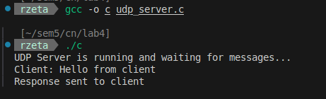
Terminal – 2 :
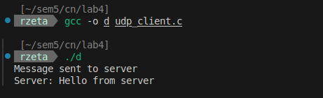

Q3)
UDP Server -
//CS22B1093 ROHAN G

#include <stdio.h>
#include <stdlib.h>
#include <string.h>
#include <unistd.h>
#include <arpa/inet.h>
#include <sys/types.h>
#include <sys/socket.h>

#define MAXLINE 1024

int main() {
int sockfd;
char buffer[MAXLINE];
const char *hello = "Hello from Rohan";
struct sockaddr_in servaddr, cliaddr;
socklen_t len;

// Create socket
if ((sockfd = socket(AF_INET, SOCK_DGRAM, 0)) < 0) {
perror("socket creation failed");
exit(EXIT_FAILURE);
}

memset(&servaddr, 0, sizeof(servaddr));
memset(&cliaddr, 0, sizeof(cliaddr));

servaddr.sin_family = AF_INET;
servaddr.sin_addr.s_addr = INADDR_ANY;
servaddr.sin_port = htons(8080);

if (bind(sockfd, (const struct sockaddr *)&servaddr, sizeof(servaddr)) < 0) {
perror("bind failed");
close(sockfd);
exit(EXIT_FAILURE);
}

len = sizeof(cliaddr);

int n = recvfrom(sockfd, (char *)buffer, MAXLINE, MSG_WAITALL, (struct sockaddr *)&cliaddr, &len);
buffer[n] = '\0';
printf("Client : %s\n", buffer);

sendto(sockfd, (const char *)hello, strlen(hello), 0, (const struct sockaddr *)&cliaddr, len);

close(sockfd);
return 0;
}
UDP Client -
//CS22B1093 ROHAN G

#include <stdio.h>
#include <stdlib.h>
#include <string.h>
#include <unistd.h>
#include <arpa/inet.h>
#include <sys/types.h>
#include <sys/socket.h>

#define MAX 1024

int main() {
int sockfd;
char buffer[MAX];
const char *message = "Hello from ROHAN";
struct sockaddr_in serv_addr;
socklen_t len;

if ((sockfd = socket(AF_INET, SOCK_DGRAM, 0)) < 0) {
perror("socket creation failed");
exit(EXIT_FAILURE);
}

memset(&serv_addr, 0, sizeof(serv_addr));

serv_addr.sin_family = AF_INET;
serv_addr.sin_port = htons(8080);

if (inet_pton(AF_INET, "172.16.25.82", &serv_addr.sin_addr) <= 0) {
perror("Invalid address or Address not supported");
close(sockfd);
exit(EXIT_FAILURE);
}

sendto(sockfd, (const char *)message, strlen(message), 0, (const struct sockaddr *)&serv_addr, sizeof(serv_addr));

len = sizeof(serv_addr);
int n = recvfrom(sockfd, (char *)buffer, MAX, MSG_WAITALL, (struct sockaddr *)&serv_addr, &len);
buffer[n] = '\0';
printf("Server : %s\n", buffer);

close(sockfd);
return 0;
}
UDP Server (me) , friend is Client -
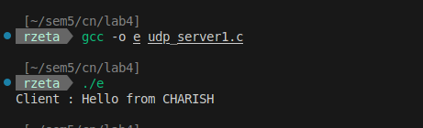
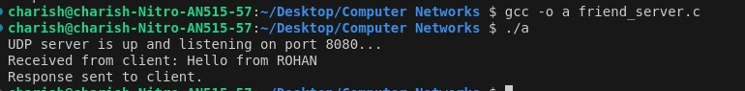
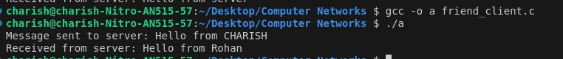
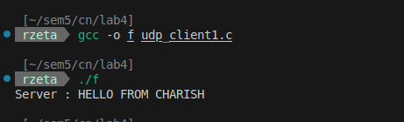
UDP Client (me) , friend is Server -

