COMPUTER NETWORKS
LAB – 5
ROHAN G
CS22B1093

Q1)
//CS22B1093 ROHAN G
#include <stdio.h>
#include <string.h>

#define FLAG 0x7E // Define the flag byte
#define ESCAPE 0x7D // Define the escape byte

void byteStuffing(char *input, int length, char *stuffed, int *stuffedLength) {
int i, j = 0;

stuffed[j++] = FLAG;

// Stuff the data
for (i = 0; i < length; i++) {
if (input[i] == FLAG) {
stuffed[j++] = ESCAPE;
stuffed[j++] = FLAG ^ 0x20; // XOR with 0x20 = 0x5E
} else if (input[i] == ESCAPE) {
stuffed[j++] = ESCAPE;
stuffed[j++] = ESCAPE ^ 0x20; // XOR with 0x20 = 0x5D
} else {
stuffed[j++] = input[i];
}
}

// Add the ending flag byte
stuffed[j++] = FLAG;

*stuffedLength = j;
}

// Function to perform byte unstuffing
void byteUnstuffing(char *stuffed, int stuffedLength,char *unstuffed, int *unstuffedLength) {
int i = 1, j = 0;

while (i < stuffedLength - 1) {
if (stuffed[i] == ESCAPE) {
i++;
if (stuffed[i] == (FLAG ^ 0x20)) { // XOR with 0x20 = 0x5E
unstuffed[j++] = FLAG;
} else if (stuffed[i] == (ESCAPE ^ 0x20)) { // XOR with 0x20 = 0x5D
unstuffed[j++] = ESCAPE;
}
} else {
unstuffed[j++] = stuffed[i];
}
i++;
}
*unstuffedLength = j;
}

int main() {
char input[100];
char stuffed[200];
char unstuffed[100];
int unstuffedLength;

// Get the user input
int inputLength;
printf("Enter the number of bytes in the data: ");
scanf("%d", &inputLength);

printf("Enter the data bytes in hexadecimal (e.g., 45 7E 56 7D 78):\n");
for (int i = 0; i < inputLength; i++) {
int byte;
scanf("%x", &byte);
input[i] = (char)byte;
}

int stuffedLength = 0;

byteStuffing(input, inputLength, stuffed, &stuffedLength);

printf("Stuffed Data (with flags): ");
for (int i = 0; i < stuffedLength; i++) {
printf("0x%X ", stuffed[i]);
}
printf("\n");

byteUnstuffing(stuffed, stuffedLength, unstuffed, &unstuffedLength);

printf("Unstuffed Data (original): ");
for (int i = 0; i < unstuffedLength; i++) {
printf("0x%X ", unstuffed[i]);
}
printf("\n");

return 0;
}

Output -
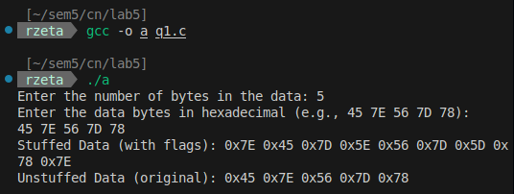
Q2)
Server -
// server.c
// CS22B1093 ROHAN G
#include <stdio.h>
#include <stdlib.h>
#include <string.h>
#include <unistd.h>
#include <arpa/inet.h>
#include <time.h>

#define PORT 8080
#define MAX_BUFFER 1024
#define PACKET_LOSS_PROBABILITY 20 // 20% chance of packet loss or corruption

// Function to simulate packet loss or corruption
int simulatePacketLossOrCorruption() {
// Generate a random number to simulate packet loss or corruption
int randomValue = rand() % 100;
return (randomValue < PACKET_LOSS_PROBABILITY);
}

int main() {
int server_fd, new_socket;
struct sockaddr_in address;
int addrlen = sizeof(address);
char buffer[MAX_BUFFER] = {0};
char ack[] = "ACK"; // Normal acknowledgment
char corruptedAck[] = "CORRUPTED_ACK"; // Simulated corrupted ACK

srand(time(0)); // Seed for random number generation

// Create socket file descriptor
if ((server_fd = socket(AF_INET, SOCK_STREAM, 0)) == 0) {
perror("socket failed");
exit(EXIT_FAILURE);
}

// Bind the socket to the port
address.sin_family = AF_INET;
address.sin_addr.s_addr = INADDR_ANY;
address.sin_port = htons(PORT);

if (bind(server_fd, (struct sockaddr *)&address, sizeof(address)) < 0) {
perror("bind failed");
exit(EXIT_FAILURE);
}

// Start listening for connections
if (listen(server_fd, 3) < 0) {
perror("listen failed");
exit(EXIT_FAILURE);
}

printf("Server is listening on port %d...\n", PORT);

// Accept the connection from the client
if ((new_socket = accept(server_fd, (struct sockaddr *)&address, (socklen_t*)&addrlen)) < 0) {
perror("accept failed");
exit(EXIT_FAILURE);
}

int packetNumber = 1;
while (1) {
memset(buffer, 0, MAX_BUFFER);
// Read packet from client
int valread = read(new_socket, buffer, MAX_BUFFER);

if (valread == 0) {
printf("Connection closed by client.\n");
break;
}

printf("\nReceived packet %d: %s\n", packetNumber, buffer);

// Simulate packet loss or corruption
if (simulatePacketLossOrCorruption()) {
int corruptPacket = rand() % 2; // Decide between loss or corruption
if (corruptPacket == 0) {
printf("Packet %d lost. No ACK sent.\n", packetNumber);
} else {
printf("Packet %d corrupted. Sending corrupted ACK...\n", packetNumber);
send(new_socket, corruptedAck, strlen(corruptedAck), 0); // Send corrupted ACK
}
} else {
printf("Packet %d received successfully. Sending ACK...\n", packetNumber);
send(new_socket, ack, strlen(ack), 0); // Send valid ACK
}

packetNumber++;
}

close(new_socket);
close(server_fd);
return 0;
}
Client -
// client.c
// CS22B1093 ROHAN G
#include <stdio.h>
#include <stdlib.h>
#include <string.h>
#include <unistd.h>
#include <arpa/inet.h>
#include <sys/select.h>
#include <time.h>

#define PORT 8080
#define MAX_BUFFER 1024
#define TIMEOUT 3 // Timeout duration in seconds

int main() {
int sock = 0, valread;
struct sockaddr_in serv_addr;
char buffer[MAX_BUFFER] = {0};
char ack[MAX_BUFFER] = {0};
int totalPackets, packetNumber = 1;

srand(time(0)); // Seed for random number generation

// Create socket file descriptor
if ((sock = socket(AF_INET, SOCK_STREAM, 0)) < 0) {
printf("\nSocket creation error\n");
return -1;
}

serv_addr.sin_family = AF_INET;
serv_addr.sin_port = htons(PORT);

// Convert IPv4 and IPv6 addresses from text to binary form
if (inet_pton(AF_INET, "127.0.0.1", &serv_addr.sin_addr) <= 0) {
printf("\nInvalid address/ Address not supported\n");
return -1;
}

// Connect to the server
if (connect(sock, (struct sockaddr *)&serv_addr, sizeof(serv_addr)) < 0) {
printf("\nConnection failed\n");
return -1;
}

// Get the total number of packets to be sent
printf("Enter the total number of packets to be transmitted: ");
scanf("%d", &totalPackets);

while (packetNumber <= totalPackets) {
// Create a packet message
snprintf(buffer, MAX_BUFFER, "Packet %d", packetNumber);
printf("\nSending packet %d: %s\n", packetNumber, buffer);

// Send the packet to the server
send(sock, buffer, strlen(buffer), 0);

fd_set readfds;
struct timeval tv;
int retval;

// Initialize the timeout structure
tv.tv_sec = TIMEOUT;
tv.tv_usec = 0;

// Set up the file descriptor set
FD_ZERO(&readfds);
FD_SET(sock, &readfds);

// Wait for the ACK from the server or timeout
retval = select(sock + 1, &readfds, NULL, NULL, &tv);

if (retval == -1) {
perror("select() error");
close(sock);
return -1;
} else if (retval == 0) {
printf("Timeout: ACK for packet %d not received. Retransmitting...\n", packetNumber);
continue; // Retransmit the same packet
} else {
// ACK received
memset(ack, 0, MAX_BUFFER);
valread = read(sock, ack, MAX_BUFFER);
if (valread > 0) {
if (strcmp(ack, "ACK") == 0) {
printf("ACK received for packet %d.\n", packetNumber);
packetNumber++; // Move to the next packet
} else if (strcmp(ack, "CORRUPTED_ACK") == 0) {
printf("Corrupted ACK received for packet %d. Retransmitting...\n", packetNumber);
} else {
printf("No ACK or incorrect ACK received. Retransmitting packet %d...\n", packetNumber);
}
} else {
printf("Error receiving ACK. Retransmitting packet %d...\n", packetNumber);
}
}
}

printf("\nAll packets transmitted successfully.\n");
close(sock);
return 0;
}
Terminal – 1(Server)
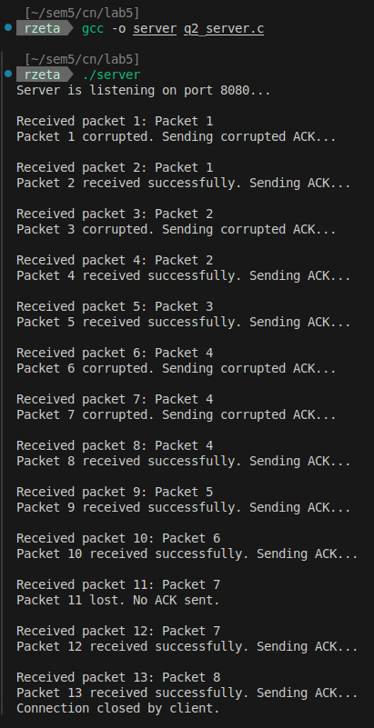
Terminal – 2(client)
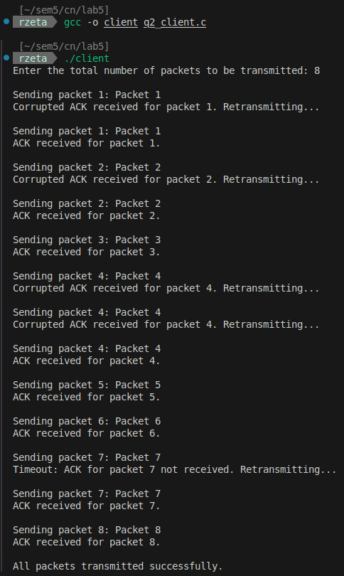
Q3)

Server -
// Receiver program for Go-Back-N protocol using TCP
//CS22B1093 ROHAN G
#include <stdio.h>
#include <stdlib.h>
#include <string.h>
#include <unistd.h>
#include <arpa/inet.h>
#include <time.h>

#define PORT 8080
#define MAX_BUFFER 1024
#define PACKET_LOSS_PROBABILITY 20 // 20% chance of packet loss or corruption

int simulatePacketLossOrCorruption() {
return rand() % 100 < PACKET_LOSS_PROBABILITY;
}

int main() {
int server_fd, new_socket;
struct sockaddr_in address;
int addrlen = sizeof(address);
char buffer[MAX_BUFFER] = {0};
int expectedSeqNum = 0; // The next packet the receiver expects

srand(time(0)); // Seed for random number generation

if ((server_fd = socket(AF_INET, SOCK_STREAM, 0)) == 0) {
perror("socket failed");
exit(EXIT_FAILURE);
}

address.sin_family = AF_INET;
address.sin_addr.s_addr = INADDR_ANY;
address.sin_port = htons(PORT);

if (bind(server_fd, (struct sockaddr *)&address, sizeof(address)) < 0) {
perror("bind failed");
exit(EXIT_FAILURE);
}

if (listen(server_fd, 3) < 0) {
perror("listen failed");
exit(EXIT_FAILURE);
}

printf("Receiver is listening on port %d...\n", PORT);

if ((new_socket = accept(server_fd, (struct sockaddr *)&address, (socklen_t*)&addrlen)) < 0) {
perror("accept failed");
exit(EXIT_FAILURE);
}

while (1) {
memset(buffer, 0, MAX_BUFFER);
int valread = read(new_socket, buffer, MAX_BUFFER);
if (valread == 0) {
printf("Connection closed by sender.\n");
break;
}

printf("\nReceived: %s\n", buffer);

if (simulatePacketLossOrCorruption()) {
printf("Packet %d lost or corrupted. No ACK sent.\n", expectedSeqNum);
continue;
}

int receivedSeqNum = atoi(buffer + 7); // Extract packet number

if (receivedSeqNum == expectedSeqNum) {
printf("Packet %d received successfully.\n", receivedSeqNum);
expectedSeqNum++;
} else {
printf("Out-of-sequence packet received. Expected packet %d.\n", expectedSeqNum);
}

char ack[MAX_BUFFER];
snprintf(ack, MAX_BUFFER, "%d", expectedSeqNum - 1);
printf("Sending cumulative ACK for packet %d\n", expectedSeqNum - 1);
send(new_socket, ack, strlen(ack), 0);
}

close(new_socket);
close(server_fd);
return 0;
}

Client -
// Simulate Go-Back-N ARQ protocol using TCP
//CS22B1093 ROHAN G
#include <stdio.h>
#include <stdlib.h>
#include <string.h>
#include <unistd.h>
#include <arpa/inet.h>
#include <sys/select.h>
#include <time.h>

#define PORT 8080
#define MAX_BUFFER 1024
#define TIMEOUT 3 // Timeout duration in seconds
#define PACKET_LOSS_PROBABILITY 20 // 20% chance of packet loss or corruption

int simulatePacketLossOrCorruption() {
return rand() % 100 < PACKET_LOSS_PROBABILITY;
}

int main() {
int sock = 0, valread;
struct sockaddr_in serv_addr;
char buffer[MAX_BUFFER] = {0};
char ack[MAX_BUFFER] = {0};
int totalPackets, windowSize;
int base = 0, nextSeqNum = 0; // Go-Back-N window variables
int ackNum = 0;

srand(time(0)); // Seed for random number generation

// Create socket file descriptor
if ((sock = socket(AF_INET, SOCK_STREAM, 0)) < 0) {
printf("\nSocket creation error\n");
return -1;
}

serv_addr.sin_family = AF_INET;
serv_addr.sin_port = htons(PORT);

if (inet_pton(AF_INET, "127.0.0.1", &serv_addr.sin_addr) <= 0) {
printf("\nInvalid address/ Address not supported\n");
return -1;
}

if (connect(sock, (struct sockaddr *)&serv_addr, sizeof(serv_addr)) < 0) {
printf("\nConnection failed\n");
return -1;
}

printf("Enter the total number of packets to be transmitted: ");
scanf("%d", &totalPackets);
printf("Enter the window size: ");
scanf("%d", &windowSize);

while (base < totalPackets) {
// Send packets within window
while (nextSeqNum < base + windowSize && nextSeqNum < totalPackets) {
snprintf(buffer, MAX_BUFFER, "Packet %d", nextSeqNum);
printf("\nSending packet %d\n", nextSeqNum);
send(sock, buffer, strlen(buffer), 0);
nextSeqNum++;
}

// Wait for ACK or timeout
fd_set readfds;
struct timeval tv;
int retval;

tv.tv_sec = TIMEOUT;
tv.tv_usec = 0;
FD_ZERO(&readfds);
FD_SET(sock, &readfds);

retval = select(sock + 1, &readfds, NULL, NULL, &tv);

if (retval == -1) {
perror("select() error");
close(sock);
return -1;
} else if (retval == 0) {
// Timeout occurred
printf("Timeout: Retransmitting from packet %d...\n", base);
nextSeqNum = base; // Go back to base for retransmission
} else {
// Read ACK from receiver
memset(ack, 0, MAX_BUFFER);
valread = read(sock, ack, MAX_BUFFER);
if (valread > 0) {
ackNum = atoi(ack);
if (ackNum >= base) {
printf("ACK received for packet %d\n", ackNum);
base = ackNum + 1; // Slide window forward
}
}
}
}

printf("\nAll packets transmitted successfully.\n");
close(sock);
return 0;
}

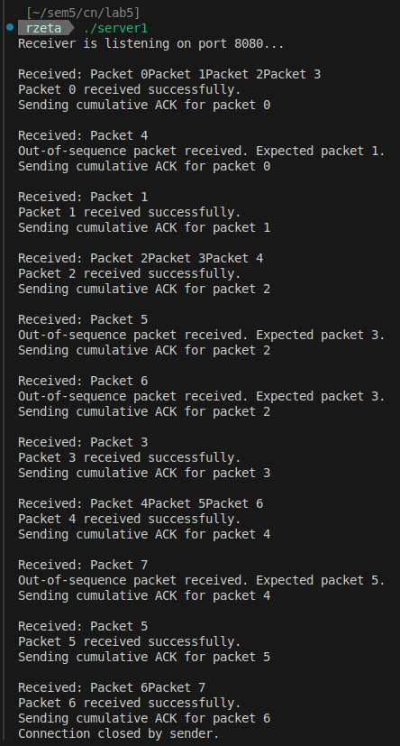
Terminal – 1 (server)

Terminal – 2 (client)
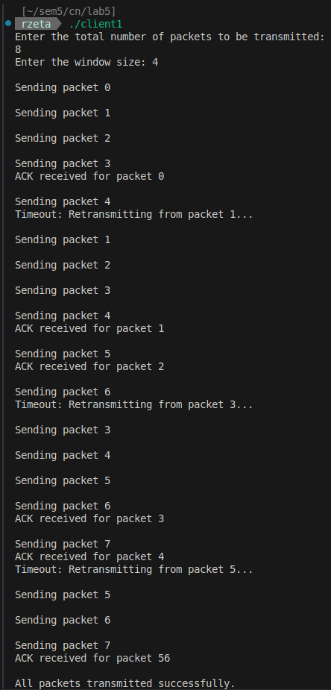

Q4)

Server -
// receiver_selective_repeat.c
#include <stdio.h>
#include <stdlib.h>
#include <string.h>
#include <unistd.h>
#include <arpa/inet.h>
#include <time.h>

#define PORT 8080
#define MAX_BUFFER 1024
#define PACKET_LOSS_PROBABILITY 20 // 20% chance of packet loss or corruption

int simulatePacketLossOrCorruption() {
return rand() % 100 < PACKET_LOSS_PROBABILITY;
}

int main() {
int server_fd, new_socket;
struct sockaddr_in address;
int addrlen = sizeof(address);
char buffer[MAX_BUFFER] = {0};
int expectedSeqNum = 0; // Expected packet number for Selective Repeat ARQ

srand(time(0)); // Seed for random number generation

if ((server_fd = socket(AF_INET, SOCK_STREAM, 0)) == 0) {
perror("socket failed");
exit(EXIT_FAILURE);
}

address.sin_family = AF_INET;
address.sin_addr.s_addr = INADDR_ANY;
address.sin_port = htons(PORT);

if (bind(server_fd, (struct sockaddr *)&address, sizeof(address)) < 0) {
perror("bind failed");
exit(EXIT_FAILURE);
}

if (listen(server_fd, 3) < 0) {
perror("listen failed");
exit(EXIT_FAILURE);
}

printf("Receiver is listening on port %d...\n", PORT);

if ((new_socket = accept(server_fd, (struct sockaddr *)&address, (socklen_t*)&addrlen)) < 0) {
perror("accept failed");
exit(EXIT_FAILURE);
}

while (1) {
memset(buffer, 0, MAX_BUFFER);
int valread = read(new_socket, buffer, MAX_BUFFER);
if (valread == 0) {
printf("Connection closed by sender.\n");
break;
}

printf("\nReceived: %s\n", buffer);

if (simulatePacketLossOrCorruption()) {
printf("Packet %d lost or corrupted. No ACK sent.\n", expectedSeqNum);
continue;
}

int receivedSeqNum = atoi(buffer + 7); // Extract packet number

if (receivedSeqNum >= expectedSeqNum) {
printf("Packet %d received successfully.\n", receivedSeqNum);
expectedSeqNum = receivedSeqNum + 1;
} else {
printf("Out-of-sequence packet received. Expected packet %d.\n", expectedSeqNum);
}

char ack[MAX_BUFFER];
snprintf(ack, MAX_BUFFER, "%d", receivedSeqNum);
printf("Sending ACK for packet %d\n", receivedSeqNum);
send(new_socket, ack, strlen(ack), 0);
}

close(new_socket);
close(server_fd);
return 0;
}
Client -
// sender_selective_repeat.c
#include <stdio.h>
#include <stdlib.h>
#include <string.h>
#include <unistd.h>
#include <arpa/inet.h>
#include <time.h>
#include <sys/select.h>

#define PORT 8080
#define MAX_BUFFER 1024
#define TIMEOUT 3
#define PACKET_LOSS_PROBABILITY 20 // 20% chance of packet loss or corruption

int simulatePacketLossOrCorruption() {
return rand() % 100 < PACKET_LOSS_PROBABILITY;
}

int main() {
int sock = 0, valread;
struct sockaddr_in serv_addr;
char buffer[MAX_BUFFER] = {0};
char ack[MAX_BUFFER] = {0};
int totalPackets, windowSize;
int base = 0, nextSeqNum = 0; // Selective Repeat ARQ window variables
int ackNum = 0;
int *ackReceived; // Track if packets have been acknowledged

srand(time(0)); // Seed for random number generation

// Create socket file descriptor
if ((sock = socket(AF_INET, SOCK_STREAM, 0)) < 0) {
printf("\nSocket creation error\n");
return -1;
}

serv_addr.sin_family = AF_INET;
serv_addr.sin_port = htons(PORT);

if (inet_pton(AF_INET, "127.0.0.1", &serv_addr.sin_addr) <= 0) {
printf("\nInvalid address/ Address not supported\n");
return -1;
}

if (connect(sock, (struct sockaddr *)&serv_addr, sizeof(serv_addr)) < 0) {
printf("\nConnection failed\n");
return -1;
}

printf("Enter the total number of packets to be transmitted: ");
scanf("%d", &totalPackets);
printf("Enter the window size: ");
scanf("%d", &windowSize);

ackReceived = (int *)malloc(totalPackets * sizeof(int));
memset(ackReceived, 0, totalPackets * sizeof(int));

while (base < totalPackets) {
// Send packets within window
while (nextSeqNum < base + windowSize && nextSeqNum < totalPackets) {
if (!ackReceived[nextSeqNum]) {
snprintf(buffer, MAX_BUFFER, "Packet %d", nextSeqNum);
printf("\nSending packet %d\n", nextSeqNum);
send(sock, buffer, strlen(buffer), 0);
}
nextSeqNum++;
}

// Wait for ACK or timeout
fd_set readfds;
struct timeval tv;
int retval;

tv.tv_sec = TIMEOUT;
tv.tv_usec = 0;
FD_ZERO(&readfds);
FD_SET(sock, &readfds);

retval = select(sock + 1, &readfds, NULL, NULL, &tv);

if (retval == -1) {
perror("select() error");
close(sock);
return -1;
} else if (retval == 0) {
// Timeout occurred
printf("Timeout: Retransmitting unacknowledged packets...\n");
nextSeqNum = base;
} else {
// Read ACK from receiver
memset(ack, 0, MAX_BUFFER);
valread = read(sock, ack, MAX_BUFFER);
if (valread > 0) {
ackNum = atoi(ack);
if (ackNum >= base && ackNum < totalPackets) {
printf("ACK received for packet %d\n", ackNum);
ackReceived[ackNum] = 1;

// Slide window if the base packet is acknowledged
while (ackReceived[base] && base < totalPackets) {
base++;
}
}
}
}
}

printf("\nAll packets transmitted successfully.\n");
free(ackReceived);
close(sock);
return 0;
}

Terminal – 1 (server):
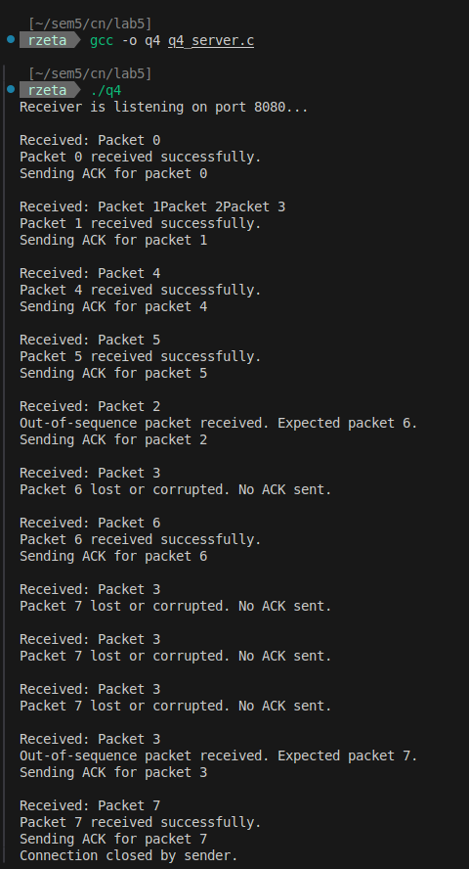

Terminal – 2 (client) :
