**HPC Tutorial - 13**

**CUDA - Parallelizing Multi-Head Self Attention Transformers**

Rohan G

CS22B1093

**CUDA Version of project code -**

**Device Code -**

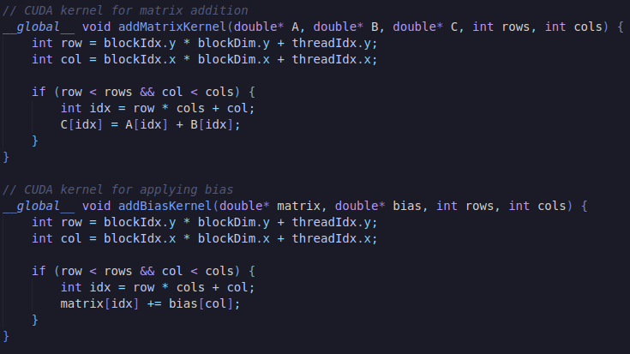

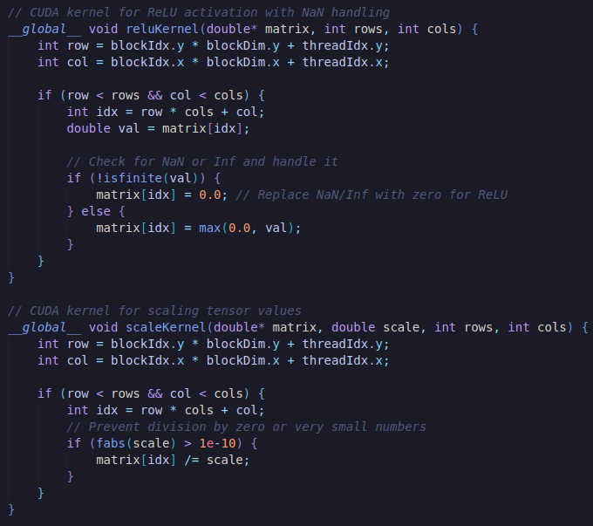  
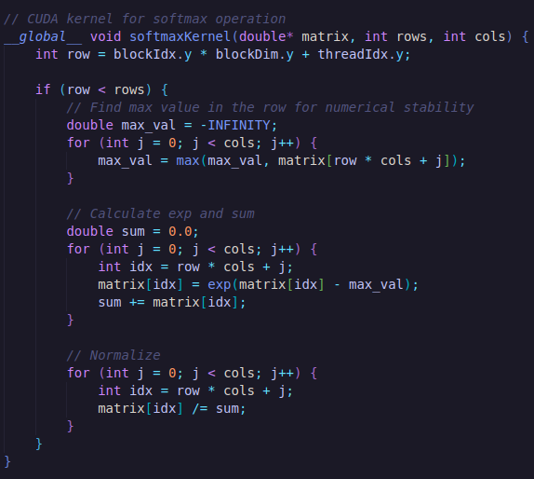  
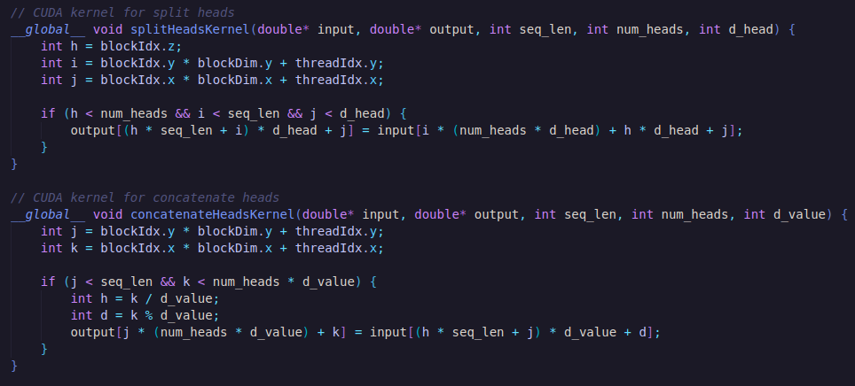

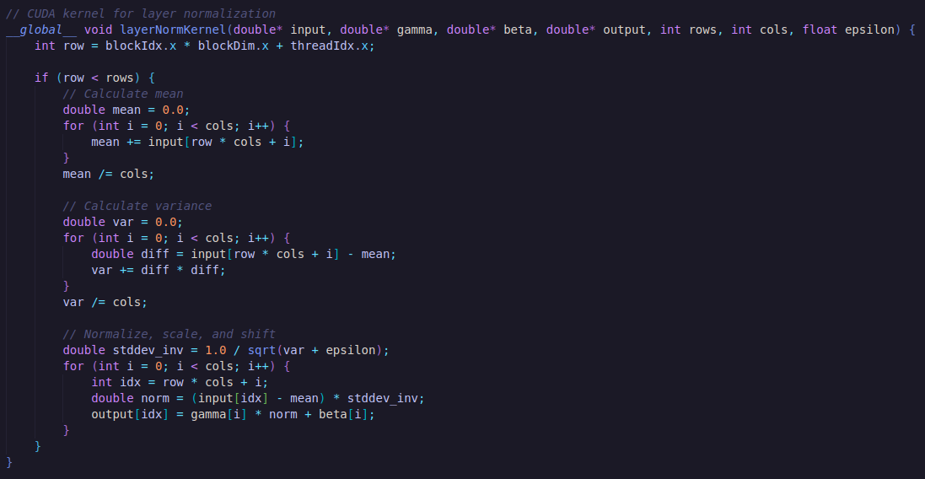  
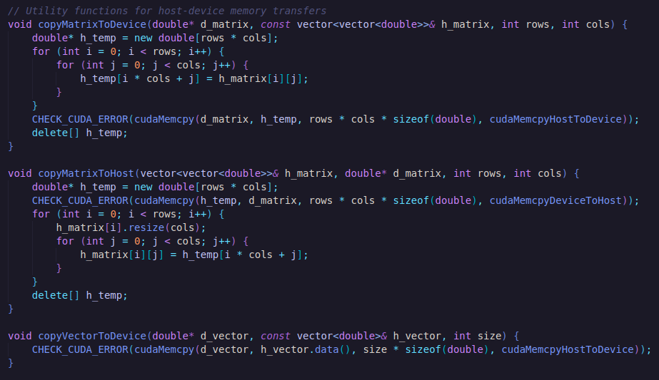  
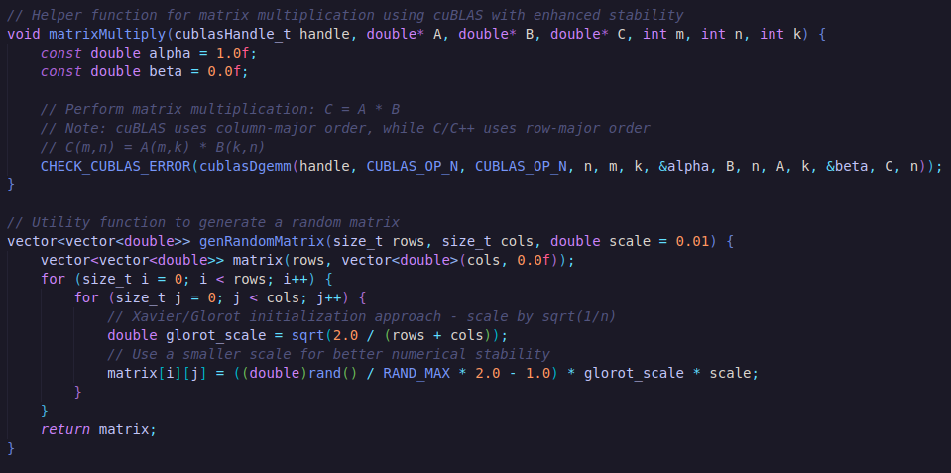  
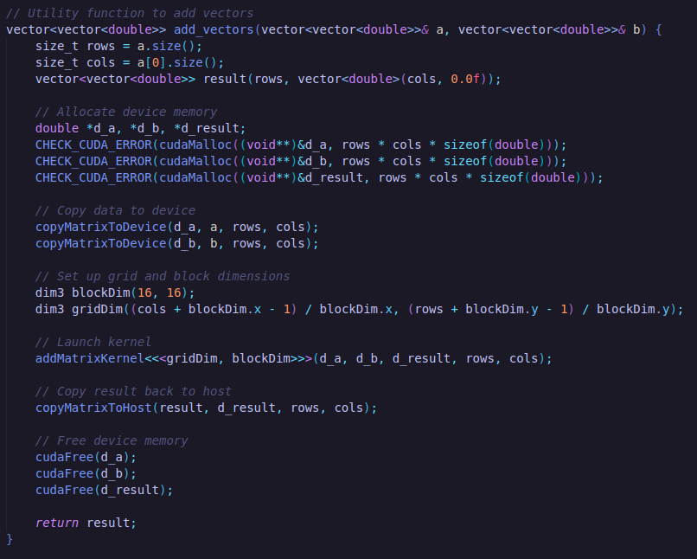  
  
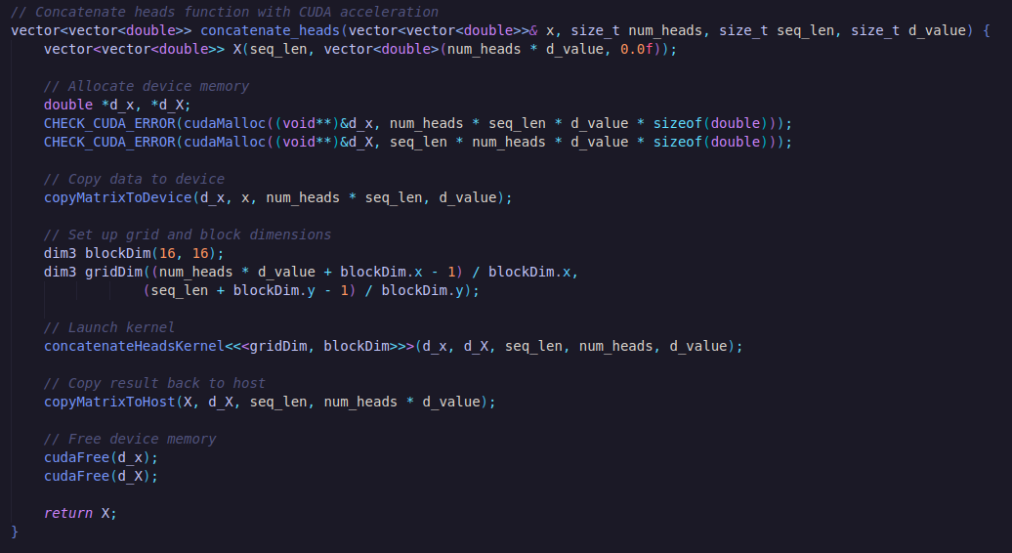  
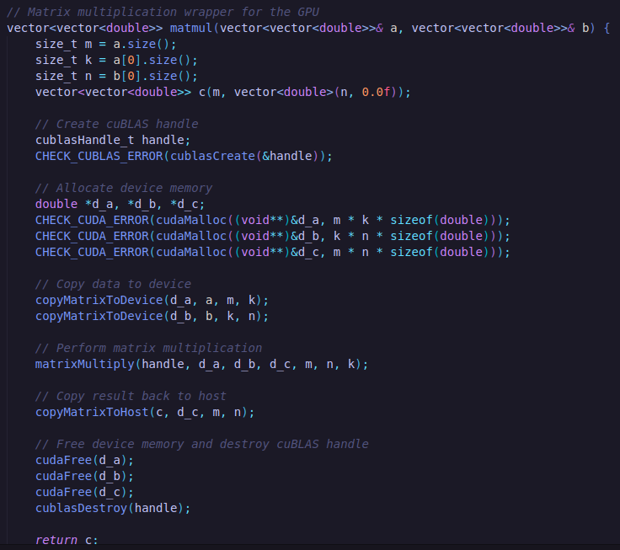

**Host Code -**

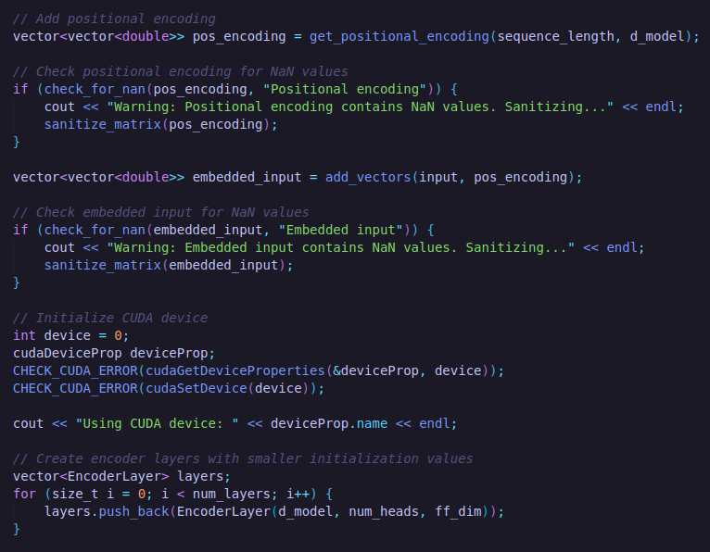

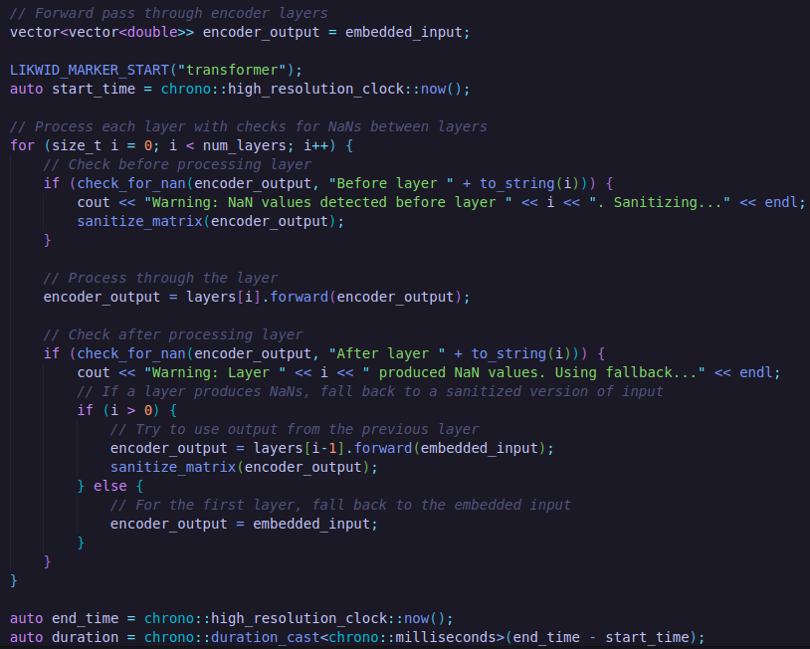

**Serial Code Output -**

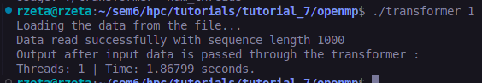

**Parallelized CUDA Output -**

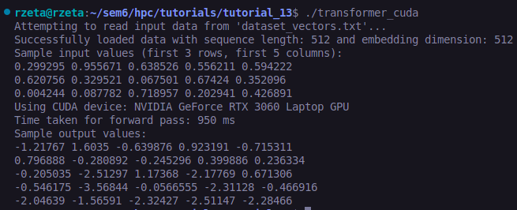

**Speedup -**

**S = T(1) / T(P) = 1.87 / 0.95 = 1.968**

**Speedup Achieved ~ 2x**

**CUDA Profiling -**

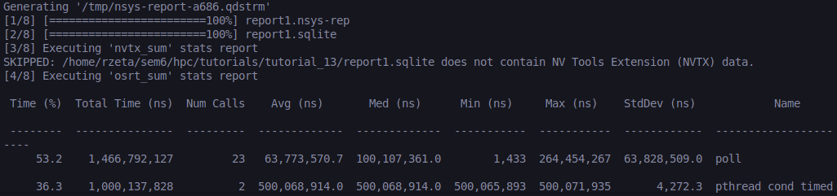

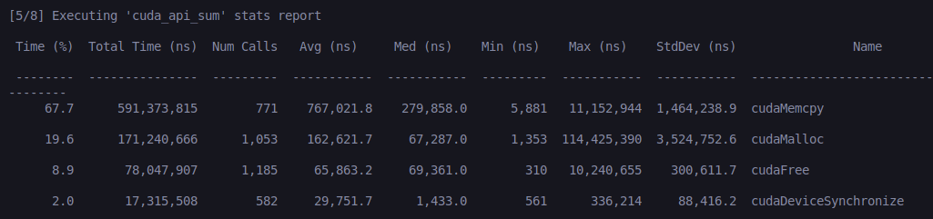

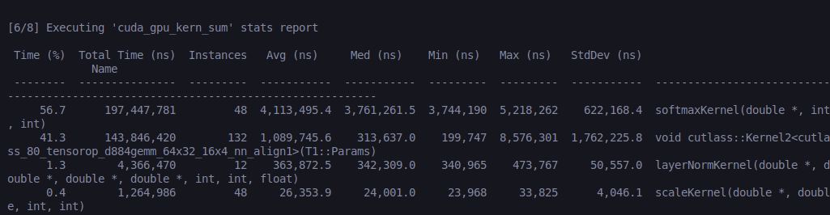

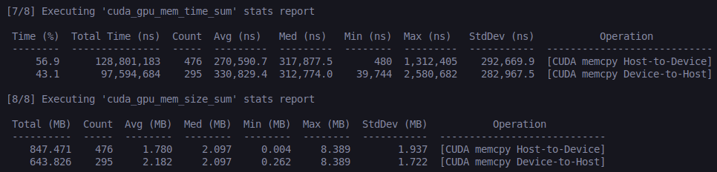

**Observations from CUDA Nsight Profiling -**

* Batch kernel launches to reduce CPU-GPU synchronization overhead.
* Optimize data transfers with pinned memory and asynchronous streaming.
* Increase block sizes to maximize SM occupancy and warp efficiency.