Operating Systems – Lab 1
CS22B1093 Rohan G

Q1)
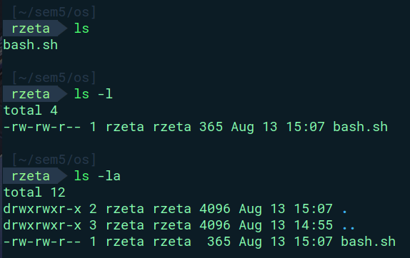
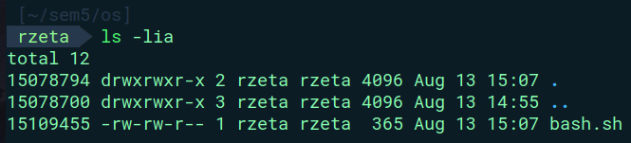
ls == list directory contents
ls -l == long listing format of ls
ls -la == long listing format of ls , -a == all
ls -lia == long listing format of ls , -a == all , -i == inode number

Q2)
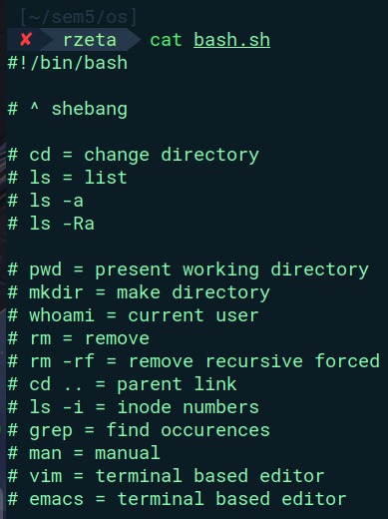

cat – concatenate files and print them on terminal
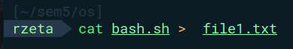

cat <filename1> <filename2> … > <newfile> [ > == directing operator]

less – better version of more , useful for reading larger files
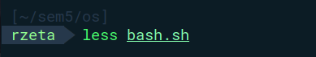

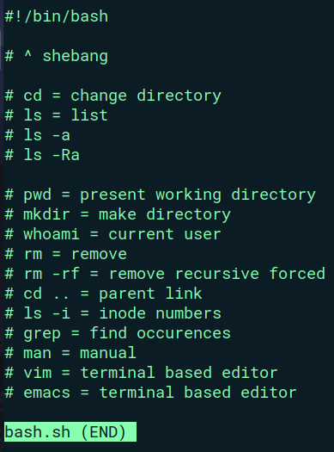

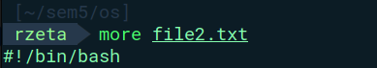

more – reading through pages in terminal
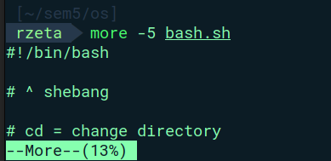

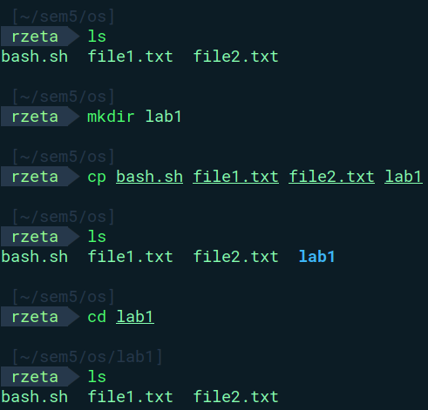
Q3)

cp == copy
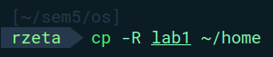

cp -R == copy , -R = recursively
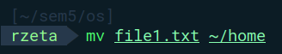

mv == move

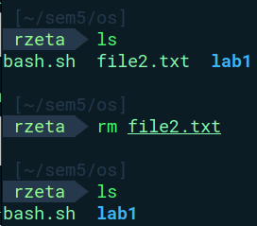

rm == remove

rm -rf == remove , -r == recursively, -f == forcefully
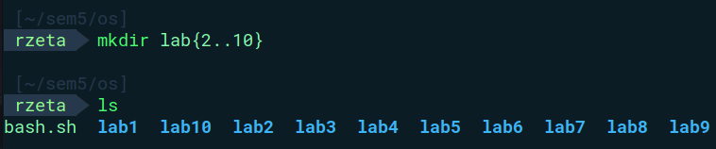
mkdir – make new directory

Q4)
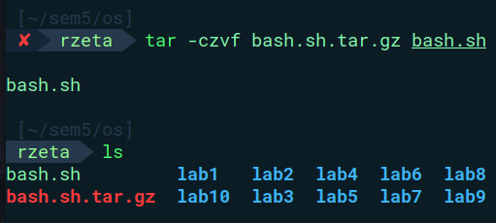

tar -czvf = archiving tool , -c == compress , -v == verbose , -f == fillename , - z == compress using gzip

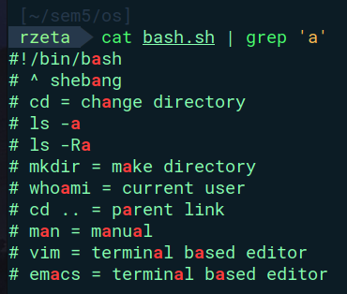

grep == find occurrences [ | == pipeline ]
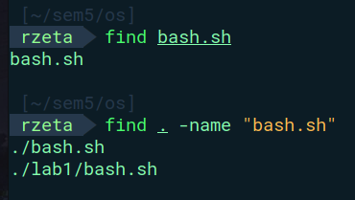

find == find files , (. == all)

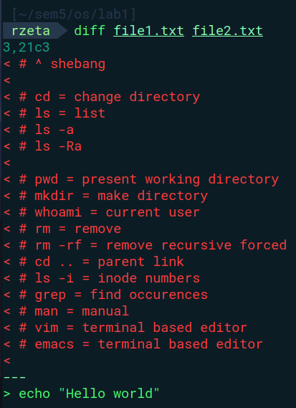

diff == difference between files

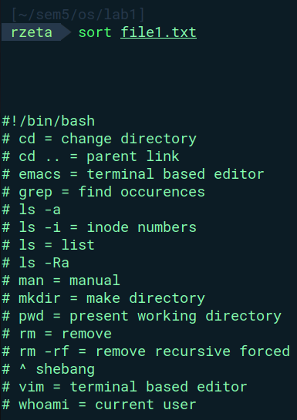

sort == sort lines in files
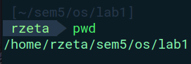

pwd == present working directory
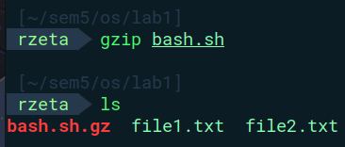

gzip == reduces file size using LZ77 coding (Lempel Ziv)

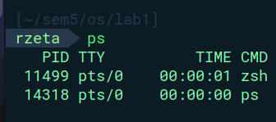

ps == displays processes
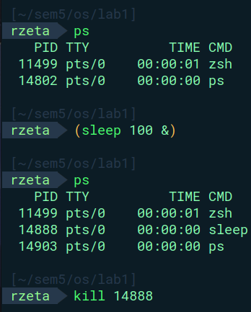

kill == kill the process with the matching process id , (sleep 100 & ) == runs a subshell in the background
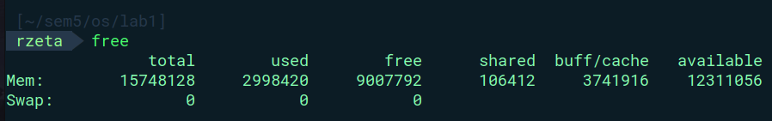
free == shows the usage of ram in the system

Q5)

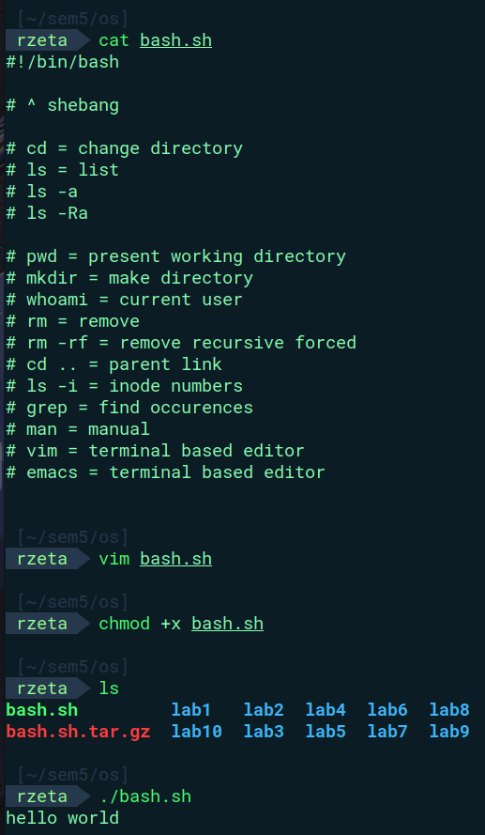

chmod == change file modes

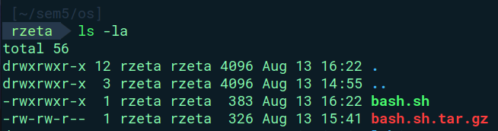
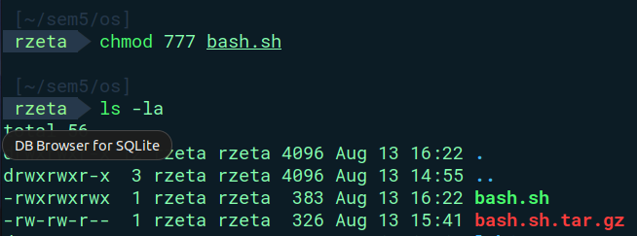

6a)
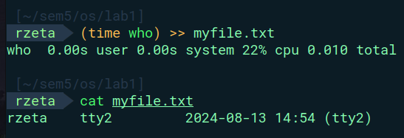

time == runs programs and outputs the system resources used

who == which user is logged in

6b)

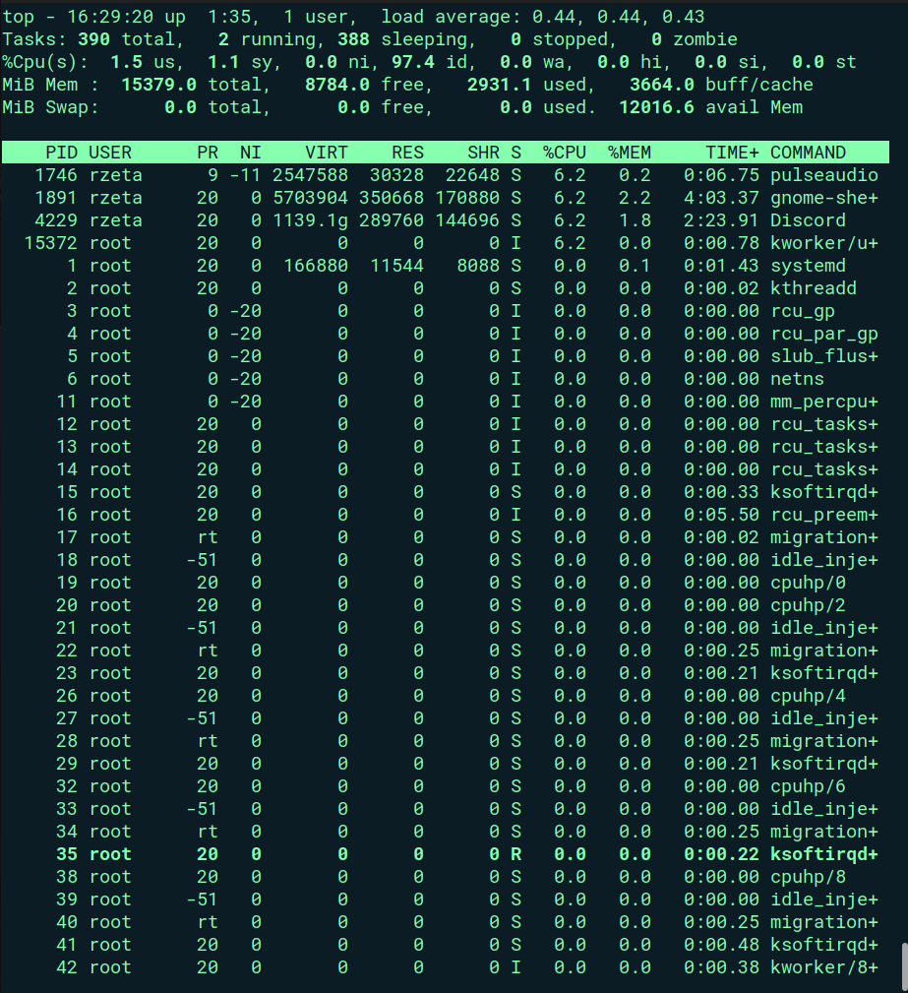
top == displays the process running
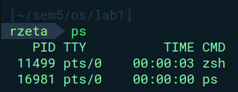

ps == snapshot of current running processes

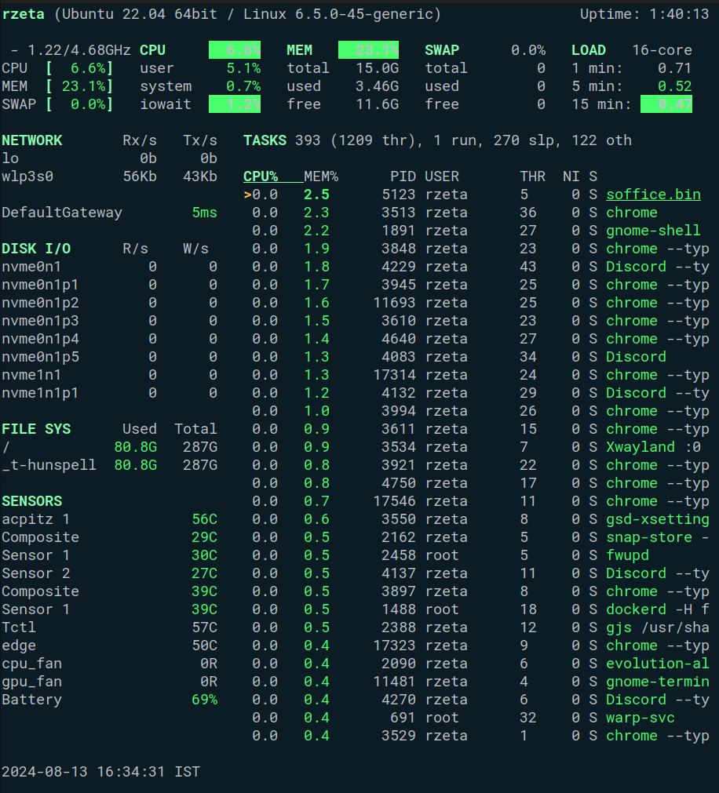
glances == bird’s eye view of the system

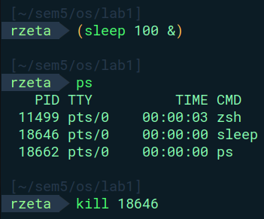

kill == kills/stops the processes given the process id
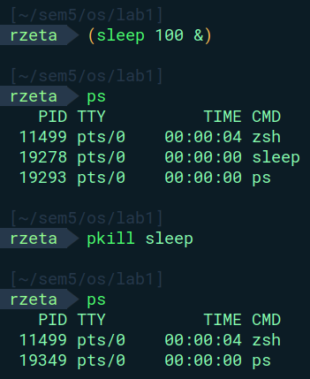

\

pkill == kill process based on name

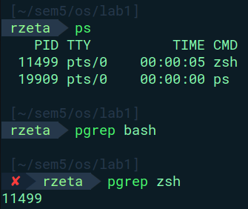

pgrep == looks through the running processes and lists them out

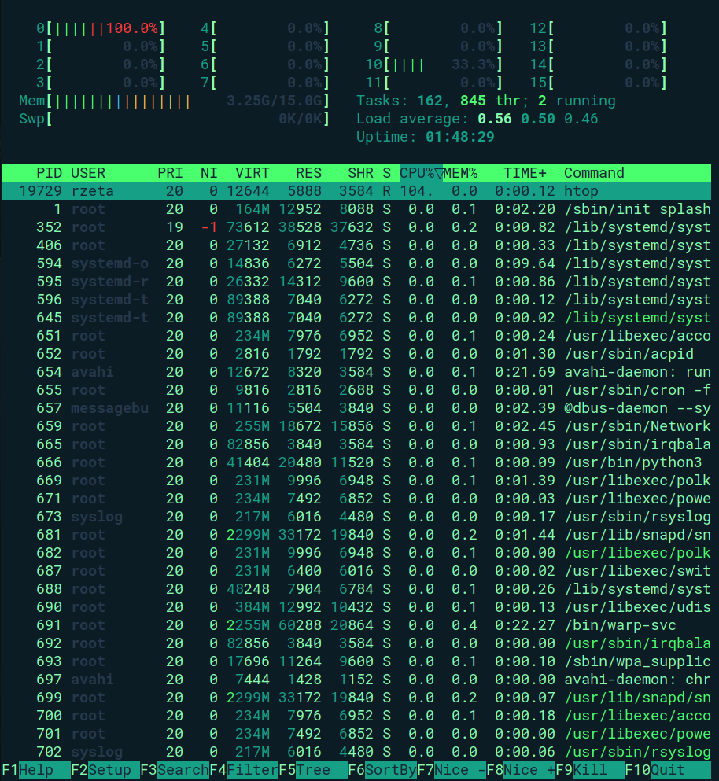
htop == more interactive and better version of top

7)
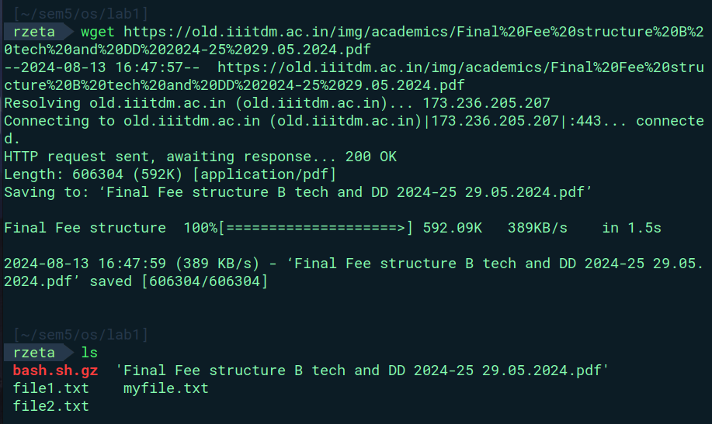
wget == terminal based network downloader

8)
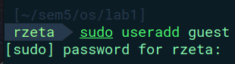

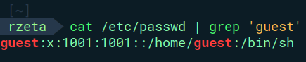

useradd == create and add new user
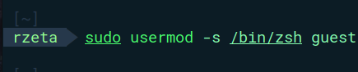

usermod == modify parameters of user
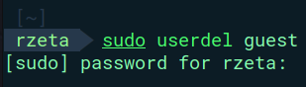

userdel == delete user
9)
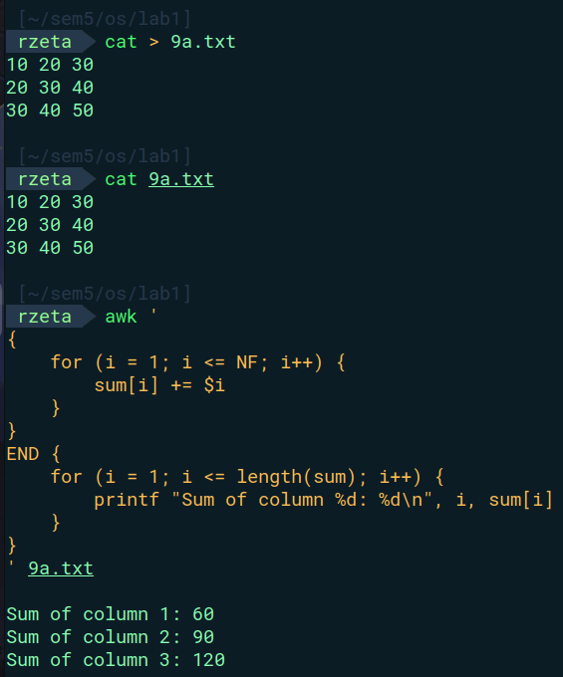

9b)
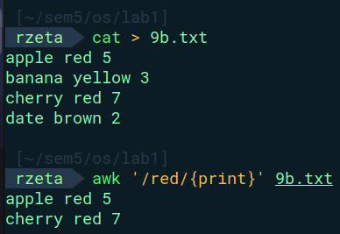

awk == powerful text processing tool
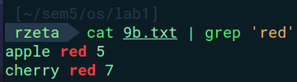

grep == search patterns in files
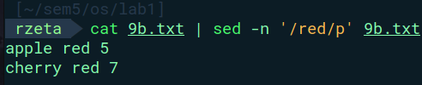

sed == stream editor , used to do basic text operations

Q4)

ssh = Open ssh login client , ssh = secured shell

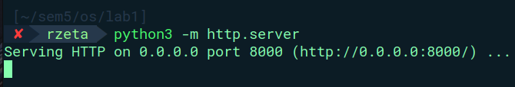
Terminal – 1

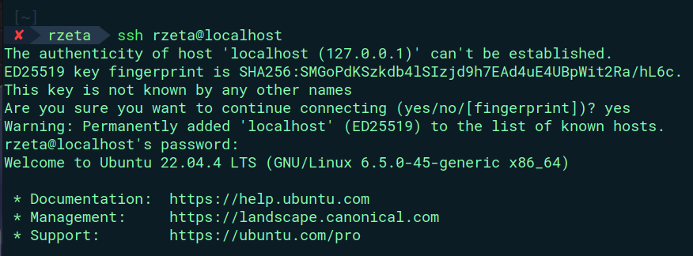
Terminal - 2

