SH2.0.1Instructions
1st – Load the image 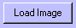
2nd – Create a text file (ex. txt) in order to store data
3rd – Select with the mouse two points diagonally making up a rectangle with covers all the desired area.
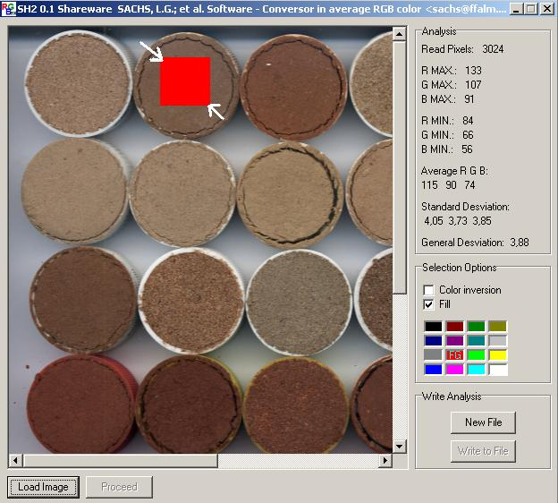
4th - Proceed the analysis 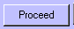
5th - Save the result 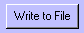
Note: Repeat the 3rd to 5th.steps up to every desired areas of the same image be got.

