Spring 2006 Stat 414.1

Midterm II Solution

- Consider the simple experiment of flipping a fair coin.

  - If we perform this experiment 6 independent times and let X be the number of heads observed, what is the mean and variance of a r.v. X?

Sol) Since X ~ Binomial(5, 1/2),
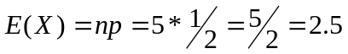
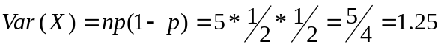

  - What is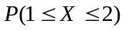?

Sol)
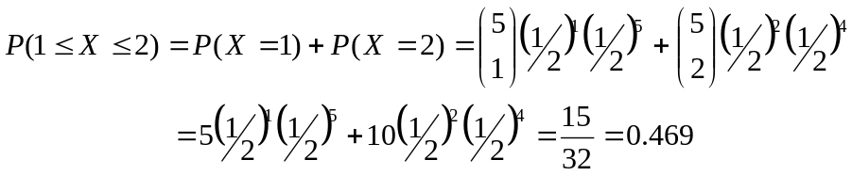

  - Suppose that 100 independent experiments are performed, what is the probability of observing at most two heads? (Hint: Use Poisson approximation to Binomial)

Sol) Since X ~ Binomial (100, 1/2), a r.v. X approximates to Poisson (λ=np=100*1/2=50). Using the p.m.f of Poisson distribution, 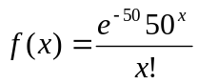:

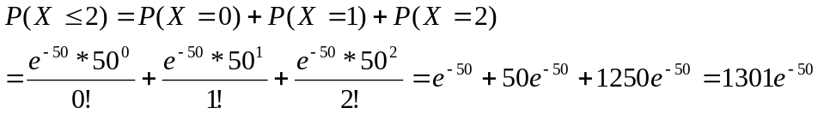

- An excellent free throw shooter attempts several free throws until she misses. The probability that she misses a free throw is p=0.1.

  - What is the probability that the first miss occurs on the 3th attempts?

Sol) Since X~Geometric (0.1), using the p.m.f of Geometric distribution, 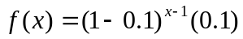:
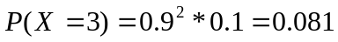

  - If we let Y be the number of shooting free throws until she misses 6 times, what is the mean and variance of a r.v.Y?

Sol) Since Y~ Neg. Bin (p=0.1, r=6), using the rules of Negative Binomial distribution:
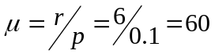;
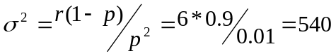

- Telephone calls enter a college switchboard according to a Poisson process on the average of one every two minutes.

  - Let X be the number of phone calls entered a college switchboard, what is the probability that two calls enter in a given one minute?
Sol) Since X ~ Poi(λ=2), using the p.m.f of Poisson distribution, 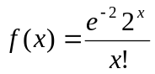:
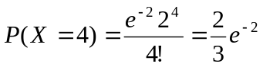

  - Let W be the waiting time until the first call arrives, what is the probability that you will have to wait between 20 minutes and 30 minutes?

Sol) Since W ~ exp (θ=1/λ=1/2), using the p.d.f of exponential distribution, 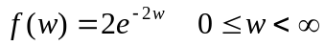:
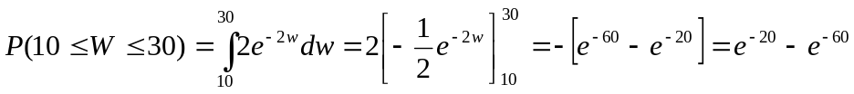

  - Let Z be the waiting time until the tenth call arrives, what is the p.d.f of Z?

Since Z ~ Gamma (θ=1/2, α=10),
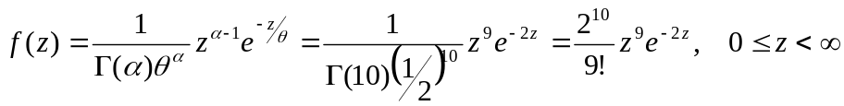:

- Suppose that the p.d.f. of a r.v X is

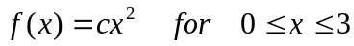

  - Find c such that f(x) is a valid p.d.f. of X

Sol) To check the validity of p.d.f ,
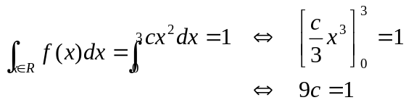
Therefore, c=1/9

  - Find the first quartile or 25th percentile of X (e.g., 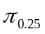)
Sol) 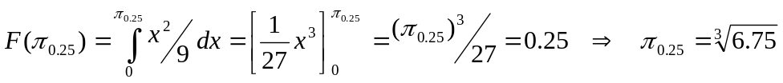

  - Consider a new r.v. Y, where Y=X². Find the p.d.f of Y.

Sol) Since the inverse function 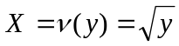, 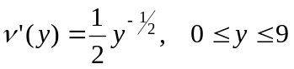, using the change of variable technique:

