Software defined network resource allocation for large-range edge-edge cooperation
network_resource_allocation
4. EECN structure construction method
本节讨论优化的EECN结构构建问题，并介绍如何构建所需的EECN结构。

4.1. Problem description
As introduced in Section 3.1, the EECN is a subset of the SDN-enabled network that connects edge servers. The network is modeled as a directed graph G = (V, E), where V is the set of vertices representing ommunication nodes (edge servers and switches) and E is the set of edges denoting communication links. Let C denote the set of edge servers. Each link e of the network has a bandwidth parameter denoted by Be and a link cost weight ωe. Here Be denotes the maximum usable computation-dedicated bandwidth of a link e. In practice, the link cost weight can be roughly configured as follows: For each link e in local networks, ωe is set to a low value; For a link e in the core network, ωe is set to a high value. Similarly, the EECN is also modeled as a directed graph Gc = (Vc, Ec), where Vc (Vc ⊆ V) is the set of vertices representing communication nodes and Ec (Ec ⊆ E) is the set of edges denoting communication links. Each link e of the EECN has a computationdedicated bandwidth parameter denoted by b c e (b c e ≤ Be).
Without considering the bandwidths, the cost of a given EECN G is denoted by cost(G) and defined as
如第 3.1 节所述，EECN 是连接边缘服务器的 SDN 网络的一个子集。该网络被建模为一个有向图 G = (V, E)，其中 V 是表示通信节点（边缘服务器和交换机）的顶点集，E 是表示通信链路的边集。令 C 表示边缘服务器的集合。网络中的每个链路 e 都有一个带宽参数 Be 和一个链路成本权重 ωe。这里 Be 表示链路 e 的最大可用计算专用带宽。在实践中，链路成本权重可以大致配置如下：对于局部网络中的每个链路 e，ωe 设置为一个较低的值；对于核心网络中的链路 e，ωe 设置为一个较高的值。类似地，EECN 也被建模为一个有向图 Gc = (Vc, Ec)，其中 Vc (Vc ⊆ V) 表示通信节点的顶点集，Ec (Ec ⊆ E) 表示通信链路的边集。EECN 的每条链路 e 都有一个计算得到的专用带宽参数，记为 b c e (b c e ≤ Be)。
不考虑带宽，给定EECN G的成本用cost(G)表示，定义为：
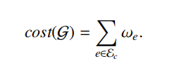(1)

The proposed solution uses a hop-loosing function to choose the links of the EECN. Let hG(vi , vj) denote the number of hops of the shortest path from vi to vj over G, and αmin, αmax and β (αmax > β > 1) denote three configuration parameters. The parameter αmax is used to restrict the maximum length of edge-edge paths.Given two edge servers (vi and vj) in a graph G(V, E), the hop-loosing function is denoted by lG(vi , vj)
and defined as
所提出的解决方案使用跳数减少函数来选择 EECN 的链路。令 hG(vi, vj) 表示图 G 上从 vi 到 vj 的最短路径的跳数，αmin、αmax 和 β (αmax > β > 1) 表示三个配置参数。参数 αmax 用于限制边-边路径的最大长度。给定图 G(V, E) 中的两个边缘服务器 (vi 和 vj)，跳数减少函数记为 lG(vi, vj)，其定义为：
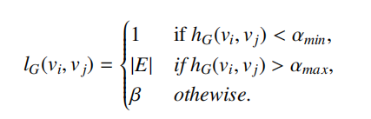(2)

In terms of the definition of hop-loosing function, the links of the path between two edge servers within the same local network can be included in the EECN. Because the costs of the links in local networks are low, the above process does not obviously increase the cost of the EECN, but can effectively improve the performance of edge-edge cooperation. In the case where hG(vi , vj) > αmax, the path between vi and vj is not limited, which can obviously reduce the cost of the EECN. As the parameter β increases, the performance of edge-edge cooperation decreases, but the cost of the EECN also decreases. The configuration of β depends on the considerations between cost and performance.
根据跳数丢失函数的定义，同一本地网络内两个边缘服务器之间的路径链路可以包含在EECN中。由于本地网络中链路的成本较低，上述过程不会明显增加EECN的成本，但可以有效提升边缘间协作的性能，当hG(vi, vj) > αmax时，vi和vj之间的路径不受限制，这可以显著降低EECN的成本。随着参数β的增大，边缘间协作的性能下降，但EECN的成本也随之降低。β的配置取决于成本和性能之间的权衡。

On the basis of the definitions of EECN cost and hop-loosing function, this paper introduces a hop-constrained minimumcost EECN construction problem, which aims at minimizing the EECN cost under the constraints on maximum hops. Formally, the hop-constrained minimum-cost EECN construction problem is designed to find a subgraph (denoted by Gc(Vc, Ec)) of a network graph G that satisfies the following requirements: minimize: cost(G) subject to
基于EECN成本和跳数丢失函数的定义，本文引入了跳数约束最小成本EECN构造问题，旨在最小化最大跳数约束下的EECN成本。形式上，跳数约束最小成本EECN构造问题旨在找到网络图G的一个子图（记为Gc(Vc, Ec)），满足以下要求：最小化cost(G)，约束条件为：
C ⊆ Vc, (3)
hGc (vi , vj) ≤ lG(vi , vj) × hG(vi , vj), ∀vi , vj(∈ C). (4)

Constraint (3) ensures that each edge server is connected to the EECN. Constraint (4) ensures that the shortest path from an edge server to another edge server satisfies the designated hop constraint. The following proposition holds.
约束条件 (3) 确保每个边缘服务器都连接到 EECN。约束条件 (4) 确保从一个边缘服务器到另一个边缘服务器的最短路径满足指定的跳数约束。以下命题成立。

4.2. EECN structure construction algorithm
As introduced in Section 4.1, the hop-constrained minimum cost EECN construction problem is NP-hard. To solve this problem, this paper introduces a link avoidance model, and presents the EECN structure construction algorithm based on the model.
如第4.1节所述，跳数约束最小成本EECN构造问题是NP难问题。为了解决这个问题，本文引入了链路规避模型，并提出了基于该模型的EECN结构构造算法。

4.2.1. Link avoidance model
In the link avoidance model, each link is allocated an avoidance degree. The links with low avoidance degrees are prioritized for use in the EECN structure construction procedure. Let st(e) and en(e) denote the start node and ending node of a link e, respectively. For an edge-edge pair < ci , cj > and a link e in a topology graph G, two indicator functions IG(e, ci , cj) and IG ′ (e, ci , cj) are defined as
在链路回避模型中，每条链路都被赋予一个回避度。回避度低的链路在EECN结构构建过程中被优先使用。令st(e)和en(e)分别表示链路e的起始节点和终止节点。对于拓扑图G中的边-边对<ci, cj>和链路e，定义两个指示函数IG(e, ci, cj)和IG′(e, ci, cj)。

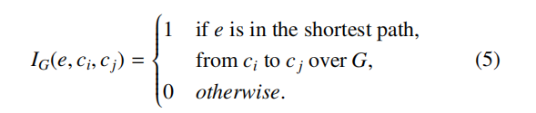
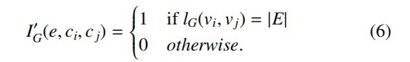

Let mcn(e, ci , cj ,G) denote the node, in the shortest path from ci to cj over G, that is the closest to the ending node of e. A function dG v (e, ci , cj) is defined as
令 mcn(e, ci, cj, G) 表示在 G 上从 ci 到 cj 的最短路径中，距离 e 的终点最近的节点。函数 dG v(e, ci, cj) 定义为：

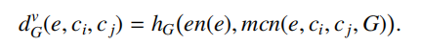(7)

A function dG h (e, ci , cj) is defined as
函数 dG h (e, ci , cj) 定义为
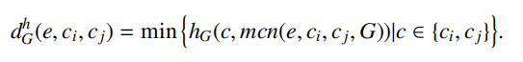(8)

For an edge-edge pair < ci , cj > and a link e in a topology graph G, the avoidance degree λG(e, ci , cj) is computed by
对于拓扑图 G 中的边-边对 <ci, cj> 和链路 e，回避度 λG(e, ci, cj) 的计算公式为：
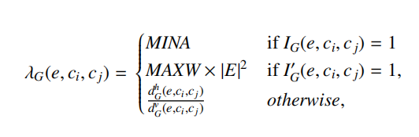(9)

where MINA denotes a parameter that is configured by a very small value (e.g., 0.01) and MAXW denotes the maximum link weight.The total avoidance degree of a link e is denoted by hs(l) and computed by
其中 MINA 表示一个参数，其值非常小（例如 0.01），MAXW 表示链路的最大权重。链路 e 的总避障度用 hs(l) 表示，计算公式为：
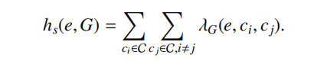(10)

4.2.2. Link avoidance model based algorithm
According to Eq. (10), the avoidance degree of a link is high if this link is close to many shortest edge-edge paths, and vice versa. Therefore, the avoidance degree is helpful to select EECN links at a low cost. On basis of the link avoidance model, this paper presents an algorithm, Algorithm 1, to solve the hop constrained minimum-cost EECN construction problem. Algorithm 1 first computes link avoidance degrees in terms of the proposed link avoidance model. Then it generates a spanning tree with the minimum weighted cost. Because the weighted cost ϖ(e) of a link e is computed by ϖ(e) = ω(e) × hs(e,G), the generated spanning tree tends to include the links with low avoidance degrees and to reduce the number of the links. Using the links with low avoidance degrees is helpful to obtain hop satisfied edge-edge paths. If the generated spanning tree does not meet the hop constraints, it is expanded by adding new links one by one. In the above procedure, the links with high avoidance degrees are prioritized to be added, which can effectively reduce the number of added links. A path is said to be a candidate edge-edge cooperation path if this path meets the hop constraint indicated by Eq. (4). We can have the following propositions.
根据式 (10)，如果一条链路靠近许多最短边-边路径，则该链路的回避度较高，反之亦然。因此，回避度有助于以低成本选择 EECN 链路。基于链路回避模型，本文提出了一种算法（算法 1）来解决跳数约束的最小成本 EECN 构建问题。算法 1 首先根据所提出的链路回避模型计算链路的回避度。然后，它生成一个加权成本最小的生成树。由于链路 e 的加权成本 ϖ(e) 由 ϖ(e) = ω(e) × hs(e,G) 计算，因此生成的生成树倾向于包含回避度较低的链路，从而减少链路的数量。使用回避度较低的链路有助于获得满足跳数约束的边-边路径。如果生成的生成树不满足跳数约束，则通过逐个添加新链路来扩展它。在上述过程中，优先添加回避度高的链路，这可以有效减少新增链路的数量。如果一条路径满足公式（4）所示的跳数约束，则称其为候选边-边合作路径。我们可以得出以下结论。

4.3. EECN structure maintenance
Algorithm 1 describes how to build the EECN structure for a batch of edge servers. In practice, a new edge server can be connected to the network at a random moment, and an existing edge server can be disconnected for some reason. When an existing edge server c is disconnected, the links that are only
used in the edge-edge paths for c are removed from the existing EECN structure. The following parts introduce how to expand the existing EECN structure to connect a new edge server
算法 1 描述了如何为一批边缘服务器构建 EECN 结构。在实际应用中，新的边缘服务器可能随时连接到网络，而现有的边缘服务器也可能由于某种原因断开连接。当现有边缘服务器 c 断开连接时，仅用于连接 c 的边缘-边缘路径的链路将从现有的 EECN 结构中移除。以下部分将介绍如何扩展现有的 EECN 结构以连接新的边缘服务器。
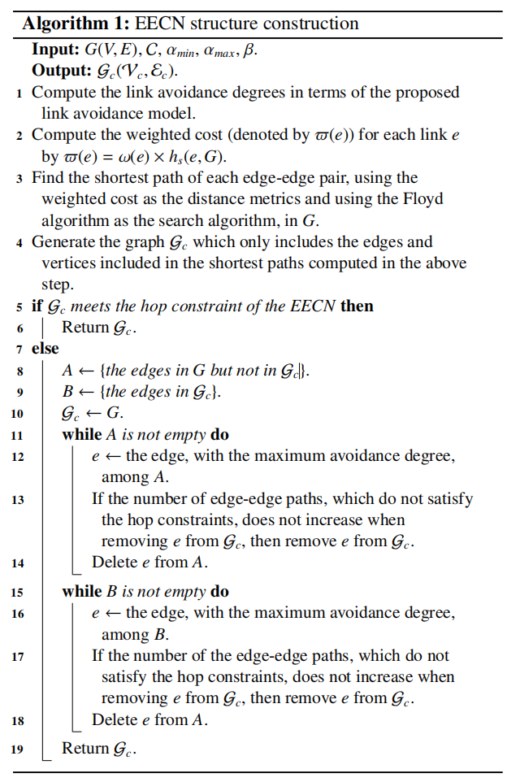

Input: G(V, E), C, αmin, αmax, β.
Output: Gc(Vc, Ec).
Compute the link avoidance degrees in terms of the proposed link avoidance model.
Compute the weighted cost (denoted by ϖ(e)) for each link e by ϖ(e) = ω(e) × hs(e,G).
Find the shortest path of each edge-edge pair, using the weighted cost as the distance metrics and using the Floyd algorithm as the search algorithm, in G.
Generate the graph Gc which only includes the edges and vertices included in the shortest paths computed in the above step.
if Gc meets the hop constraint of the EECN then Return Gc.
else
A ← {the edges in G but not in Gc}.
B ← {the edges in Gc}.
Gc ← G.
while A is not empty do
e ← the edge, with the maximum avoidance degree, among A.
If the number of edge-edge paths, which do not satisfythe hop constraints, does not increase whenremoving e from Gc, then remove e from Gc.
Delete e from A.
while B is not empty do
e ← the edge, with the maximum avoidance degree, among B.
If the number of the edge-edge paths, which do not satisfy the hop constraints, does not increase whenremoving e from Gc, then remove e from Gc.
Delete e from A.
Return Gc.

输入：G(V, E), C, αmin, αmax, β。
输出：Gc(Vc, Ec)。
1 根据所提出的链路回避模型计算链路回避度。
2 计算每条链路 e 的加权成本（记为 ϖ(e)），公式为 ϖ(e) = ω(e) × hs(e,G)。
3 在图 G 中，使用加权成本作为距离度量，并使用 Floyd 算法作为搜索算法，找到每对边之间的最短路径。
4 生成图 Gc，其中仅包含上一步计算的最短路径中包含的边和顶点。
5 如果 Gc 满足 EECN 的跳数约束，则返回 Gc。
6 否则
6 .1 A ← {G 中但不在 Gc 中的边}。
6 .2 B ← {Gc 中的边}。
6 .3 Gc ← G。
6 .4 当 A 非空时执行以下操作：
6 .4.1 e ← A 中回避度最大的边。
6 .4.2 如果从 Gc 中移除 e 后，不满足跳跃约束的边-边路径的数量没有增加，则从 Gc 中移除 e。
6 .4.3 从 A 中删除 e。
6 .5 当 B 非空时执行以下操作：
6 .5.1 e ← B 中回避度最大的边。
6 .5.2如果从 Gc 中移除 e 后，不满足跳跃约束的边-边路径的数量没有增加，则从 Gc 中移除 e。
6 .5.3 从 A 中删除 e。
6 .6 返回 Gc。

Let Gco (Vco , Eco ) denote the existing EECN structure and Co denote the existing edge servers. For each link e of E − Eo c and a new edge server q, a limited avoidance degree is denoted by h ′ s (e, q) and computed by
令 Gc0 (Vc0 , Ec0) 表示现有的 EECN 结构，C0 表示现有的边缘服务器。对于 E−Ec0 中的每个链路 e 和一个新的边缘服务器 q，其有限回避度记为 h′s (e, q)，计算公式为：
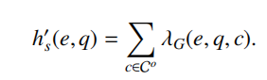(11)

On basis of the limited avoidance degree, the edge-edge paths for a new edge server are constructed by Algorithm 2. Algorithm 2 uses an idea similar to Algorithm 1. However, because the network services of ongoing edge-edge cooperation are affected when the existing EECN structure changes, Algorithm 2
does not change the existing EECN structure. When the number of new edge servers exceeds a designated threshold, the EECN structure can be rebuilt by Algorithm 1 to reduce the overall cost. The rebuilt EECN structure is used in a reliable switch manner. In this manner, the switch from an old path to a new
path is conducted in terms of different cases. If the old path is not in use, the old path is deleted and the new path takes effect. If the old path is in use, it is replaced by the new path when it is still used for a designated time or the corresponding edge-edge cooperation end within the above time.
基于有限的回避度，算法 2 构建新边缘服务器的边缘-边缘路径。算法 2 的思想与算法 1 类似。然而，由于现有 EECN 结构的变化会影响正在进行的边缘-边缘协作的网络服务，因此算法 2 不会改变现有的 EECN 结构。当新边缘服务器的数量超过指定阈值时，可以使用算法 1 重建 EECN 结构以降低总体成本。重建后的 EECN 结构以可靠切换的方式使用。这样，根据不同的情况进行从旧路径到新路径的切换。如果旧路径未使用，则删除旧路径并启用新路径。如果旧路径正在使用，则当旧路径继续使用达到指定时间或相应的边缘-边缘协作在该时间内结束时，用新路径替换旧路径。
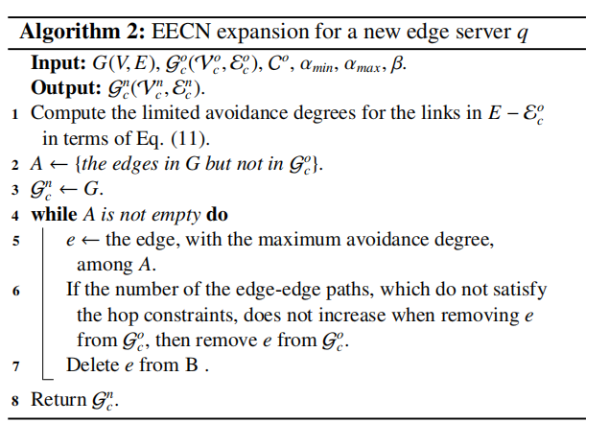

Algorithm 2: EECN expansion for a new edge server q
Input: G(V, E), Gc0(Vc0, Ec0), C0, αmin, αmax, β.
Output: Gcn(Vcn, Ecn).
1 Compute the limited avoidance degrees for the links in E−Ec0 in terms of Eq. (11).
2 A ← {the edges in G but not in Gc0}.
3 Gcn ← G.
4 while A is not empty do
4.1 e ← the edge, with the maximum avoidance degree, among A.
4.2 If the number of the edge-edge paths, which do not satisfy the hop constraints, does not increase when removing e from Gc0, then remove e from Gc0.
4.3 Delete e from B .
5 Return Gcn.

算法 2：针对新边缘服务器 q 的 EECN 扩展
输入：G(V, E), Gc0(Vc0, Ec0), C0, αmin, αmax, β
输出：Gcn(Vcn, Ecn)
1. 根据公式 (11) 计算 E−Ec0 中链路的有限回避度。
2. A ← {G 中但不在 Gc0 中的边}。
3. Gcn ← G。
4. 当 A 非空时，执行以下操作：
4.1. e ← A 中回避度最大的边。
4.2. 如果从 Gc0 中移除 e 后，不满足跳数约束的边-边路径的数量没有增加，则从 Gc0 中移除 e。
4.3. 从 B 中删除 e。
5. 返回 Gcn。

5. Bandwidth allocation method
6. Experimental Evaluation
6.1. Experimental settings
The experiments used the BRITE topology generator [42] to generate Waxman topologies with different scales. In each topology, some nodes were selected as the edge servers. The proposed solution (i.e., ODBR) attempts to use an EECN structure to connect edge servers with minimum cost under hop constraints. The above problem becomes a Steiner tree building problem if the hop constraints are ignored. For the above rea
son, the proposed EECN structure construction method is evaluated by comparing the Steiner tree structure. So far, there have existed several Steiner tree building algorithms. The experiments used a KMB algorithm (i.e., Markowsky and Berman’s algorithm [44]) based solution [43] to build Steiner trees. The default values of the parameters used in the EECN structure construction are as follows: ωe = 1 for each link e; αmin = 1;
αmax = 5; β = 1.3; the network topology includes 1000 nodes. Unless otherwise specified, the EECN is built in a static mode.
实验使用 BRITE 拓扑生成器 [42] 生成不同规模的 Waxman 拓扑。在每个拓扑中，选择一些节点作为边缘服务器。所提出的解决方案（即 ODBR）尝试使用 EECN 结构在跳数约束下以最小成本连接边缘服务器。如果忽略跳数约束，上述问题将转化为构建 Steiner 树的问题。基于上述原因，本文通过与 Steiner 树结构进行比较来评估所提出的 EECN 结构构建方法。目前，已经存在多种 Steiner 树构建算法。实验采用基于 KMB 算法（即 Markowsky和Berman的算法 [44]）的解决方案 [43]来构建Steiner 树。EECN 结构构建中使用的参数默认值如下：每条链路 e的ωe = 1；αmin = 1；
αmax = 5；β = 1.3；网络拓扑包含1000个节点。除非另有规定，EECN 以静态模式构建。

6.2. Performance Evaluation
6.2.1. Cost of the EECN structure
In the experiment, the cost of the structure that connects edge servers is measured by the sum of the links of the structure. Fig. 2 shows the cost of the structure that connects edge servers.Fig. 3 presents the comparison of the EECN cost in the static and dynamic structure building modes. In this experiment, the EECN costs of different structure building modes are compared based on an evaluation group. Each evaluation group includes a designated number of edge servers. In the static structure building mode, the EECN is built for the edge servers by Algorithm
在本实验中，连接边缘服务器的结构成本通过结构中所有链路的总和来衡量。图2展示了连接边缘服务器的结构成本。图3对比了静态和动态结构构建模式下 EECN 的成本。本实验基于评估组比较了不同结构构建模式下的 EECN成本。每个评估组包含指定数量的边缘服务器。在静态结构构建模式下，边缘服务器的 EECN由算法构建。

1. The dynamic structure building mode first uses Algorithm 1 to build an initial EECN for half of randomly-selected edge servers in the evaluation group and 10 edge servers not in the evaluation group. Then the initial EECN is expanded to connect unselected edge servers in the evaluation group one by one, in
a random order, by Algorithm 2. In addition, the edge servers not in the evaluation group are removed from the EECN one by one, in a random order.
1. 动态结构构建模式首先使用算法1为评估组中随机选择的一半边缘服务器和10个不在评估组中的边缘服务器构建初始 EECN。然后，使用算法 2 将初始 EECN 扩展，以随机顺序逐个连接评估组中未被选择的边缘服务器。此外，以随机顺序从 EECN 中逐个移除不在评估组中的边缘服务器。

6.2.2. Hops of hop-acceptable edge-edge paths
In the experiment, an edge-edge path is said to be hop acceptable if the edge-edge path satisfies Eq. (4) when lG(vi , vj) is replaced by β. To evaluate the hops of edge-edge paths in the EECN structure, this paper introduces a hop expansion rate.
For a hop-acceptable edge-edge path between two edge servers (vi and vj), the hop expansion rate is denoted by hr(vi , vj) and defined as

在实验中，如果边-边路径满足公式 (4)，且其中 lG(vi, vj) 被 β 取代，则称该边-边路径是跳数可接受的。为了评估 EECN 结构中边-边路径的跳数，本文引入了跳数扩展率。
对于两个边缘服务器 (vi 和 vj) 之间的跳数可接受的边-边路径，跳数扩展率记为 hr(vi, vj)，其定义为：

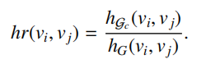
Note that G denotes the network topology. According to Eq. (12), hr(vi , vj) ≥ 1.
Fig. 4 depicts the hop expansion rate with different parameters. From this figure, the hop expansion rates of the EECN are obviously lower than those of the Steiner tree.
Fig. 5 shows the number of hop-acceptable edge-edge paths with different parameters.
Fig. 6 presents the comparison of hop-acceptable edge-edge paths in different structure building modes. In the dynamic structure building mode, the EECN was built in the manner introduced in Section 6.2.1.

注意，G 表示网络拓扑结构。根据公式 (12)，hr(vi , vj) ≥ 1。
图 4 展示了不同参数下的跳数扩展率。从图中可以看出，EECN 的跳数扩展率明显低于斯坦纳树。
图 5 展示了不同参数下可接受跳数的边-边路径的数量。
图 6 比较了不同结构构建模式下可接受跳数的边-边路径。在动态结构构建模式下，EECN 的构建方式如 6.2.1 节所述。

6.2.4. Adaptability and scalability
In the experiment, the maximum runtime of the EECN structure construction for the networks with different nodes (i.e., 1000, 2000, 3000 and 4000 nodes) is 1005, 1435, 1879 and 2138 ms, respectively. Because the EECN structure is used to provide long-term service and edge servers are usually steady, the above experimental results show that the scalability of the EECN structure construction is desirable.
实验中，对于节点数分别为 1000、2000、3000 和 4000 的网络，EECN 结构构建的最大运行时间分别为 1005、1435、1879 和 2138 毫秒。由于 EECN 结构用于提供长期服务，且边缘服务器通常运行稳定，上述实验结果表明 EECN 结构构建具有良好的可扩展性。

