Initial Evaluation Plan for the TSMS 3D-PAWS Intercomparison Study
Updated: 24 January 2024

The 3D-PAWS datasets from Turkey comprise nine stations located at three different locations (Ankara, Konya, Adana). The initial data were collected during the 10-19 January 2024 visit. Stations deployed in Ankara and Konya started data collection in August 2022. The Adana stations started collection observations in October 2022. 3D-PAWS data are stored in daily (recording) files. The reference data from the Turkish State Meteorological Service (TSMS) from each site are stored in one data file per site. All the data can be accessed in the project Google folder (https://drive.google.com/drive/folders/195bngGBz-CDWZotwQOtkaHOGhT1uS2HX?usp=drive_link), the eyewall.rap.ucar.edu data server, and CHORDS (3D-PAWS only): http://3d-calibration.chordsrt.com/instruments.

The following is a summary of each site.
Ankara
Current Data Period: 16-Aug-2022 to 12-Jan-2024

Stations:
3D-PAWS_TSMS00: Original station installed in November 2019. This station has not been modified except to replace failed sensors and to clean the sensors. This station will serve as a long-term 3D-PAWS reference for the study. Data are transmitted using a network cable. The station is connected to commercial power.

3D-PAWS_TSMS01: This station was built by ICD. This is the 3D-PAWS reference station for Ankara. A reference station is defined as we didn’t upgrade any sensors, and only performed routine maintenance (cleaning the rain gauge, radiation shield cleaning, leveling sensors, etc). The station uses a Raspberry Pi for data logging. Data are transmitted using a network cable. The station is connected to commercial power.

3D-PAWS_TSMS02: This station was built by TSMS. During the visit, the sensors were updated including the replacement of the HTU21D humidity sensor for a STH31D humidity sensor. Routine maintenance was performed on the station. The station uses a Raspberry Pi for data logging. Data are transmitted using a network cable. The station is connected to commercial power.

A photo of the Ankara 3D-PAWS station configuration is shown in Figure 1.

STH31D upgrade: around 13 UTC on January 17, 2024

TSMS reference dataset: paws_17130.txt
(https://drive.google.com/file/d/1BxmPOawnAsZ2hAN0rYzscmncmCg1vP1w/view?usp=sharing)

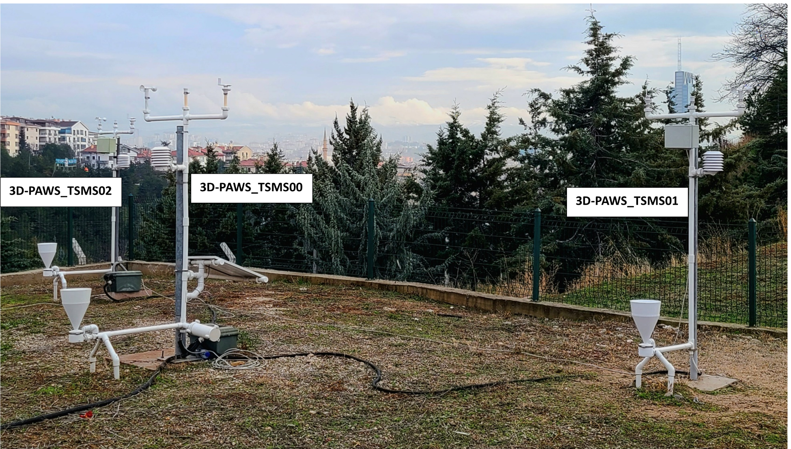
Fig. 1: 3D-PAWS station configuration for Ankara site.

Konya
Current Data Period: 16-Aug-2022 to 12-Jan-2024

3D-PAWS_TSMS03: This station was built by ICD. The station had routine maintenance performed and the HTU21D humidity sensor was replaced with the STH31D humidity sensor. The station uses a Raspberry Pi for data logging. Data are transmitted wirelessly to a central GSM modem. The station is connected to commercial power.

3D-PAWS_TSMS04: This station was built by ICD. This is the 3D-PAWS reference station for Konya. The only updates during the visit was routine cleaning and leveling. The station uses a Raspberry Pi for data logging. Data are transmitted wirelessly to a central GSM modem. The station is connected to commercial power.

3D-PAWS_TSMS05: This station was built by TSMS. The station had routine maintenance performed and the HTU21D humidity sensor was replaced with the STH31D humidity sensor. The station uses a Raspberry Pi for data logging. Data are transmitted wirelessly to a central GSM modem. The station is connected to commercial power.
STH31D upgrade: within an hour of the last record of TSMS03 of the last record in the dataset on January 12 2024

TSMS reference dataset: paws_17245.txt
(https://drive.google.com/file/d/17gGSK8qa-fD4_vOxAst-Gdcbk3u3XENo/view?usp=drive_link)

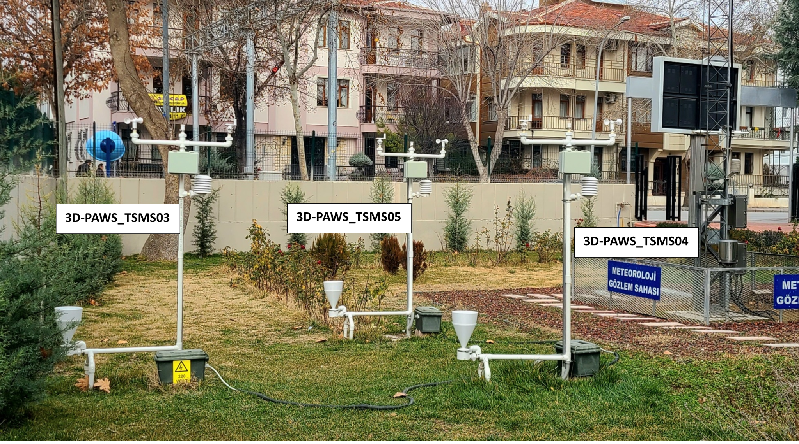
Fig. 2: 3D-PAWS station configuration for Konya site.

Adana
Current Data Period: 09-Nov-2022 to 15-Jan-2024

3D-PAWS_TSMS06: This station was built by ICD. The station had routine maintenance performed and the HTU21D humidity sensor was replaced with the STH31D humidity sensor. The station uses a Particle system for data logging. Data are transmitted wirelessly to a central GSM modem. The station is connected to solar power with a Lipo Polymer and USB Voltaic battery backup.

3D-PAWS_TSMS07: This station was built by ICD. This is the 3D-PAWS reference station for Adana. The station uses a Particle system for data logging. The only updates during the visit was routine cleaning and leveling along with the replacement of a broken anemometer cup mechanism. Data are transmitted wirelessly to a central GSM modem. The station is connected to solar power with a Lipo Polymer and USB Voltaic battery backup.

3D-PAWS_TSMS08: This station was built by TSMS. The station had routine maintenance performed and the HTU21D humidity sensor was replaced with the STH31D humidity sensor. The cup anemometer mechanism was also replaced. The station uses a Particle system for data logging. Data are transmitted wirelessly to a central GSM modem. The station is connected to solar power with a Lipo Polymer and USB Voltaic battery backup.

A photo of the Adana 3D-PAWS station configuration is shown in Figure 3.

STH31D upgrade: within the hour after the last record of TSMS08 data onJan 15, 2024

TSMS reference dataset: paws_17351.txt
(https://drive.google.com/file/d/1-9TIZ1DGU8o4ceSOgXV_4EyI6J_HBnfr/view?usp=drive_link)

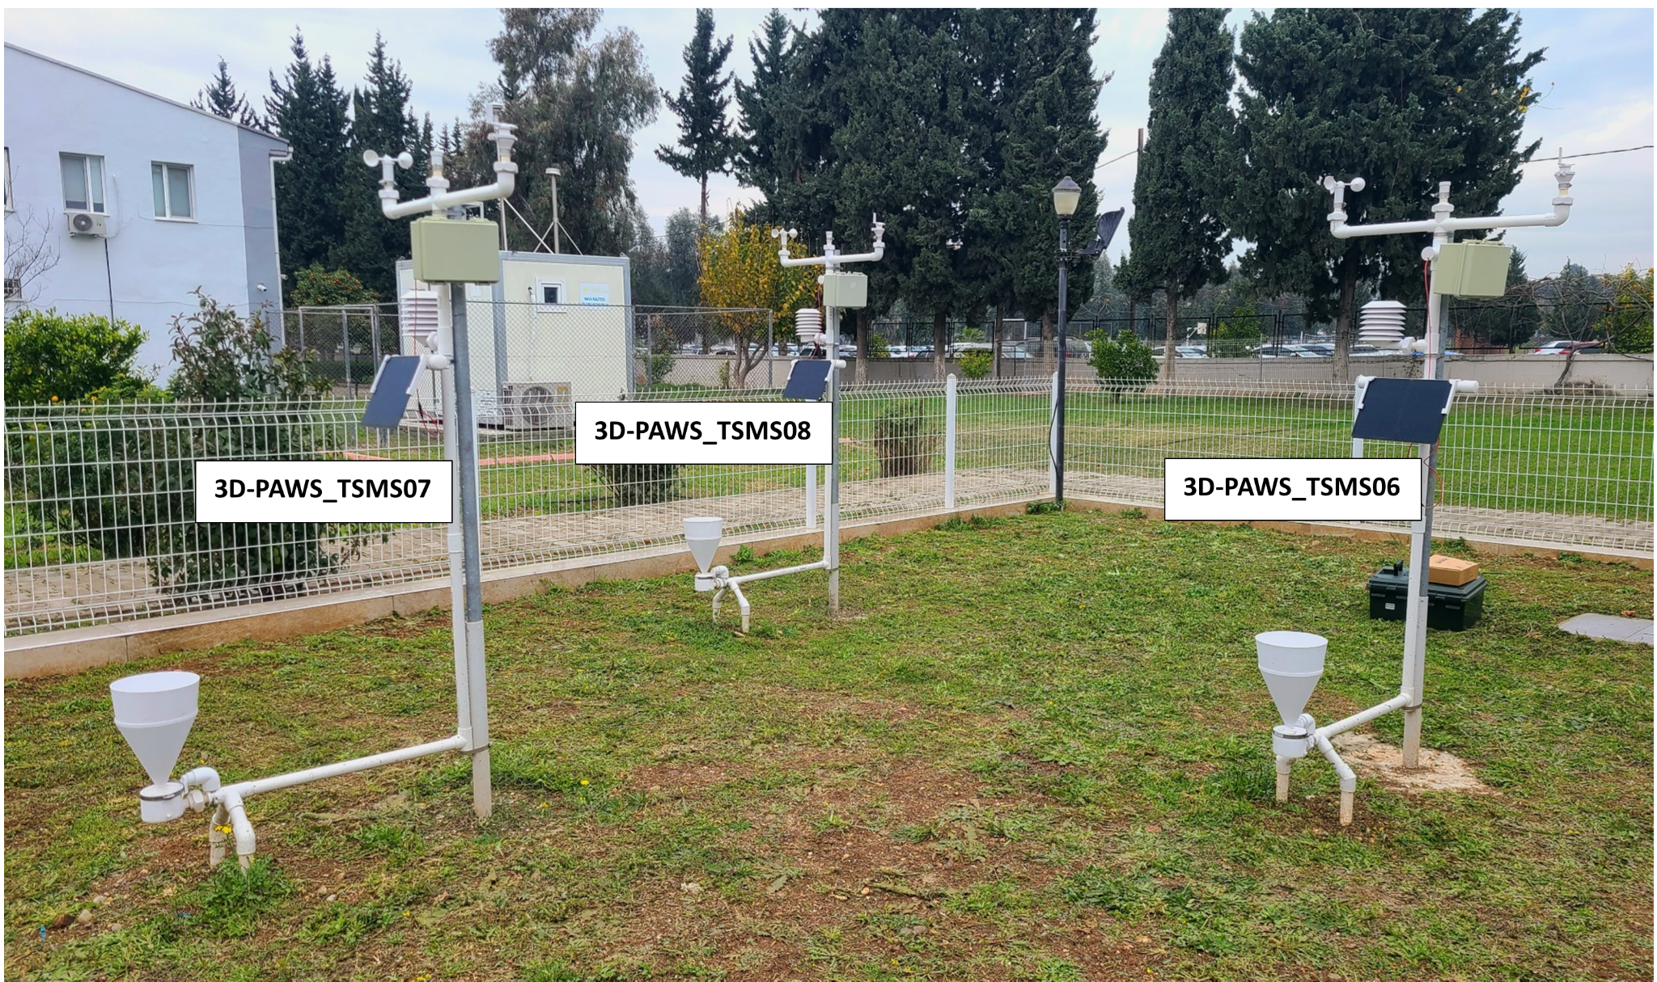
Fig. 3: 3D-PAWS station configuration for Adana site.

Data Formats:
3D-PAWS data are space/tab delimited with the following format: year mon day hour min int bmp2_temp bmp2_pres bmp2_slp bmp2_alt bme2_hum htu_temp htu_hum mcp9808 tipping vis_light ir_light uv_light wind_dir wind_speed
*Note: Some of the initial 3D-PAWS records and record filenames had a slightly different format(s)

TSMS data are semi-colon delimited with the following format: STATION_NO;DATETIME;YEAR;MONTH;DAY;HOUR;MINUTE;TEMPERATURE(°C);HUMIDITY(%);ACTUAL_PRESSURE(hPa);AVG_WIND_DIRECTION(0-360);AVG_WIND_SPEED(m/sec)

Data Analysis
The data evaluation will focus on parameters: temperature, station pressure, relative humidity, wind speed, wind direction, and rainfall. The comparison will include, but not limited to, comparison of sensors between stations, comparison of parameters, performance of systems in different climatic conditions, comparison of station builds (ICD vs. TSMS), comparison of performance of hardware configurations (e.g., RPi, Particle, commercial vs. batter power, etc.). Performance in different seasons (winter/summer, etc.), performance for different temporal scales (e.g., minute, hourly, synoptic, daily, pentads, monthly, etc.), and comparison of the parameters with the reference stations.
The following are some initial processing tasks to support more efficient data analysis.

Initial data processing tasks:
- Data reformatting: all the data should be reformatted into a common format. Brianna suggested the 3D-PAWS format that Joey developed (as listed in the data format section above). The reference data should have similar format, e.g., date time pressure humidity, temperature rainfall wind_direction, wind speed. As long as it is consistent and well-documented, slight formatting differences should be fine. The filenames for the reference dataset should have the station name to make it easier to use. The 3D-PAWS files should include the station name (e.g., TSMS00).
  - The reformat should start with a copy of the original files be keep the same temporal format (e.g., daily for 3D-PAWS, complete record for reference data).
  - Temporal reformats:
    - Reformat the reference data to daily files
    - Reformat each station to a complete record (make sure the headers are removed)
    - Create monthly stratification for both datasets
  - Create matched pair datasets at the minute resolution for each combination for each site (e.g., TSMS00-Reference, TSMS01 vs. Reference, TSMS00 vs. TSMS01, etc.)
  - Other formats for analysis?

- Plotting - the fun part. We should create a variety of initial plots to get a first look at the data before any QC, flagging, etc. is done.
  - Time series plots:
  - Scatterplots: create scatter plots of all the parameters except wind using the matched pair datasets to see how each station compares to the reference and with each other.
  - Wind rose plots: For wind parameters, we should create wind rose plots; I am sure python has that function built in, especially if you use the MetPy library from Unidata.

- Other plots: Once we look at the initial plots, we will have ideas for other comparisons such as temporal averaging, seasonal comparisons, etc.

- Data QC: Once we see the initial datasets, we will want to apply Brianna’s QC and redo the various analyze.

- Statistical Evaluation: We will want to compute various statistics for different stratifications such as bias, mean squared errors, error distributions (e.g., boxplots), etc. to quantify the data quality.

- Station reliability: we will want to compute reliability of stations stratified by location (climate), sensor (temperature, pressure, etc), hardware configuration (Raspberry Pi’s vs. Particle, commercial power vs. battery power, wireless networking vs. network cable, etc.)

- We will need to understand the reference sensor uncertainty and differences in sampling (e.g, 2 m winds vs. 10 m winds)

- Other analysis: we will think of many other ways to explore the data on this quest for knowledge which can be added to this document. A critical component of the study is to document all the process so we can tell the story in the report/publication.

