12/1/25, 5:18 PM ACC - Document Processed - ryan.zimmerman@southwestresumes.com - Southwest Resume Services Mail


� ecorp

Mail

Compose

lnbox 7,356



ACC - Document Processed E,tomal lobo,'

Chat Starred

Snoozed
Meet Sent

Drafts
More

Labels

 Notes

Project Manage... 1,308

ACCNoReply@azcc.gov


Log email to HubSpot •

Dear Sir/Madam,
The Arizona CorporatiOfl Commission has processed your submission for the following Entity Name: SPARKDATAANALYTICS, LLC
Document/Service: Articles of Organization

Log in to your dashboard at for more information.
You can access the Arizona Corporation Commission online filing system using the following website to verify the approval status. Sincerely,
Arizona Corporation Commission
1300 W. Washingtoo St
Phoenix, AZ 85007
602-542-3026
1-800-345-5819 (within AZ only) answers@azcc.gov

(Note: This email has been sent by an automated process. Please do not reply to this email address.)

2 Attachments • Scanned by Gmail


tome
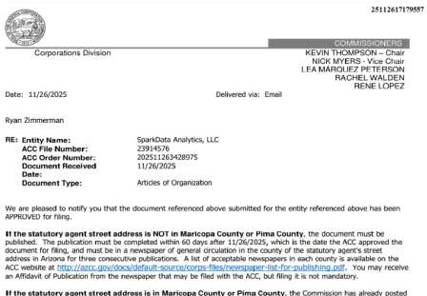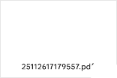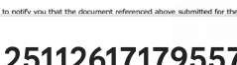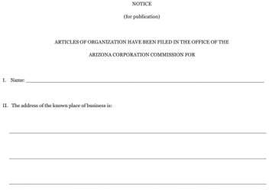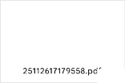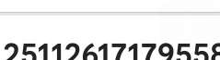
f-i Reply
� Forward

