BOOS
CREATE ORDER
User Tutorial

This tutorial explains how to open the Order menu, access Create Order, enter the required order information and proceed to the Order Details page.

Step 1 – Click the Order Menu
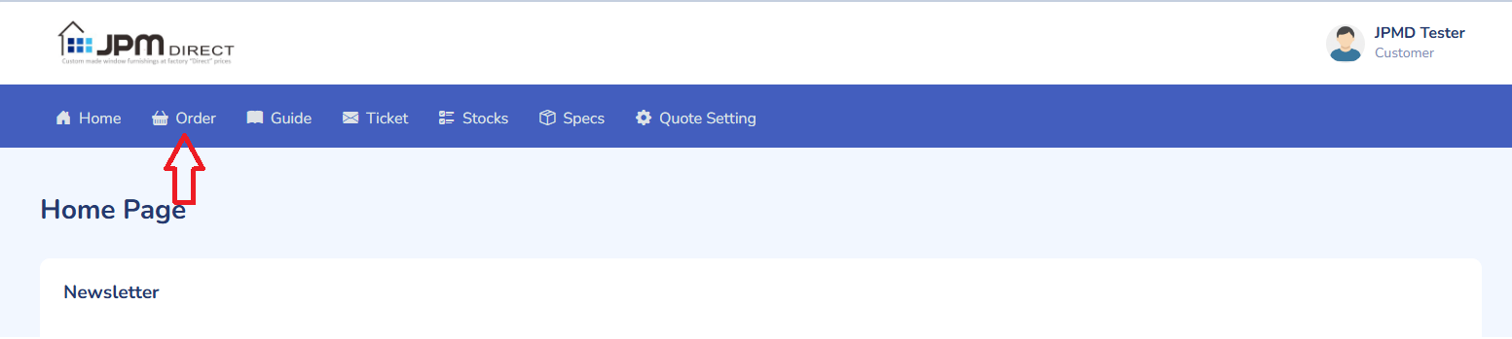
From the BOOS main navigation, click Order. This will open the Order menu and display the available order functions.

Figure 1. Select Order from the main navigation.

Step 2 – Click Create Order
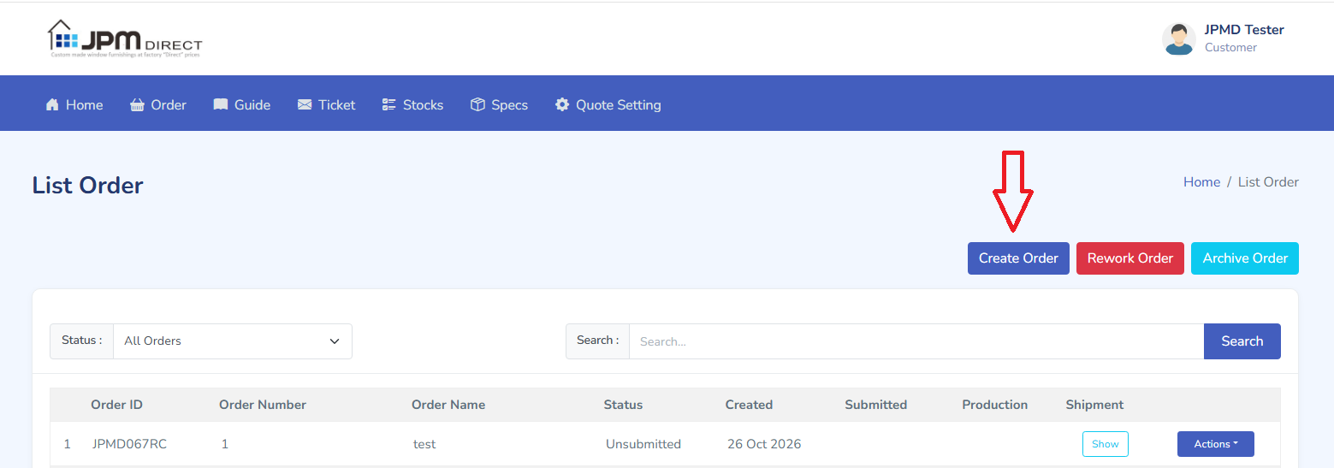
In the Order menu, select Create Order to open the new order form.

Figure 2. Select Create Order.

Step 3 – Complete the Create Order Form and Submit
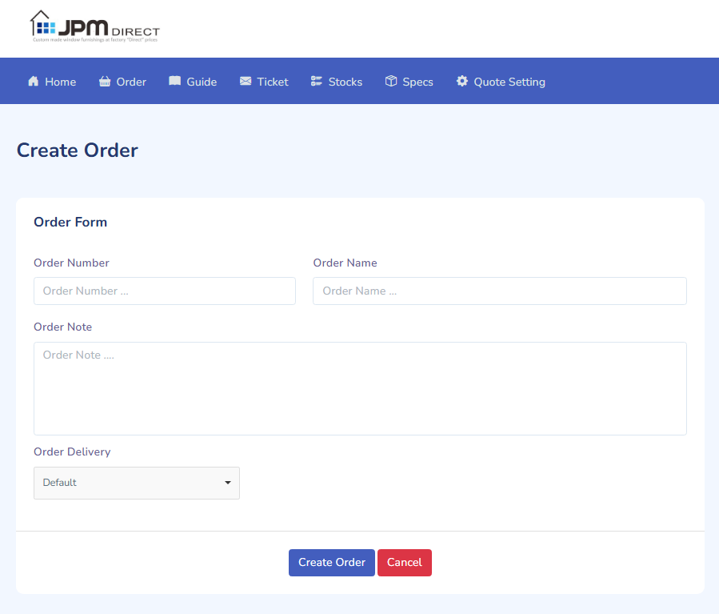
On the Create Order page, enter the information according to your requirements. Complete all mandatory fields and review the information before clicking Submit. The fields shown may vary depending on your BOOS configuration and the type of order.

Figure 3. Example of the Create Order form and Submit button.

Step 4 – Continue to the Order Details Page
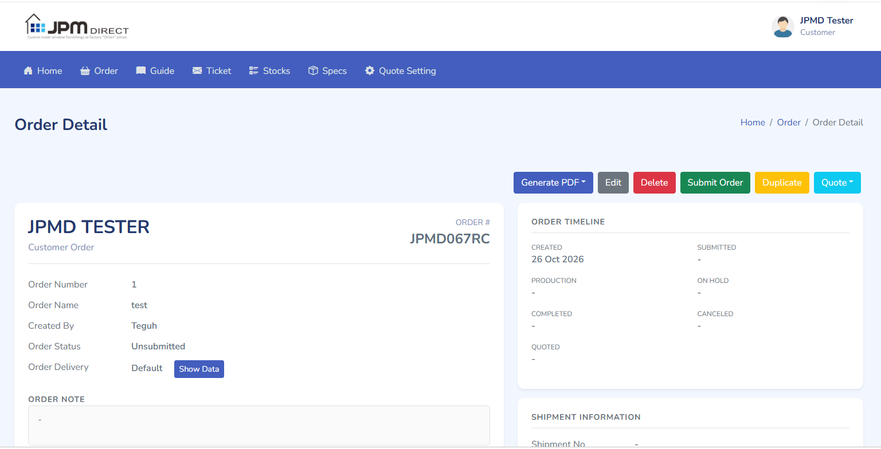
If the order is created successfully, BOOS will automatically redirect you to the Order Details page. From this page, you can continue by adding the required items to the order.

Figure 4. Example of the Order Details page after successful submission.

What Happens Next?
After you reach the Order Details page, continue with the process of adding order items. Check that the order header is correct before adding products.

Quick Process
- Click Order.
- Click Create Order.
- Enter the required information and click Submit.
- After successful submission, BOOS redirects you to the Order Details page.
- Add the required items to the order.
Document version: 1.1 | Prepared: November 2026

