11 October 2025

John L Knowlton C.Chem., MRSC, Dip. Cos. Sci. (GB)
Cosmetic Solutions,
9 Maletsatsi,
North Road,
Edenburg,
Rivonia,
Sandton
2128

To Whom It May Concern

My name is John L Knowlton and I am the founding member and current owner of Cometic Solutions, an eminent cosmetic consultancy business of some 27 years standing, based in Johannesburg in South Africa. The purpose of this communication is to provide a character reference for Mr. Daniel Faucitt, whom I have known in my professional and personal capacities for approximately 10 years.

At the outset, it is immediately obvious that Daniel is a highly intelligent and professionally accomplished individual with significant achievements to his name, including the award of two university degrees, with honours, and the success of managing the IT environment and other business sectors of RégimA Skin Care in South Africa and RégimA Skin Care in the UK, as well as holding the position of CEO in the case of the latter.

In my own experience, working with Daniel is our respective professional capacities has been a very rewarding and satisfying experience. Daniel is an inspirational individual, who displays a high degree of innovation and creativity when faced with a plethora of business challenges, and his capability in the IT sectors of the RégimA businesses has been exemplary, contributing enormously to their past and present success. Despite his intellectual capability, Daniel is also a great team player and I have often enjoyed working closely with him to achieve specific objectives in the interest of the RégimA businesses that we have both worked in.

On a personal level, Daniel is a sensitive and compassionate individual, who places a high level of importance in the wellbeing of others. I have always found Daniel to be an intuitively kind and generous individual, and he has provided me with support in my personal capacity on numerous occasions in the time that I have known him.

In conclusion, I believe Daniel Faucitt to be a highly capable individual who acts with integrity and aplomb, both in the discharge of his professional duties in all aspects of business, and his willingness to help and support the interests of others on a personal level. As such, I feel very fortunate to be associated with Daniel in the way that I am, and I value our relationship tremendously.

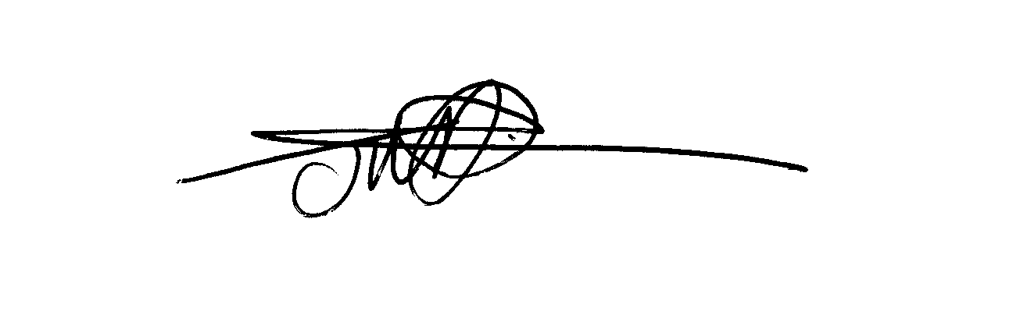
Yours sincerely,

John L Knowlton C.Chem., MRSC, Dip. Cos. Sci. (GB)

CEO of Cosmetic Solutions

