Deploying MDATP for Mac with MEM powershell scripts
Version 1.0

6th April 2020
Authored
Neil Johnson, Microsoft Intune CxE

MEM MDATP for Mac Deployment Script overview
The following PowerShell scripts are available to help with MDATP deployment for Mac from the Microsoft graph GitHub repository.

Script Name | Function
MacOS_MDATP_Deployment_Add.ps1 | Creates all profiles and applications for MDATP for Mac in MEM but does not assign them to any groups.
MacOS_MDATP_Deployment_Add_Assign.ps1 | Creates all profiles and applications for MDATP for Mac in MEM and assigns them to the group that is specified.

Profiles Created
Both scripts will create the same five profiles. Four custom macOS | configuration profiles and one macOS | application profile.

Profile | Type | Purpose
macOS MDATP Kernel Extension | Custom | This is a custom macOS | Configuration profile that configures macOS to trust kernel extensions signed by Microsoft’s developer certificate.
macOS MDATP Notifications | Custom | This is a custom macOS | Configuration profile that configures macOS to allow MDATP to show the end user critical notifications when necessary.
macOS MDATP Full Disk Access | Custom | This is a custom macOS | Configuration profile that configures macOS to allow MDATP full access to the disk.
macOS MDATP Onboarding | Custom | This is a custom property list macOS | Configuration profile for MDATP which tells the MDATP application which tenant to connect to.
macOS MDATP System Extension | Custom | This is a custom macOS | Configuration profile that configures macOS to trust system extensions signed by Microsoft’s developer certificate.
macOS Microsoft Defender ATP | Application | This is a macOS | app profile that configures the client to download and install the MDATP binaries.

Command Line Arguments Description
The scripts take the following command line parameters:

- OnboardingXMLFilePath < file path>
This is the path to your MDATP WindowsDefenderATPOnboarding.xml file. To obtain this file, perform the following steps.

- From a browser, go to https://securitycenter.windows.com/dashboard
- Sign in with an administrator account
- Click Settings > Onboarding
- Select macOS from the dropdown for onboarding process
- Select Mobile Device Management / Microsoft Intune from the deployment dropdown
- Click Download onboarding package
- Inside the WindowsDefenderATPOnboardingPackage.zip make a copy of the WindowsDefenderATPOnboarding.xml file within the Intune folder.

- AADGroup <AzureAD Group Name>

This is the name of the Azure AD Group that the profiles will be assigned to. This is only available in the MacOS_MDATP_Deployment_Add_Assign.ps1 script.

Deployment Example
In this example I have saved my WindowsDefenderATPOnboarding.xml file in the same directory as the MacOS_MDATP_Deployment_Add_Assign.ps1 script. Once the script is run it will create all five policies and assign them to the group provided.

Important:
If any users or devices are in the AAD Group, they will begin receiving the deployment profiles at their next check-in.

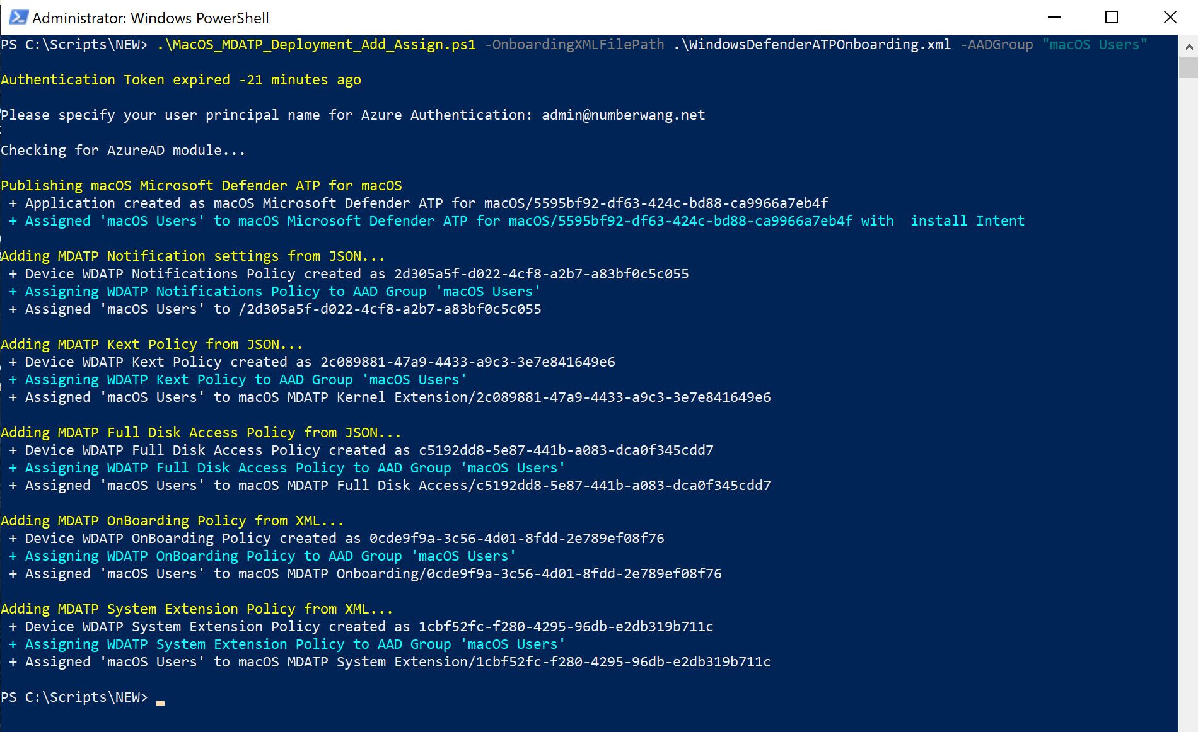

MEM Policies
Once done, the following macOS | Configuration profiles will appear in your MEM console:

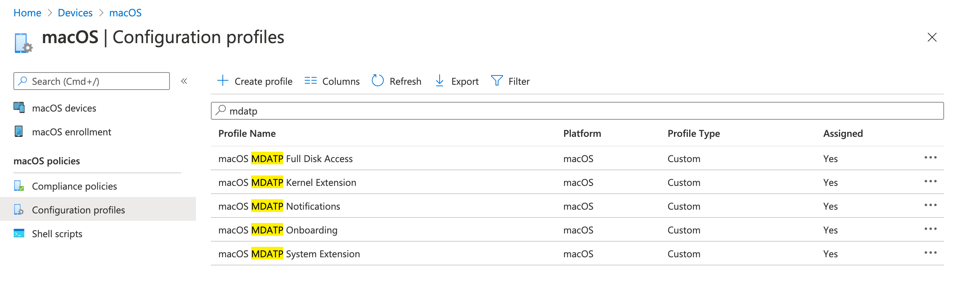
Once done, the following macOS | apps will appear in your MEM console:

