**1D DATA VISUALIZATION:**

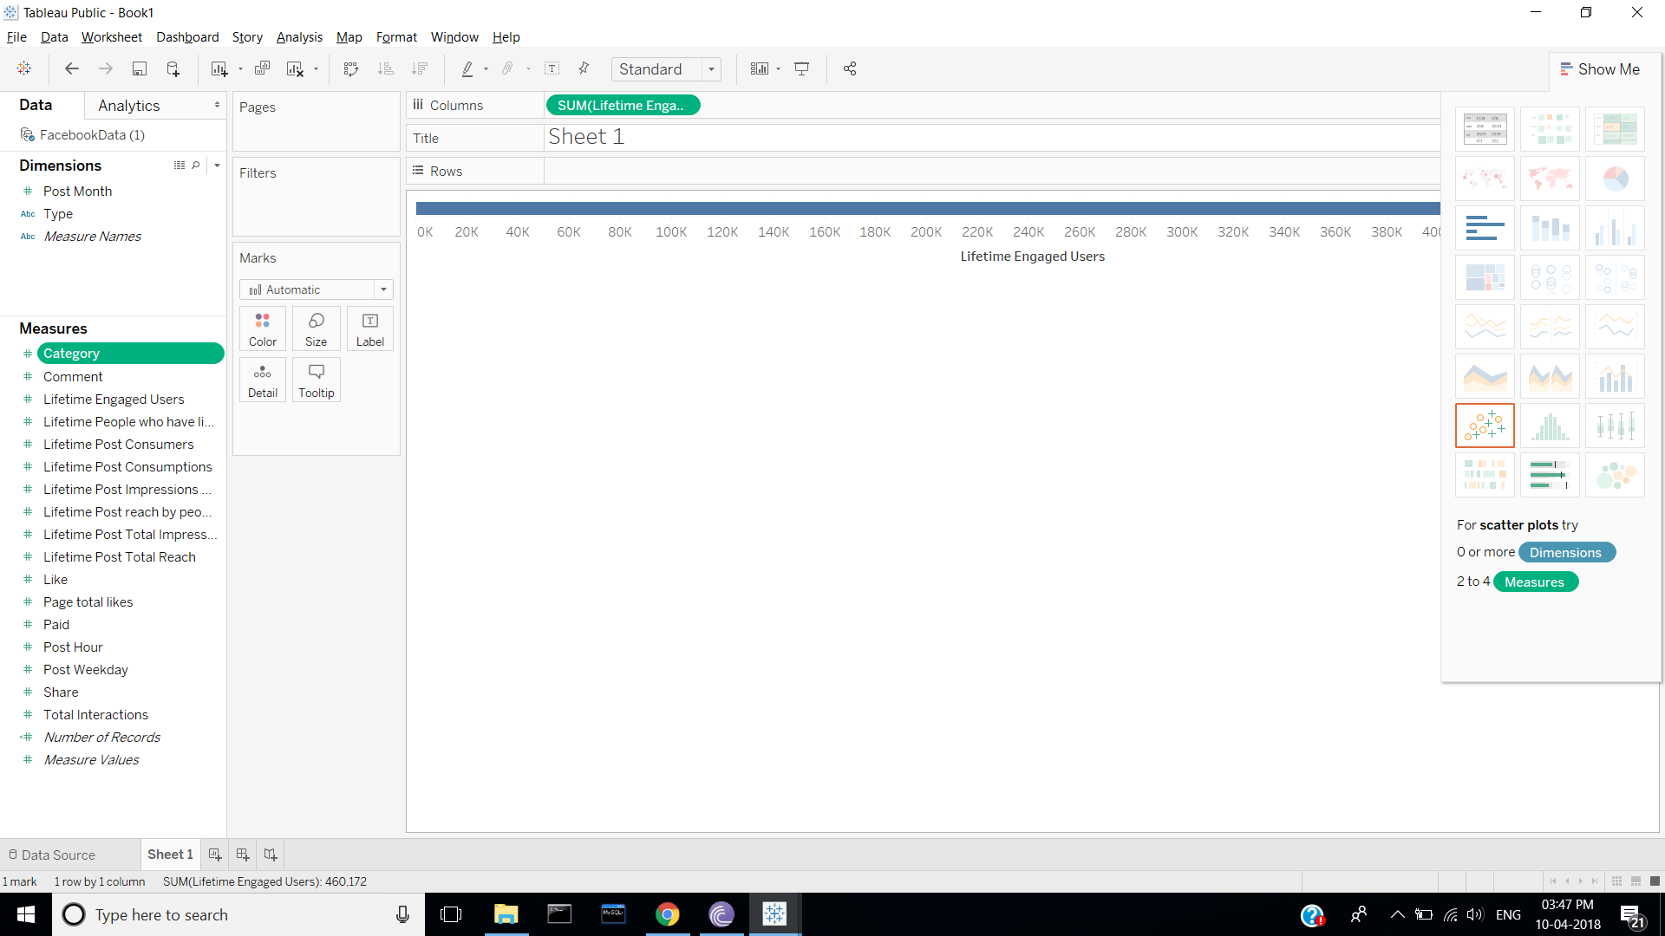

STEPS:

1. Go to sheets.

2. Select category you want to display.

3. Choose the type of Graph you want to Visualize.

4. Drag the selected category and drop on colums for 1D data visualization.

**2D DATA VISUALIZATION:**

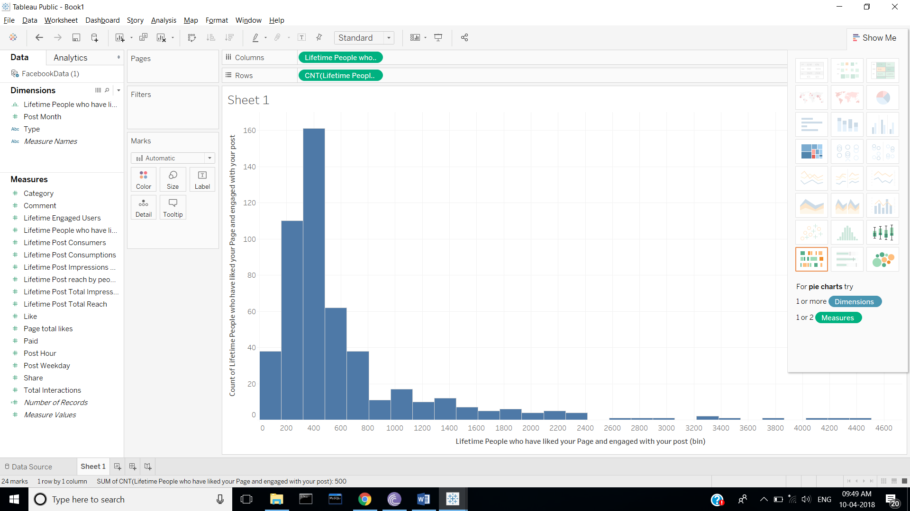

Steps:

1. Follow same steps 1,2,3 as followed for 1D.
2. For 2D visualization select histogram type of graph.
3. For 2D data visualization we drag and drop the selected categories one in row and other in column.

**MULTIDIMENSIONAL DATA VISUALIZATION:**

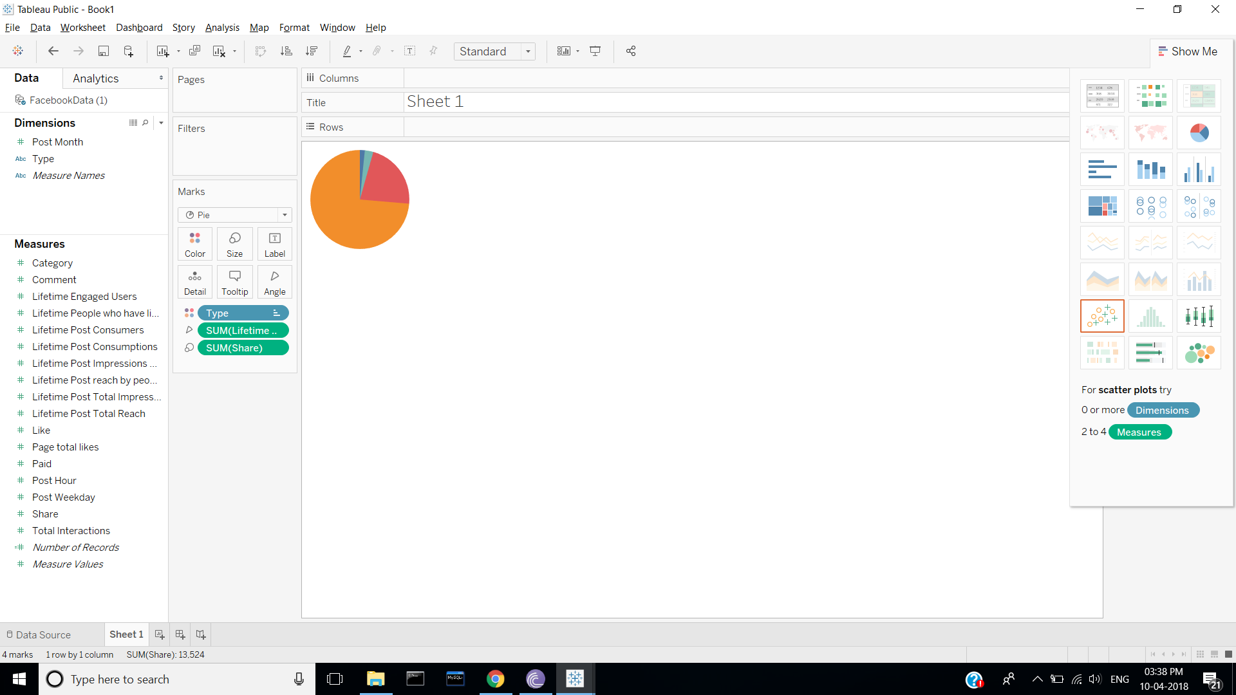

Steps:

1. Follow same steps 1,2,3 as followed for 1D.
2. For multidimensional visualization select piecharts type of graph.
3. For multidimensional data visualization select more than 2 categories and drag and drop on piechart.