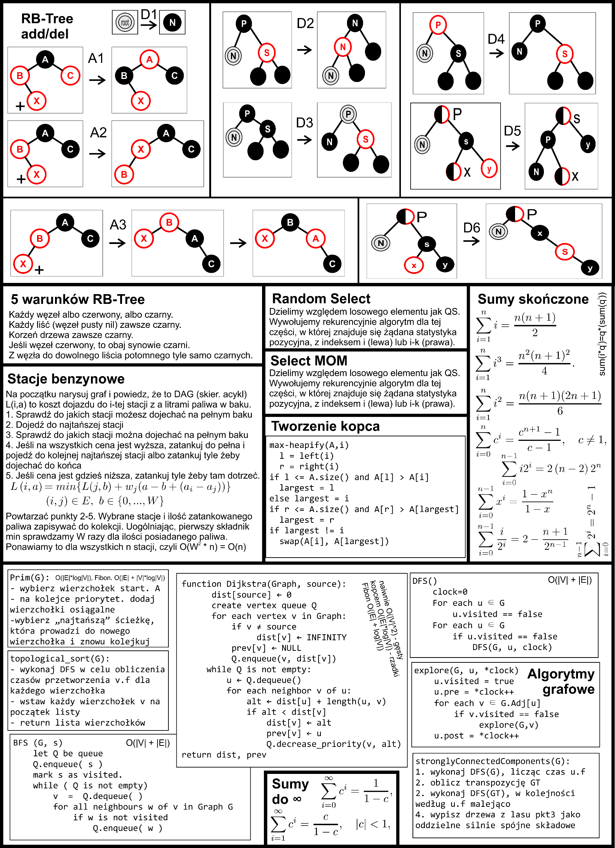

|  |
| --- |
| **JAN KOWALSKI** |

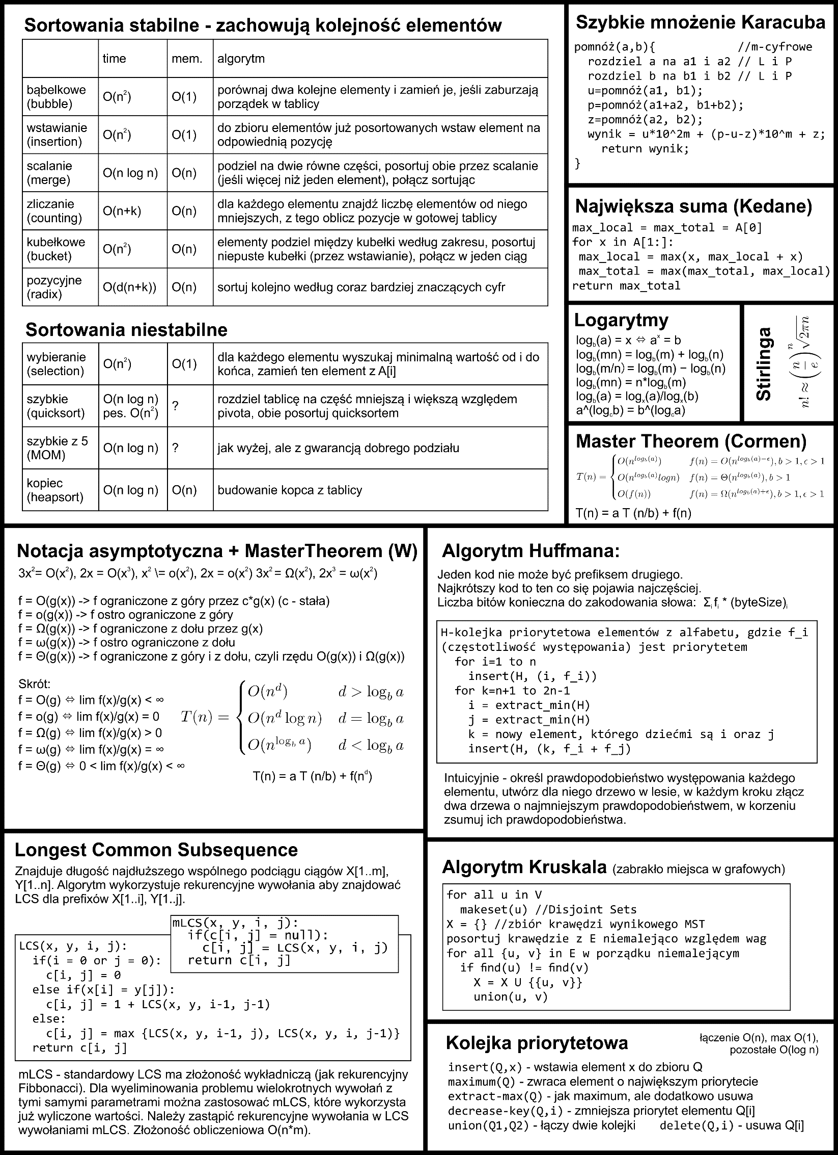

|  |
| --- |
| **JAN KOWALSKI** |