Exercise 1

import numpy as np
import matplotlib.pyplot as plt
# Function to generate a random rectangle
def generate_random_rectangle():
x = np.random.randint(0, 51) # Random x-coordinate in [0, 20]
y = np.random.randint(0, 51) # Random y-coordinate in [0, 20]
width = np.random.randint(1, 51) # Random width in [1, 20]
height = np.random.randint(1, 51) # Random height in [1, 20]
return [x, y, width, height]
# Generate two random rectangles R1 and R2
R1 = generate_random_rectangle()
R2 = generate_random_rectangle()
while R1[2] == 0 or R1[3] == 0:
R1 = generate_random_rectangle()
while R2[2] == 0 or R2[3] == 0:
R2 = generate_random_rectangle()
# Create a figure and axis
fig, ax = plt.subplots()
# Plot rectangles R1 and R2 with different colors
ax.add_patch(plt.Rectangle((R1[0], R1[1]), R1[2], R1[3], color='orange', alpha=0.5, label='Rectangle 1'))
ax.add_patch(plt.Rectangle((R2[0], R2[1]), R2[2], R2[3], color='blue', alpha=0.5, label='Rectangle 2'))
ax.set_xlim(0, 50)
ax.set_ylim(0, 50)
ax.set_xlabel('X-axis')
ax.set_ylabel('Y-axis')
ax.set_title('Random Rectangles')
ax.legend()
plt.show()

Result
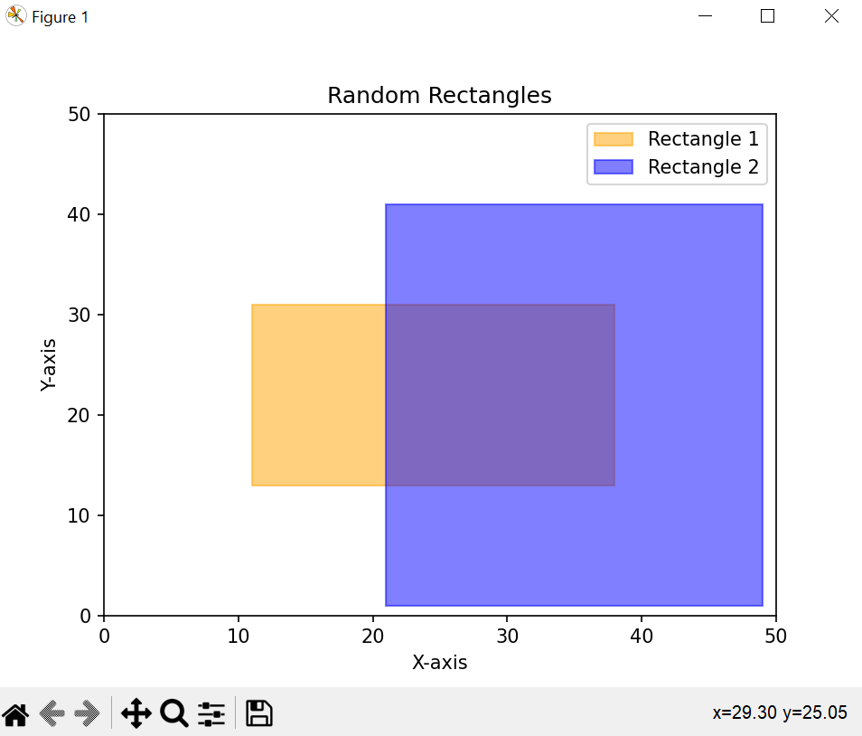

Exercise 2

import numpy as np
import matplotlib.pyplot as plt
def generate_random_rectangle():
x = np.random.randint(0, 21) # Random x-coordinate in [0, 20]
y = np.random.randint(0, 21) # Random y-coordinate in [0, 20]
width = np.random.randint(1, 21)
height = np.random.randint(1, 21)
return [x, y, width, height]
def compute_central_point(rectangle):
x = rectangle[0] + rectangle[2] / 2
y = rectangle[1] + rectangle[3] / 2
return [x, y]
def check_intersection(rect1, rect2):
x1, y1, w1, h1 = rect1
x2, y2, w2, h2 = rect2
center1 = compute_central_point(rect1)
center2 = compute_central_point(rect2)
intersect = (abs(center1[0] - center2[0]) * 2 < (w1 + w2)) and (abs(center1[1] - center2[1]) * 2 < (h1 + h2))
return intersect, center1, center2
R1 = generate_random_rectangle()
R2 = generate_random_rectangle()
while R1[2] == 0 or R1[3] == 0:
R1 = generate_random_rectangle()
while R2[2] == 0 or R2[3] == 0:
R2 = generate_random_rectangle()
intersection, center1, center2 = check_intersection(R1, R2)
print(f"Central point of R1: {center1}")
print(f"Central point of R2: {center2}")
print(f"Rectangles intersect: {intersection}")
fig, ax = plt.subplots()
ax.add_patch(plt.Rectangle((R1[0], R1[1]), R1[2], R1[3], color='red', alpha=0.5, label='Rectangle 1'))
ax.add_patch(plt.Rectangle((R2[0], R2[1]), R2[2], R2[3], color='blue', alpha=0.5, label='Rectangle 2'))
ax.set_xlim(0, 20)
ax.set_ylim(0, 20)
ax.set_xlabel('X-axis')
ax.set_ylabel('Y-axis')
ax.set_title('Random Rectangles')
ax.legend()
plt.show()

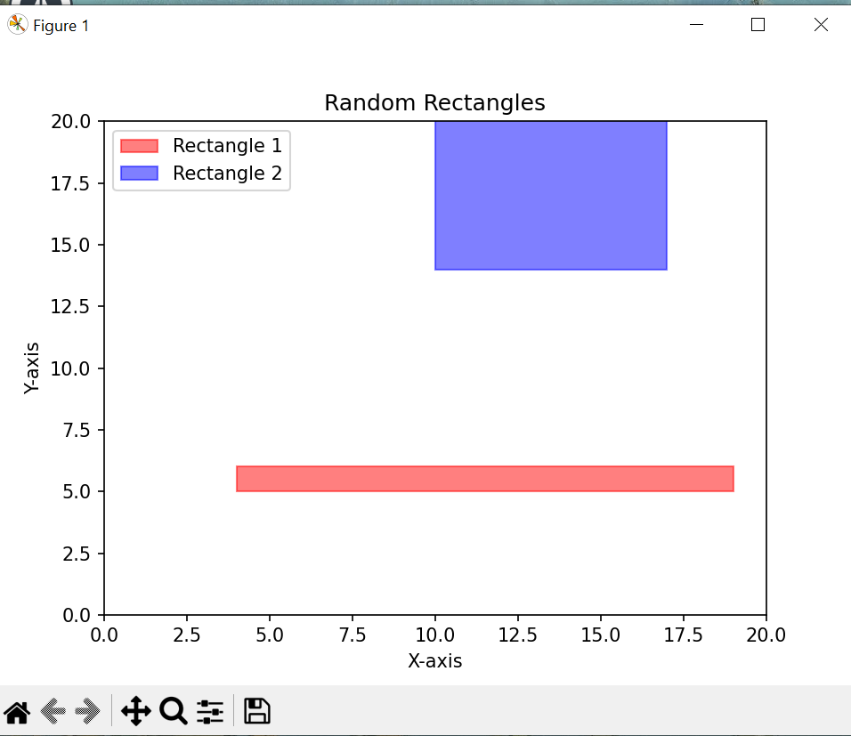
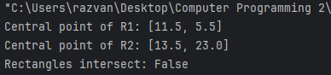

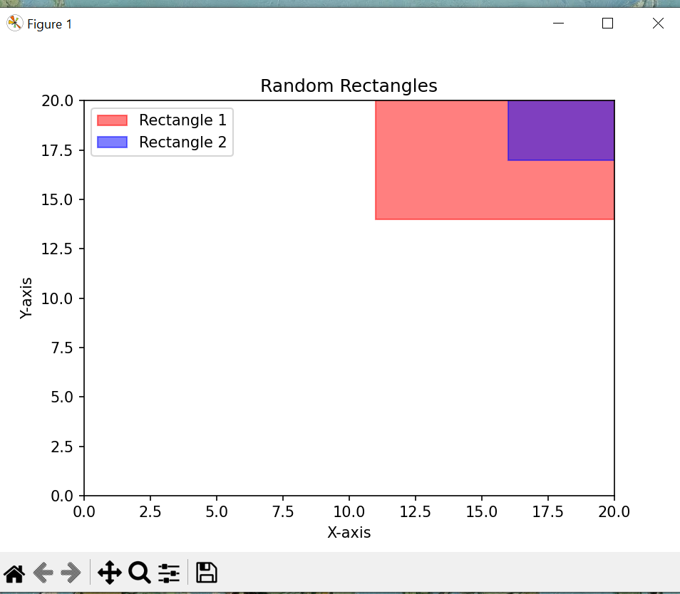

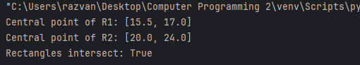

Exercise 3
import numpy as np
import matplotlib.pyplot as plt
def egg_holder(x, y):
return -(y + 47) * np.sin(np.sqrt(np.abs(x / 2 + (y + 47)))) - x * np.sin(np.sqrt(np.abs(x - (y + 47))))
x = np.linspace(-512, 512, 100)
y = np.linspace(-512, 512, 100)
X, Y = np.meshgrid(x, y)
Z = egg_holder(X, Y)
# Create a 3D plot using plot_surface
fig = plt.figure(figsize=(10, 8))
ax = fig.add_subplot(111, projection='3d')
ax.plot_surface(X, Y, Z, cmap='viridis')
ax.set_title('Egg Holder Function - plot_surface')
# Create a 3D plot using plot_wireframe
fig = plt.figure(figsize=(10, 8))
ax = fig.add_subplot(111, projection='3d')
ax.plot_wireframe(X, Y, Z, cmap='viridis')
ax.set_title('Egg Holder Function - plot_wireframe')
# Create a contour plot using contourf
plt.figure(figsize=(8, 6))
contour = plt.contourf(X, Y, Z, cmap='viridis', levels=50)
plt.colorbar(contour)
plt.title('Egg Holder Function - contourf')
plt.xlabel('x')
plt.ylabel('y')
plt.show()

